SPARROWS WEEKLY SUGGESTED HOME LEARNING – WB 1.6.20
Hello Sparrows! I cannot believe we are now in June, we have been apart for so long and I cannot wait to see all of your smiling faces again! I hope you all had a fantastic half term and did lots of activities in the amazing weather we had. Why don’t you send me a tweet or email to let me know what you got up to? I spent a lot of time in the garden, made a flower bed, had a BBQ and went on a bike ride.
Thank you to those families who have been in contact. There are still a few families who have not been in contact and I would love to hear from you. It really brightens up my day and I will reply which I am sure will put a smile on your face too. You can email the office at enquiries@saintoswalds.wigan.sch.uk FAO Sparrows or tweet us @saintoswalds @mrs_wibberley @MrsOsborne73. This week we are continuing our text Yeti and the Bird by Nadia Shireen. You can find the story on YouTube if you need to read/listen to it again.
Mrs Osborne said she has seen even more smiling faces around Ashton this week so keep your eyes peeled as you may see her on your walks and you can give her a wave or a shout across the street.
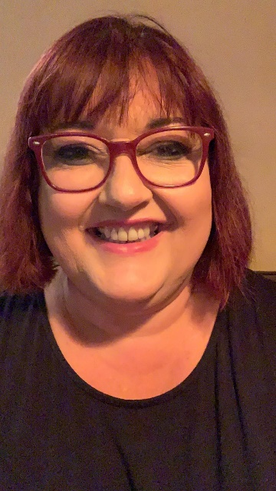
We look forward to hearing from you this week! Keep smiling, enjoy this time with your family, get lots of fresh air and stay safe.
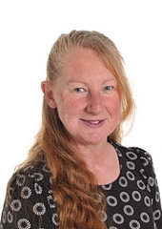
Mrs Wibberley, Mrs Osborne and Mrs Dean xx
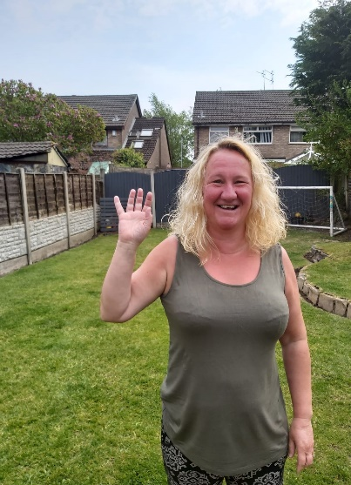
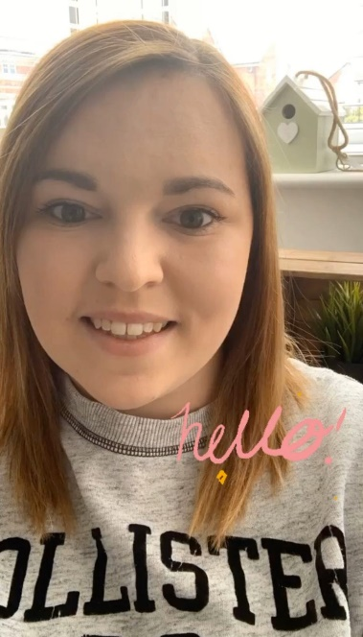

ENGLISH | MATHS
Reading – Read every day for pleasure for 10 minutes.  You can also listen to stories on www.vooks.com. This website is full of stories that come with videos and are a big hit in Sparrows as there are so many to choose from. Maybe your child can share their favourite story with you. You can get a free subscription for 1 month.  Comprehension –  - Choose a book from around your house and read it with an adult. Tell your adult why you chose that book and your adult can ask you questions about the book (there are some questions below to guide you).  - Orally retell a familiar story with repetitive phrases (e.g. The Three Little Pigs). Join in with your adult as they read it to you and act out the story. You can often find masks and props on the internet for popular stories if you wish to print them off.  Writing –  - Write a postcard from bird back to Yeti while she is on one of her journeys.  - Discovery Education have asked our school to take part in their News Bite film for National Writing Day. This is a fantastic opportunity and all you need to do is write a Haiku about Summer 2020 and film yourself reading it. Please see below for all the details and important information on the filming.  Phonics – Your child will be able to tell you which phonics group they are in. If they don’t know, please contact school so we can help you.  Mrs Osborne and Mrs Dean’s groups –  1. Go to https://www.phonicsbloom.com/ or https://new.phonicsplay.co.uk/ and play your favourite game to practise all the new sounds you have learnt over the past few weeks.  2. Find objects around the house that have the sound ‘oo’ (moon) in them. Write the words and draw pictures to match.  Mrs Wibberley’s group –  1. Go to https://www.phonicsbloom.com/ or https://new.phonicsplay.co.uk/ and play your favourite game to practise all the new sounds you have learnt over the past few weeks.  2. Find objects around the house that have the sound ‘oy’ and ‘oi’ in them. ‘oi’ was learnt during phase 3. Put these words into sentences and draw pictures to match.  Miss Lea and Mrs Davies’ groups –  1. Go to https://www.phonicsbloom.com/ or https://new.phonicsplay.co.uk/ and play your favourite game to practise all the new sounds you have learnt over the past few weeks.  2. Play the phase 5 yes/no game below. Challenge - Can you come up with your own questions using the sounds you have learnt? | Basic skill – Read, write and interpret mathematical statements involving addition (+), subtraction (-) and equals (=) signs.  You can use objects to help you work out the statements if you need to and remember the equals sign does not always come at the end!  There are some great games on this website if you would like to use them https://www.topmarks.co.uk/maths-games/5-7-years/addition-and-subtraction  Unfortunately White Rose have started charging for their home learning tasks, however BBC Bitesize have partnered with White Rose and have some great daily tasks including maths for free. Follow this link for a daily maths task https://www.bbc.co.uk/bitesize/tags/zjpqqp3/year-1-and-p2-lessons/1  If your child finds this challenging, please follow this link https://www.hamilton-trust.org.uk/blog/learning-home-packs/ and use the previous year group’s tasks.
R.E. | OTHER
The theme is: Reconciliation – Being sorry.  We have choice – sometimes we choose well, and sometimes wrongly.  Listen to the following story https://www.youtube.com/watch?v=oFxvzcltljU What happens as a consequence? Talk about the situations where we have to choose what to do and how sometimes we make good choices – good for others and for ourselves – and sometimes we make wrong choices, which make others and ourselves unhappy.  Draw some pictures of good and wrong choices and sort them into the two groups.  As a challenge you could write some sentences… I was happy when I … I was sad when I … | Science/Geography – Why do birds migrate? Can you find out more about this and write a report to teach others?  Music – Compose a song that Yeti and the bird might sing in the forest each night.  PSHE/Art – Look at the expressions of the creatures at different points in the story. How are they feeling? How can you tell?  Choose one or two expressions to draw/paint/recreate in whatever way you would like to.  PE – Create an obstacle course or draw a fun track with chalk and pretend it is the bird’s flight path.

Information from Discovery Education
Write a haiku simply on summer as a season or perhaps, a haiku on what it feels like to return to school after weeks of lockdown, being reunited with friends and teachers (For those still at home, we are suggesting it could be a haiku that expresses thoughts on what home schooling is like for them).
We would like our News Bites item to feature several children reading their poems directly to camera, and to include shots of the poems written on the page as well, so we will need you to film the children, using iPhones (or similar!), holding the phone landscape not portrait. The children will need to be head and shoulders in shot like a news reporter and the poem on the page should be filmed separately (also landscape).
We have resources on the site which give some guidance on haiku writing https://central.espresso.co.uk/espresso/primary_uk/servlet/file/store66/item1129206/doc.pdf
You have this week to send your clips to the school office enquiries@saintoswalds.wigan.sch.uk FAO Sparrows or tweet us @saintoswalds. Discovery Education do require a permission form (below) to be completed so please make sure this is also done and sent to the school email address above.

ACQUIRED MATERIALS LICENSE
Child’s Name (“Owner”):
School (if relevant):
Description of materials
(“Materials”):

- For good and valuable consideration, receipt of which is hereby acknowledged, Owner hereby grants to DISCOVERY EDUCATION EUROPE LIMITED, its parents, successors, licensees and assigns (“DE”), the right to incorporate the Materials described above in the project tentatively titled: Discovery Education child video reports (the “Project”), and to use and authorize others to use the Materials as so incorporated in the Project, and in any subsequent versions and formats of the Project, and in the distribution, sale, licensing, marketing, advertising, promotion, exhibition and other exploitation of the Project in all markets and media (whether now known or hereafter developed), throughout the universe, in perpetuity. DE may assign its rights in the Project, in whole or in part, to any individual or entity without restriction. Owner acknowledges that DE has no obligation to produce or use the Project or to utilize the Materials.

- Owner warrants and represents that Owner has the right to grant all rights granted hereunder, and that DE’s use of the Materials as permitted hereunder will not infringe on the rights of any third party, including, without limitation, trademark, copyrights, patent or any other intellectual property rights. Owner agrees to indemnify, defend, and hold harmless DE, its parents, successors, licensees and assigns, from and against any and all claims, damages, liabilities, costs and expenses arising out of any breach of the foregoing warranty. Owner acknowledges that DE will rely on this permission potentially at substantial cost to DE, and Owner hereby waives any right to injunctive or other equitable relief and agrees not to assert any claim of any nature whatsoever against anyone relating to the exercise of the permissions granted hereunder.

AGREED AND ACCEPTED:
(Please Print) Name of child: |  |  | Signature:
 |  |  | Date:

I am a parent or legal guardian of the child who has signed this release and I hereby agree that I and the child named above will be bound by all the provisions contained herein.
(Please Print)  Name of parent/ legal guardian: |  |  | Signature:
Address: |  |  | Date:
Post Code:
Phone:
Phase 5 Yes/No Game
Could you carry an elephant on your head?
Would you like to wave a magic wand?
Would you crawl into a thorn bush?
Have you ever seen a live crocodile?
Are you ready for school by nine in the morning?
Would you scream if you saw a snake?
Can magpies perch on clouds in the sky?
Would you put ice cream in the freezer?
Has a cat got sharp claws?
Do you go to school in the holidays?
Could you fly to Mars on a bike?
Could you make up a story about a giant?
