SPARROWS WEEKLY SUGGESTED HOME LEARNING – WB 11.5.20
Hello Sparrows! We hope you had a great time last week celebrating VE Day and finishing our topic on Lost and Found. On Tuesday 12th May it is National Limerick Day so we thought you would enjoy making some simple but silly poems all about animals. Poems can be quite tricky to write sometimes so it is ok if your poem is only a couple of lines long as it is still a poem!
We have loved receiving your emails, tweets and messages this week so thank you to those families who have been in contact. You are still very quiet though as we have only heard from a couple of families! We would love to hear what you are up to whether it is to do with your weekly tasks or not. Maybe you have been doing some baking, gardening, building a den, blowing bubbles or even just spending quality time with your family on a walk and we would love to see all those activities too. You can email us at enquiries@saintoswalds.wigan.sch.uk or tweet us @saintoswalds and we will respond to all of your messages.
Mrs Wibberley spoke to Mrs Osborne the other day and Mrs Osborne said she has seen some of you on your walks around Ashton, which has really made her smile so make sure you give the teachers a wave if you see them! I am sure it makes you smile as well as we are all missing school and want to see our friends and teachers again which is why it is important to keep in contact.
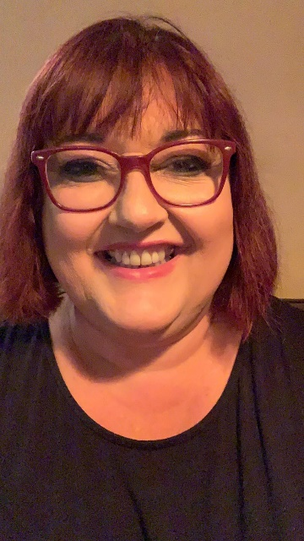
We look forward to hearing from more of you this week and we cannot wait for you to make us laugh with your silly poems! Keep smiling, enjoy this time with your family, use your daily exercise time and stay safe.
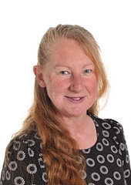
Mrs Wibberley, Mrs Osborne and Mrs Dean xx
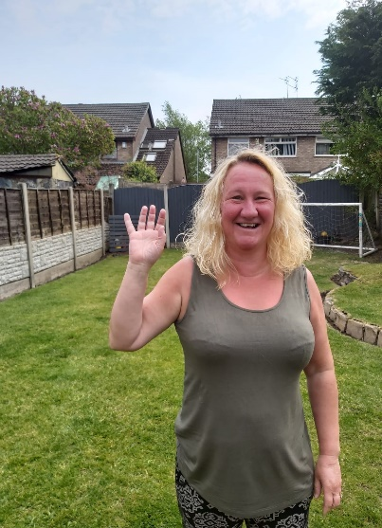
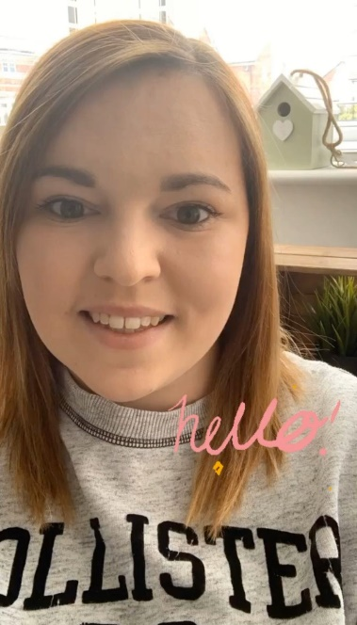

ENGLISH | MATHS
Reading – Read every day for pleasure for 10 minutes.  You can also listen to stories on www.vooks.com. This website is full of stories that come with videos and are a big hit in Sparrows as there are so many to choose from. Maybe your child can share their favourite story with you. You can get a free subscription for 1 month.  Comprehension –  - Complete the comprehension below on ‘A new pet’.  - Find a story all about animals and let someone from your family read it to you. Maybe a grandparent would like to read one to you over zoom.  - Read a story with animals in it that has repetitive text that you can join in on whilst an adult reads the books. (We’re going on a bear hunt, Goldilocks and the Three Bears, The Three Little Pigs etc)  Writing –  - Use a writing frame like the Toucan poem below to construct your own animal poems.  - Write some simple silly poems about your choice of animals (2 lines is plenty per poem). There are some funny poems below for you to share and have a go at reading by yourself that might give you some inspiration.  - Choose a pet that you have/would like to have and create a simple leaflet explaining how to look after that animal.  Phonics – Your child will be able to tell you which phonics group they are in. If they don’t know, please contact school so we can help you.  Mrs Osborne and Mrs Dean’s groups –  1. Go to https://www.phonicsbloom.com/uk/game/phonics-frog?phase=3 Your child has covered qu, ch, sh, th, ng, ai, ee and is learning igh this week so you can select the sounds you want them to focus on. Encourage your child to chop and blend the words independently.  2. Find objects around the house that have the sound ‘igh’ in them. Write the words and draw pictures to match.  Mrs Wibberley’s group –  1. Go to https://www.phonicsbloom.com/uk/game/word-pairs?phase=4https://www.phonicsbloom.com/uk/game/word-pairs?phase=4 Encourage your child to chop and blend the words independently.  2. Find objects around the house that have the sound ‘ie’ and ‘igh’ in them. ‘igh’ was learnt during phase 3. Put these words into sentences and draw pictures to match.  Miss Lea and Mrs Davies’ groups –  1. Go to https://www.phonicsbloom.com/uk/game/tricky-trucks?phase=5 You can choose decodable words or tricky words. It would be great if you could try both!  2. Think of words with the sound ‘oo’ (phase 3), ‘u-e’, ‘ue’ or ‘ew’ in them (moon, rude, blue, screw). Be careful not use words where the ‘oo’ sound makes a ‘you’ sound (tune, queue, few). Sort the words into a table using the correct spelling. Use these words to write some sentences and draw pictures to match. | Basic skill – Continue with your recall on number bonds to 20. This song might help you with remembering them – give it a go:  https://www.youtube.com/watch?v=4EsPtTkwNIo  If you find this challenging, try learning them to 10 first. Here’s Jack Hartmann with his song and dance to help you https://www.youtube.com/watch?v=lD9tjBUiXs0  White Rose Home Learning – Year 1 – Summer Term - Week 3 (4.5.20)  https://whiterosemaths.com/homelearning/year-1/  The focus is on number bonds and fact families. If your child finds this challenging, please adjust it so they are working within 10 to start.  You can also follow the link to the previous year group if they find this work challenging. It all helps.  White Rose Home Learning – EYFS – Summer Term - Week 3 (4.5.20)  https://whiterosemaths.com/homelearning/early-years/
R.E. | OTHER
The theme is: Pentecost – Holidays and Holydays.  Ascension Day. Jesus goes back to his Father.  After his Resurrection, Jesus appeared to the disciples and made a promise to send his Holy Spirit to them. Read the passage below: The promise of the Spirit based on John 13:33; 14:18.  Before Jesus left his friends, he promised to send them a helper, the Holy Spirit.  The holy day, Ascension Thursday, celebrates Jesus’ return to his Father.  The image of a dove is used to help explain the power of the Holy Spirit. Your task is to make a dove to put up in your house to remember Jesus’ promise of sending a helper. You can use whatever materials you would like. One idea is to cut out the body of a bird, make a slit in its body where the wings would go, fold a piece of paper into a fan and push through the slit to make the wings. Alternatively, you could make a stained glass window using tissue paper. The options are endless so send me your pictures so I can see what you come up with! | Science – As your poems are all about animals, I would like you to choose a couple of the animals you have written about and find out some facts about them.  Some questions to help you with your research: What are their young called? Are they a herbivore, omnivore or carnivore and what do they like to eat? What type of animal are they? (Mammal, amphibian etc) What is their habitat like?  You can display your findings in whatever way you like and I look forward to seeing them!  Here is a link to a matching game that I thought you might like too. Just download it, print it out and have fun! https://littleowlsresources.com/farm-animals-and-their-young-match-game  Geography – Using the animals from your poems, find out where they come from. Can you name the country and continent in which they are from? If you can, you could draw pictures of your animals and place them on a map with the country.  Art – Make animal masks (just google animal mask templates and there are plenty to choose from) or make an animal using a paper plate and collage materials (google has plenty of ideas and inspiration to help you).  Computing – Can you type up your poems to practise your typing skills? You could even find pictures on a safe search engine such as Kiddle or KidRex to add to your poems!

A New Pet
Tom was six. He lived in a flat with his Mum. The flat was on the top floor. It was very high up!
One day, Tom said to his Mum, “Mum, can I have a dog?”
But Mum shook her head and said, “No Tom, you can’t have a dog. There are no dogs allowed in a flat.”
Tom wanted to cry. Then he said, “Mum, can I have a cat?”
But Mum shook her head and said “No Tom, you can’t have a cat. There are no cats allowed in a flat.”
Now Tom did start to cry, “I want my own pet!” he shouted.
Mum patted Tom on the back and gave him a kiss, “Don’t cry Tom, I will see what I can do.”
The next day, when Tom got home from school, there was a small cage on the table. Tom was excited! He ran to look in the cage. In the cage was an orange hamster! Mum put the hamster in Tom’s hands.
Tom smiled and said, “I will call it Rusty. Thank you, Mum!”

- How old is Tom?

- Where does Tom live?

- What pets did Tom want?

- How does Tom feel when Mum says “No?” How do you know this?

- How does Mum try to make Tom feel better?

- Why was Tom excited when he saw a cage on the table?

- What was in the cage?

- Why did Tom call his pet, ‘Rusty?’

- How do you know Tom is happy about his new pet?

10. Do you have a pet or would you like one? What kind of pet?

