SPARROWS WEEKLY SUGGESTED HOME LEARNING – WB 13.7.20
Hello Sparrows! I can’t believe we’re now in the last week of the year! This is your last week of being a year 1 so I have put together some activities to help you remember the your time in year 1 and some activities to help you think about the year you have ahead of you in year 2.
Please keep in contact as usual and keep us updated with what you get up to in your summer holiday as well. You can email the office at enquiries@saintoswalds.wigan.sch.uk FAO Sparrows or tweet us @saintoswalds @mrs_wibberley @MrsOsborne73.
It has been an absolute pleasure to teach you this year and we have thoroughly enjoyed watching you all grow. As we can’t be together for your last day in which we would usually buy you a little gift, we have included a little something at the bottom of your task sheet that you can print if you wish to as a little keepsake for the year we have had together. Good luck in year 2!
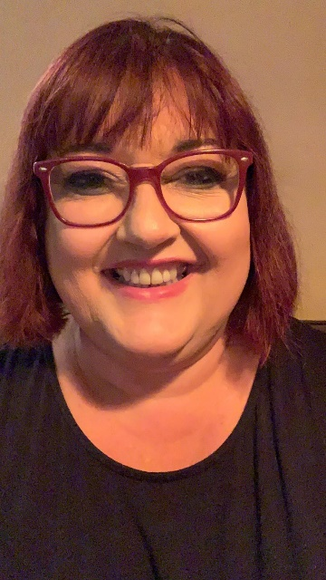
Mrs Wibberley, Mrs Osborne and Mrs Dean xx
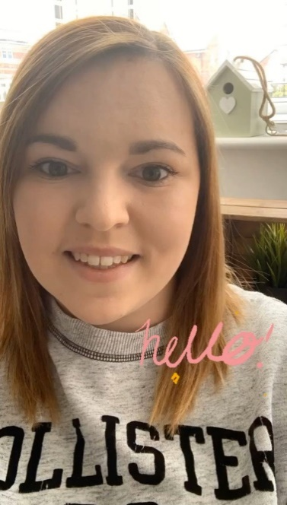
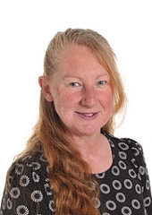
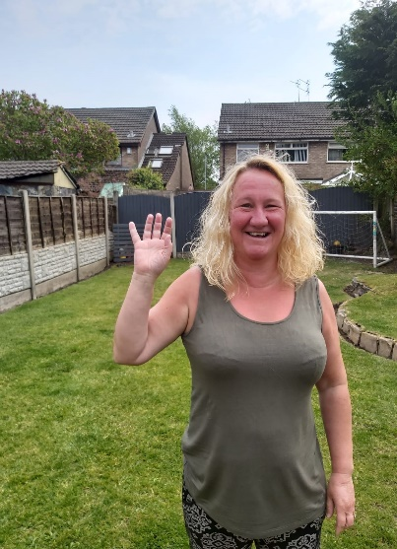

ENGLISH | MATHS
Reading – Read every day for pleasure for 10 minutes.  You can also listen to stories on www.vooks.com. This website is full of stories that come with videos and are a big hit in Sparrows as there are so many to choose from. Maybe your child can share their favourite story with you. You can get a free subscription for 1 month.  Comprehension –  - Share the poem below with your family and try your best to read the words that have the sounds you have learnt.  - Complete the Dilly and the Three Monsters comprehension activity below.  Writing –  - Complete the Summer Holiday Bucket List activity below (you don’t need to fill all 20 points!)  - Make acrostic poems for your friends using their names. There are some words below to help you if you are struggling to think of your own.  - Make a list of all the things you would like to tell your new teacher so they can get to know you. You could even write a letter and when you find out who your new teacher is, you can send it to school by email, post or put a picture on Twitter for them to see it.  Phonics – Your child will be able to tell you which phonics group they are in. If they don’t know, please contact school so we can help you.  Mrs Osborne and Mrs Dean’s groups –  1. Go to https://www.phonicsbloom.com/ or https://new.phonicsplay.co.uk/ and play your favourite game to practise all the new sounds you have learnt over the past few weeks.  2. Find objects around the house that have the ‘oi’ sound in them. Write the words and draw pictures to match.  Mrs Wibberley’s group –  1. Go to https://www.phonicsbloom.com/ or https://new.phonicsplay.co.uk/ and play your favourite game to practise all the new sounds you have learnt over the past few weeks.  2. Find objects around the house that have the sound ‘o-e’ in them. Put these words into sentences and draw pictures to match.  Miss Lea and Mrs Davies’ groups –  1. Go to https://www.phonicsbloom.com/ or https://new.phonicsplay.co.uk/ and play your favourite game to practise all the new sounds you have learnt over the past few weeks.  2. Complete the phase 5 animal mosaic below. | Basic skill – Recognise, find and name a half as one of two equal parts of an object, shape or quantity.  Recognise, find and name a quarter as one of four equal parts of an object, shape or quantity.  Unfortunately White Rose have started charging for their home learning tasks, however BBC Bitesize have partnered with White Rose and have some great daily tasks including maths for free. Follow this link for a daily maths task https://www.bbc.co.uk/bitesize/tags/zjpqqp3/year-1-and-p2-lessons/1  If your child finds this challenging, please follow this link https://www.hamilton-trust.org.uk/blog/learning-home-packs/ and use the previous year group’s tasks.
R.E. | OTHER
See below for the information and activities for this week’s RE task. | Science – Follow the instructions below to complete the rainbow experiment.  PSHE/Transition –  - Complete the Year 1 memories task below.  - Complete the transition activity to year 2 below.  Art – Paint a self-portrait that you can look back on this time next year…you will change in many ways from growing up, looking different and your art skills will improve too as you learn more!  Summer holidays –  - Complete your bucket list ideas that you have written down for your writing task.  - Complete the summer activity below throughout your holiday.  History – Create a time capsule of all the things that will remind you of your time in year 1 and the time you have spent in lockdown. Decide a year you would like to open it again.
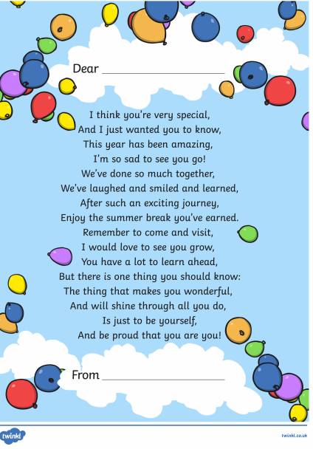
Mrs Wibberley, Mrs Osborne and Mrs Dean
Sparrows
