SPARROWS WEEKLY SUGGESTED HOME LEARNING – WB 27.4.20
Hello Sparrows! It’s been five weeks since we last saw each other and I miss you all terribly! I hope you and your families are all well and keeping safe. I have created some tasks to keep you busy so that your brains can continue to grow. Our new text was supposed to be Lost and Found by Oliver Jeffers so your tasks are based on this text.
Thank you to those who have sent me letters, pictures and updates on Twitter. I have loved seeing them all and I reply to every single one of them so we can keep in contact. Keep sending them in as they put a big smile on my face and I love seeing what you are up to.
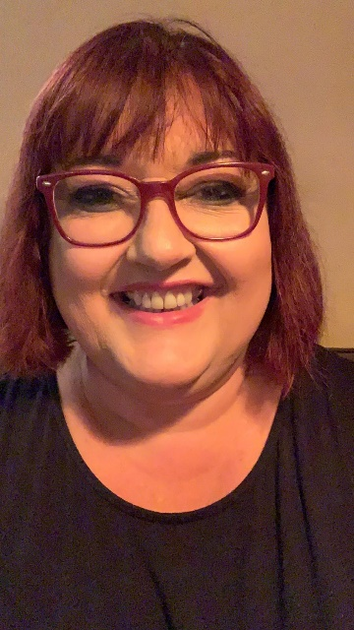
I can’t wait to see all of your faces again but until then keep smiling, enjoy this time with your family, use your daily exercise time and stay safe.
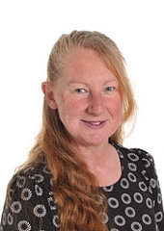
Mrs Wibberley, Mrs Osborne and Mrs Dean xx
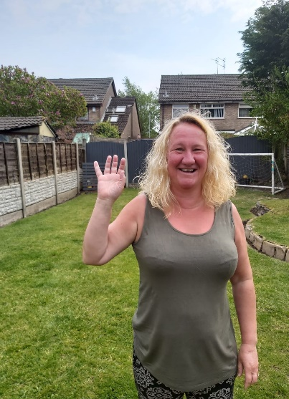
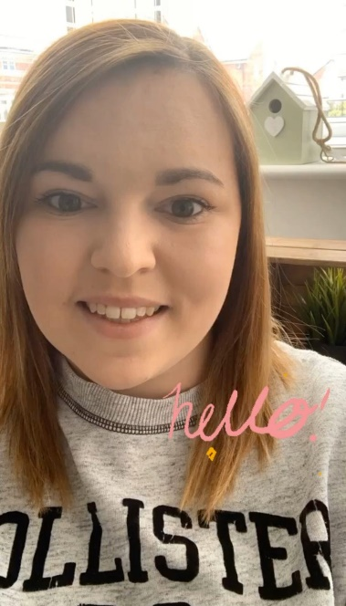

ENGLISH | MATHS
Reading – Read every day for pleasure for 10 minutes.  Comprehension  - Before reading the story for the writing task. Use the front cover of the book (See below) to predict what you think will happen in the story. Write your prediction down, for example, ‘I think the penguin will… because…’  - Use this link to watch and read the story https://www.youtube.com/watch?v=cRAAQ8EWzig  - Complete the reading comprehension (found below) about the story Lost and Found.  Writing – Based on the story Lost and Found by Oliver Jeffers.  Make a list of things that the boy and penguin might pack in their suitcase. Can you put some of them into a sentence using a describing word? For example - A blue coat. Extra challenge, use ‘and’ in your sentence. For example - A blue coat and a fluffy hat.  Remember to use the phonics sounds you have learnt, capital letters, full stops and finger spaces. ‘And’ is a bonus!  Phonics – Your child will be able to tell you which phonics group they are in. If they don’t know, please contact school so we can help you.  Mrs Osborne and Mrs Dean’s groups –  1. Go to https://new.phonicsplay.co.uk/ Select phase 2 and play Buried Treasure.  2. Find objects around the house that have the sound ‘ai’ in them. Write the words and draw pictures to match.  Mrs Wibberley’s group –  1. Go to https://new.phonicsplay.co.uk/ Select phase 4 and play Buried Treasure.  2. Find objects around the house that have the sound ‘ay’ and ‘ai’ in them. ‘ai’ was learnt during phase 3. Put these words into sentences and draw pictures to match.  Miss Lea and Mrs Davies’ groups –  1. Go to https://new.phonicsplay.co.uk/ Select phase 5 and play Buried Treasure.  2. Think of words with the sound ‘ai’ (phase 3), ‘ay’ or ‘a-e’ in them. Sort the words into a table using the correct spelling. Use these words to write some sentences and draw pictures to match. | Basic skill - Count in multiples of twos, fives and tens forwards and backwards from any given number. Jack Hartmann might help here with his songs and dances – give it a go:  https://www.youtube.com/watch?v=OCxvNtrcDIs  White Rose Home Learning – Year 1 – Summer Term - Week 1 (20.4.20)  https://whiterosemaths.com/homelearning/year-1/  The focus is on doubling, halving, grouping and sharing.  If your child finds this challenging, please follow the link to the previous year group’s work. It all helps.  White Rose Home Learning – EYFS – Summer Term - Week 1 (20.4.20)  https://whiterosemaths.com/homelearning/early-years/
R.E. | OTHER
The theme is: Pentecost – Holidays and Holydays.  Create a picture of your favourite holiday or day out. You can use whatever materials you would like to use to create your picture. Write some sentences about why this was your favourite holiday or day out. | Science – Find out about penguins... Where can you find them? How are they adapted to living in that environment? What do they eat? Be creative to present your findings! You could make a poster, a video, or a song just to name a few. Some links to help:  http://www.coreknowledge.org.uk/resources/Science%20Resource%20Pack-%20Year%201-%20Animals.pdf  https://www.twinkl.co.uk/resource/t-g-303-ks1-penguin-fact-file-powerpoint (Set up a free account using the code CVDTWINKLHELPS)  Geography – Find out about the South Pole... Try to find it on a map. How is the South Pole different to where you live? Be creative to present your findings! You could make a poster, a video, or a song just to name a few.  Some links to help:  https://www.twinkl.co.uk/resource/t-t-2544289-north-and-south-poles-song-powerpoint  https://www.bbc.co.uk/bitesize/topics/zyhp34j/articles/zjg46v4  Art –Using your own choice of materials, create a sea creature that the boy and penguin might come across on their journey.

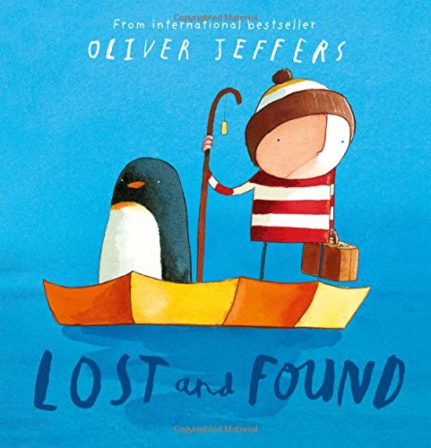

Lost and Found by Oliver Jeffers Reading Comprehension

- What did the little boy find on his doorstep?

cat boat penguin bags

- Circle the word that means ‘unusual’.

nice strange cold normal

- How did the penguin feel when the boy left him at the South Pole?

___________________________________________________________

___________________________________________________________

- What were the waves as big as?

___________________________

- Tick the word that describes the South Pole.

hot icy muddy sandy

- Tick or cross the statements to show if they are true or false.

They walked to the South Pole.

The penguin was lonely.

They pulled the boat out of the garage.

In the end, the boy sailed home alone.

