SPARROWS WEEKLY SUGGESTED HOME LEARNING – WB 4.5.20
Hello Sparrows! We hope you enjoyed our new story Lost and Found as much as we did! Thank you to those children who have sent emails, tweets and photos, it has been lovely to see what you have been up to. You are a bit quiet though Sparrows as we have only heard from a couple of children. It would be great to hear from more of you so we can keep in contact as we miss you terribly! Remember you can email us at enquiries@saintoswalds.wigan.sch.uk or tweet us @saintoswalds FAO Mrs Wibberley.
Your tasks this week are linked to the story Lost and Found again with some added VE Day activities, as we will be celebrating this on Friday with a bank holiday.
We look forward to hearing from more of you this week! Keep smiling, enjoy this time with your family, use your daily exercise time and stay safe.
Mrs Wibberley, Mrs Osborne and Mrs Dean xx
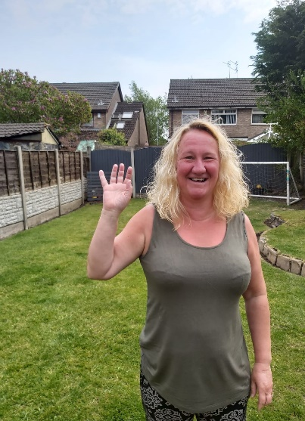
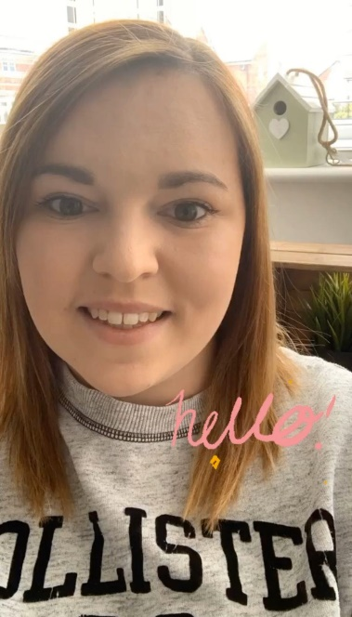

ENGLISH | MATHS
Reading – Read every day for pleasure for 10 minutes.  Comprehension  - Complete the reading comprehension about Pepin the Penguin (see below).  - Now that you are familiar with the story, act out the story. Maybe your family members will join in too. You could record it so I can see it or maybe perform it for family members you cannot see at the moment over a video chat i.e. zoom.  - Talk to your adult about a time you have been lost and relate your experience to the story.  Writing – Based on the story Lost and Found by Oliver Jeffers.  - Write a set of instructions on how to get from the boy’s house to Antarctica.  - Write a script and record a video of you doing a missing penguin news report.  Phonics – Your child will be able to tell you which phonics group they are in. If they don’t know, please contact school so we can help you.  Mrs Osborne and Mrs Dean’s groups –  1. Go to https://new.phonicsplay.co.uk/ Select phase 2 and play Picnic on Pluto.  2. Find objects around the house that have the sound ‘ee’ in them. Write the words and draw pictures to match.  Mrs Wibberley’s group –  1. Go to https://new.phonicsplay.co.uk/ Select phase 4 and play Picnic on Pluto.  2. Find objects around the house that have the sound ‘ou’ and ‘ow’ in them (e.g. cloud and cow). ‘ow’ was learnt during phase 3. Put these words into sentences and draw pictures to match.  Miss Lea and Mrs Davies’ groups –  1. Go to https://new.phonicsplay.co.uk/ Select phase 5 and play Picnic on Pluto.  2. Think of words with the sound ‘oa’ (phase 3), ‘oe’ or ‘o-e’ in them. Sort the words into a table using the correct spelling. Use these words to write some sentences and draw pictures to match. | Basic skill – Recall number bonds to 20. This song might help you with remembering them – give it a go:  https://www.youtube.com/watch?v=4EsPtTkwNIo  If you find this challenging, try learning them to 10 first. Here’s Jack Hartmann with his song and dance to help you https://www.youtube.com/watch?v=lD9tjBUiXs0  White Rose Home Learning – Year 1 – Summer Term - Week 2 (27.4.20)  https://whiterosemaths.com/homelearning/year-1/  The focus is on halves and quarters.  If your child finds this challenging, please follow the link to the previous year group’s work. It all helps.  White Rose Home Learning – EYFS – Summer Term - Week 2 (27.4.20)  https://whiterosemaths.com/homelearning/early-years/
R.E. | OTHER
The theme is: Pentecost – Holidays and Holydays.  What is a Holyday?  The word holiday comes from holyday. In times past the only holiday anyone had was a saint’s feast day or important feast days like Easter and Christmas. Some days of the year are ‘holy days’, when we celebrate these special times in the Church’s year.  We have just celebrated the feast of Easter when we remember Jesus rising from the dead.  The Holydays we have covered in school so far are Christmas Day, Ash Wednesday, Palm Sunday, Good Friday and Easter Sunday.  Draw pictures and write a sentence about each holyday. Here are some videos to help you remember the Holydays we have covered.  https://www.youtube.com/watch?v=v3656G6tWuI  https://www.youtube.com/watch?v=z-39h0xYqdE  https://www.youtube.com/watch?v=HL8R158Ujp4&list=PLQ2FQzlJocj-hZNCIEPgpWX8ch-mjUiCW | Science – Carry out your own ice experiment– place three ice cubes (or more) in different places around your home (in beakers!) and predict which ice cube will melt the fastest, then record your investigation – take photos if you can so I can see what happens! Here are some instructions on how to make your experiment fair. https://www.kids-earth-science.com/science-experiments.html  History – Have an adult read the following article to you about VE Day https://www.bbc.co.uk/newsround/48201749  Plan your own ‘stay at home’ street party.  What games could be played? What decorations would be put up? What food would be eaten? Who would be there?  You could design your own VE Day party invitation, create your own Union Jack flag bunting, or make a Union Jack flag out of Lego!  Music – Listen to some music that might have been played at the street parties on VE Day. Here’s a couple to get you started!  https://www.youtube.com/watch?v=NHw2Nv7PkDg  https://www.youtube.com/watch?v=Jn_QNyMQcVM&t=54s  Art – Design and create your own igloo model using recyclable materials. If you’re feeling brave, you could make a full size one for you to fit in!  Computing – Use some of the resources on Childnet to refresh your memory on e-safety with help from Smartie the Penguin https://www.childnet.com/resources/smartie-the-penguin

My name is Pepin and I am a penguin. I am a type of bird but I can’t fly. I like to waddle when I walk. I have black and white feathers. I have a black and orange beak. I have black webbed feet.
I am a good swimmer and I like to swim as I can leap out of the water. The water is very cold! I live in a very cold place called Antarctica. There is lots of ice here! I have lots of fat on my body to keep me warm. I like eating seafood and squid is the best. I like to lie on my belly and slide through the snow. Do you like playing in the snow?

- What is Pepin?
- An eagle
- A fish
- A penguin
- A whale

- Can Pepin fly?
- No
- Yes

- Is Pepin a good swimmer?
- Yes
- No

- Where does Pepin live?
- England
- Spain
- Antarctica
- America

- Is it hot or cold where Pepin lives?
- No
- Yes

- How does Pepin keep warm in the snow?
- He has a long beak.
- He has webbed feet.
- He has lots of fat on his body.
- He has black and white feathers.

