STARLINGS WEEKLY SUGGESTED HOME LEARNING – WB 1.6.20
Hi Starlings! Hope you all had a lovely half term and managed to get out and enjoy the beautiful weather we were blessed with. Here are this week’s home learning tasks. Please remember to tweet or email school, I really enjoy seeing what you are doing. Please also let me know if you are having any trouble with these, I’m here to help. #StaySafeStayHomeSaveLives
Mrs Grindley and Mrs Catterall xx
ENGLISH | MATHS
Reading – Read every day for pleasure for 20 minutes.  Comprehension tasks  Ivan The Terrible  https://central.espresso.co.uk/espresso/modules/e2_comprehension_lks2/books/book_ivan_terrible.html  Read the extract and answer the comprehension questions.  Writing – Use the image below to write a paragraph of what you think may be being said between the two zebras. Use direct speech. I have included a checklist to remind you about direct speech.  Complete the Missing Punctuation Worksheet below.  Write a Haiku Poem for Discovery Espresso – See details below.  https://central.espresso.co.uk/espresso/primary_uk/servlet/file/store66/item1129206/doc.pdf  Spellings – Y4 – RWI book – Unit 13 – Adding the suffix -ion - create a poster including these words – confession, permission, expression, discussion, admission and submission  Y3 – RWI book – Unit 13 – Adding the prefix super- - Complete the super- worksheet below | 15 minutes on TT Rockstars each day  https://ttrockstars.com/  Year 3 –  White Rose – Week 5 – Fractions  Use worksheets below and BBC Bitesize to support the videos  https://whiterosemaths.com/homelearning/year-3/  Year 4 -  White Rose – Week 5 – Fractions  https://whiterosemaths.com/homelearning/year-4/  Use worksheets below and BBC Bitesize to support the videos
R.E. | OTHER
Reconsiliation – Inter-relating  CHOICES  Read the story below together and discuss the questions.  Design a table like this and record some choices you make this week. Record what choice you made, if it was good or wrong and what the consequences were for you and others.  Choice Good or Wrong Consequence | Science – Inner City Habitats  https://central.espresso.co.uk/espresso/modules/s2_habitats/video_pages/multivideo_city.html  Watch the videos and complete the online activities  Geography  Create a messy map of your local area – see example below  Music – Time for music Y3/4 Lesson 5  https://www.stoswaldswigan.co.uk/classes/fun-learning-games/music

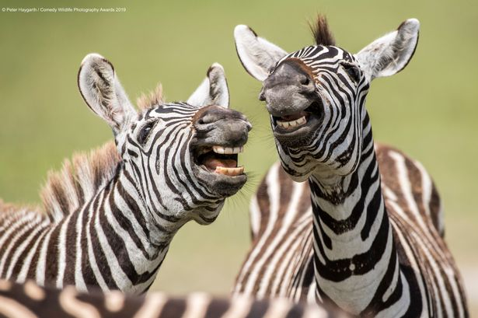
____________________________________________________________________________________________________________________________________________________________________________________________________________________________________________________________________________________________________________________________________________________________________________________________________________________________________________________________________________________
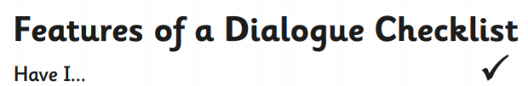
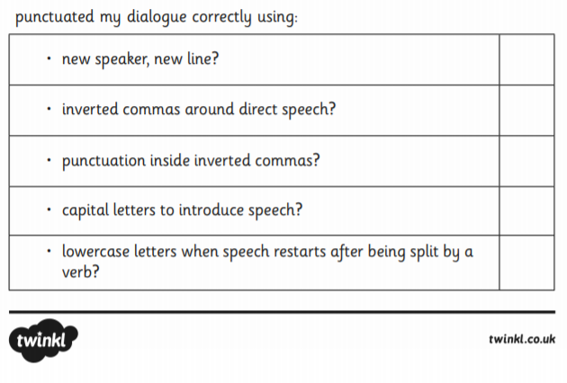

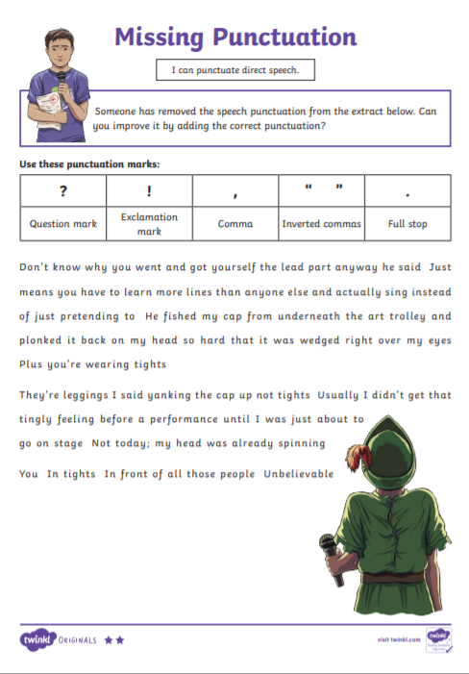
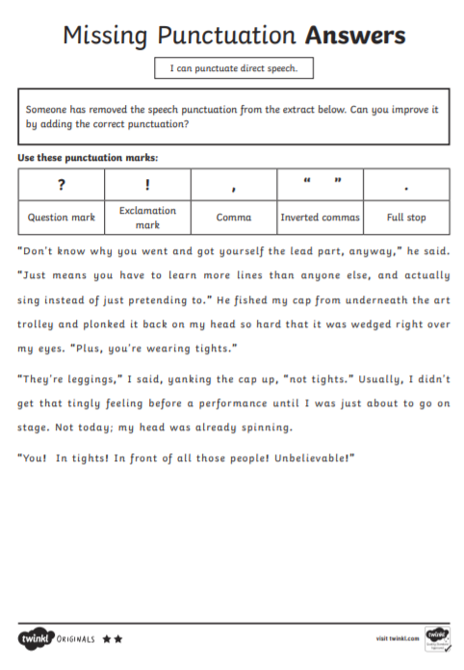

Discovery Education are looking for News Bites viewers to write haikus on the theme of Summer term 2020, please. That could mean a haiku simply on summer as a season or perhaps, for some of the older children, a haiku on what it feels like to return to school after weeks of lockdown, being reunited with friends and teachers (For those still at home, we are suggesting it could be a haiku that expresses thoughts on what home schooling is like for them).
They would like their News Bites item to feature several children reading their poems directly to camera, and to include shots of the poems written on the page as well, you will need to film your child, using iPhones (or similar!), holding the phone landscape not portrait. The children will need to be head and shoulders in shot like a news reporter and the poem on the page should be filmed separately (also landscape).
They hope you will find this a fun assignment. They will of course need parental consents signed, please see the form below.
They have resources on the site which give some guidance on haiku writing.
https://central.espresso.co.uk/espresso/primary_uk/servlet/file/store66/item1129206/doc.pdf
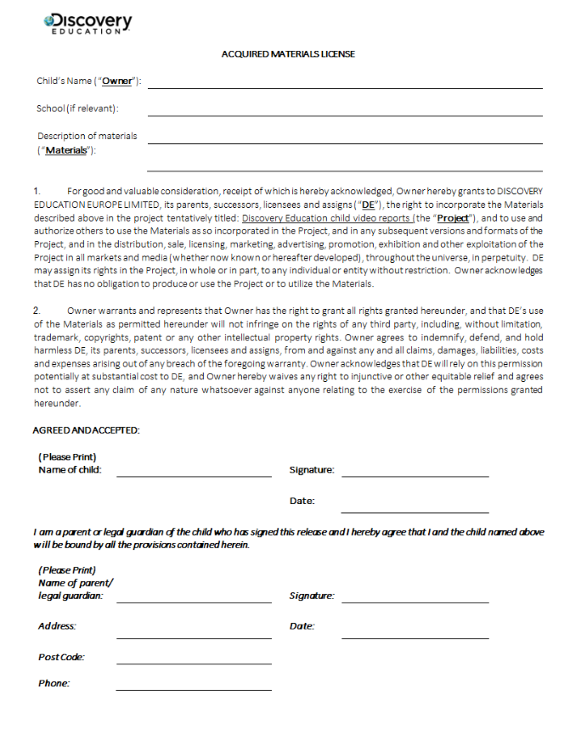

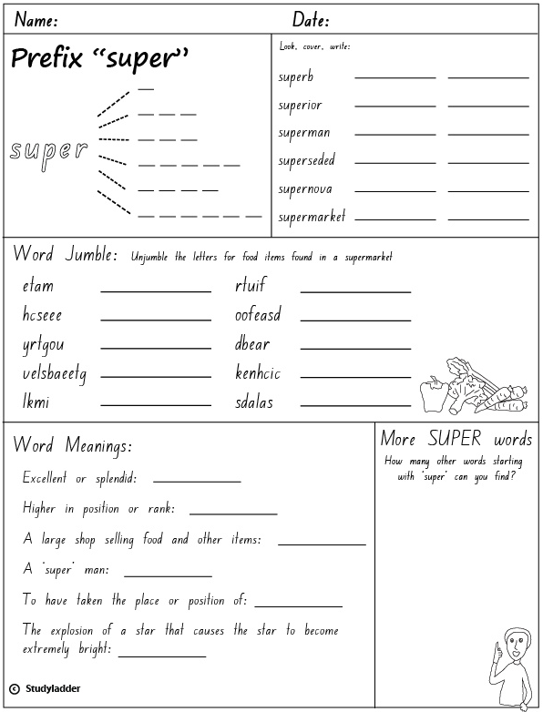

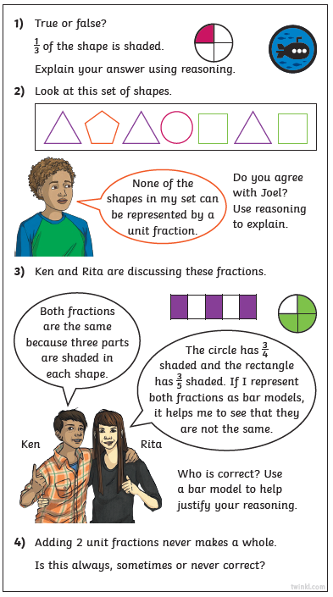

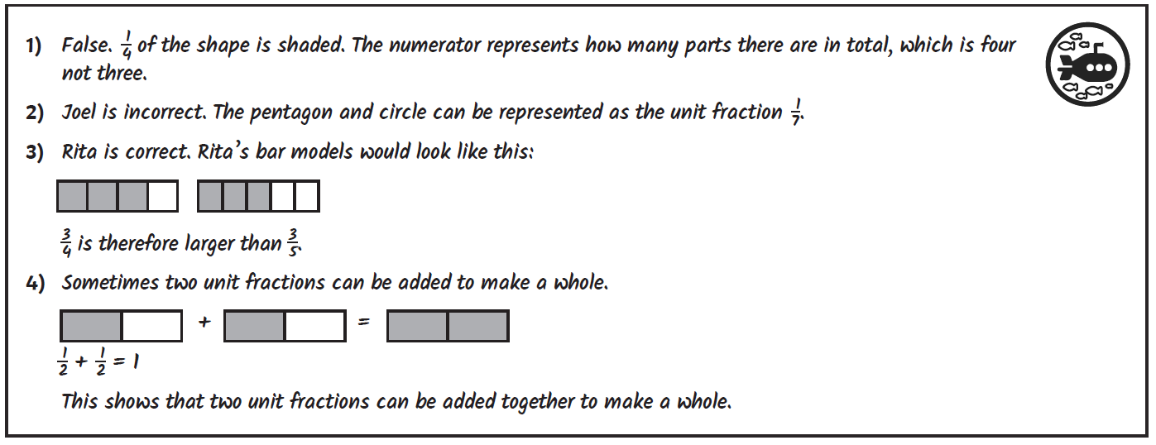

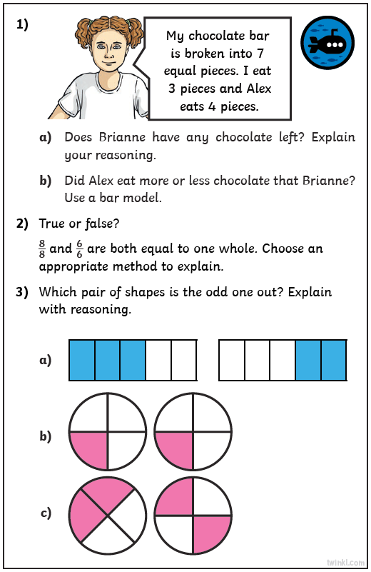

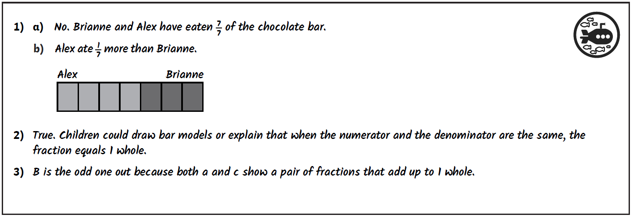

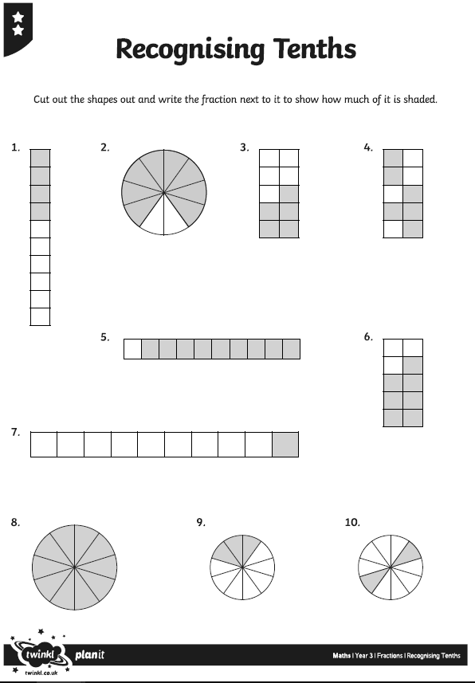
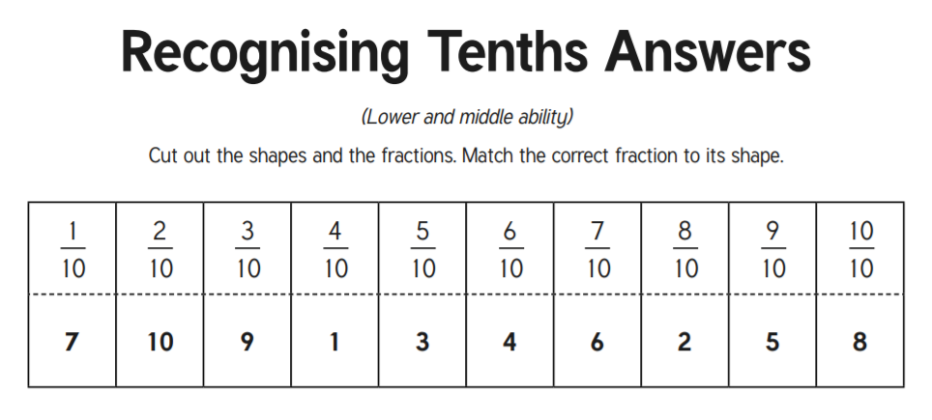

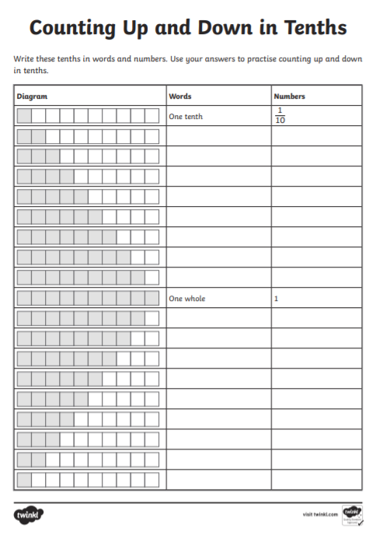

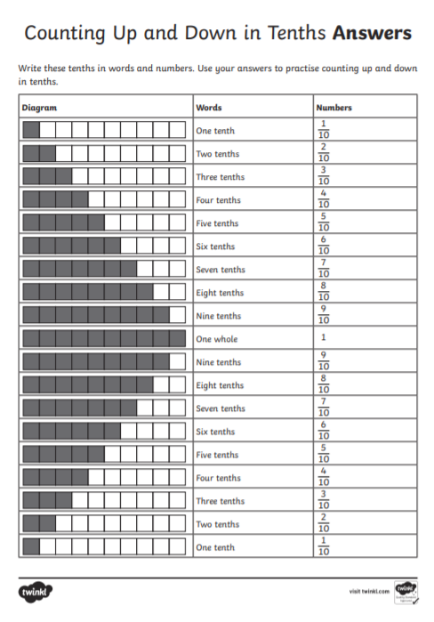

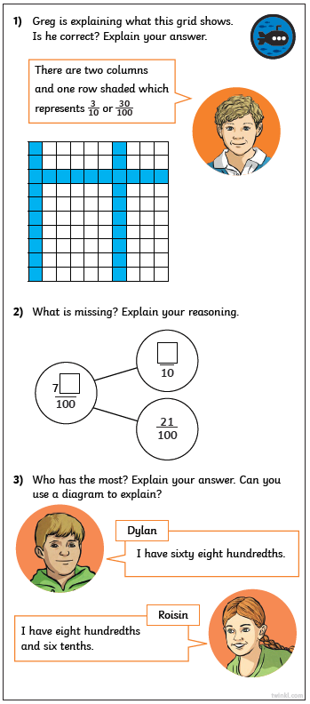
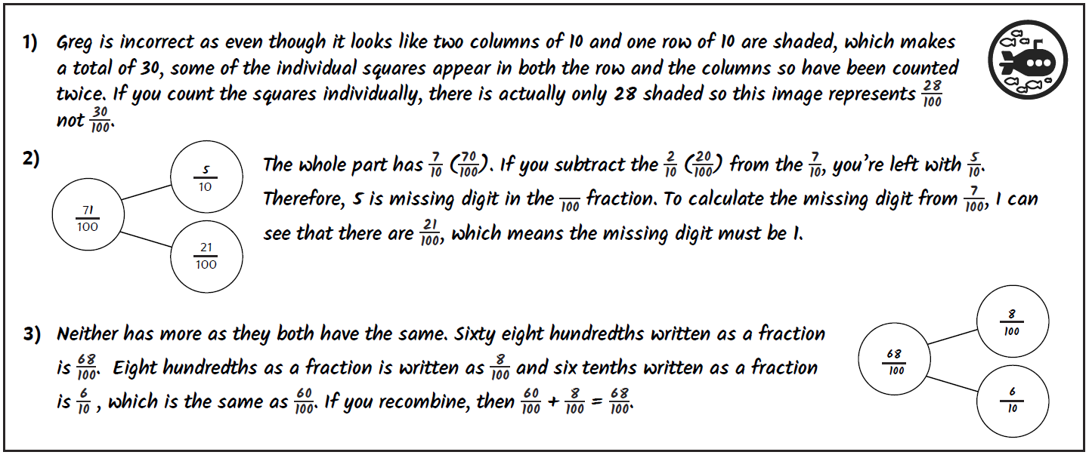

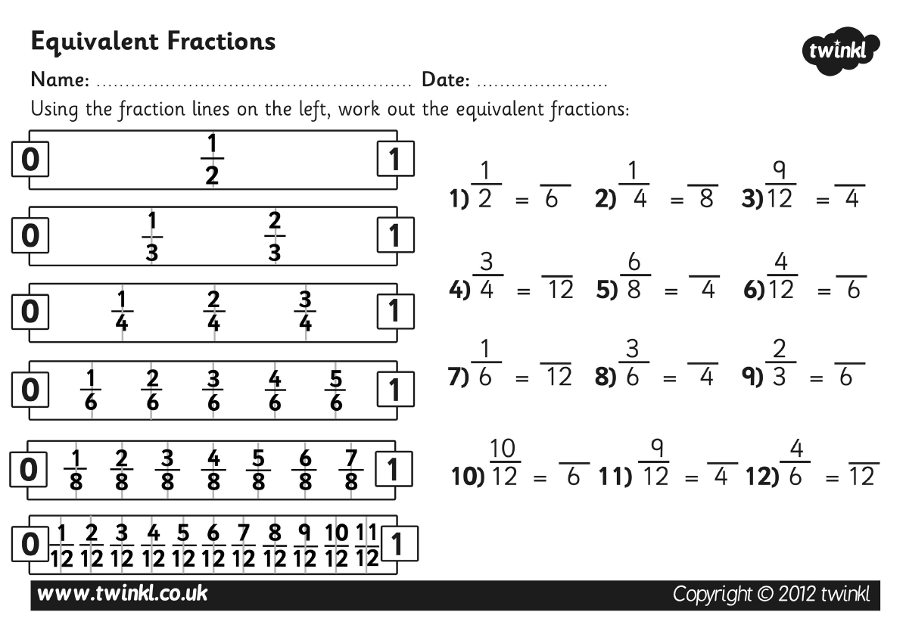

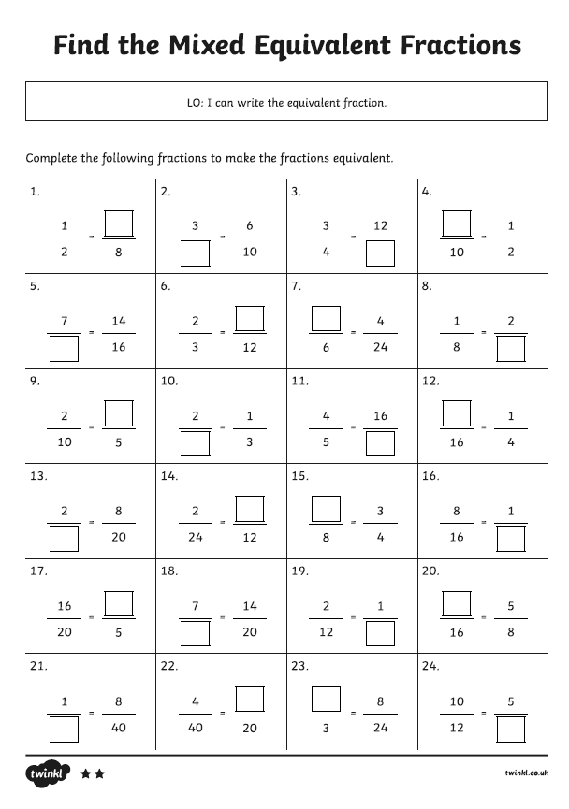

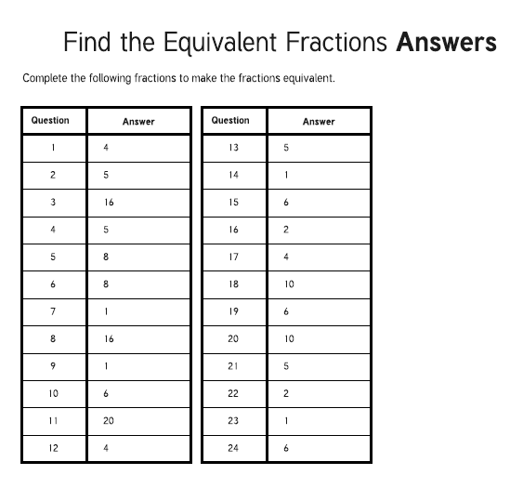

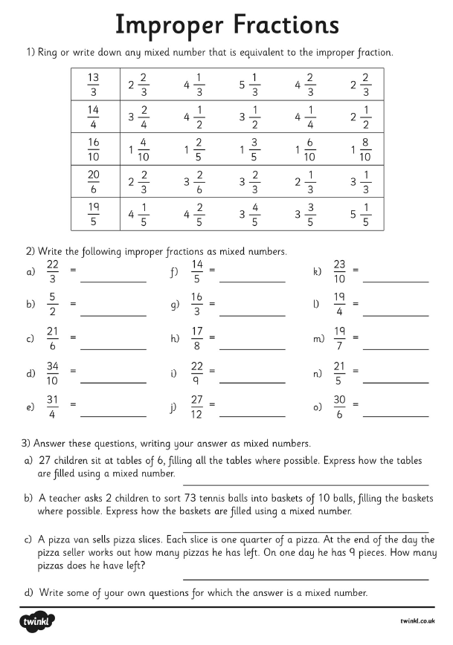

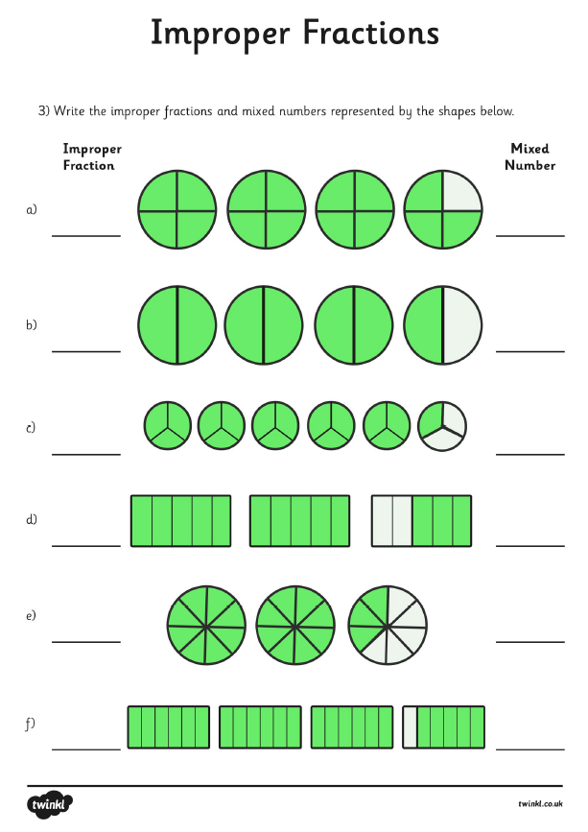
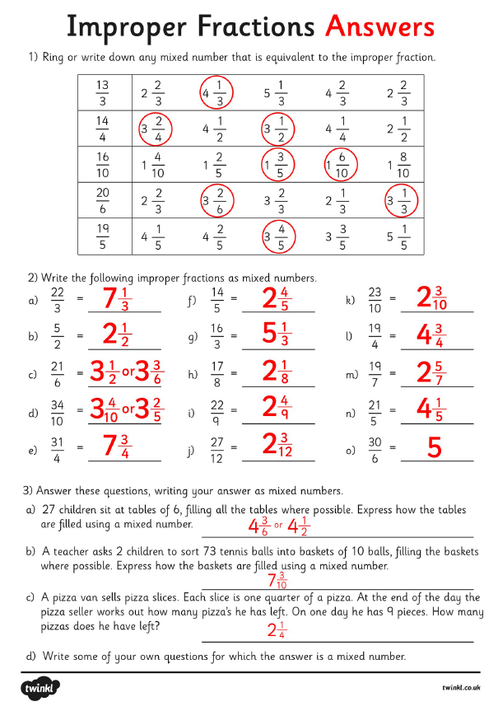

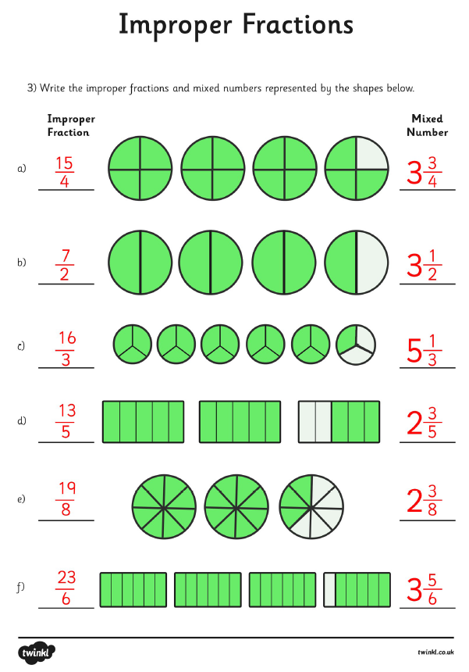

RE
Share this story:
It was holiday time, and lots of children were playing in the park. Tom and Andrew had met some of their friends and were looking forward to a good game of football. Just then, along came Paul. “Just look,” said Tom, “he’s got his sister with him!” And there she was. Jane was dressed in her shorts and was wearing new trainers. “What have you brought her for?” asked Andrew. “I had to choose,” said Paul. “Mum said I could come if I brought Jane, but if not, I would have to play with her at home.”

“It’s all right,” said Jane, “I can play football. I’ve been practising at home, and I’ve got my new trainers.” Tom liked Jane. He’d seen her kicking a football in the school playground and knew she wouldn’t spoil the game, but he felt a bit afraid of saying so. He thought Andrew wouldn’t be friends with him if he did.

“Hurry up,” shouted the rest of the gang. “Aren’t you going to play today?” It was now or never. “Come on Jane,” said Tom, “we’d better put our football boots on and show them.” Then he turned to Andrew, “Give her a chance,” he said. The game started before Andrew had a chance to answer. And they all enjoyed it. Tom, Paul and Andrew, and of course, Jane. None of them regretted that Paul had brought his sister with him.

SOME KEY QUESTIONS

- What do the words choice and consequence mean?
- What choices can you find in the story?
- What two choices did Mum give Paul?
- What do you think Paul said to his Mum?
- How do you think Jane felt when she heard what Tom said, and what Andrew said?
- How do you think Paul felt?
- What were the consequences of Paul’s choice?
- What choices have you had to make recently? How did you choose and what were the consequences? (Perhaps give some examples of class choices.)

Example of a Messy Map of local area

