STARLINGS WEEKLY SUGGESTED HOME LEARNING – WB 13.7.20
Hi Starlings! Can you believe we’re in the last week of the summer term already? I hope you enjoy your final weekly tasks before summer! Remember to get in touch to show me what you’ve done or if you have any problems, I’m here to help! Have a lovely summer and I look forward to seeing you all back in school in September!
Mrs Grindley and Mrs Catterall XX
ENGLISH | MATHS
Reading – Read every day for pleasure for 20 minutes.  Last week we celebrated the 72nd birthday of the NHS. The NHS has been very important to everyone over the last few months so I thought we could celebrate the NHS ourselves this week.  Comprehension – Celebrating The NHS  Writing –  - Write an acrostic poem about someone in the NHS eg. doctor, nurse, paramedic, reflecting the job they do and how they help us.  - Complete the NHS wordsearch  - Research who Clement Attlee and Aneurin Bevan are. (There names are on the wordsearch) Write a paragraph about each man.  Spellings –Contractions revision–Think carefully about where the apostrophe is! Complete the activity below, learn the spellings and put them into sentences. | 15 minutes on TT Rockstars each day  https://ttrockstars.com/  Year 3 –  White Rose – Week 11 – Measurement  Use worksheets below and BBC Bitesize to support the videos  https://whiterosemaths.com/homelearning/year-3/  Year 4 -  White Rose – Week 11 – angles and shape  Use worksheets below and BBC Bitesize to support the videos  https://whiterosemaths.com/homelearning/year-4/  If you’d like to, you could look at the week 12 videos too and complete some of the activities on BBC Bitesize linked to these lessons.
R.E. | OTHER
SPECIAL PLACES  Relate  Our world has been given to us by God, to enjoy, to share and to take care of so we should see it as a Special Place and take of it.  Think of as many ways as they can that enable us all to care for God’s world and to protect it as a special place. Make a promise to care for the world and write it on a heart shape.(See below) Illustrate your promise. | Have a go at the puzzle activities on the sheets below.  Music – Time for music Y3/4 Lesson 11  https://www.stoswaldswigan.co.uk/classes/fun-learning-games/music  Art- Create some summer landscape pictures. These could include the seaside, a summer garden, a summer woodland or the city you researched.

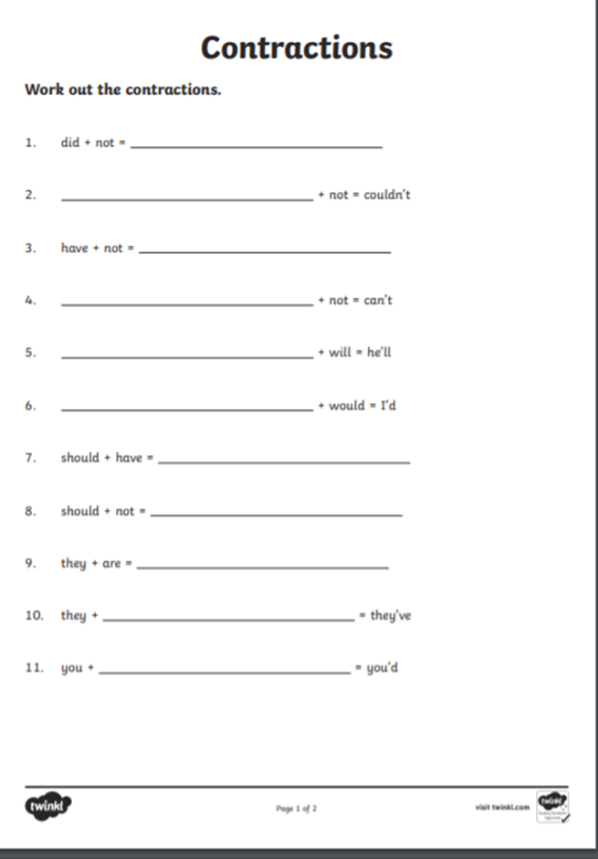
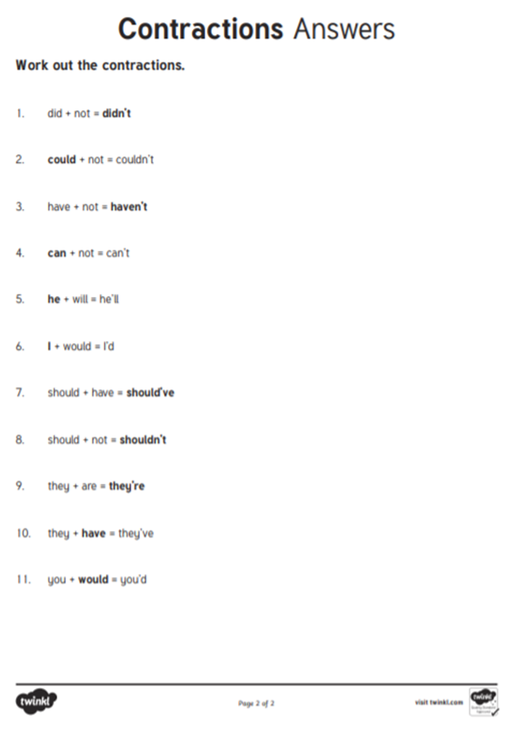
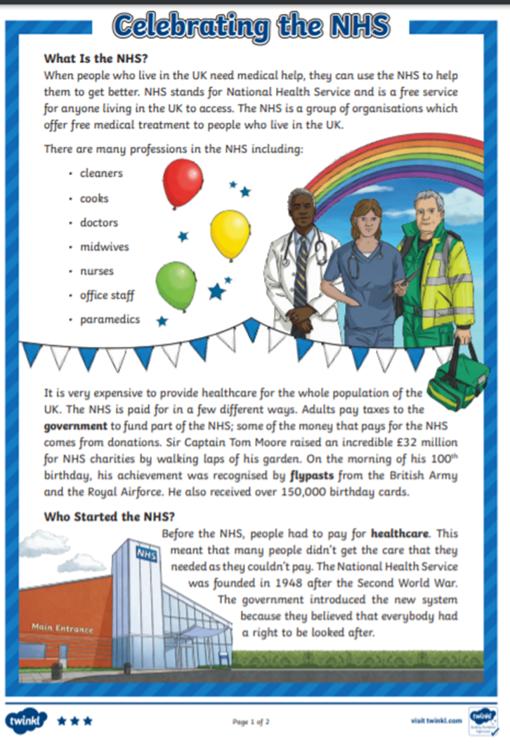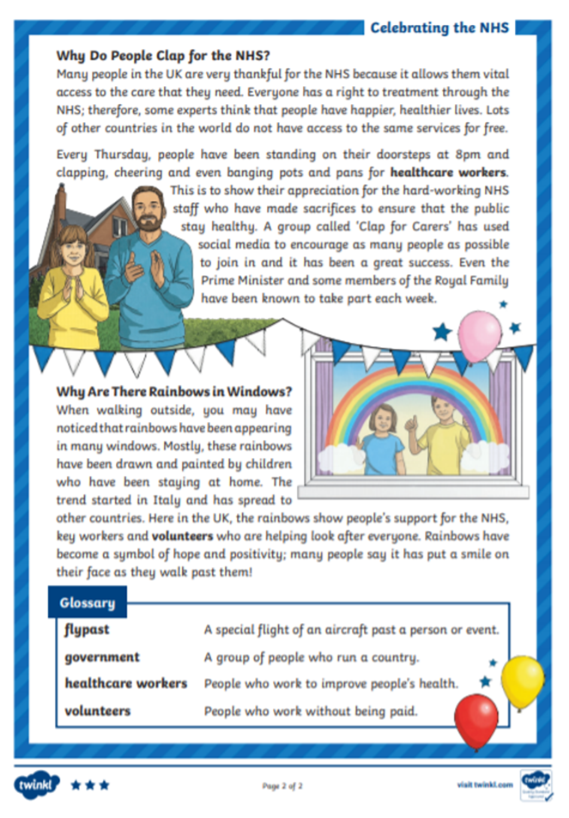

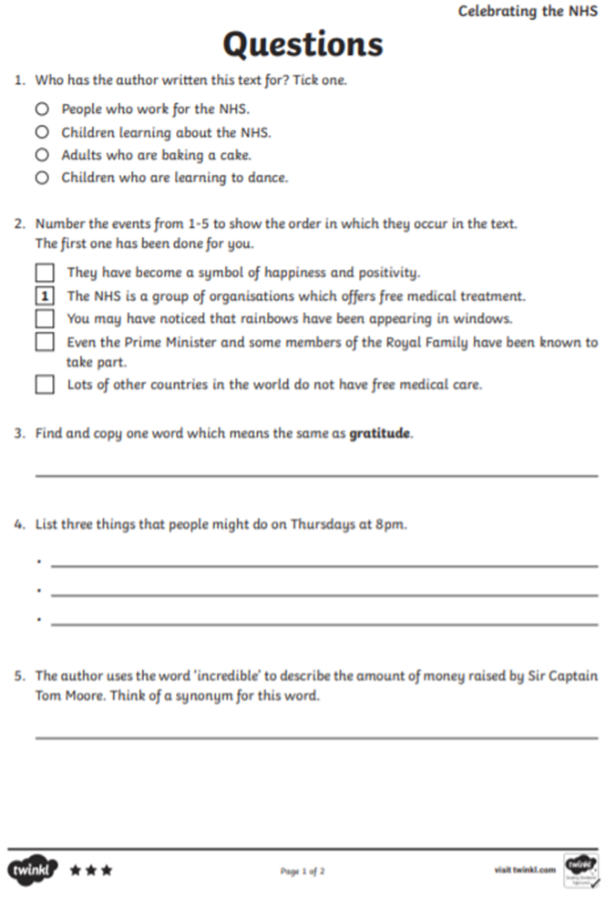
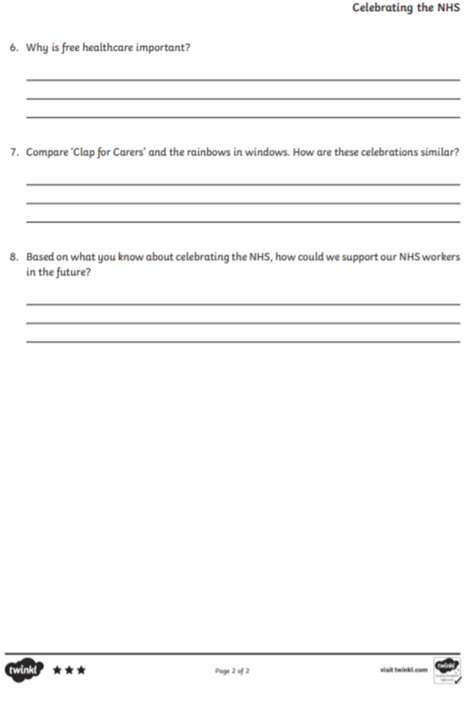
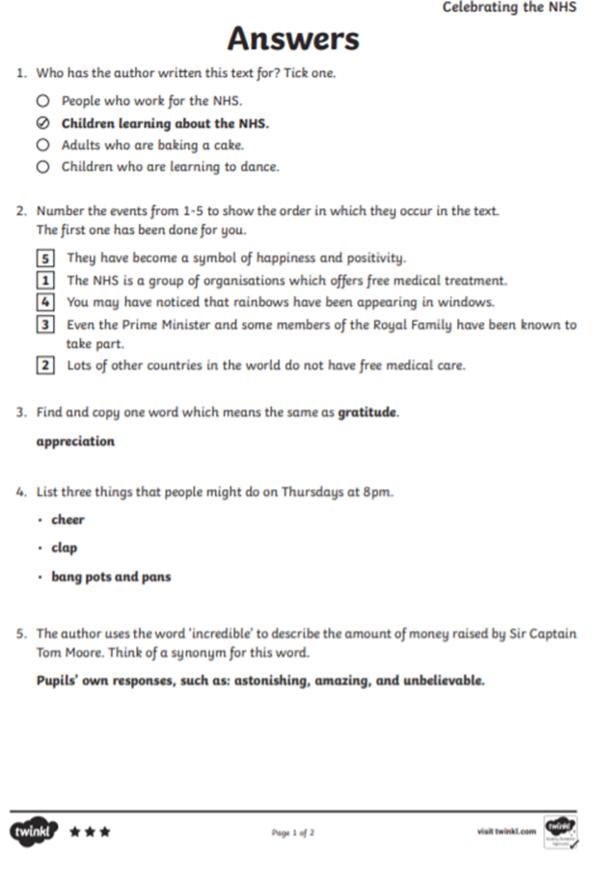
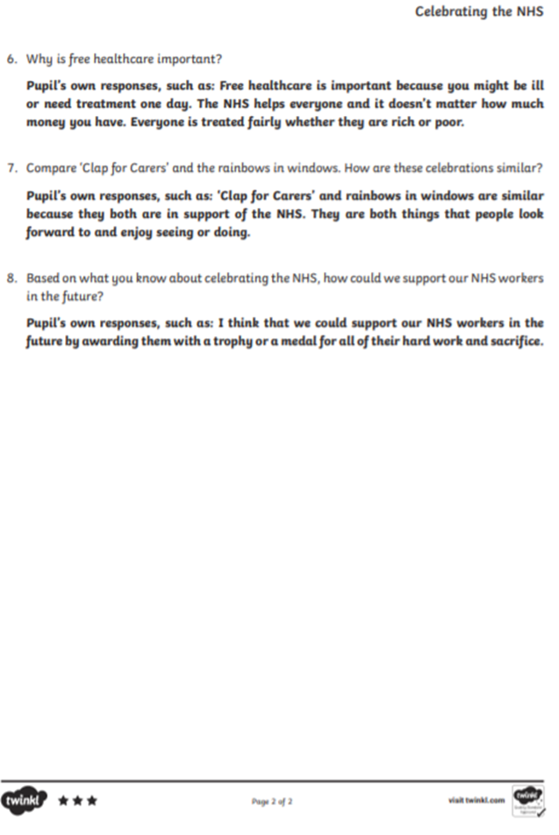
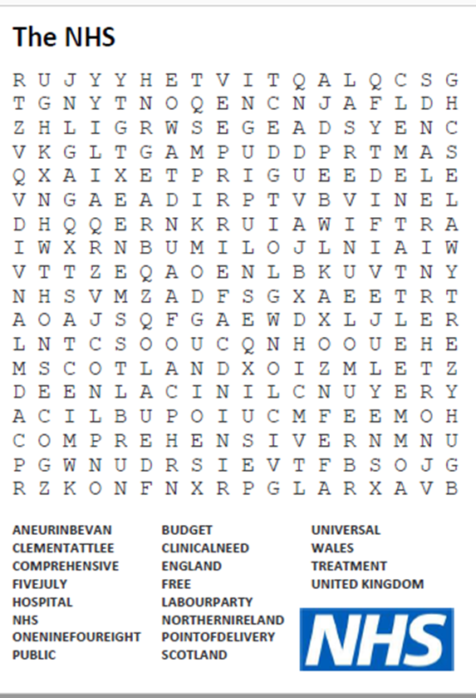
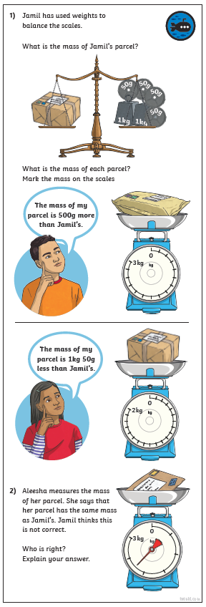 | 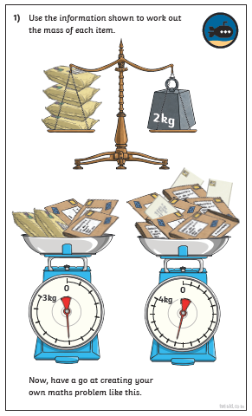
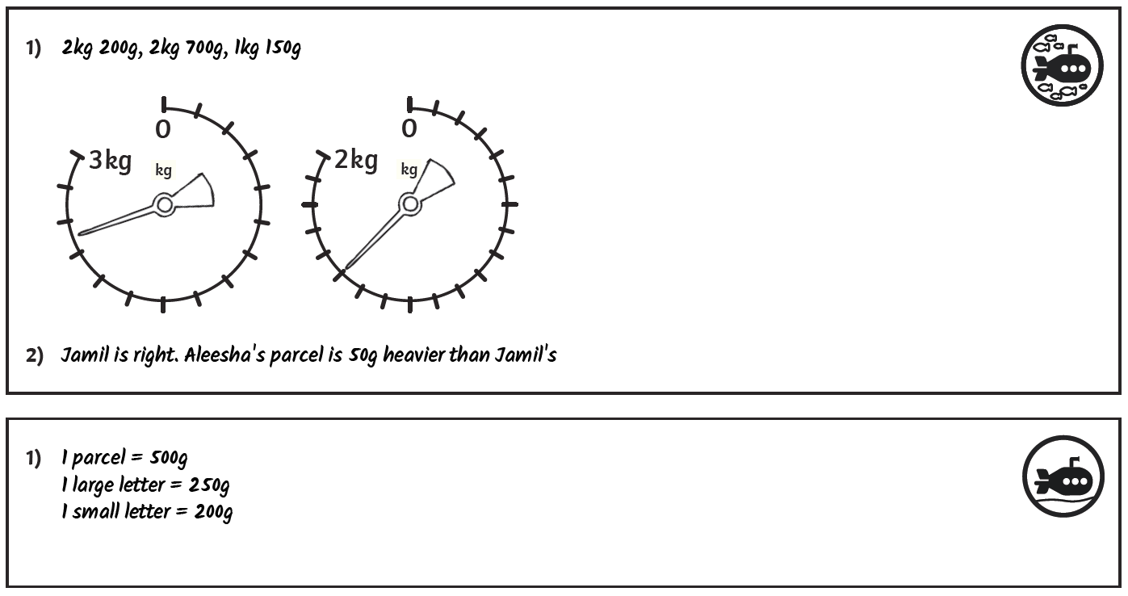
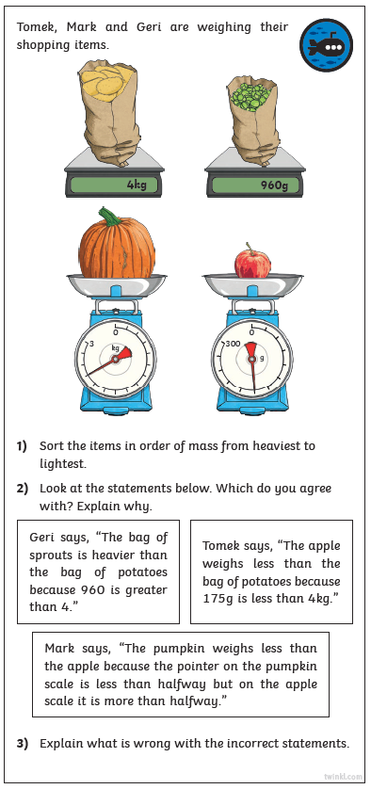 | 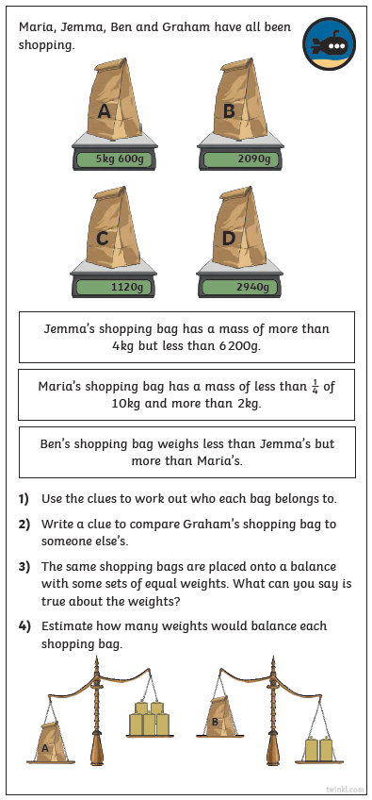

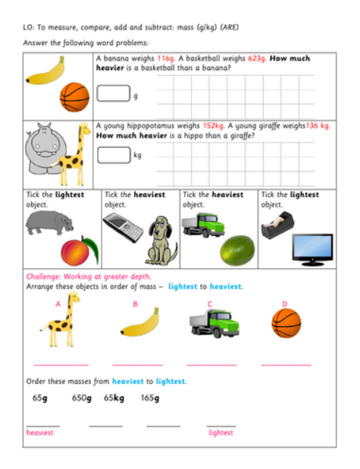
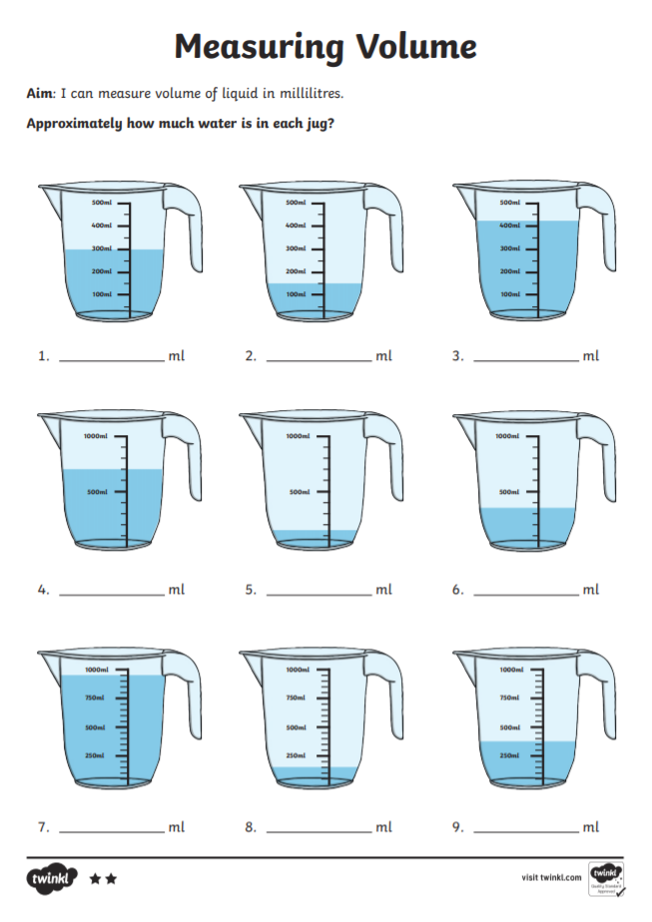
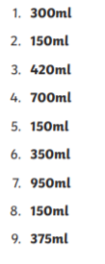
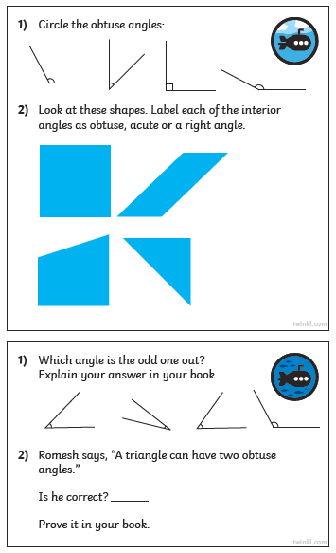 | 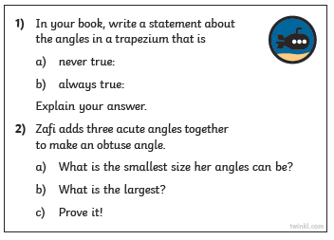

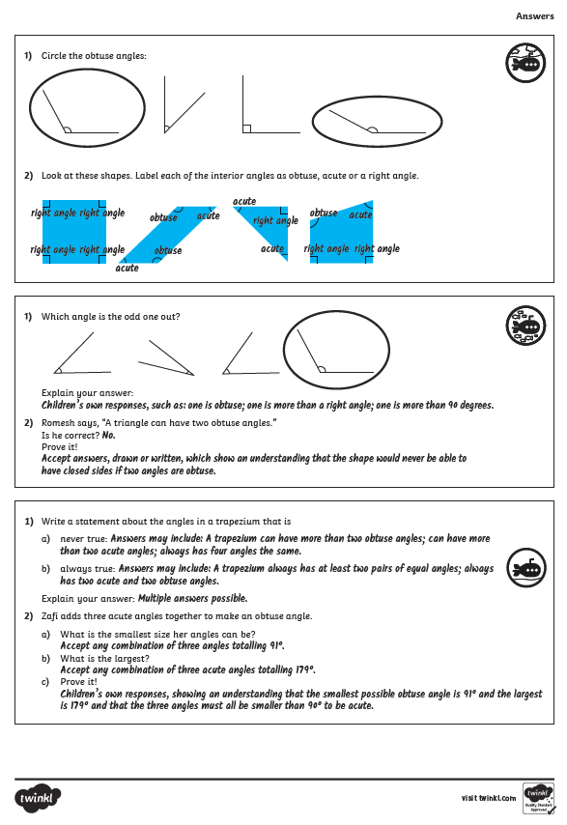
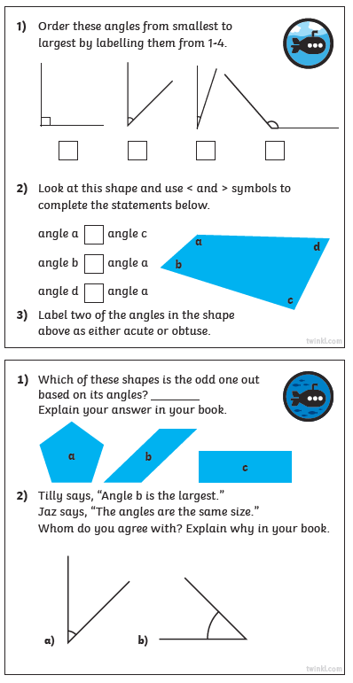 | 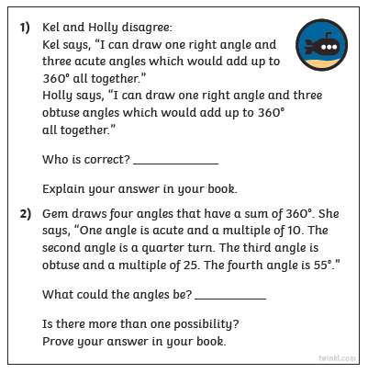
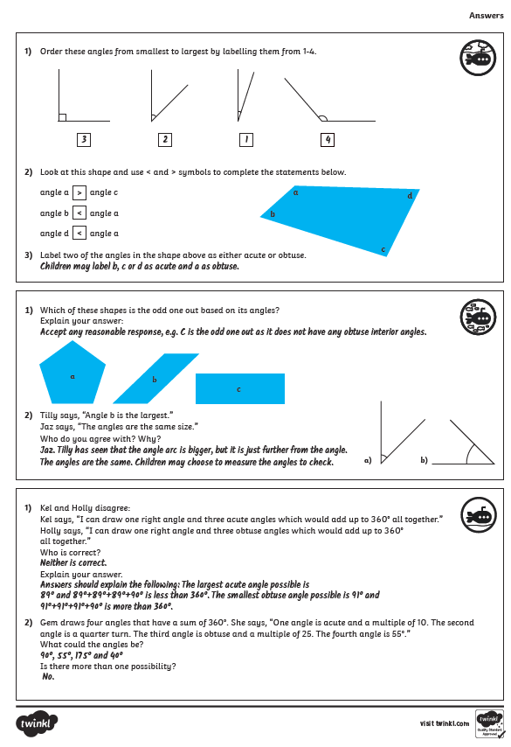
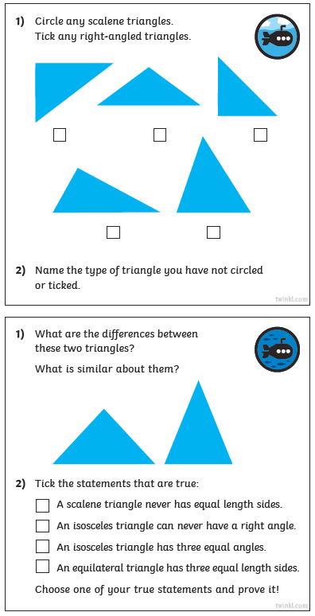 | 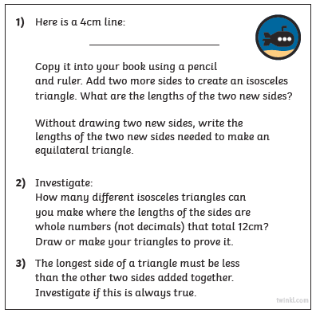
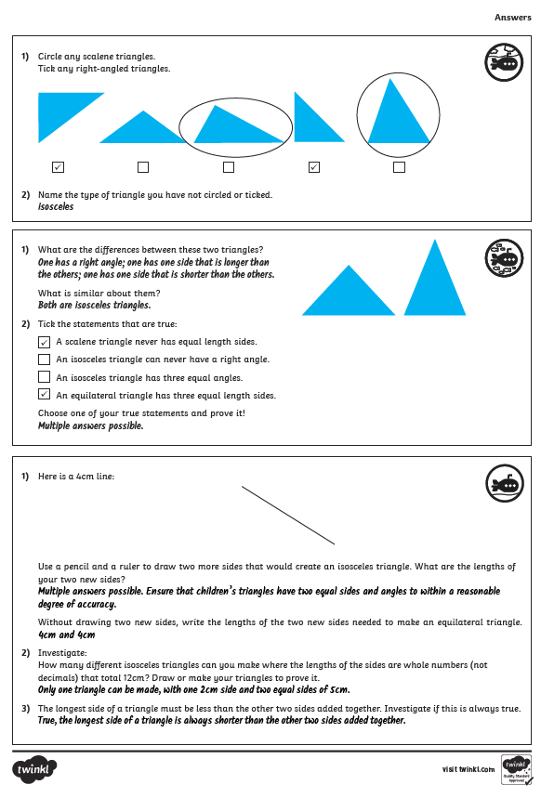
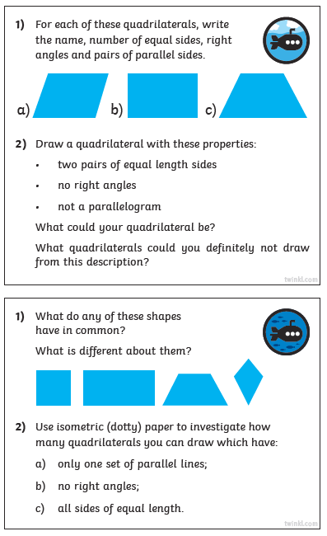 | 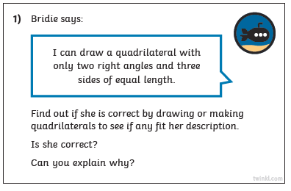
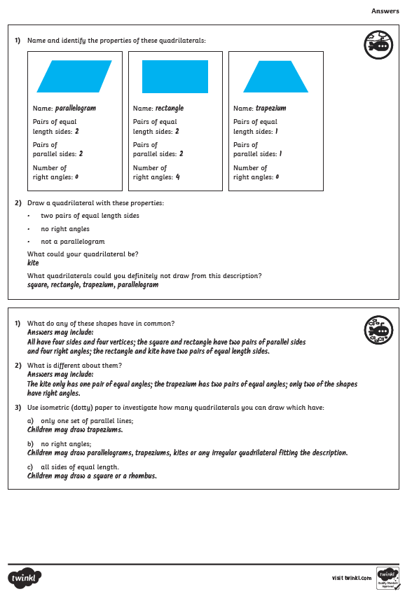
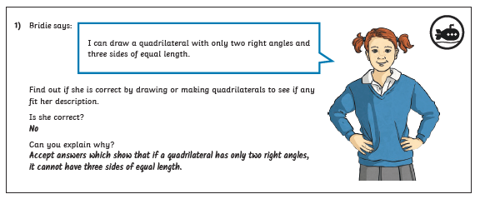
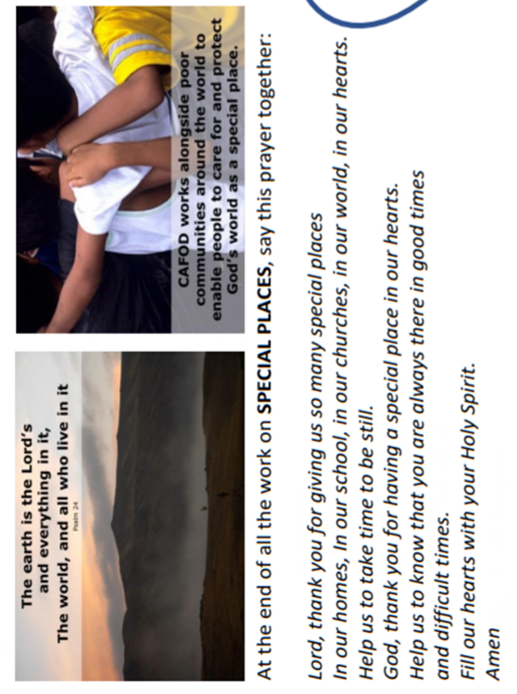
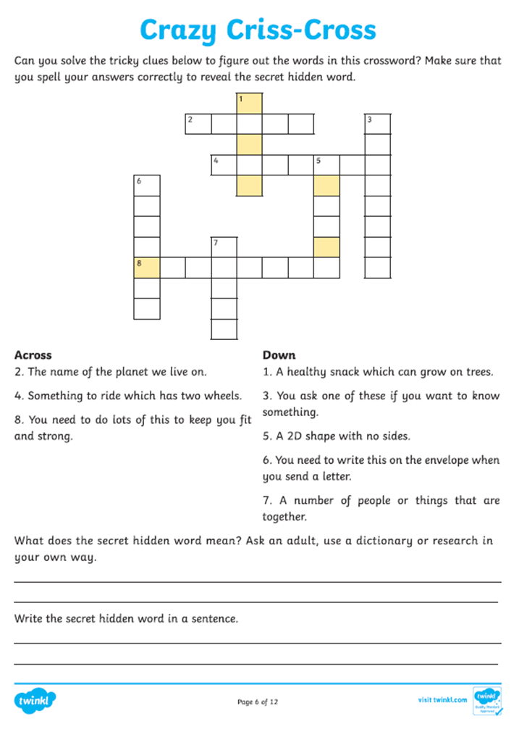
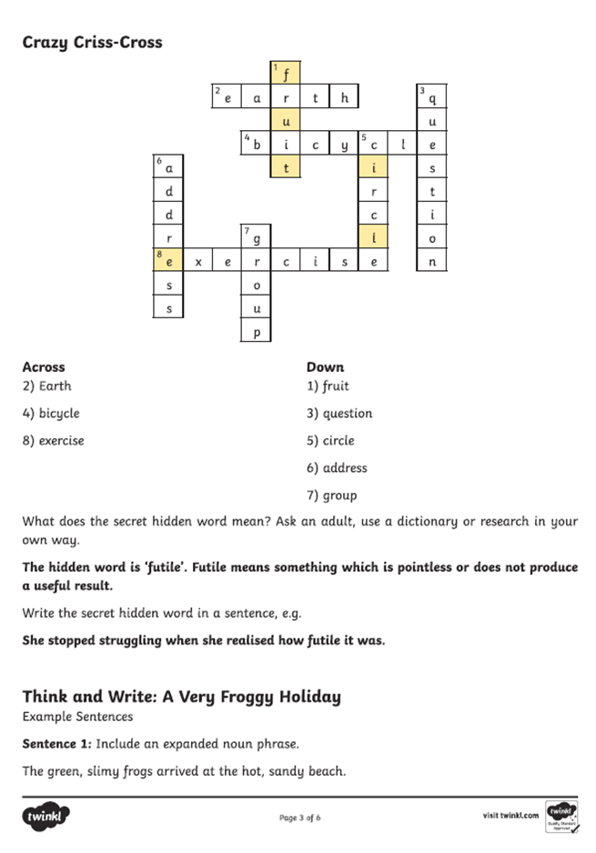
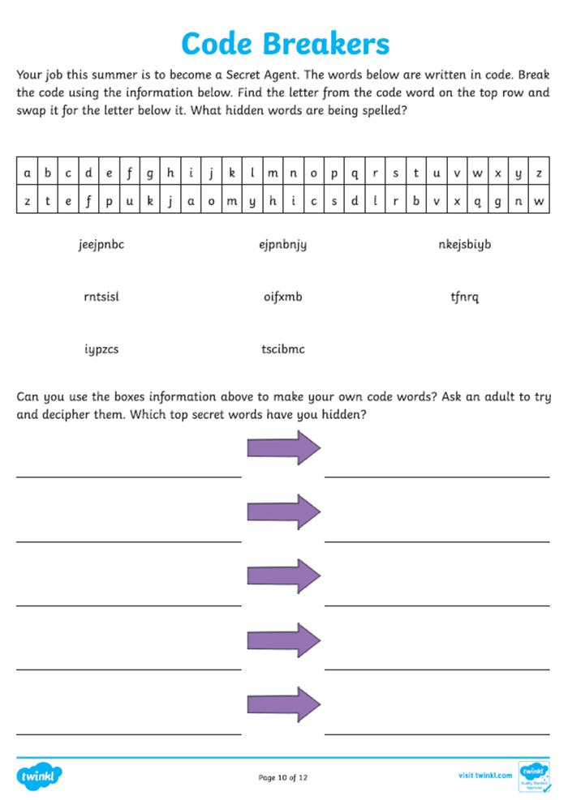
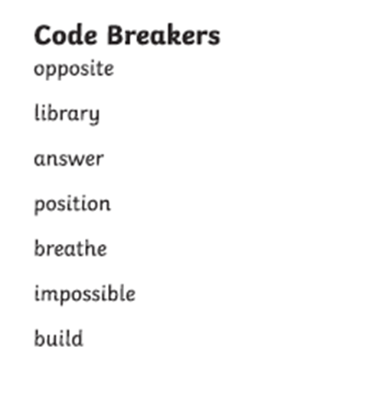
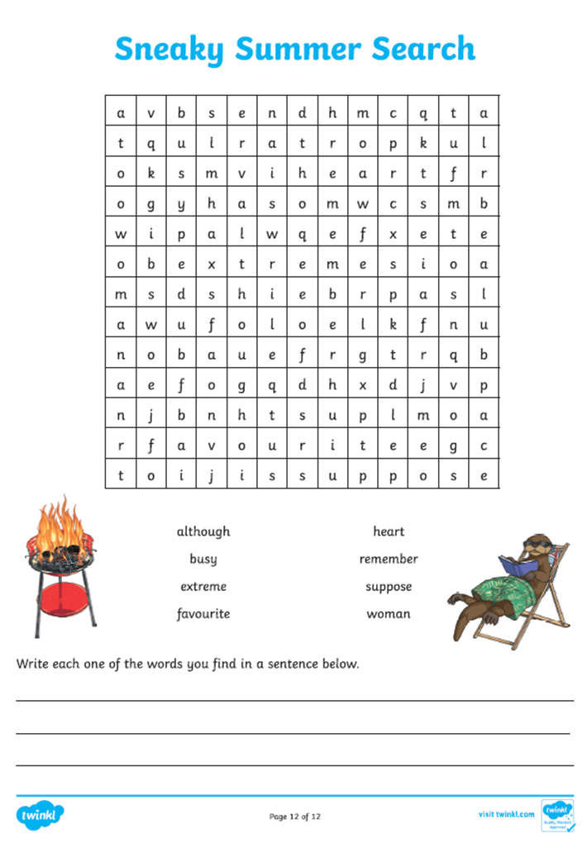
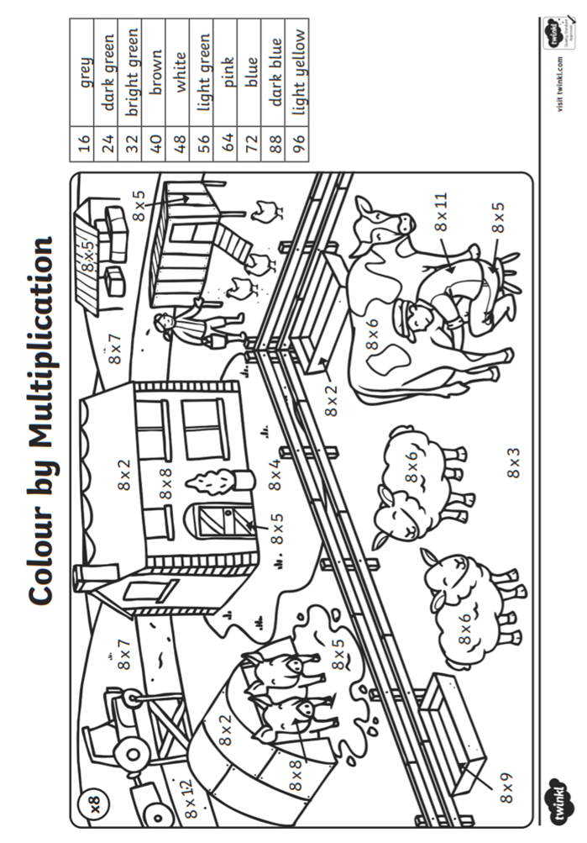
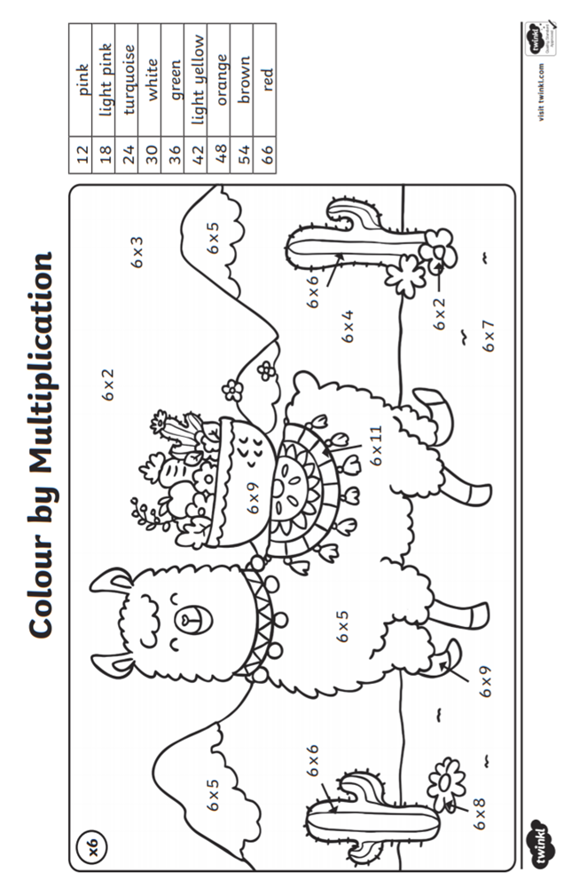

And finally, a little rainbow of hope from me to you! Feel free to print it off and keep as a memory of the class that was cut short by Covid-19. I really enjoyed having each and every one of you in the Starlings nest this year and I’m so sad we didn’t get a chance to finish the year. Have a lovely summer and I sincerely look forward to seeing you all again in school in September. Mrs Grindley xx
