STARLINGS WEEKLY SUGGESTED HOME LEARNING – WB 18.5.20
Hi Starlings! You were very quiet last week! Please remember to email me through school or tweet me, I really enjoy seeing what you’re doing. If you need the Discovery Education password to complete the tasks below, please email school. #StaySafeStayHomeSaveLives
Mrs Grindley and Mrs Catterall XX
ENGLISH | MATHS
Reading – Read every day for pleasure for 20 minutes.  Comprehension tasks  The BFG read the extract and complete the online activities.  https://central.espresso.co.uk/espresso/modules/e2_comprehension_lks2/books/book_bfg.html  Writing – Write a character description of the BFG – use as many expanded noun phrases as you can. (refer to last week’s grammar task on nouns and adjectives) Don’t forget to think about his appearance, feelings and character. Refer to actions in the text to give examples eg He was very sneaky when he hid in the shadows.  - Complete the adjectives word search below  - Create an acrostic poem about the Giant (See below for an example of an acrostic poem about a Mammoth)  Spellings – Y4 – RWI book – Unit 12 – Adding the ir- to words beginning with r – complete the worksheet below  Y3 – RWI book – Unit 12 – Adding the prefix anti- - Create a poster similar to the example below with pictures to explain the words | 15 minutes on TT Rockstars each day  https://ttrockstars.com/  Year 3 –  White Rose – Week 4 – Multiplication and Division  Use worksheets below and BBC Bitesize to support the videos  https://whiterosemaths.com/homelearning/year-3/  Year 4 -  White Rose – Week 4 – Multiplication and Division, Perimeter and Area  https://whiterosemaths.com/homelearning/year-4/  Use worksheets below and BBC Bitesize to support the videos
R.E. | OTHER
The theme is: Serving and is linked to Pentecost.  REVEAL  Read Corinthians 12: 4-8, 11 (See below)  - Record the skills you think God has given you and what you would like the Holy Spirit to give them the energy to do. (You can choose how to record this ie. Mind map, writing, pictures)  - Read The Holy Spirit Prayer (See below)  Write your own prayer thanking God for the Holy Spirit | Science – What are the types of teeth?  https://www.bbc.co.uk/bitesize/topics/z27kng8/articles/zsp76yc  Complete the worksheet below labelling the different teeth.  Can you design a poster to show the function of each of the types of teeth?  History, Art, DT  Continue finding out about the Egyptians for your scrap book. This week find out as much as you can about mummies. Can you make your own paper mummy following the instructions and using the templates shown below?  https://www.twinkl.co.uk/resource/t-t-16327-egyptian-mummy-paper-model-pack  Music – Time for music Y3/4 Lesson 4  https://www.stoswaldswigan.co.uk/classes/fun-learning-games/music

L.I. Find all the adjectives in the wordsearch?

a | b | o | f | u | s | q | u | e | a | k | y | w | c | r
n | f | r | a | l | i | p | z | a | t | j | s | a | g | u
s | r | a | o | s | h | r | i | l | l | x | l | c | e | s
u | e | r | y | k | p | i | c | r | a | z | y | k | u | t
o | s | e | d | r | e | k | w | d | a | o | m | y | h | y
r | h | y | a | s | t | n | j | e | x | l | v | i | s | a
e | o | h | z | o | b | e | a | u | t | i | f | u | l | t
g | s | r | z | f | c | e | n | o | h | h | q | u | r | e
n | e | w | l | t | r | s | n | e | i | c | u | a | h | r
a | q | u | i | e | t | e | a | t | c | r | t | g | y | r
d | t | v | n | d | c | c | s | r | k | o | u | e | e | i
w | e | a | g | l | o | o | m | y | f | o | x | p | e | b
s | h | r | l | n | e | o | z | j | r | k | e | u | u | l
l | m | u | e | l | p | l | i | i | f | e | y | k | l | e
a | d | u | g | l | y | a | r | e | d | d | o | m | b | b

crazy beautiful dazzling bent
wacky spiral sharp gloomy
broken rough terrible sly
ugly crooked dull squeaky
rusty shrill dangerous deep
wet blue quiet fresh
tall thick huge rare

Now use two of the adjectives you have found in sentences.
_________________________________________________________________________________________________________________________________________________________________________________________________________________________________
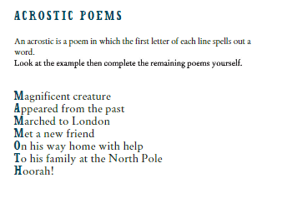

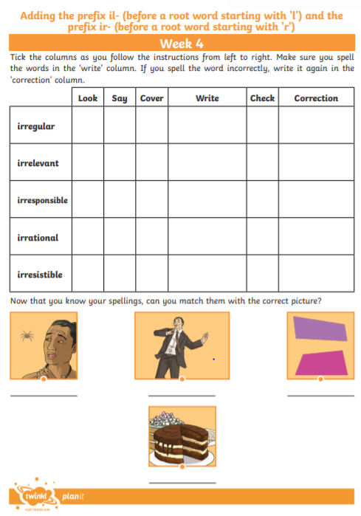
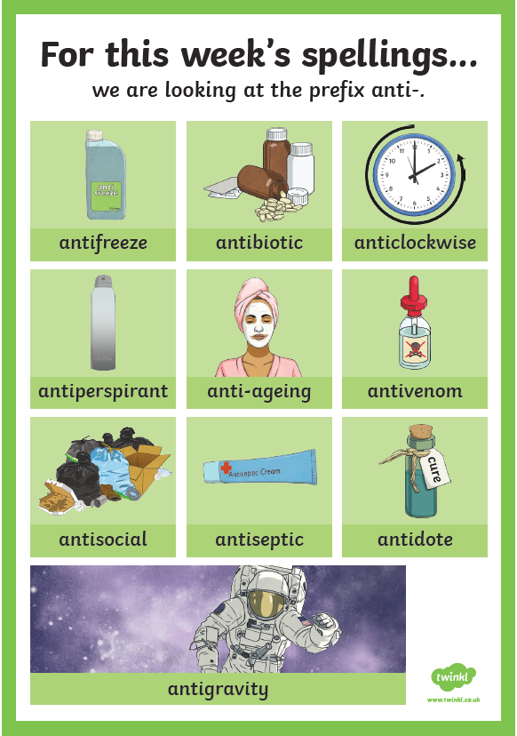
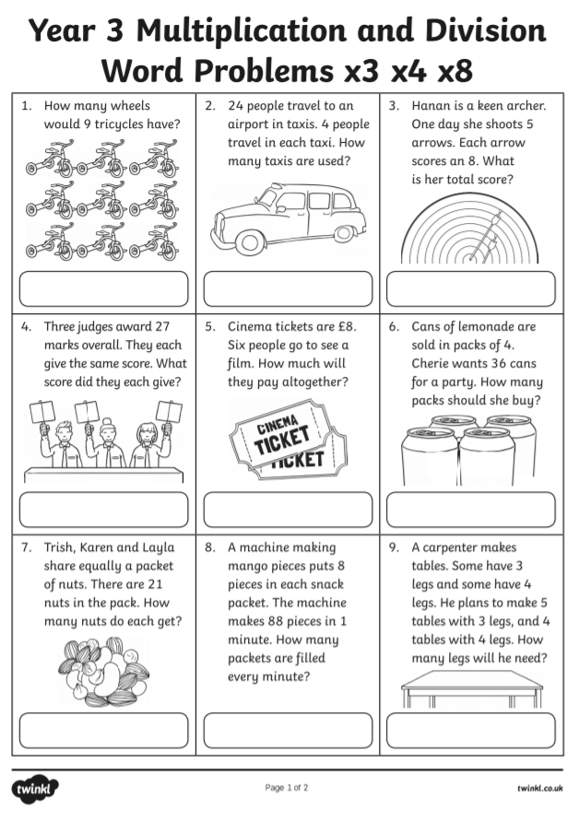

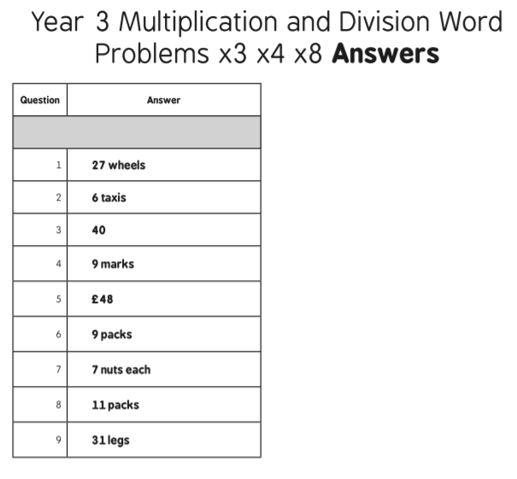

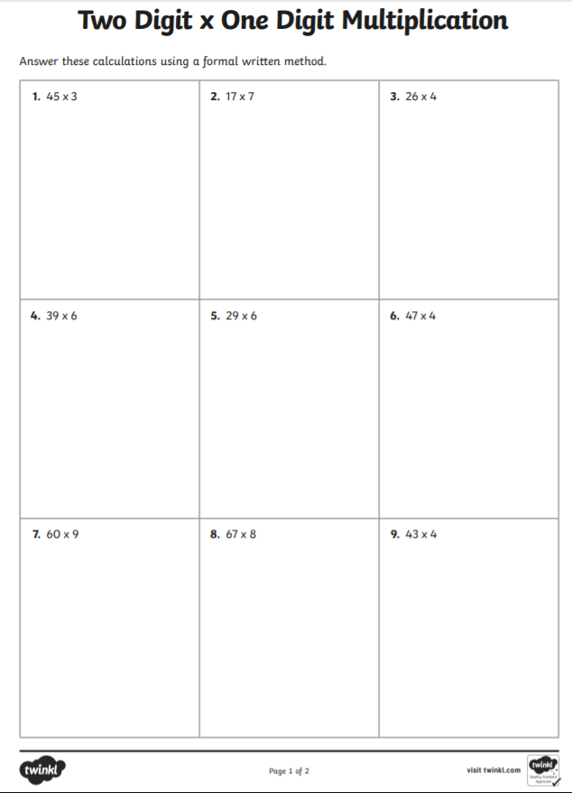

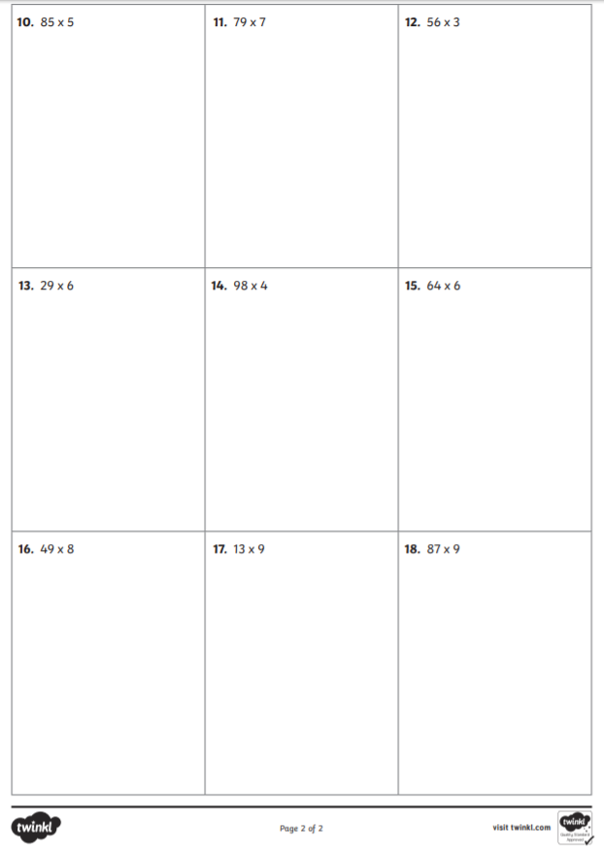

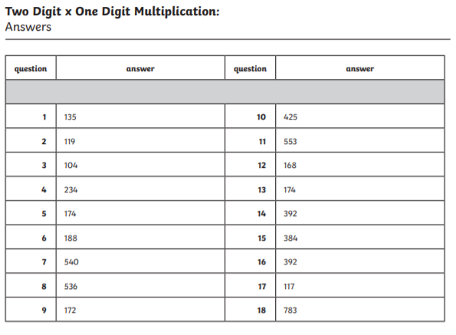

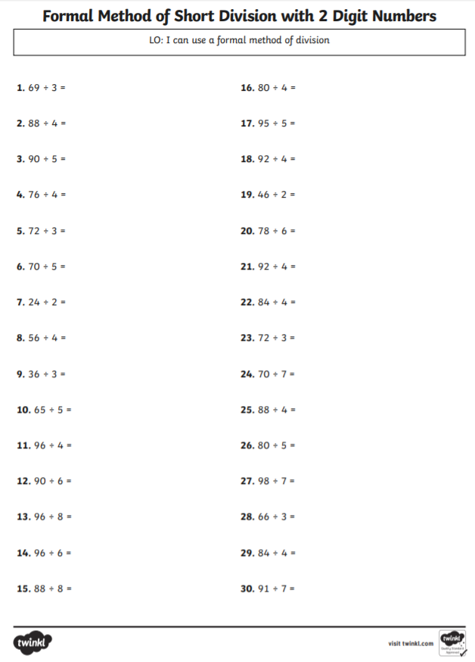

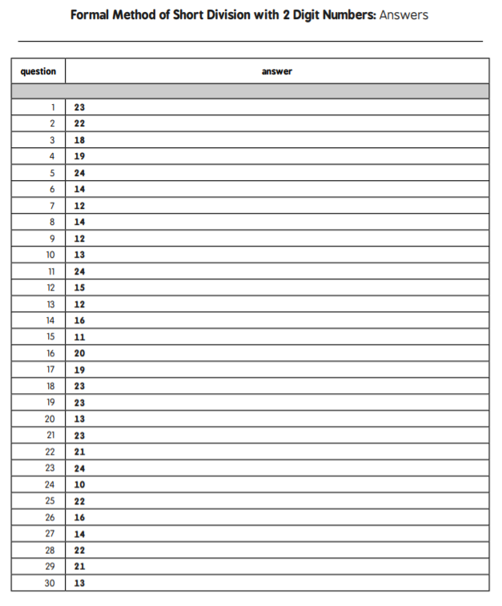

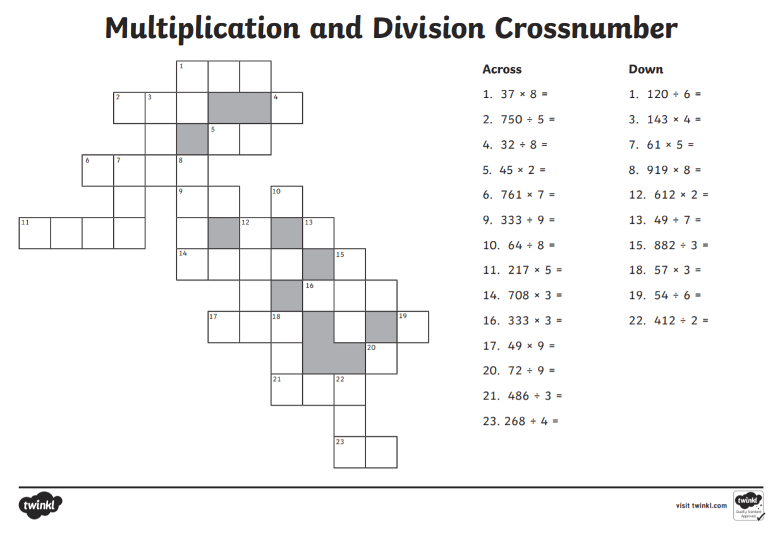
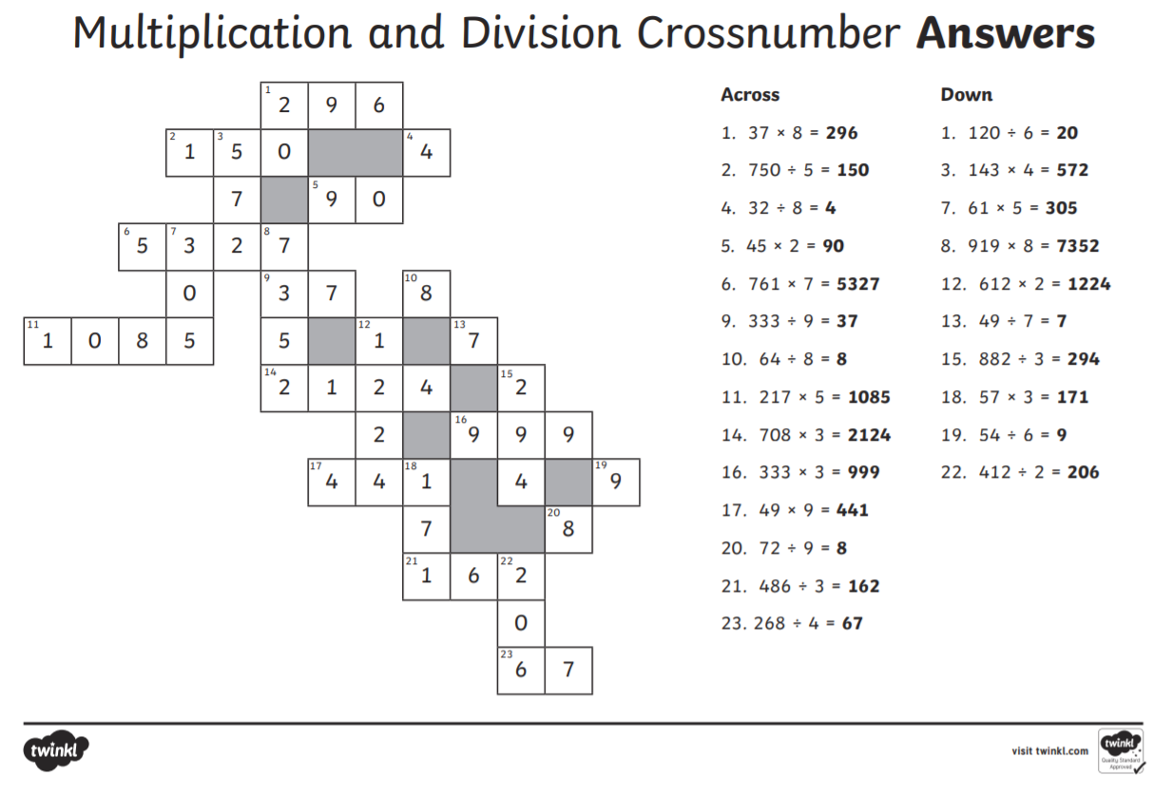

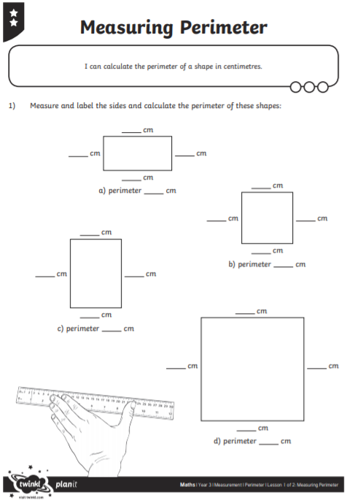

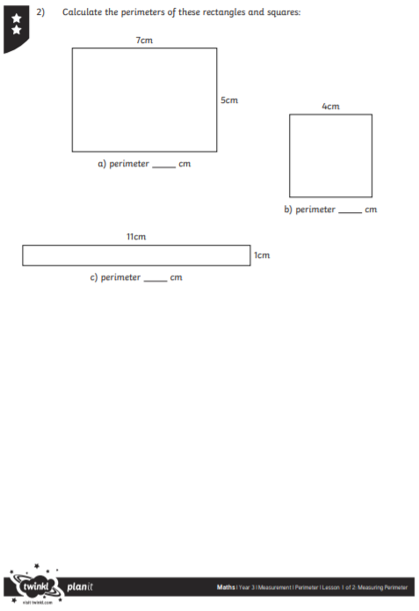
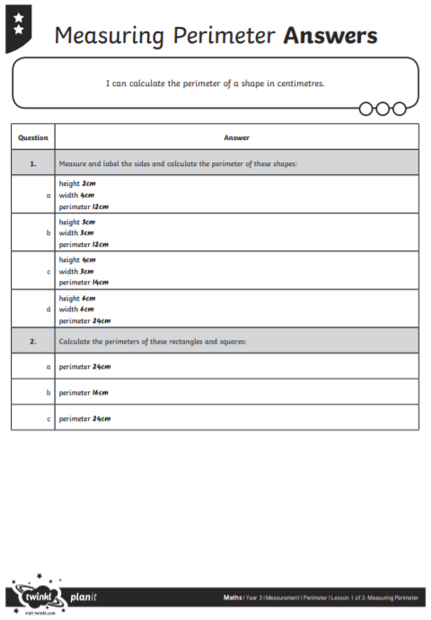
These answers may differ depending on how this prints.

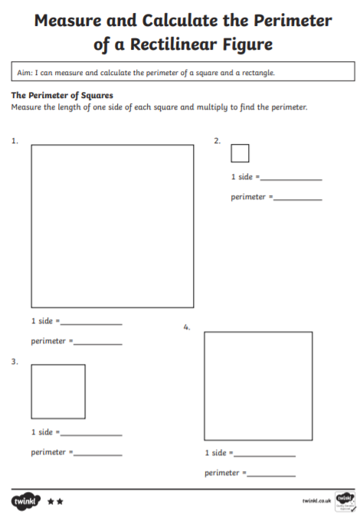
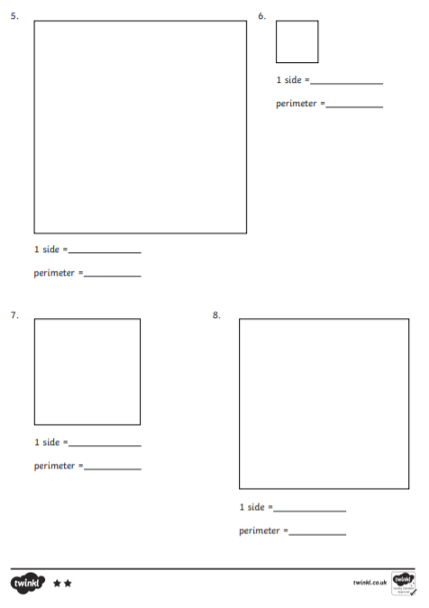
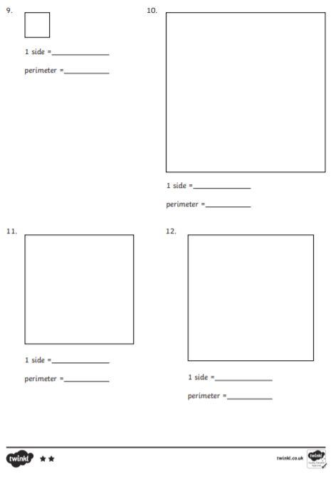
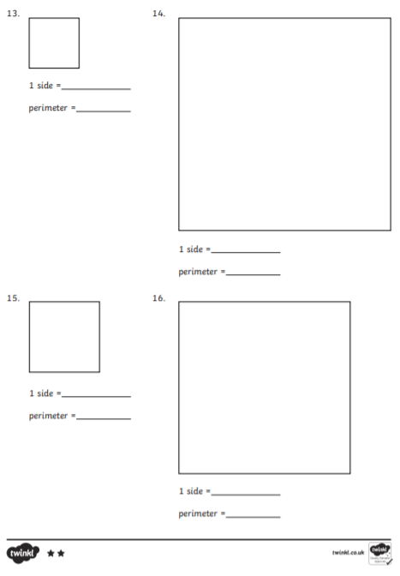

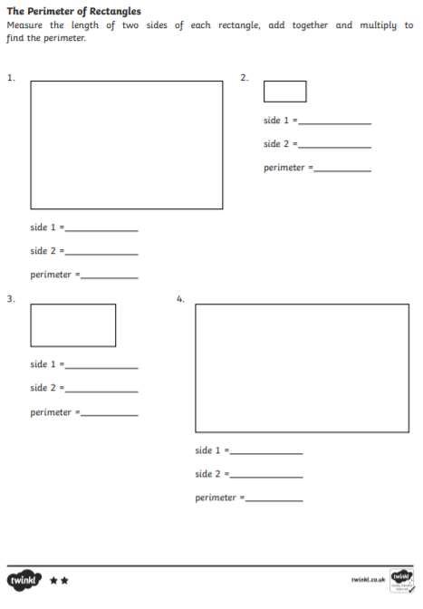

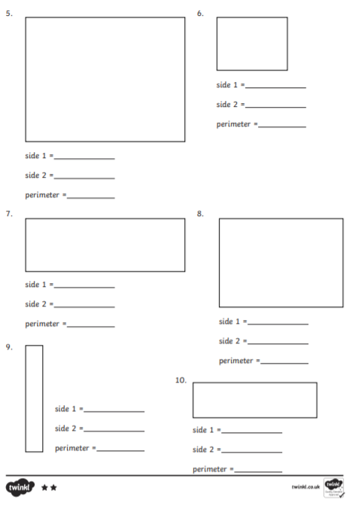
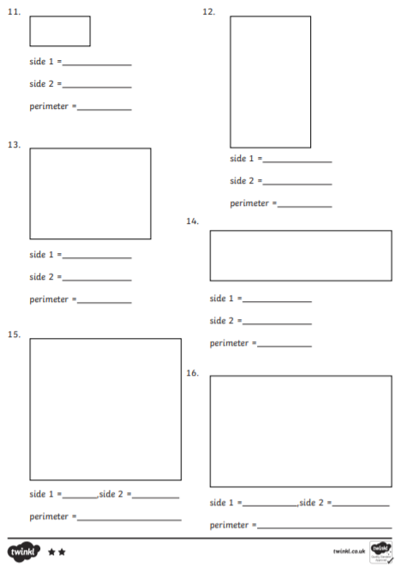
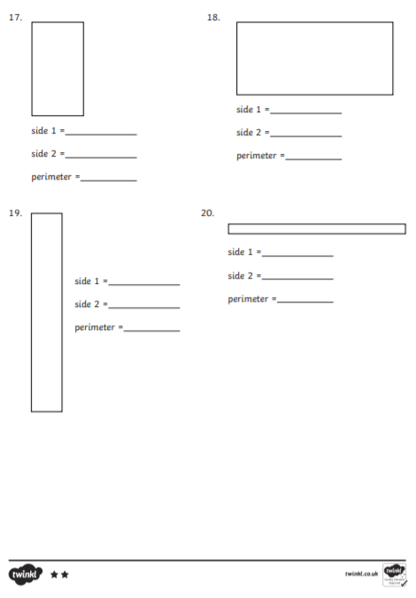
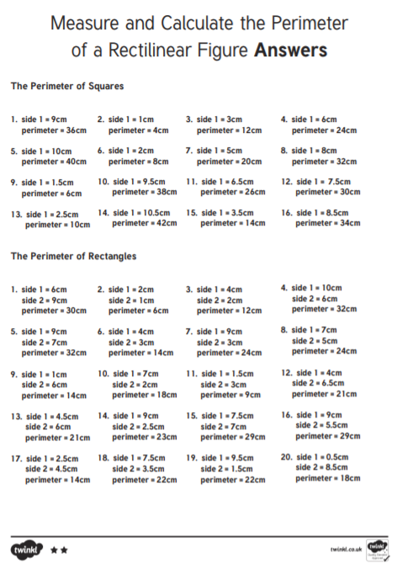
These answers may vary depending on the printing.

