STARLINGS’ WEEKLY SUGGESTED HOME LEARNING – WB 27.4.20
Hi Starlings! Hope you’re all ok and are being good for the people at home, just like you are in class! We have been extremely lucky with the weather – hope you’re all getting fresh air and are managing to complete some daily exercise. Below are some tasks for you to have a go at. Keep going with all the other brilliant, creative work that you’ve been doing too. Hope you’ve managed to find some flour and have done some baking! Keep sending us messages / pictures on Twitter as we love to see them and we check regularly and respond! Also if you want to share your work with me, you can email it to enquiries@saintoswalds.wigan.sch.uk FAO Mrs Grindley. Take care - #StaySafeStayHomeSaveLives
Mrs Grindley and Mrs Catterall XX
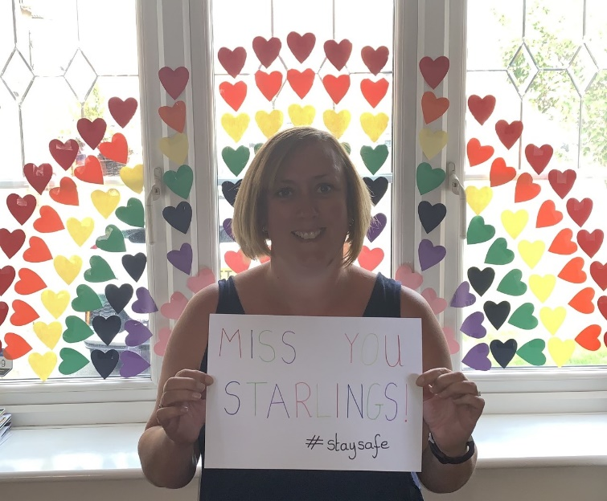

ENGLISH | MATHS
Reading – Read every day for pleasure for 20 minutes.  Comprehension tasks – https://fatherreading.wordpress.com/2019/04/27/our-planet-ks2-cutest-baby-animals-comprehension/  Sharks comprehension is also below  Writing – Research your favourite animal and create a non-chronological report about that animal.  See below for examples and a checklist to give an idea.  Spellings – Y3 – words with the c sound spelt ch e.g. character, chaos, chemist, chorus, school – make a poster of all the ones you can think of. (examples below). Write sentences with each of the words in.  Y4 – words ending in zhun spelt - sion e.g. confusion, explosion, collision, decision – make a poster of all the ones you can think of. Write sentences with each of the words in  These activities are from Twinkl and you can access the website, set up a free account with the code CVDTWINKLHELPS | TT Rockstars  https://ttrockstars.com/  White Rose Home Learning – Year 3 – Summer Term - Week 1 – 20.4.20 - Fractions  https://whiterosemaths.com/homelearning/year-3/  Year 4 – Summer Term - Week 1 – 20.4.20 - Decimals  https://whiterosemaths.com/homelearning/year-4/  The Week 1 and Week 2 activities take the learning back a step if it is too difficult. Also, your child can go to the previous year group if they are finding the tasks too challenging. This might build a bit of confidence.
R.E. | OTHER
The theme is: Serving and is linked to Pentecost.  Explore the danger of fire and how to be safe. Create a fire safety poster for your home. The link below gives you information.  https://www.manchesterfire.gov.uk/staying-safe/  Wind Power  Use balloons to show wind power. Blow up a balloon. Ask the children to put the balloons down on the floor. Discuss what happens? How could you make them stay on the spot? Can you always control the balloon? Why or why not? Will it go where you want it to? What makes it move?  Show some BBC learning zone clips on wind power and fire e.g. making pottery. Notice how both wind and fire engage the senses: seeing, touching, hearing and smelling. Talk about how they do this. | Science – Animals – Research what Food Chains are and make a poster to show a food chain.  https://www.bbc.co.uk/bitesize/topics/zbnnb9q  https://www.stem.org.uk/resources/elibrary/resource/34119/education-pack-food-chains  History – Ancient Egyptians – Start to create a scrap book all about the Ancient Egyptians – this week complete the front cover and do some independent research. You can present this as a spider diagram or as a poster or any other creative way you wish to. Here’s some links to get you started.  https://www.bbc.co.uk/iplayer/episode/b00jzygg/horrible-histories-series-1-episode-2  https://www.bbc.co.uk/bitesize/topics/zg87xnb
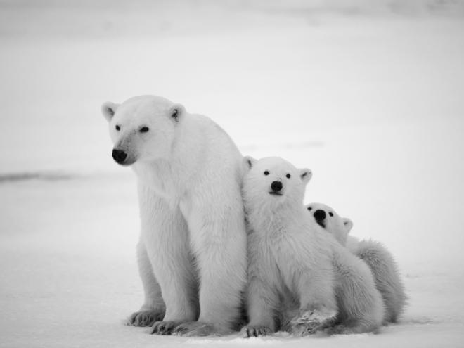
Example from Literacy Waggoll
Polar Bears
Have you ever wondered about polar bears? If so, this report will tell you everything you need to know. Polar bears are the kings of the Artic. Read on to find out more.
Where do Polar Bears live?
Polar bears live in countries around the Arctic: Canada, Russia, the United States, Greenland and Norway. In the winter, temperatures in the Arctic are usually around minus 29 degrees. In the summer, polar bears live on the land. In the winter they live on the ice.
A polar bear and its cubs.
What do Polar Bears do?
Polar bears are solitary which means they spend most of their life alone. The animal will spend its days wandering across the land or swimming in the Artic sea, stalking its prey or napping in shrubs or snow dens. When a polar bear swims under water it closes its nostrils so no water can get in. Polar bears are excellent swimmers because they use their big front feet to paddle and their back legs to steer.
What do Polar Bears look like?
Polar bears are well-equipped for survival in a harsh, cold environment. They have two coats of fur and a thick layer of blubber to help insulate the polar bear's body from the cold. Also, polar bears have wide, large paws which help them to walk in the snow. Their claws help them to catch their prey and to dig out snow dens in the winter. Their fur is white to help them camouflage in the snow, although their skin is actually black underneath.
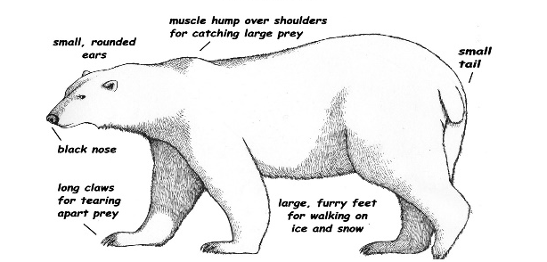
.

A polar bear’s body.

What do Polar Bears eat?
Polar bears are carnivores so they eat only meat. They feed mainly on seals but they may also eat walruses or dead whales and narwhals. They will wait patiently by a hole in the ice until a seal comes up to the surface to breathe before they attack it. They have a great sense of smell which they use to find their prey and then they use their sharp claws to catch and tear it up to eat. In addition, they are also excellent swimmers which helps them to hunt too.
Did you know?
Polar bears are the largest carnivores that lives on land.

