STARLINGS WEEKLY SUGGESTED HOME LEARNING – WB 4.5.20
Hi Starlings! Hope you’re all ok and are continuing to be good for the people at home, just like you are in class! Thank you to the children who emailed or tweeted your work last week. It was lovely to see what you have been up to and of course your smiling faces – we do miss those! Below are some tasks for you to have a go at. Keep going with all the other brilliant, creative work that you’ve been doing too and don’t forget your daily exercise! Keep sending us messages / pictures on Twitter as we love to see them and we check regularly and respond! Take care - #StaySafeStayHomeSaveLives
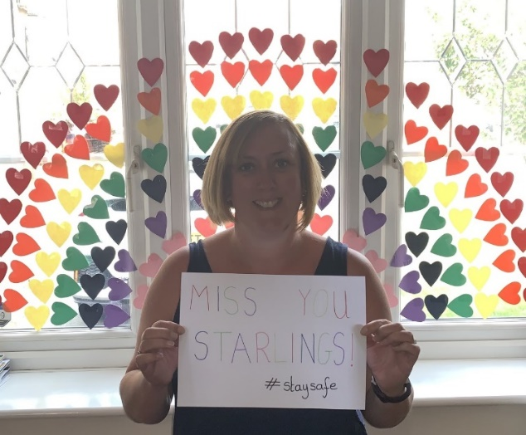
Mrs Grindley and Mrs Catterall XX

ENGLISH | MATHS
Reading – Read every day for pleasure for 20 minutes.  Comprehension tasks –Pet care of a dog (See below)  https://www.twinkl.co.uk/resource/t2-e-3760-lks2-reading-comprehensions-bumper-resource-pack  Writing – Write your own report for taking care of a pet (If you don’t have a pet you could write about an imaginary pet or write about how you would take care of a plant)  Spellings – Y3 – adding the suffix ian (RWI Book 3 Unit 10) e.g. magician, mathematician, (See attached list) – choose the right word (See below)  Write sentences of your own with each of the words in.  Y4 – adding il- and revising un-, in-, mis-, dis- (RWI Book 4 Unit 10) e.g. illegal, illogical, illegible, illiterate. (See pre-fix work below)  Write sentences of your own with each of the words in. | 4 times table – instant recall  https://www.bbc.co.uk/teach/supermovers/ks1-maths-the-4-times-table-with-cyril-the-swan/zmsw382  White Rose Home Learning – Year 3 – Summer Term - Week 2 – 27.4.20 - Fractions  https://whiterosemaths.com/homelearning/year-3/  If this is a step to far, Week 1 and Week 2 just above the Summer Term links go back to basic fractions to support your child.  There is also the option to go to the year 2 Maths work too. Everything helps.  https://whiterosemaths.com/homelearning/year-2/  Year 4 – White Rose Home Learning – Summer Term – Week 2 – 27.4.20 – Decimals, Halves and Quarters and Money  https://whiterosemaths.com/homelearning/year-4/
R.E. | OTHER
The theme is: Serving and is linked to Pentecost.  REVEAL  Read the extract from Acts 1: 6-11 (See below)  Draw a picture of Jesus at the ascension – add a speech bubble to show the promise Jesus made or write a paragraph to describe what happened.  Imagine you are one of the apostles after Jesus had returned to his Father. Having witnessed how Jesus served others, how will you continue his mission? In a method of your own choosing, record what actions you would take and give reasons for your choices | Science – What is a food chain? Watch the BBC bitesize clips below  https://www.bbc.co.uk/bitesize/topics/zx882hv/articles/z3c2xnb  https://www.bbc.co.uk/bitesize/topics/zbnnb9q/articles/zwbtxsg  Complete the worksheet (See below)  History – Ancient Egyptians – Start to create a scrap book all about the Ancient Egyptians – this week continue with your scrap book – what can you find out about the pyramids? Can you write a non-chronological report about them to add to your book?  http://www.primaryhomeworkhelp.co.uk/egypt/pyramids.htm  https://www.bbc.co.uk/iplayer/episode/b00jzygg/horrible-histories-series-1-episode-2  https://www.bbc.co.uk/bitesize/topics/zg87xnb  Music – Time for music Y3/4 Lesson 2  https://www.stoswaldswigan.co.uk/classes/fun-learning-games/music
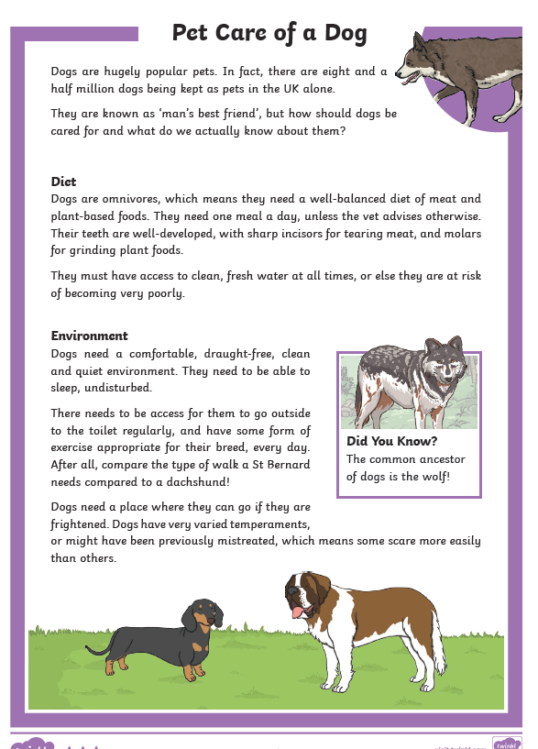

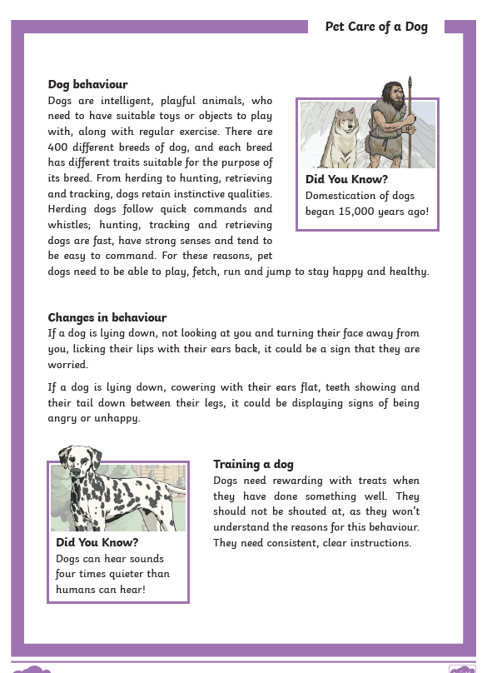
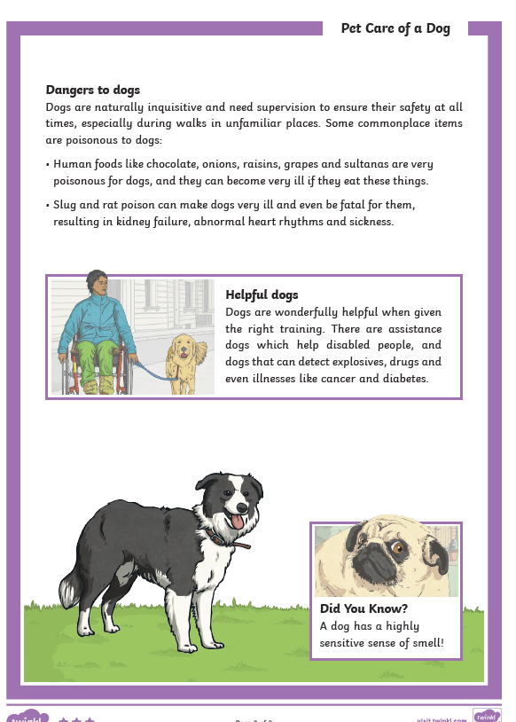
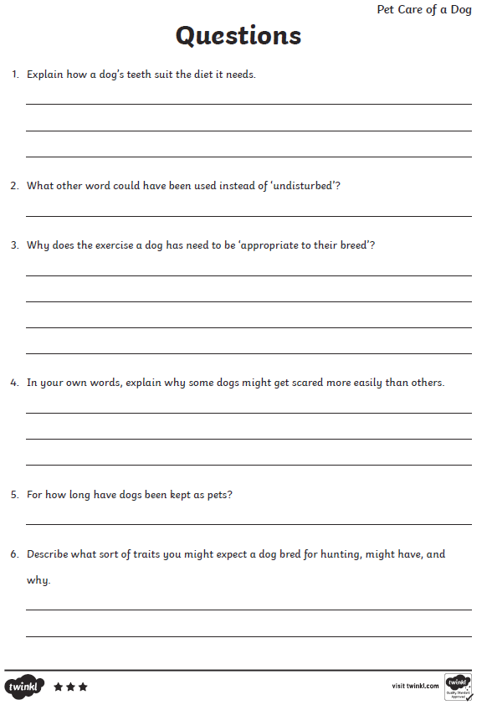
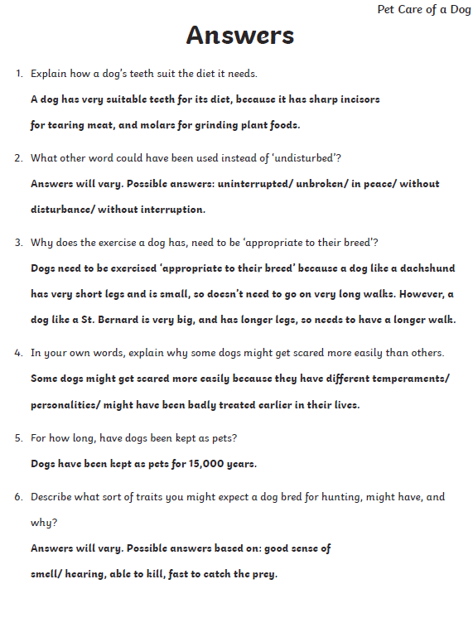

Choose the right word
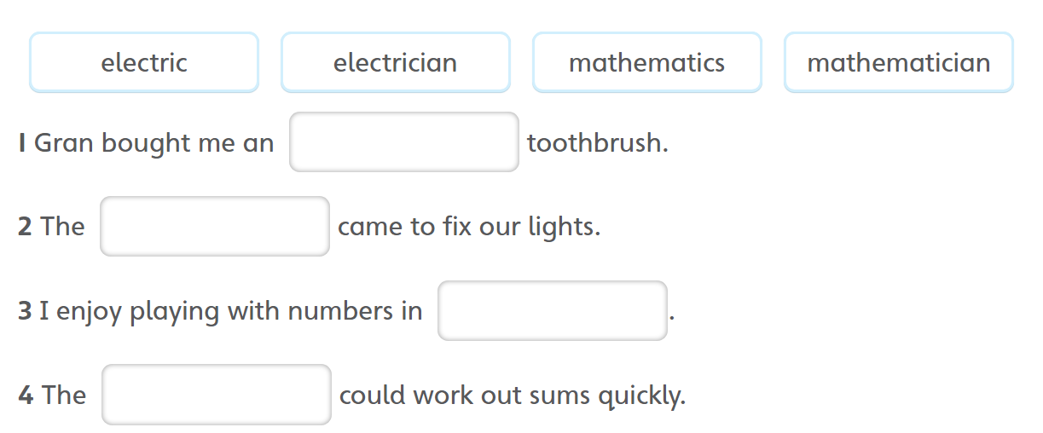

Spellings This week’s focus is adding the suffix –ian to words ending in c or cs.
music
musician
electric
electrician
optic
optician
magic
magician
politics
politician
mathematics
mathematician
Jumping Orange Words
difficult
grammar
guard
guide

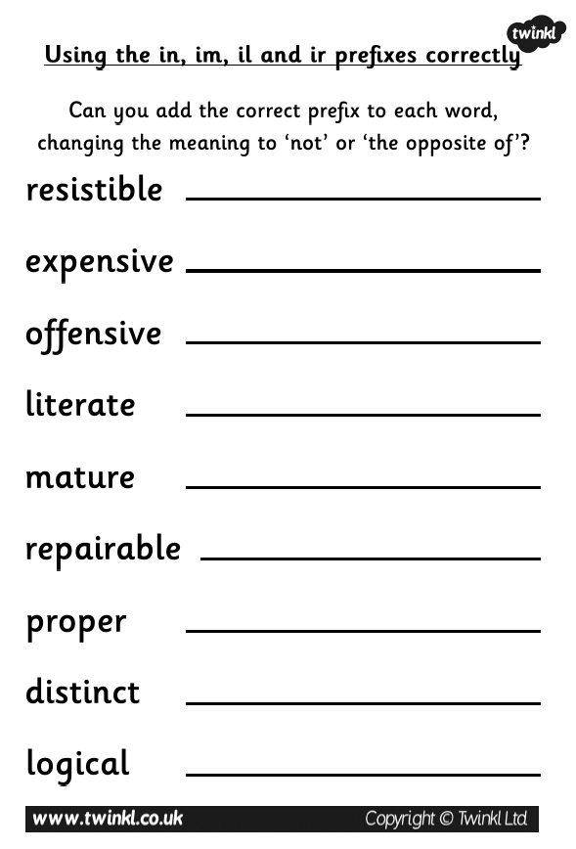
RE
After Jesus had been raised to new life, he told his friends,
“You will receive the power of the Holy Spirit. You will be my witnesses here in Jerusalem and all over the world.”
As he said this, he disappeared from sight.
They realised that he had gone back to his Father as he had said he would.

Based on Acts 1: 6-11

.

The Church celebrates the Ascension forty days after Easter Sunday, the day of the Resurrection.
Teaching Point

A disciple is a follower of Jesus. An apostle is someone who is sent out to spread the Good News of Jesus to the whole world.

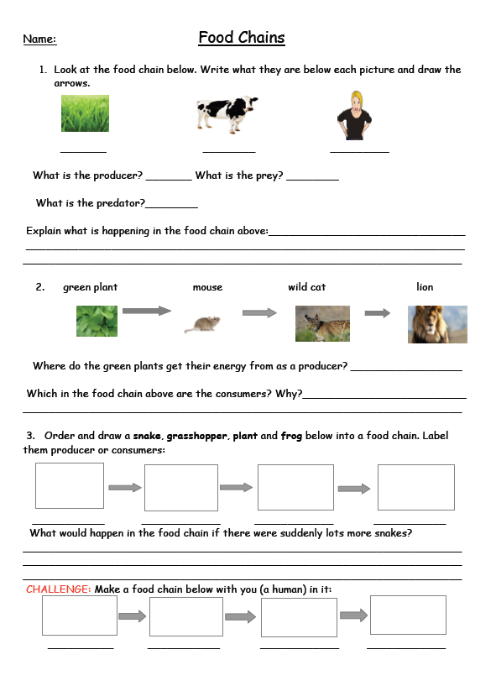

Food chain answers

