SPARROWS’ WEEKLY SUGGESTED HOME LEARNING – WB 8.6.20
Hello Sparrows! We have come to the end of our topic on Yeti and the Bird and we hope you enjoyed the activities. On Monday 8th June, it is National Best Friends day and your activities are based on this, as I am sure you are all missing your friends terribly! We thought it would be a great chance for you all to think about your friends and the happy times that you had before lockdown and the happy times that are to come. We have included some colouring pictures and a card template if you wish to use them.
Thank you to those families who have been in contact. There are still a few families who have not been in contact and we would love to hear from you. It really brightens up our day and we will reply which we are sure will put a smile on your face too. You can email the office at enquiries@saintoswalds.wigan.sch.uk FAO Sparrows or tweet us @saintoswalds @mrs_wibberley @MrsOsborne73.
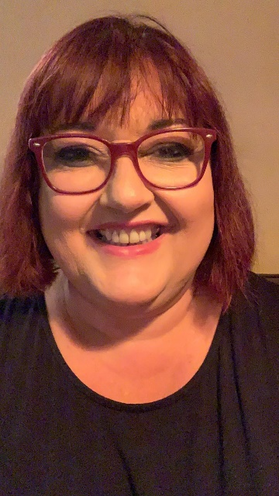
We look forward to hearing from you this week! Keep smiling, enjoy this time with your family, get lots of fresh air and stay safe.
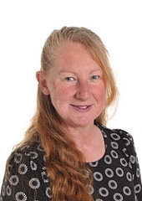
Mrs Wibberley, Mrs Osborne and Mrs Dean xx
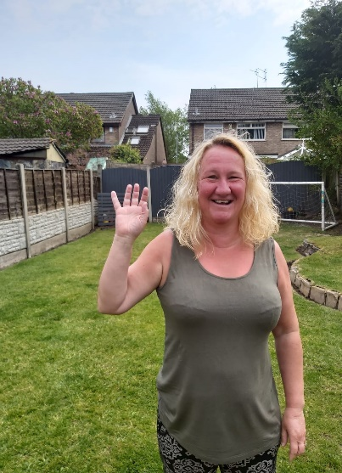
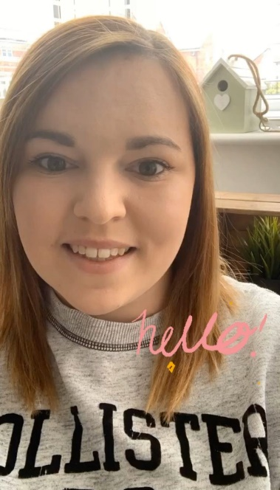

ENGLISH | MATHS
Reading – Read every day for pleasure for 10 minutes.  You can also listen to stories on www.vooks.com. This website is full of stories that come with videos and are a big hit in Sparrows as there are so many to choose from. Maybe your child can share their favourite story with you. You can get a free subscription for 1 month.  Comprehension –  - Complete the friendship comprehension below.  - Let an adult read the ‘Friendship Problem Scenario’ story and discuss the questions underneath it.  Writing –  - Complete the ‘How can ___ be a good friend’ writing frame explaining how you can be a good friend to others.  - Write a post card and draw a picture for a friend. If you know where they live you could post it through their letterbox whilst on a walk. If you do not know where they live, you can wait until we return to school to give it to them.  - Make a poster of the things you would like to do with your friends when you can be with them again.  Phonics – Your child will be able to tell you which phonics group they are in. If they don’t know, please contact school so we can help you.  Mrs Osborne and Mrs Dean’s groups –  1. Go to https://www.phonicsbloom.com/ or https://new.phonicsplay.co.uk/ and play your favourite game to practise all the new sounds you have learnt over the past few weeks.  2. Find objects around the house that have the short ‘oo’ (book) sound in them. Write the words and draw pictures to match.  Mrs Wibberley’s group –  1. Go to https://www.phonicsbloom.com/ or https://new.phonicsplay.co.uk/ and play your favourite game to practise all the new sounds you have learnt over the past few weeks.  2. Find objects around the house that have the sound ‘ir’ and ‘er’ in them. ‘er’ was learnt during phase 3. Put these words into sentences and draw pictures to match.  Miss Lea and Mrs Davies’ groups –  1. Go to https://www.phonicsbloom.com/ or https://new.phonicsplay.co.uk/ and play your favourite game to practise all the new sounds you have learnt over the past few weeks.  2. Complete the phase 5 learning challenges below. | Basic skill – Read, write and interpret mathematical statements involving addition (+), subtraction (-) and equals (=) signs.  You can use objects to help you work out the statements if you need to and remember the equals sign does not always come at the end!  There are some great games on this website if you would like to use them https://www.topmarks.co.uk/maths-games/5-7-years/addition-and-subtraction  Unfortunately White Rose have started charging for their home learning tasks, however BBC Bitesize have partnered with White Rose and have some great daily tasks including maths for free. Follow this link for a daily maths task https://www.bbc.co.uk/bitesize/tags/zjpqqp3/year-1-and-p2-lessons/1  If your child finds this challenging, please follow this link https://www.hamilton-trust.org.uk/blog/learning-home-packs/ and use the previous year group’s tasks.
R.E. | OTHER
The theme is: Reconciliation – Being sorry.  Jesus helps us when we make wrong choices.  Read the story below about Levi the tax collector.  - What was Levi’s job?  - What wrong choice did he make?  - What was Levi’s answer to Jesus’ invitation to follow him?  - What invitation did Levi give to Jesus?  - How do you think Levi changed?  Role play the story and retell the story to an adult. Make sure you include the details of what Levi did, the wrong choices he made, what Jesus said to him, why Jesus chose Levi and what Levi did at the end. | DT – Find a recipe and make something for a friend. You could make cookies, cakes, fruit kebabs etc. If you can’t deliver them to your friend, enjoy them with your family but take a picture so you can show your friend on Twitter or in person when we return to school.  History – Ask your family members what games they used to play with their friends when they were your age. Are they different to your games? Is your Grandma’s game different to your mum’s game? Can you learn how to play one?  Geography/Computing – Use a computer to research some games that children play in a contrasting non-European country. Can you teach it to your family and have a go? Did you enjoy the games? How are they different to your games?  Eco – Daisy chains are often a sign of friendship. If you find any daisies, can you make a daisy chain and wear it?

Friendship Comprehension
Today is Sunday.
It is a bright and beautiful day.
Adam and his friends are playing on a beach.
Tim is making a sand castle.
Anna is collecting shells in a bucket.
Ella is taking a nap under an umbrella.
Adam is swimming in the sea.
There are many fish in the sea.
Birds are flying.
Children have a beach set to play.
There is a crab near the basket.
They all are having fun.

- Which day is it? ____________________________________

- Where are Adam and his friends playing? __________________

- Who is making a sand castle? ____________________________

- What is near the basket? __________________________

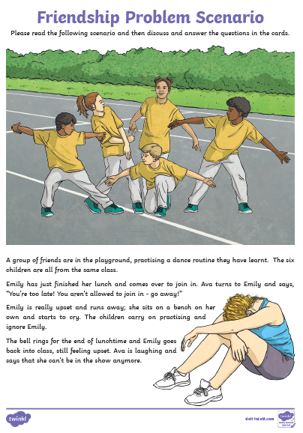

- How do you think Emily feels when Ava tells her she can’t join in and that she has to go away?

- Why do you think Ava said that to Emily?

- Do you think Ava knows Emily will be upset? Why do you think this?

- How do you think the other children will feel when they see Ava speaking to Emily like that?

- What do you think will happen during the next playtime or lunchtime?

- If you were part of the group, what would you do?

- If you were Emily, what would you do?

