**VE DAY**

**75TH** **ANNIVERSARY**

**FRIDAY 8TH MAY 2020**

**ALL WELCOME**

**HEROES & HEROINES**

* Countless men, women and even animals showed acts of **heroism** during WWII. Starting with **animals**, children could look at the PDSA Dickin medal and design their own version of this award.
* **Colonel Tom Moore** is a former British Army officer who has raised millions for the NHS. Why not create a family photo saluting him or children could write him a letter, thanking him for all he has done for his country.
* Create a fact file about the man who helped to break the German Enigma code, **Alan Turing** or **Mavis Batey,** one of the leading female codebreakers at Bletchley Park.
* Children could listen to and recreate their own version of **Winston Churchill’s** VE Day speech.
* **Irena Sendler**, a Polish social worker saved 2,500 Jewish children during WWII. After researching her life, children can write a diary entry based on a day in her life.
* **Havildar Lachhiman Gurung** won the Victoria Cross while serving with the Gurkha Rifles in Burmna in 1945. Ask your child to write a biography about this courageous man.

**#TheLearningProjects**

**#VEDay75**

**Hosted by** 

**THEN AND NOW**

* Ask your child to imagine that they’re being evacuated. What would they pack? Draw and label essential items and then design a luggage label.
* Your child could write a postcard to a family member about VE Day anniversary celebrations today, or imagining that they are celebrating VE Day in 1945.
* Find out what happened in the **local area** on VE Day. How will this be different today? Why?
* What does **peace** look like? Task your child with creating a poster illustrating their ideas for peace.
* Comparing war time to what we are experiencing now (pandemic), are there any similarities and differences? Your child could present their findings in a table.
* Create a bravery medal/ design a medal/ research medals
* Wear red, white and blue
* Diary entry as Queen Elizabeth II joining in the celebrations secretly
* What happened in the local area on VE Day?
* Make a mini air raid/Anderson shelter
* Bunting
* What does peace look like?
* Salute for Captain Tom Moore (see BBC)
* Act out Churchill’s speech
* Newspaper report/front page recounting the day
* Wartime recipes - cake/lemonade- rationed ingredients only?
* Postcard to missing family member about VE Day celebrations
* Write a message to Captain Tom Moore in Morse Code
* Design a VE day coin/plate/etc.
* [Lion and the Unicorn](https://youtu.be/qgzBOYMDkbM)- Shirley Hughes listen
* Diary writing in role - soldier’s feelings now war is over. Or step into the roll of a person in a VE Day photograph
* Reflect on why VE Day is so important to remember
* Comparing war time to what we are experiencing now (pandemic) thinking about similarities and differences?
* 1940s music and dancing
* Research what happened in their local area on VE Day
* Watch the Queen’s speech
* VE day celebration party
* ‘Walk On’- recreate and perform
* Importance of St Paul’s Cathedral during WWII
* RAF, Spitfire - make paper planes
* Significance  of Alan Turing
* Letter to Tom Moore
* Poppy crafts - painting poppies or making them using materials found at home
* Hot Seating/drama activity with family members/siblings - asking questions and acting as different people who had experienced the war e.g. a soldier, child, a woman who had been called to work
* Talk about rationing and how people dealt with having less food, grew their own vegetables etc. Could they plan a week’s meals using the rations provided? (average weekly rations per adult [here](https://www.historic-uk.com/CultureUK/Rationing-in-World-War-Two/)).
* Create their own ‘radio broadcast’ celebrating VE day - this could be recorded and uploaded to virtual classrooms
* Write a poem about WW2
* Design a tea towel about WW2: Look at designs from 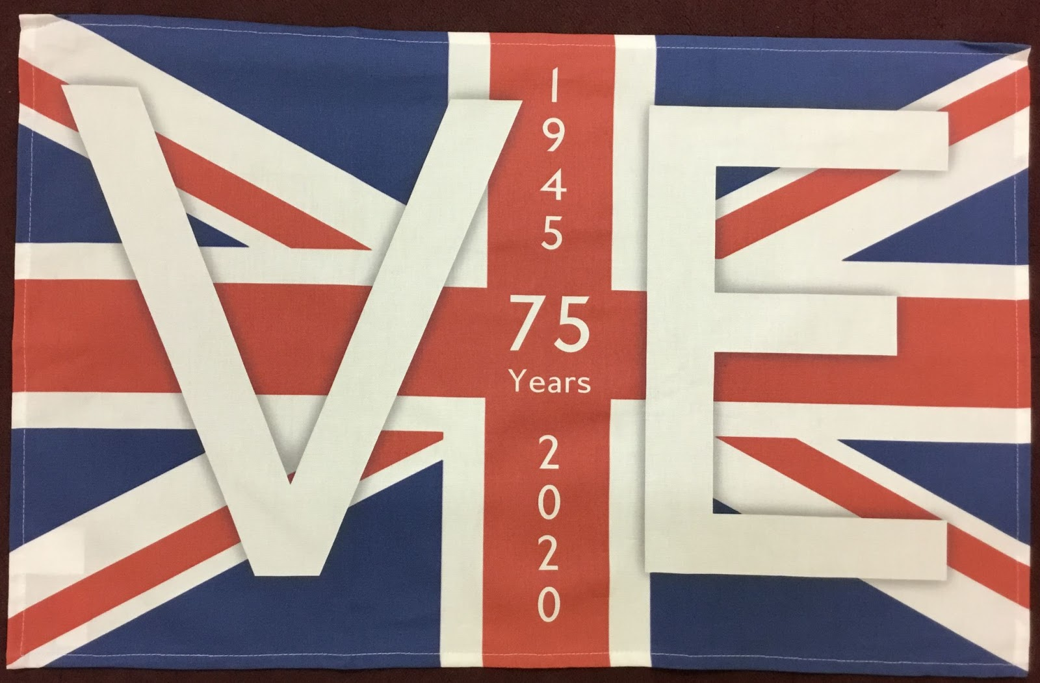
* Look at work by Dareell Wakeham: 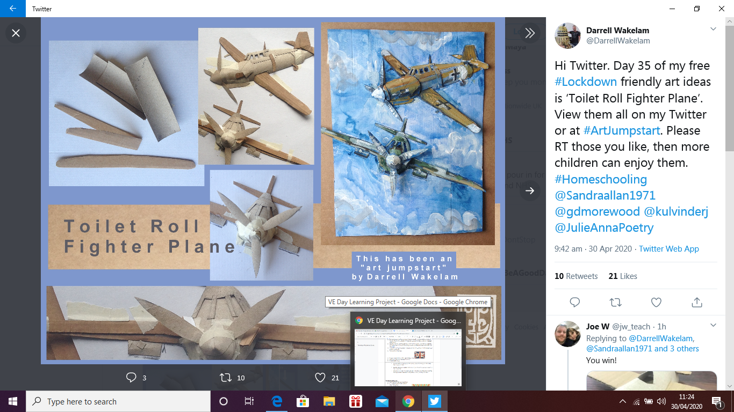 and make a Fighter plane using recycled material from home.
* Design a luggage label
* Collage of a soldier/Fighter plane
* Science investigation: investigate what materials are best seen in a black out or not seen.
* Use crazytalk with a photo of Winston Churchhill
* First Aid: Learn how to make a sling or put someone in recovery position. Important skill to have in the war. Research about St Johns Ambulance or Red Cross.
* Pack a suitcase : what would you plack if you were being evacuated? (could use a cereal box to design suitcase and then add items designed)
* Take a look at the website: <https://www.rafmuseum.org.uk/cosford/>
* Look at stamps to celebrate : create a stamp of their own
* Find out the PDSA Dickin medal. Design a medal for an animal now. What colours,symbols would you include? What would be on the medal? <https://en.wikipedia.org/wiki/Dickin_Medal>
* Possible other heroes:
  + [Havildar Lachhiman Gurung](https://www.telegraph.co.uk/news/obituaries/military-obituaries/gurkha-obituaries/8199764/Havildar-Lachhiman-Gurung-VC.html) won the Victoria Cross while serving with the Gurkha Rifles in Burma in 1945
  + Yevdokiya Nikolayevna Zavaliy- When this 17-year-old WWII nurse was mistaken for a man on the field
  + Mavis Batey was one of the leading female codebreakers at Bletchley Park, cracking the Enigma ciphers that led to the Royal Navy’s victory at Matapan in 1941
  + Irena Sendler -  the Polish social worker who hid 2,500 Jewish children from the Nazis during World War II.
  + <https://www.bluecross.org.uk/story/remembering-animals-second-world-war> - find out about the animlas that were heroes during WW2.

**LET’S CELEBRATE**

* Wear **red, white** and **blue** to mark this special occasion.
* Create VE Day **bunting** and display this in your window or garden.
* Learn the popular WWII **song** ‘White Cliffs of Dover’ and perform this as a family. Or, listen and **dance** to 1940s music.
* Children may wish to plan a VE Day anniversary celebration **party**. This could include wartime recipes and is an opportunity to discuss rationing.
* Princess Elizabeth (then) and Princess Margaret secretly joined in with the VE Day celebrations in 1945. Write a story about her experience.
* Sit down and watch the **Queen’s special televised address** to the nation on Friday 8th May 2020.

**REMEMBER**

* To commemorate the 75th anniversary of VE Day, design a commemorative tea towel about the end of WWII in Europe.
* Children could also design a commemorative coin, plate or stamp.
* The Spitfire was a sign of **victory**. Using recycled materials from around the home, make a model of this plane. [The RAF Museum website](https://www.rafmuseum.org.uk/) may help.
* Learn about **courage** by listening to this abridged version of [The Lion and the Unicorn](https://safeYouTube.net/w/BFmB).
* Why is VE Day so important? Children could use websites and books to research or speak to older relatives.
* Children can write a newspaper report recounting the events from **8th May 1945**.

**INSPIRATION**

* Throughout WWII, many men and women displayed heroic acts and still **inspire** us today. Children may want to design a bravery medal for an inspirational individual.
* Why did St Paul’s Cathedral become an inspiration to the British during WWII? Research and then draw a detailed sketch of this remarkable building.
* Children can write an acrostic poem using the letters **VE DAY** as a writing frame.
* Using the Morse code alphabet, children could have fun writing messages of **gratitude** to WWII heroes and heroines.
* Learn how to make a sling or put somebody in the recovery position (an important skill to have during the war).

