WAGTAILS’ WEEKLY SUGGESTED HOME LEARNING – WB 11.5.20
Hello again! As I am typing this, I cannot believe this is the third weekly task sheet I am completing for you! It’s not just me thinking these days are flying by, is it?

The amount of emails and tweets I am receiving off you is fantastic and it is so lovely to see you, your work and all the life skills you have been developing. You all seem to be enjoying spending your precious time with loved ones and making many lifelong memories. Keep it up – hopefully it won’t be too long until you are back with your friends in class having fun with me!

On Tuesday 12th May, it is National Limerick Day so this has inspired me to create your weekly tasks around poetry, rhyming and rhythm. I can hear you all asking, “what’s a limerick?” but don’t worry all will be revealed in the comprehension tasks set. Rhyming and poetry is an important part of understanding the world around us. It helps express emotions about particular places, people and anything important to you. Limerick poems help younger people, like yourselves, to put humour into their writing and connect words together that rhyme. We all need a bit of humour in our lives right now so when completing the tasks, aim to make me fall off my chair with laughter. I want your work this week to brighten everyone’s week with plenty of giggles.

Enjoy!
Love from
Miss Silver and Mrs Costello

ENGLISH | MATHS
Reading – Read every day for pleasure for 15 minutes.  Please make use of the brilliant resource, Epic! It is the leading digital library for under 12 year olds and it is free for 30 days to all parents.  Comprehension tasks  - Read the limericks (see resource below) and investigate the structure of a limerick. How many lines does a limerick have? How many syllables are there in each line? What is the rhythm of the limerick like? What is the pattern of rhyming in the limerick?  - Choose your favourite limerick and learn it off by heart. Practise reciting your chosen limerick and then perform it to your family members. Can you film your performance and send it to me?  - Watch these videos and read the information on the following website to learn about limericks. Then, write 5 interesting facts you learned from the information.  https://www.youtube.com/watch?v=Wy65TkCadfU  https://www.youtube.com/watch?v=VtLQO1Gk39g  https://www.youtube.com/watch?v=sP53CvrQmac  https://www.youtube.com/watch?v=Wy65TkCadfU  https://www.poetry4kids.com/lessons/how-to-write-a-limerick/  Writing  - Have a go at the rhyming games (see resources below)  - Write your own funny limerick. You may use the scaffold below to help you if you wish.  Extra challenge – Can you create a book of your own limericks, just like Edward Lear did?  Spellings – adding the suffix –ness  - Complete the worksheets below. You may wish to write the answers on a piece of paper rather than printing the worksheets.  - Try using some of these –ness words in your day-to-day vocabulary. For example, I am going to spread some kindness today. I will write a letter to my nana to help end her loneliness. Thank goodness we are all healthy. | Basic Skill – Continue to develop a rapid recall of the 2, 5 and 10 times tables.  Use these games on Topmarks to help you:  https://www.topmarks.co.uk/maths-games/5-7-years/times-tables  White Rose Home Learning – Year 2 – Summer Term - Week 3 – 4/5/20 – Fact families addition and subtraction bonds to 20, compare number sentences, related facts and add and subtract ones.  https://whiterosemaths.com/homelearning/year-2/  If your child finds this challenging, please look at the previous year’s home learning. Year 1 – Summer Term – Week 3 – 4/5/20 – number bonds, fact families, add together and find a part and add more and count on within 20.  https://whiterosemaths.com/homelearning/year-1/
R.E. | OTHER
The theme is: Holidays and Holydays – Pentecost: The feast of the Holy Spirit  Have a look at the picture from Church’s Story 2 pages 76-77 (see below). After his Resurrection, Jesus appeared to the disciples and made a promise to send his Holy Spirit to them. Read the first two paragraphs from God’s Story 2 page 81 The promise of the Spirit based on John 13:33; 14:18 (see below).  Before Jesus left his friends, he promised to send them a helper, the Holy Spirit. The holy day, Ascension Thursday, celebrates Jesus’ return to his Father.  SOME KEY QUESTIONS  - What happened on Ascension Day?  - Why were Jesus’ friends sad again?  - What was the promise Jesus gave to his friends?  - Who was the helper and guide?  - How did this make Jesus’ friends feel?  - Create a collage of Jesus talking to his friends; add speech bubbles and retell the words of Jesus’ promise. | Music – Have a go at completing the body percussion lesson on the BBC Bitesize website. Here is the link: https://www.bbc.co.uk/bitesize/articles/zjcwqp3 When reading, performing and creating limericks you need to have a sense of rhythm so use these activities to help you with that.  DT – Make a musical instrument, such as a drum or a maraca using recyclable materials. Practise making different rhythm patterns.  PE – Join in with this family dance workshop based on rhythm: https://www.youtube.com/watch?v=qLYpAwiqinU After this, join in with this 5-a-day dance routine: https://www.youtube.com/watch?v=gBTvnJpwcKw Try your best to stick with the rhythm.  As an extra challenge, can you create your own dance following a particular rhythm?  Computing – Complete the Block Coding Year 2 starter unit. There are three lessons for you to complete. You will complete unit 2a and 2b in the coming weeks. You do not have to complete all three lessons in one sitting. Feel free to complete the lessons throughout the week at different times. Please email or tweet school to receive the login details. Here is a link to the starter unit: https://central.espresso.co.uk/espresso/coding/unit.html#/unit2s/lesson1

Limericks
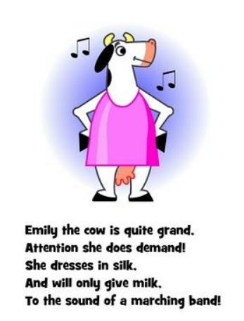
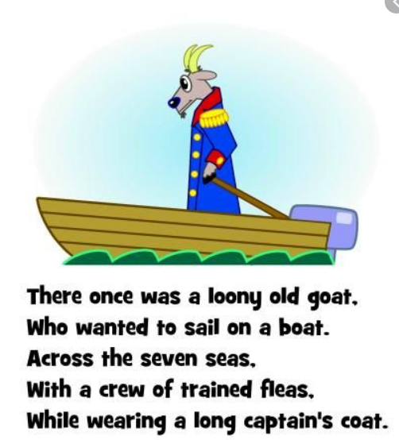

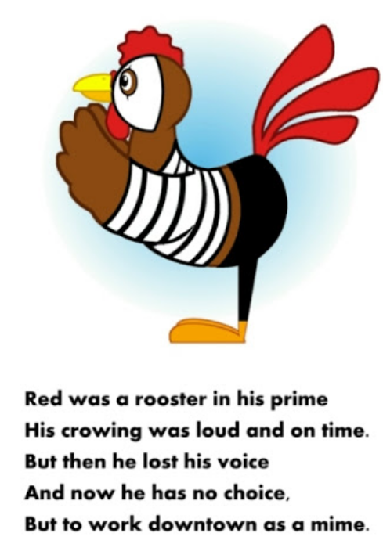

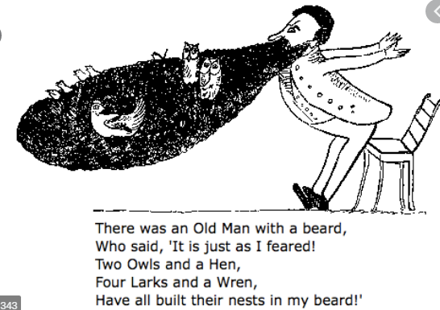

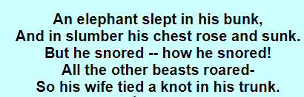

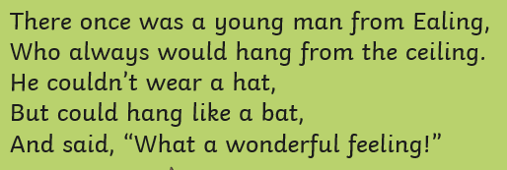

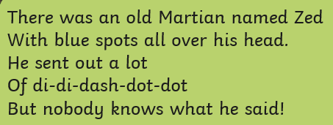

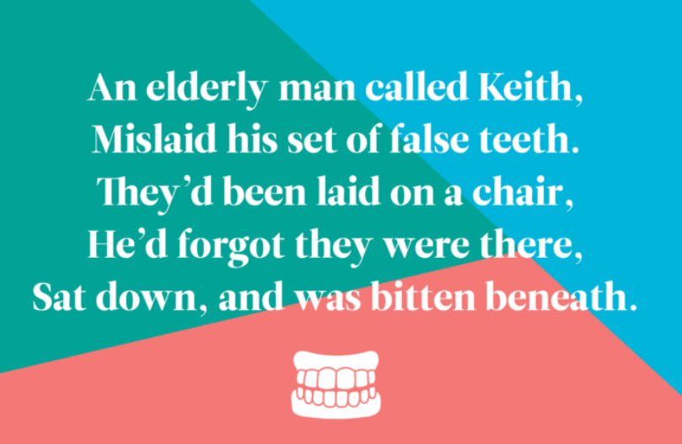

Rhyming games
These online games are on Discovery Education – Espresso. Please email or tweet school to get the login details.

https://central.espresso.co.uk/espresso/primary_uk/subject/module/activity/item1075525/grade1/module1122235/index.html?source=search-all-all-all-all&source-keywords=rhyming

https://central.espresso.co.uk/espresso/primary_uk/subject/module/activity/item1075726/grade1/module1122235/index.html?source=search-all-all-all-all&source-keywords=rhyming

https://central.espresso.co.uk/espresso/primary_uk/subject/module/activity/item1074105/grade1/module1122235/index.html?source=search-all-all-all-all&source-keywords=rhyming

https://central.espresso.co.uk/espresso/primary_uk/subject/module/activity/item1217940/grade1/module1217337/index.html?source=search-all-all-all-all&source-keywords=rhyming

Extra challenge
Can you create posters full of different rhyming words?
Can you create a rhyming dictionary with a bank of rhyming words?
Can you spot any rhyming words when reading your books?

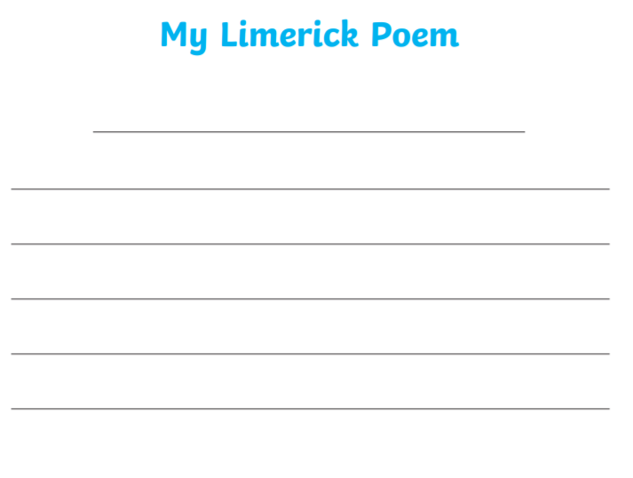
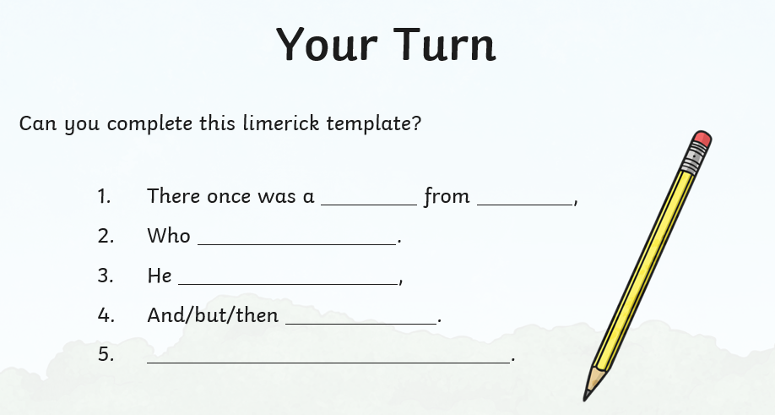
Limerick template

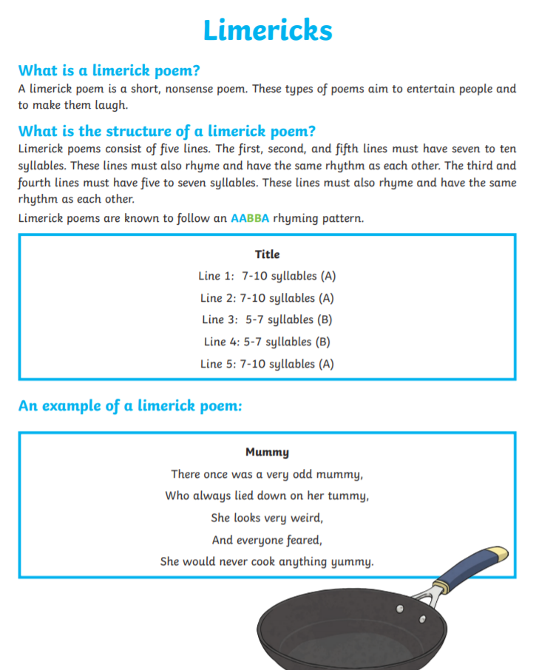
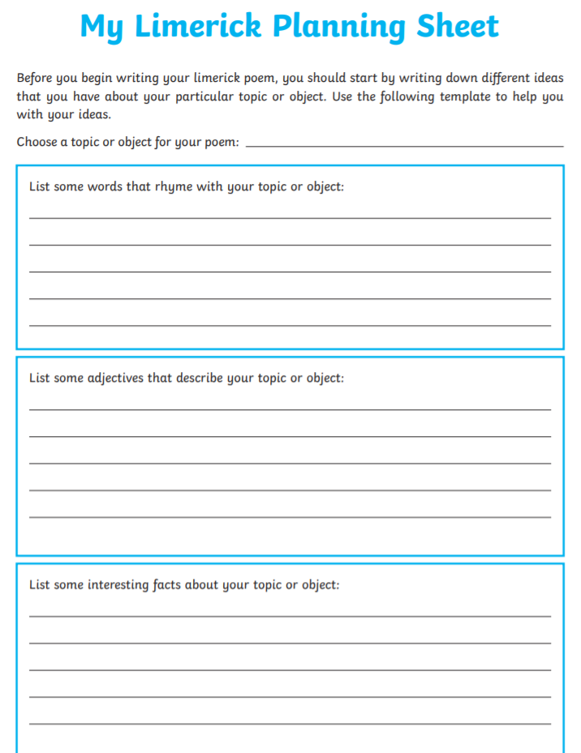
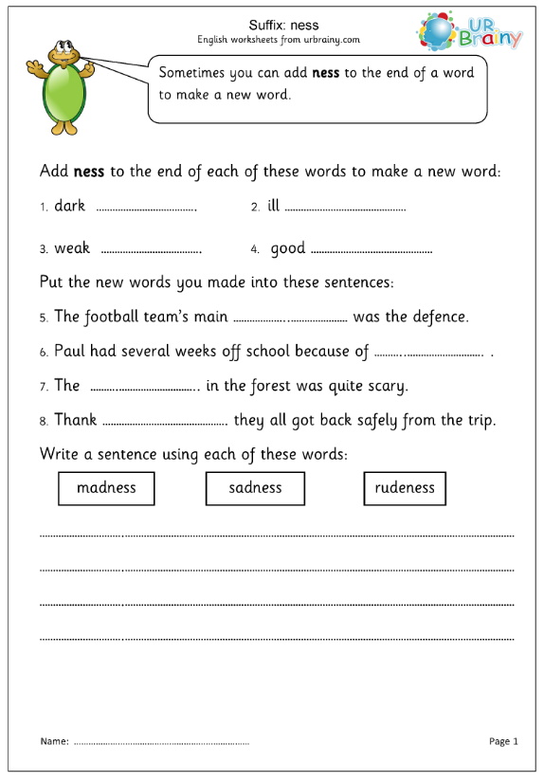
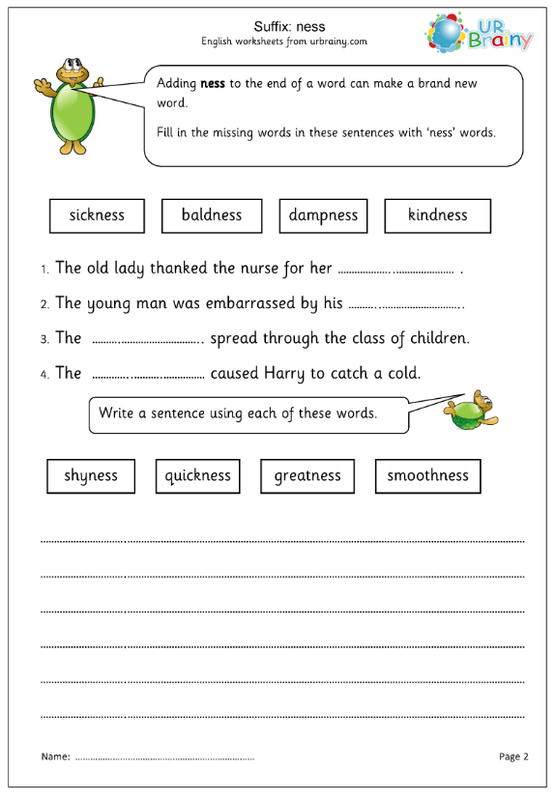
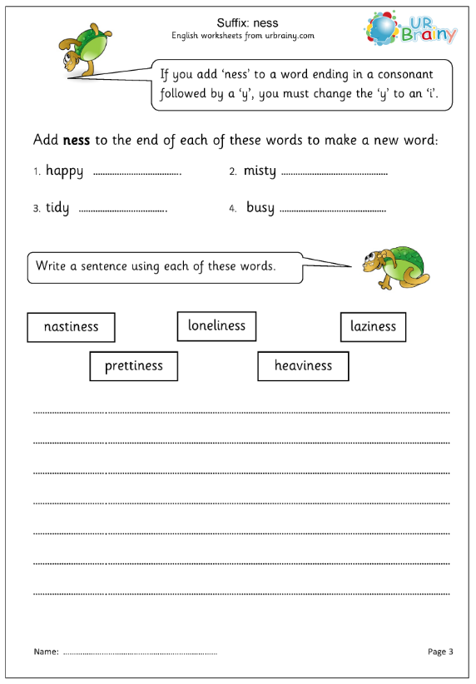
RE

