WAGTAILS’ WEEKLY SUGGESTED HOME LEARNING – WB 13.7.20
HELLO my wonderful Wagtails! It was great to hear from so many of you last week and I was one proud teacher as I read such polite emails and looked at such wonderful work.

It is the final week of the school year which I can’t quite believe! I hope you enjoy your final week of home learning tasks and, as always, feel free to email me about anything.

This week’s learning focuses on supporting you with transitioning to your new class in Key Stage 2. It will give you the opportunity to reflect on your time in Wagtails class, discuss your favourite memories and achievements whilst also considering your hopes and dreams for the next academic year.

I’ve loved every minute spent with you all in class and I am so gutted that our time together ended abruptly. I have attached a small something for you all at the end of this pack for you to do with whatever you wish. I have printed mine on photograph paper, framed it and I will hang it somewhere special in the classroom.

Have the most amazing summer break with your family and friends. Make lots of memories and keep that smile shining brightly.
See you around school in September!
Big hugs!
Miss Silver and Mrs Costello
xxx
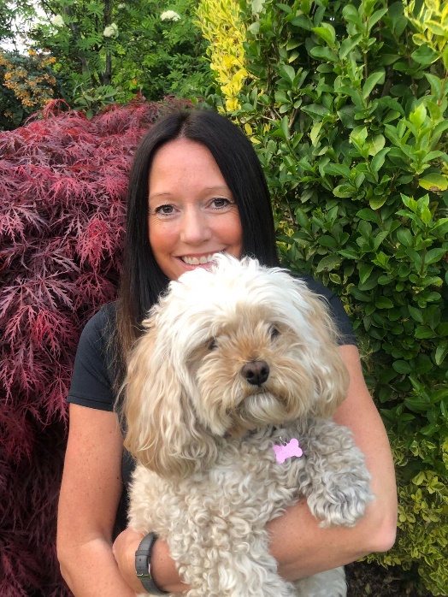
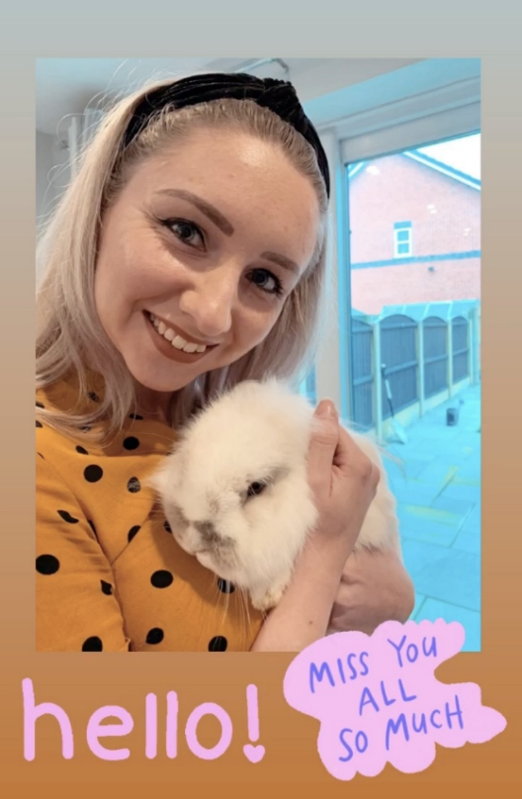

ENGLISH | MATHS
Reading – Read every day for pleasure for 15 minutes.  Comprehension  - Read the three poems below. Colour in the words that stand out to you. Draw or paint pictures that come into your head when reading the poems. Challenge – Can you come up with you own ‘end of year poem’?  Writing  - Below you will find a different transition activity to complete each day. Complete these and share them with me.  - Can you write a guide to being in year 2 for the year 1 children coming into Wagtails class next year?  - Complete the ‘spreading my wings from year 2 to year 3’ booklet. Keep this safe and give it to your new teacher in September.  Spellings  - Make sure you are confident in spelling all the year 2 common exception words (see below). Make sure you can use them correctly in a piece of writing.  - Familiarise yourself with the year3/4 common exception words ready for September (see below). Can you read them all? Do you know what they all mean? | Basic Skill – Measures – weight, length, capacity and temperature  Work through this Espresso unit on measures: https://central.espresso.co.uk/espresso/primary_uk/subject/module/frontscreen/item849225/grade1/index.html  Through videos, activities and printable resources, you will be introduced to useful concepts and methods that will help you develop confidence and accuracy in understanding units of measurements and reading scales, as well as comparing and ordering lengths, mass, volume and capacity. You are also given opportunities to practise measuring and recording results.  If you wish to continue working through the Hamilton Trust’s home learning packs, click on the following link and download the Year 2 Week 10 pack.  https://www.hamilton-trust.org.uk/blog/learning-home-packs/
R.E. | OTHER
Theme: NEIGHBOURS – Everyone is our neighbour and loved by God  - Say this prayer with your family:  Lord Jesus, teach me to care,  Lord Jesus, teach me to share,  Lord Jesus, teach me to be kind  to neighbours everywhere.  Lord Jesus, help our sisters and brothers all over the world to have a fair share.  - Cut out a template of a candle. Write the prayer on one side and write a way you can be a good neighbour on the back.  - Below you will find CAFOD’s resource pack of the week. The theme this week is activities and ideas on speaking up about what you care about. Have a go at completing some of the activities. | 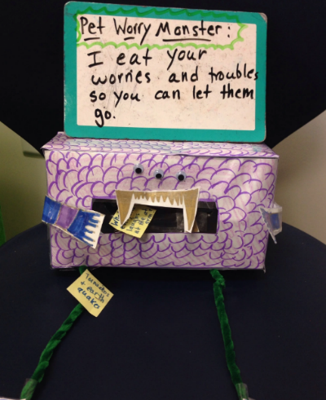  PSHE – Create a worry monster using a shoebox or tissue box. A worry monster eats your troubles away. You might be worried about returning to school, feeling safe in public or struggling with year 3 work. Whatever is worrying you, write it down or draw pictures and feed them to your worry monster. (grown ups – this will allow you to have a peek at what is worrying your child so you can start a discussion with them)  Art – Sketch a portrait of yourself. Use this video to help you: https://www.bbc.co.uk/teach/class-clips-video/art-and-design-draw-self-portrait/z6ytscw  Music – Create your own beat using https://www.incredibox.com/  STEM – Use this link to find a variety of activities that will develop your science, technology, engineering and maths skills. These activities are easy-to-resource and provide you with the stimulus to talk about the world around you.  https://www.stem.org.uk/home-learning/primary  PE – Use this link to find family-friendly activities and begin moving together in your living room, garden or local park. https://www.activekidsdobetter.co.uk/active-home  Summer-themed activities (resources below)  - Create a summer bucket list.  - Complete the word search.  - Relax using the mindfulness colouring sheets.

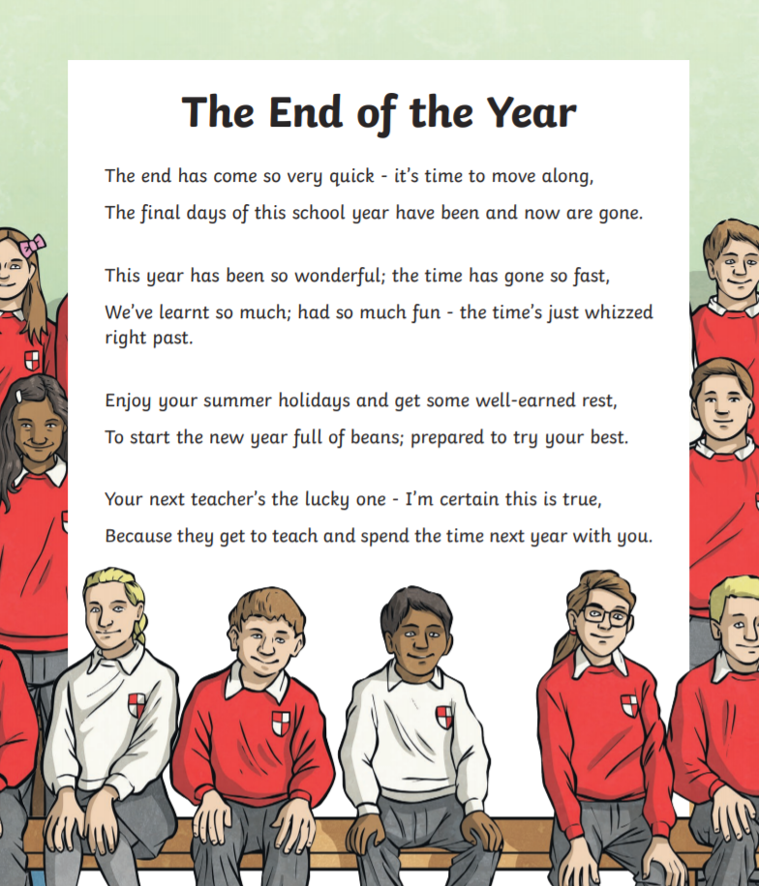

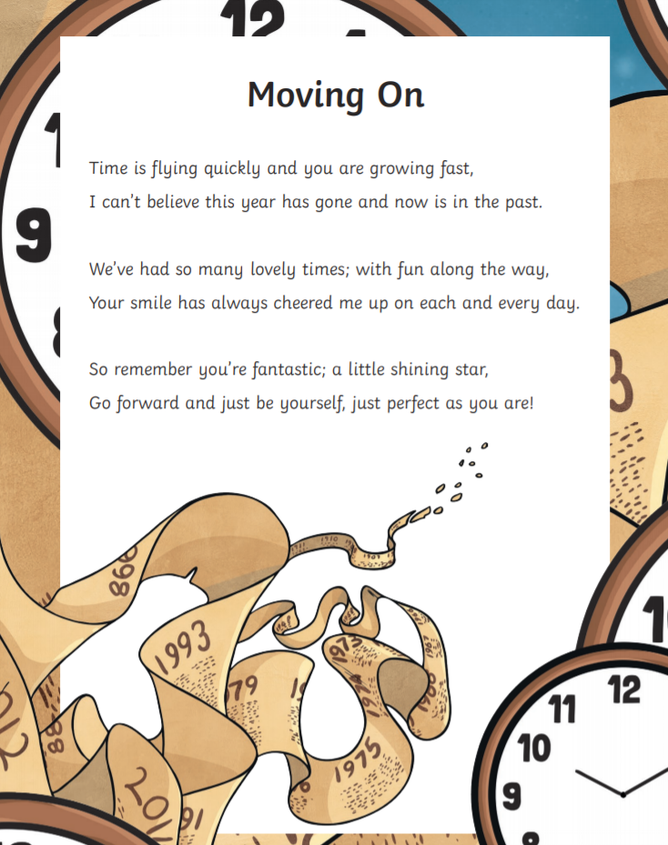
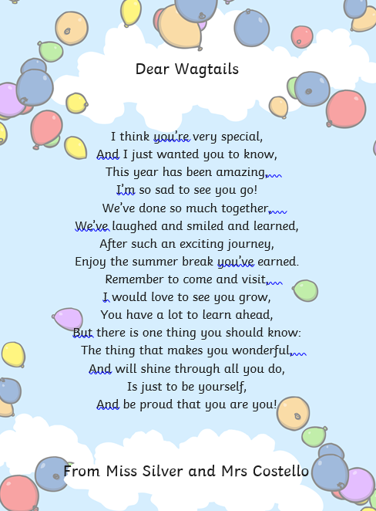

Monday’s transition activity
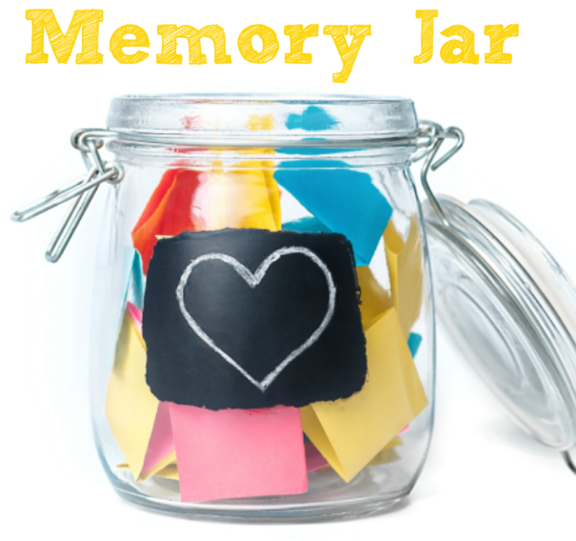
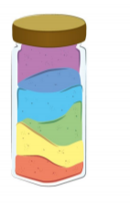
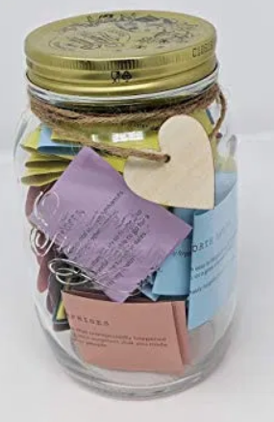
Over the last year, you will have created many school memories that you will cherish forever. Capture these memories in a fun way by creating a ‘Memory Jar’. Using coloured paper to draw or write down your favourite memories. You can use different colours to show different categories of memory e.g. blue for friendship, yellow for teachers, red for favourite lessons, green for school trips. Use a jam jar or a plastic bottle to collect your memories; you could even personalise your jar with decoration.

Tuesday’s transition activity
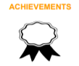
Your have achieved so much over the course of the year and now it is time to reflect on what makes you proud. Think about your proudest academic achievements and your proudest achievements outside of the classroom too. After discussing your accomplishments, choose one. Work with a member of your family to design and create an achievement medal. Do this by cutting a piece of cardboard into a circle or star shape, painting it gold or sticking shiny paper to it. Write the number one on the medal and add string or ribbon. Why not have a ceremony and get a grown up to present the medal?

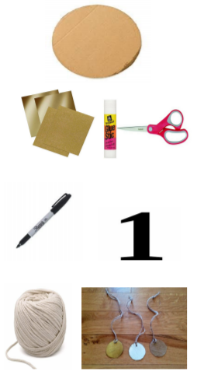
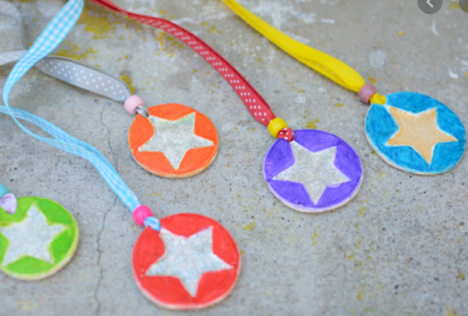

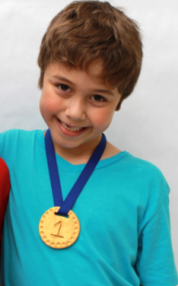

Wednesday’s transition activity
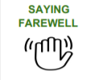
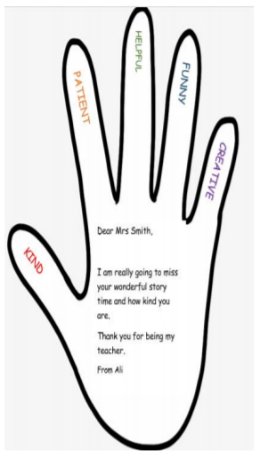
Ending the academic year is a time for to say farewell to current teachers and sometimes to classmates too. Talk to a grown up about the friendships you have made this year. Who is important to you and why? What are you going to miss most about your teachers? Draw around your hand on paper and then carefully cut it out. On the template, draw or write a goodbye message to a friend or teacher. On each finger, you could write the qualities that this special person has displayed over the year e.g. kindness, being helpful, etc.

Thursday’s transition activity
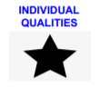
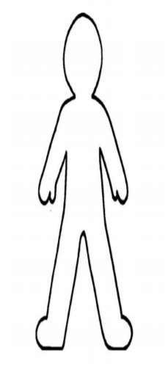
Think about what makes you special. What makes you different to other people? You could ask other family members to contribute to this too and record a list of individual qualities together. Following this, record your individual qualities on a person template. You may wish to do this by creating a collage using cut out pictures from magazines that represent your individual qualities. Alternatively, you could draw pictures to represent your qualities onto a template. Talk about the importance of being unique with a family member.

Friday’s transition activity
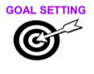
Read or listen to the story ‘Giraffes Can’t Dance’ https://www.youtube.com/watch?v=vZjsLK5vwNU. Talk about how Gerald the giraffe showed determination when trying to achieve his goals. What would you like to achieve next year, e.g. ‘to improve my handwriting’, ‘count in tens’ or ‘show more kindness to others’. After this, choose 5 things from the list which you would like to achieve during your next school year. Work with a grown up to create a vision board. This can be done by cutting out pictures that represent the goals, pasting onto card and decorating. You could add personal qualities to you vision board too.

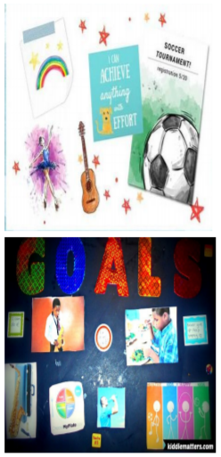
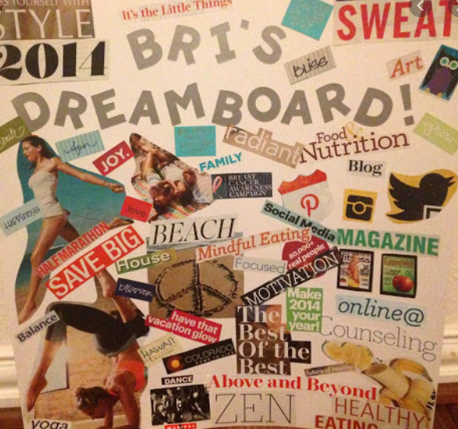

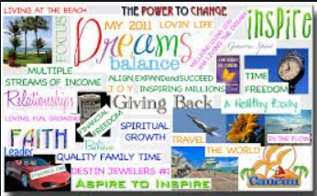

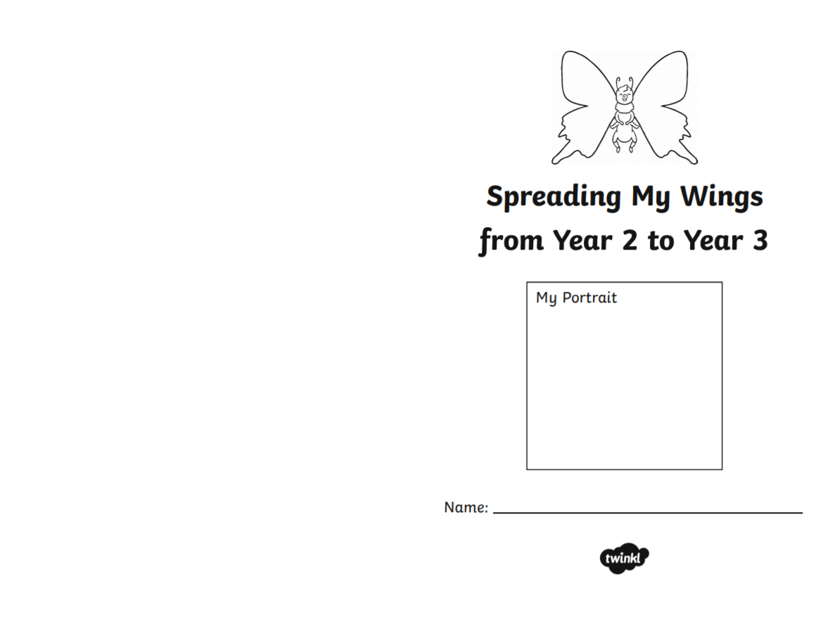
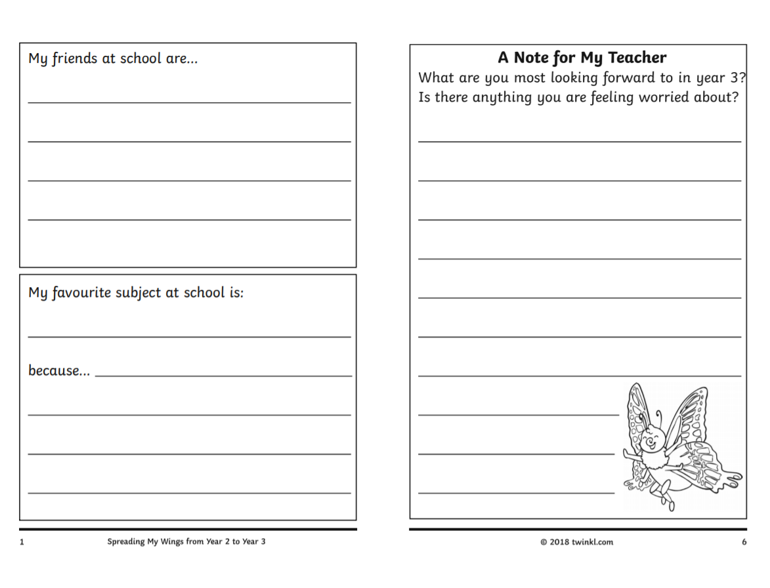
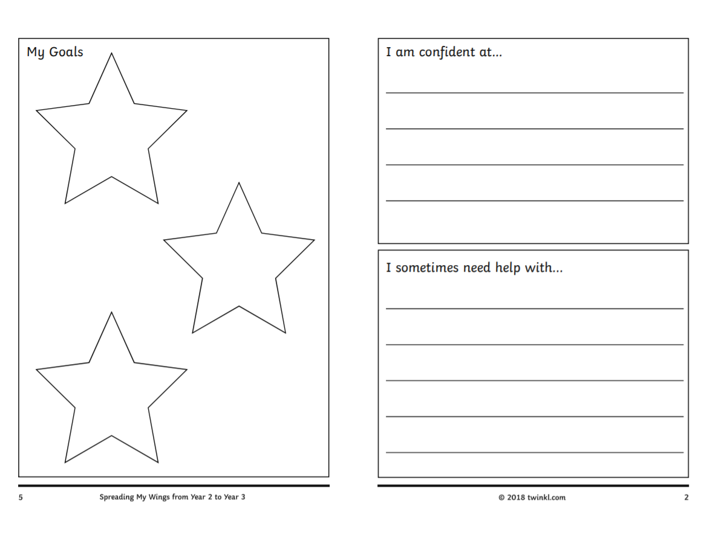
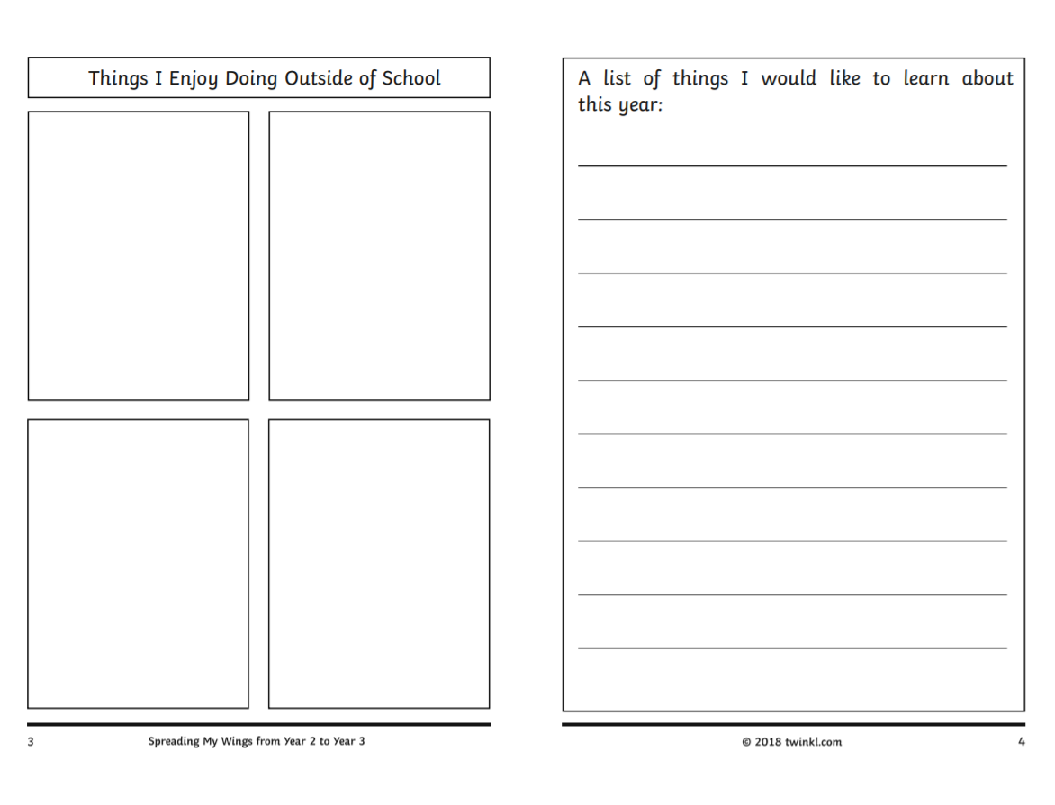
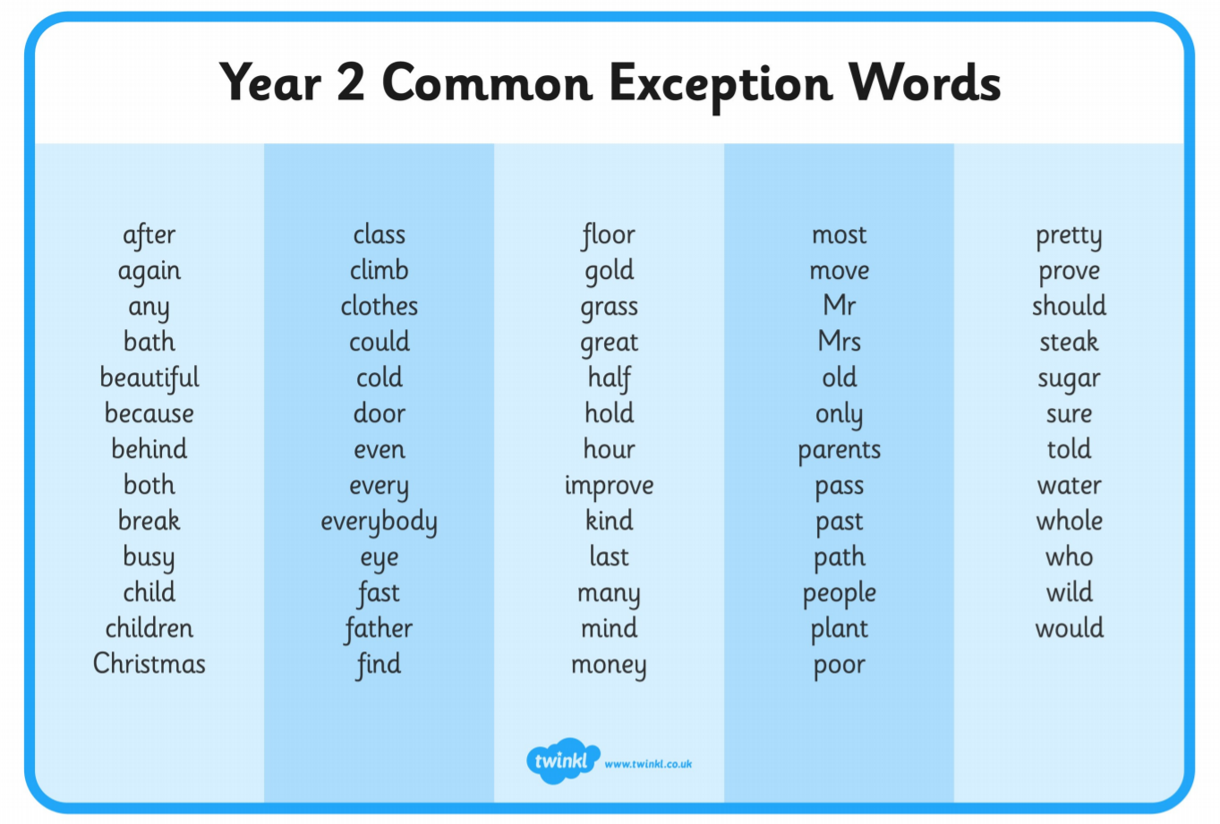
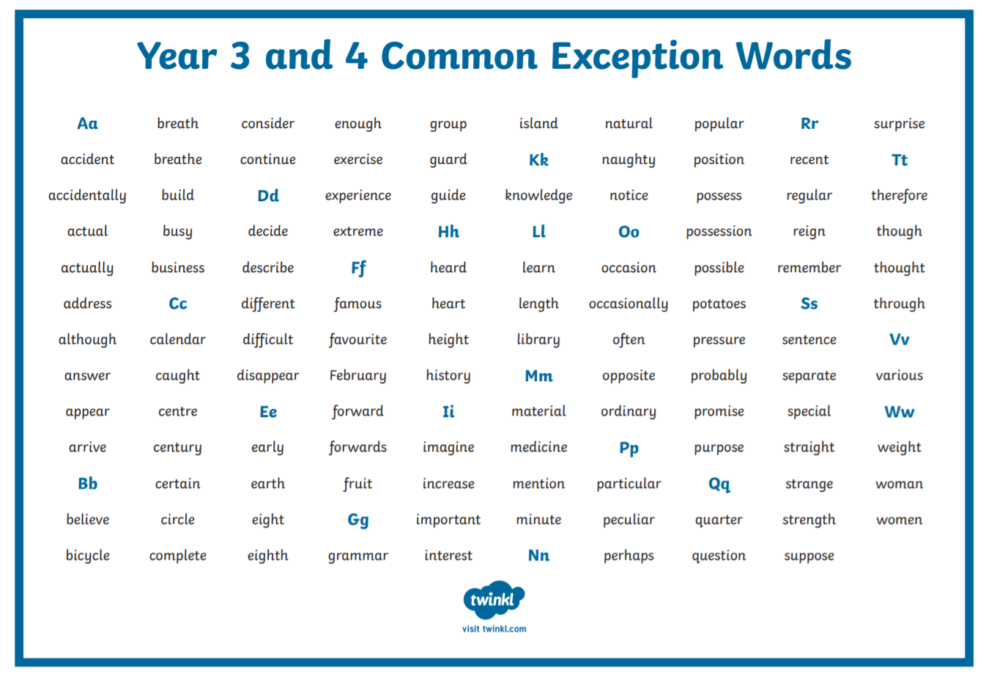
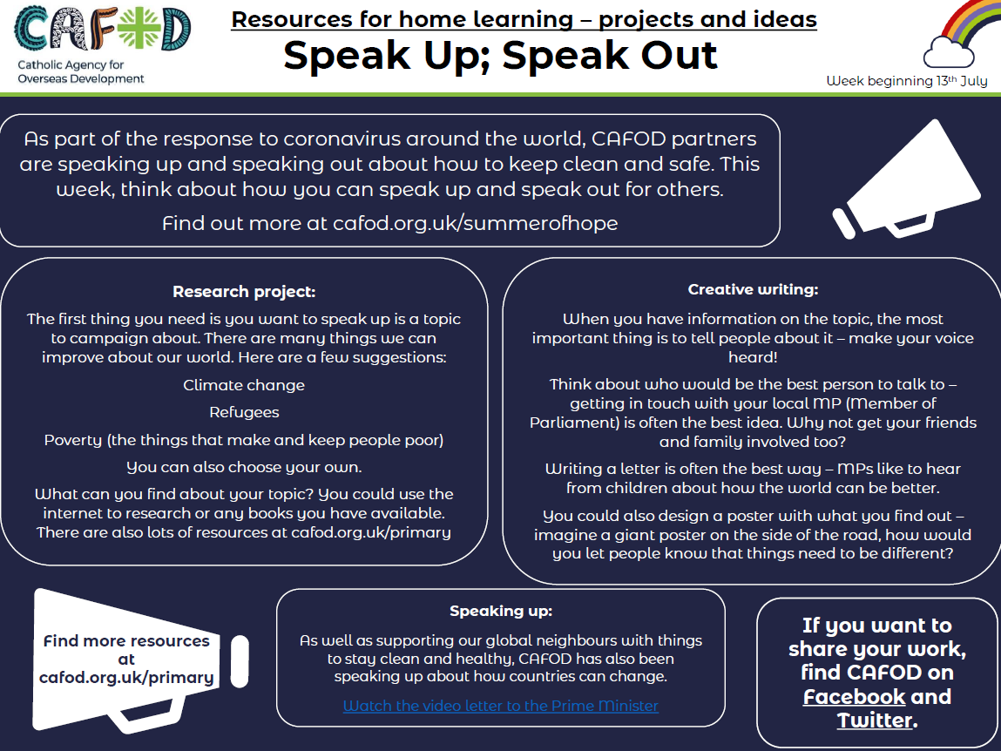
RE
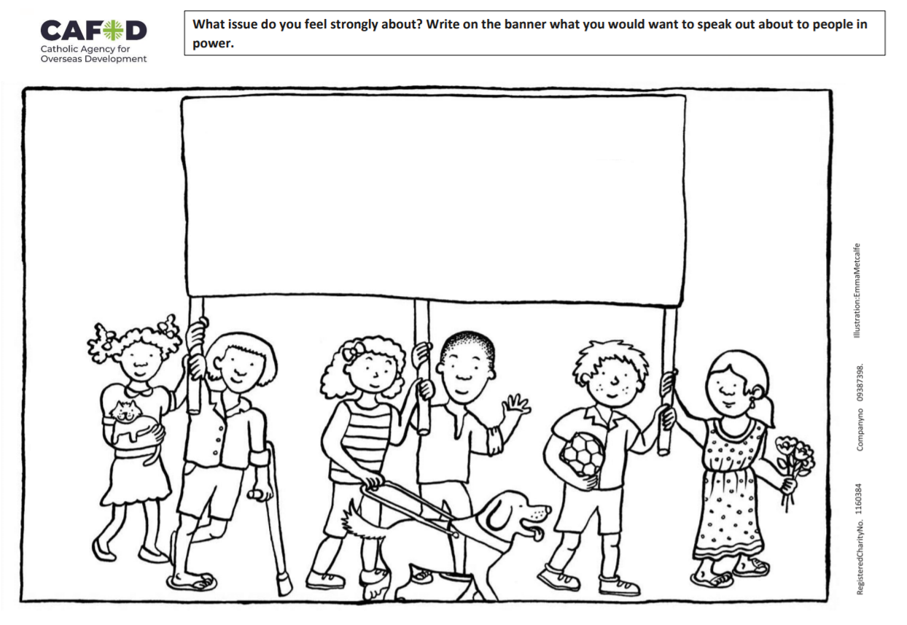
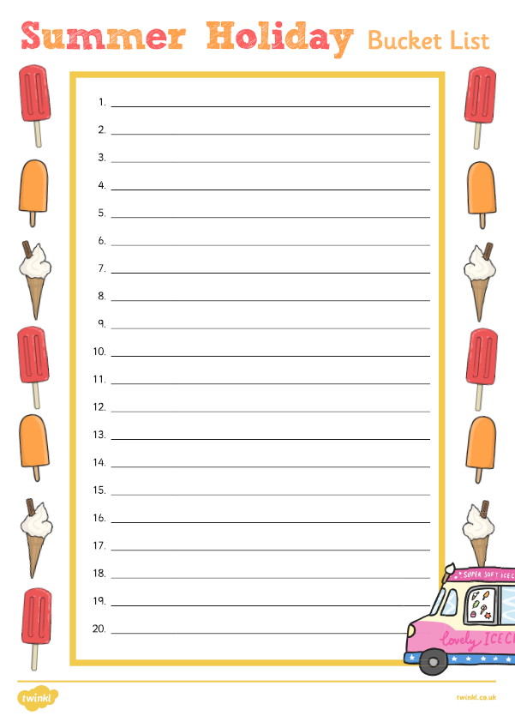
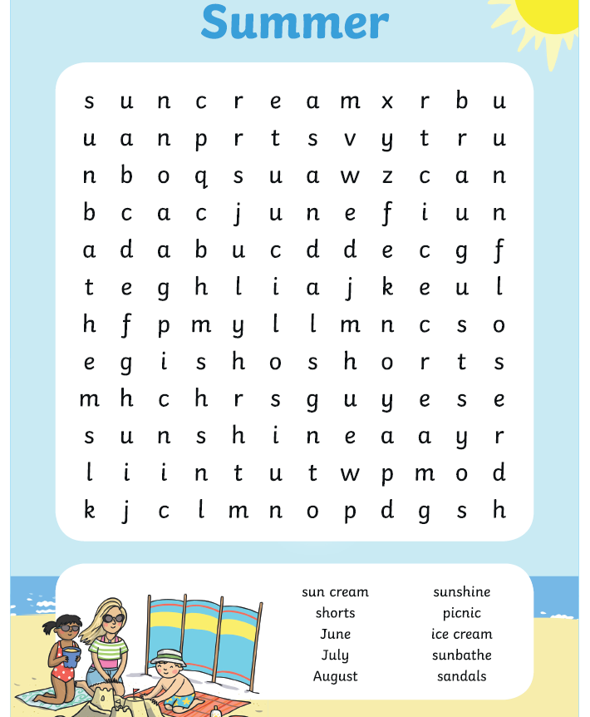
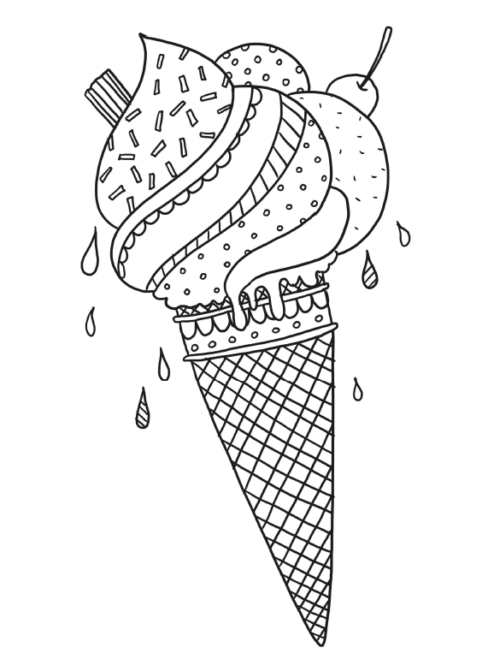
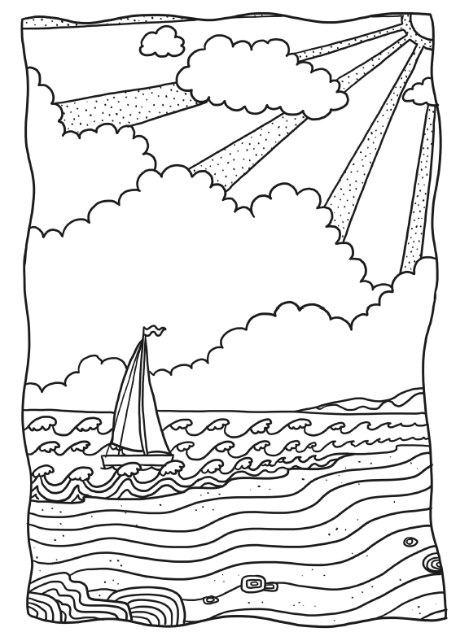
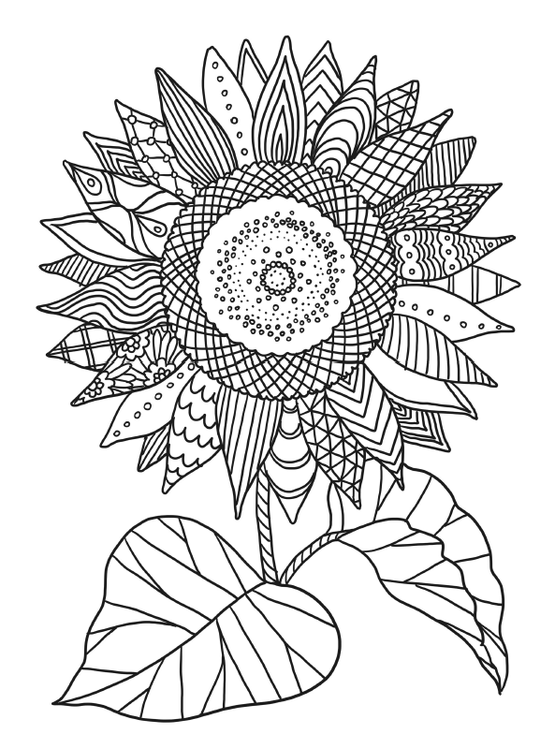
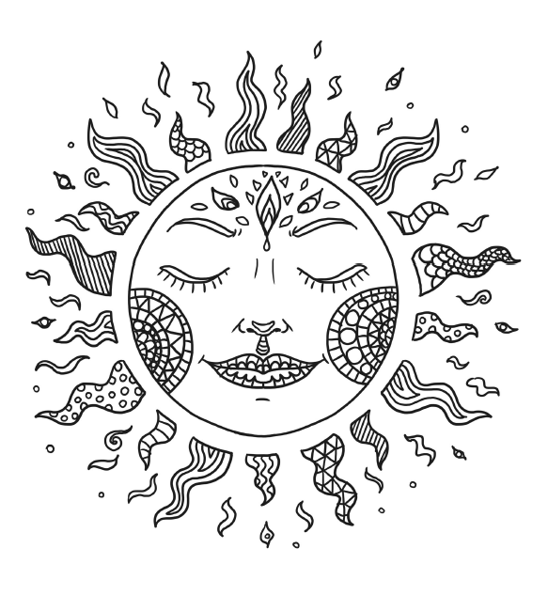

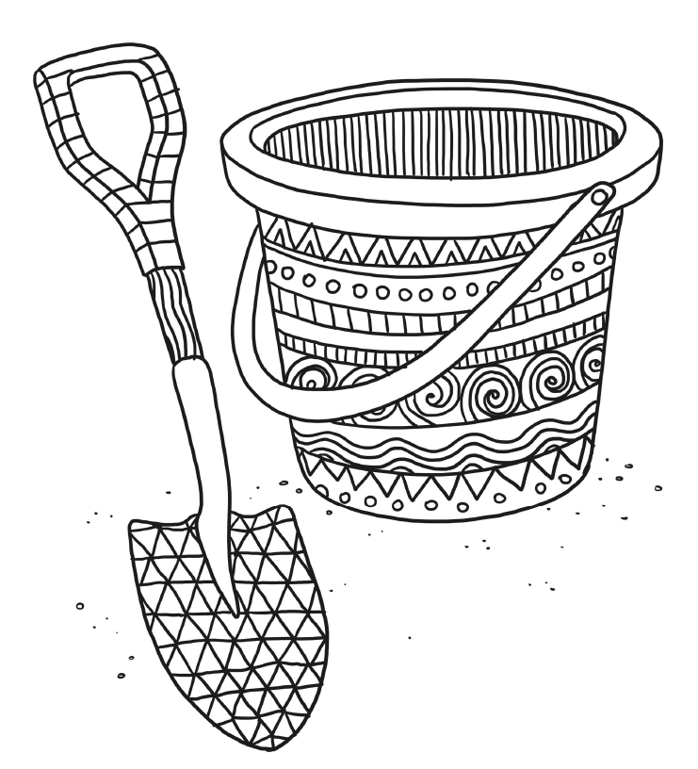

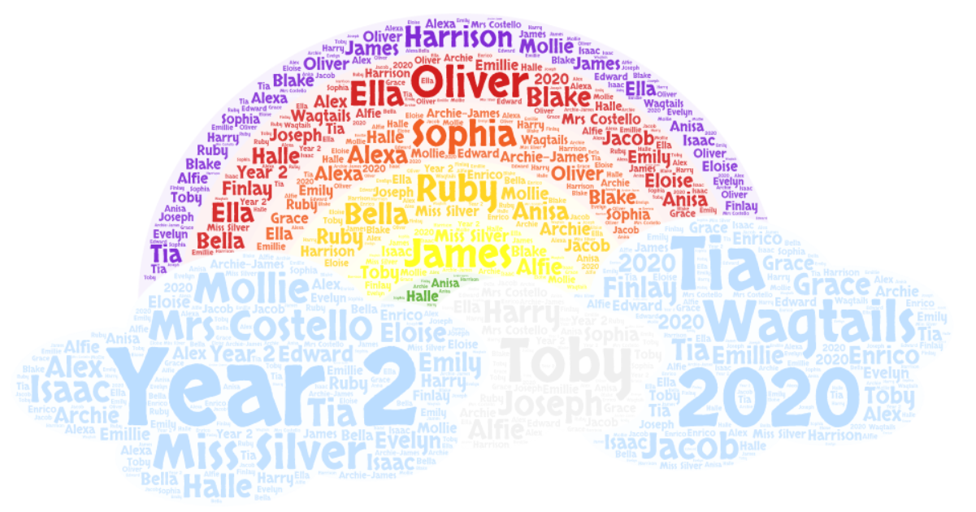
The year Lockdown happened.
Thank you for all the wonderful memories, Wagtails!
Love from
Miss Silver and Mrs Costello
xxx

