WAGTAILS’ WEEKLY SUGGESTED HOME LEARNING – WB 18.5.20

Well done Wagtails for brightening up our week with all the hilarious limericks you sent us. You certainly rose to the challenge and made Miss Silver laugh so much she fell off her chair! We love reading your work (even though it makes us miss you even more!)
This week, we are going to introduce our new text, Yeti and the Bird by Nadia Shireen to you. However, before we read/listen to the book, we need your help! On Sunday morning, Miss Silver woke up to a huge snowy footprint on her doorstep with a letter addressed to Year 2. Read the letter below and help us by completing the tasks.
This week is also Mental Health Awareness UK week and the theme this year is ‘kindness’. You will see many of your tasks link to this theme too.

Have a wonderful week. Start each day with a big smile.

Love from
Miss Silver and Mrs Costello

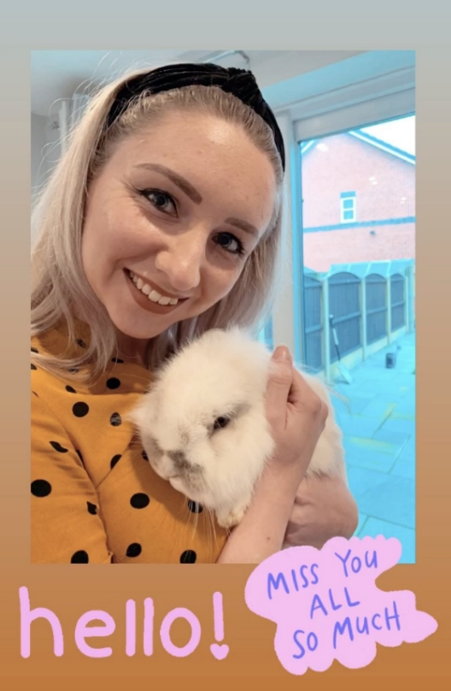

ENGLISH | MATHS
Reading – Read every day for pleasure for 15 minutes.  Please make use of the brilliant resource, Epic! It is the leading digital library for under 12 year olds and it is free for 30 days to all parents.  Comprehension tasks  - Read the letter Miss Silver found on her doorstep (see below). Discuss with a family member about why someone would be lonely and not have a friend. Write rules for friendships and how to make friends on strips of paper. You could link your friendship rules to make a paper chain and hang them up for everyone to see.  - Look at the pictures of Yetis and read the descriptions (see below). Would you be friends with one? Why or why not? Write up your sentences e.g. I would be friends with a Yeti because… I would not be friends with a Yeti because…  - Read the information about Yetis and complete the questions (see below).  Writing  - Read the first three pages of the book (see below). Describe the Yeti (using picture from first page) and pick out the adjectives that Nadia Shireen has used. What do the adjectives have in common? (clue – what do they all end in?) Create your own sentences using adjectives with the –est suffix. (see word bank below) Remember to use a comma when you use more than one adjective. e.g., The Yeti was the tallest, meanest beast in town.  Watch your spelling – remember some root words change when we add the suffix –est. e.g big – biggest (double g)  happy – happiest (change y for an i)  - Using your rules of friendship from the first comprehension task, what advice could you give the Yeti? Does he realise that everyone is scared of him because of his size? Write a letter to the Yeti to cheer him up and offer advice. Here are some appropriate sentence starters.  Dear Yeti,  I am writing to you because…  Also I think you should…  Why don’t you try…?  Use special note paper and an envelope. Post them to school so I can send them to the Yeti.  Spellings – words ending in –le.  See word bank below.  - Using the words from the word bank, practise spelling them in different ways. Here are a few ideas:  - Use chalk and write the words on a pavement outside.  - Trace the words into shaving foam.  - Create and play a memory game using the words.  - Trace the words in rainbow colours.  - Text the spelling words to a family member.  - Play hangman.  - Write a story about each spelling word.  - Play a ‘what letter is missing?’ game.  - Put the words in ABC order. | Basic Skill – Dividing by 2, 5 and 10.  Remember, divide means share equally.  - Join in with this song and dance about division (sorry to the non-Liverpool supporters! – I wish he were a blue!) https://www.bbc.co.uk/teach/supermovers/ks1-maths-division-with-mighty-red/zrh9scw  - Watch this video and play the game. https://www.bbc.co.uk/bitesize/topics/zqbg87h/articles/z9jxhv4  - Play hit the button https://www.topmarks.co.uk/maths-games/hit-the-button Remember to click on either 2, 5 or 10 division facts.  Unfortunately, White Rose has started to charge for their worksheets.  Open the link to Hamilton Trust’s home learning packs.  https://www.hamilton-trust.org.uk/blog/learning-home-packs/  Download the Year 2 Week 3 pack.  The activities will download onto your computer. Some activities have PowerPoint presentations that talk you through the maths skill.  Some of the activities are differentiated so please choose the activity that is best suited to you.  If you are finding the Year 2 pack too hard, feel free to download the Year 1 pack.
R.E. | OTHER
The theme is: Holidays and Holydays – Pentecost: The feast of the Holy Spirit  The disciples were afraid when Jesus had left them and they had gathered together in one room. The coming of the Holy Spirit at Pentecost changed them. It is a holy day because this gift of the Holy Spirit is very special. The Holy Spirit helps and guides us in our lives just as happened to the disciples. The Holy Spirit appeared to Mary and the disciples like tongues of fire, giving them strength and courage to serve others. Watch this video – The Holy Spirit comes (Day of Pentecost)  https://www.youtube.com/watch?v=IqG_lvZhU-A  - Role-play the coming of the Holy Spirit with your family.  - Using craft materials make a face on a paper plate or a round piece of card to show how the disciples felt. Discuss what captions would be appropriate and display the faces with some of the captions e.g. ‘The Holy Spirit bring us happiness.’ ‘The disciples were astonished.’ etc. | Science - Write a report about yetis. Where do they live? What do they eat? Do they have any special adaptations?  Art - Look at images of yetis (or abominable snowmen) and create your own illustrations of one.  PSHE - Be kind and think of others whilst at home with this tick sheet (see below) of thirty kind act ideas. When you carry out a random act of kindness for someone else, it cannot only give them a boost but research shows that helping others can be beneficial to our own mental health as well. Write a kindness diary throughout the week. Either use the template below or create your own.  Mindfulness – Spend some quiet time relaxing and reflecting. Colour in the positivity mindfulness colouring pages (see below). Complete the kindness word search too.  Computing – Start to work your way through the Block Coding Year 2 unit 2a on Espresso. There are 6 lessons. You have several weeks to complete all the lessons so do not rush your way through them. Please email or tweet school to receive the login details. Here is a link to unit 2a: https://central.espresso.co.uk/espresso/coding/unit.html#/unit2a/lesson1

Dear Year 2,
I have heard you are a kind class who are good friends with each other and look after one another. Is this true?
I am a Yeti who lives in the big, snowy mountains. Sadly, I have no friends and I am not entirely sure why as I really do try to make friends.
Can you help me to make some friends?
Yours sincerely,
the Yeti.

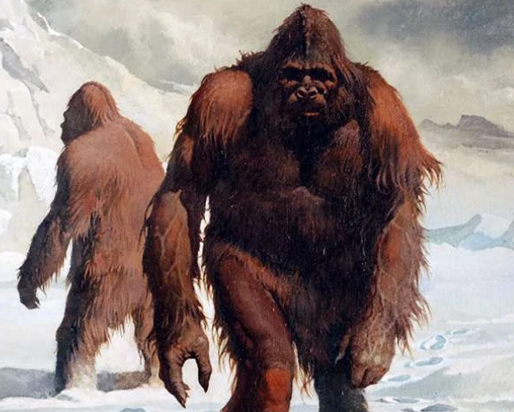
The Yeti is a mysterious creature said to live in the mountains of Asia.
The yeti can stand at least 6 – 10 foot tall. It has also been said the Yeti can weigh at least 200 - 400 pounds.

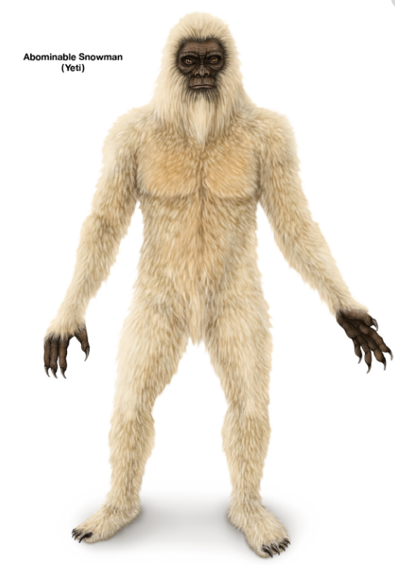

The yeti has been described as having both white or brown shaggy fur and a strong body like an ape.

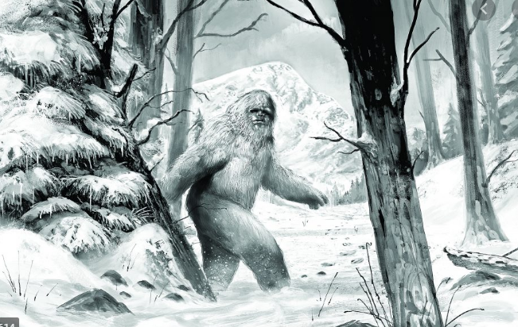
The big, scary-looking Yeti (also called the abominable snowman) is supposed to look like an ape that walks upright. There is no real evidence that it exists, but there have been reports of footprints in the snow which could have been made by a yeti.

The Yeti – Reading comprehension
The story of the figure called the Yeti or Abominable Snowman is an exciting mystery. This dark, ape-like figure is said to live in the Himalayan Mountains of Tibet, where some of the highest mountains in the world are found.
In 1921 English mountain climbers first saw him. He left footprints.
In 1925 the Yeti was spotted again. Footprints were also found. They looked like human footprints but were too big and wide.
In the 1930s and 1940s the Yeti was rarely seen. Yet mountain climbers told of seeing strange footprints. Scientists said animals made the footprints.
From 1954 to 1960 lots of people went to the Himalayas to try and find the Yeti. No one saw him but again found unusual footprints.
Some people feel that there are Yetis in many parts of the world. Scientists are unsure about this. The search continues!

Questions
- Why does the text say the Yeti is an exciting mystery?
_______________________________________________________________________________________________________________________________________________________________________________________

- What would be a good title for this information?
_____________________________________________________________

- Which clue is talked about in the search of the Yeti? __________________

- Which group of people are LEAST likely to see the Yeti? Circle the answer.

Mountain climbers Scientists People who live in Tibet Sailors

- Do all people believe in Yetis? _______________________

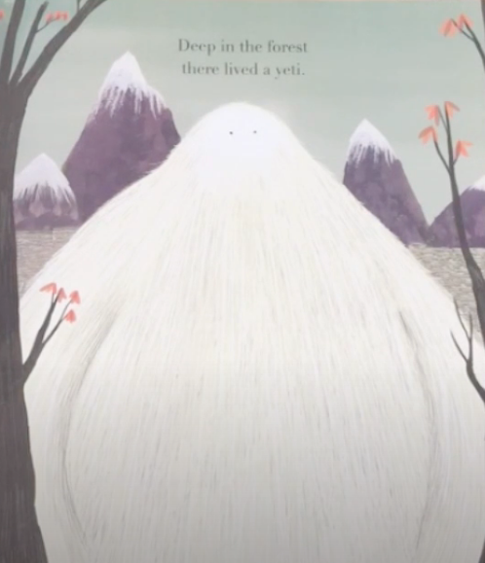

Deep in the forest there lived a yeti. (page 1)
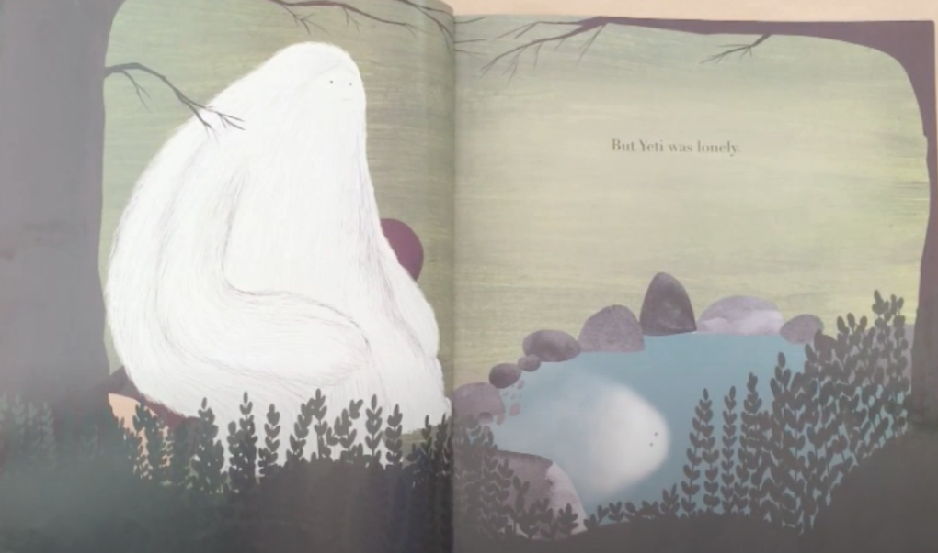
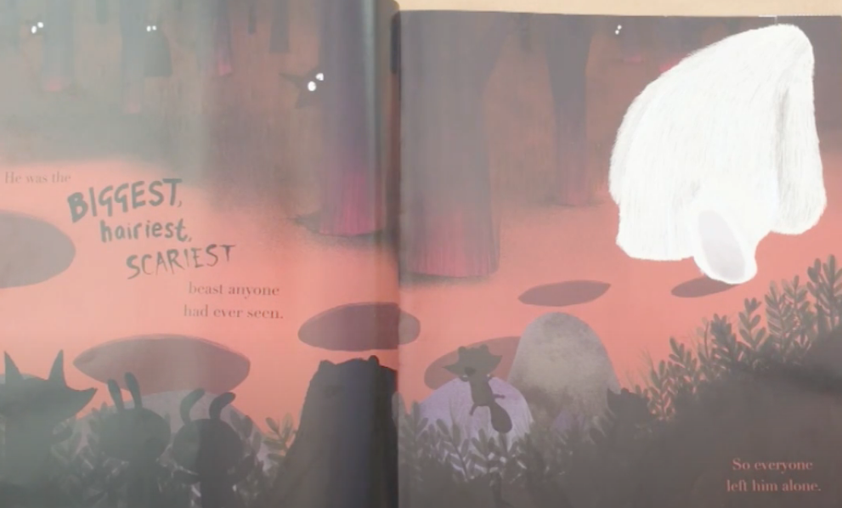
He was the BIGGEST, HAIRIEST, SCARIEST beast anyone had ever seen. So everyone left him alone. (page 2)
But Yeti was lonely. (Page 3)

Word bank – add the –est suffix to these root words and create your own descriptive sentences about the yeti.

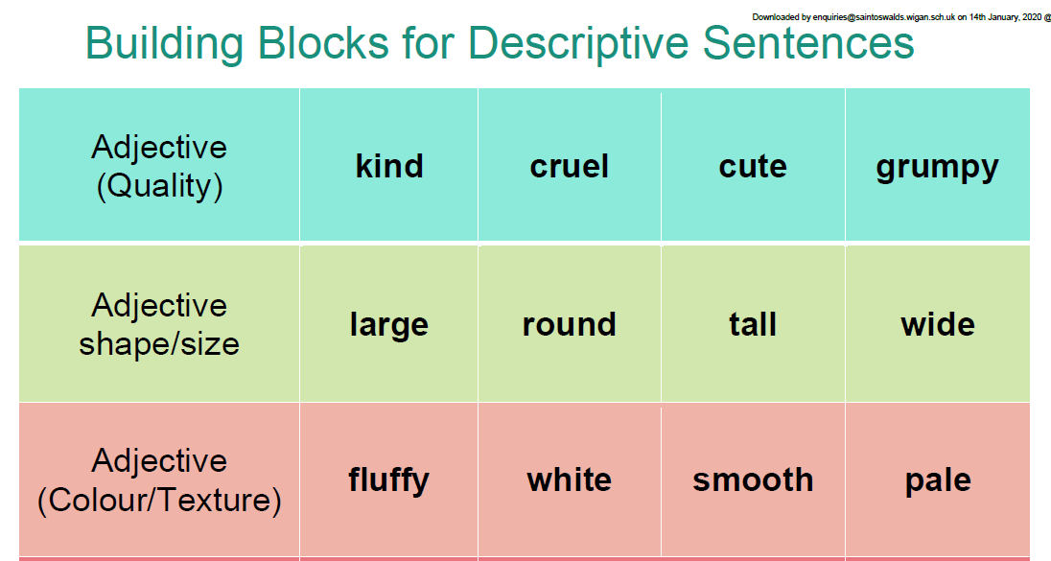

Spelling list – words ending in -le

