WAGTAILS’ WEEKLY SUGGESTED HOME LEARNING – WB 27.4.20
Hello my Wonderful Wagtails! I hope you are all safe and well and making your grownups smile each day! I’m missing you all terribly – teaching just isn’t the same without your faces in front of me. I have created some tasks to keep you busy learning at home based on what would be our new text in school, Lost and Found by Oliver Jeffers. There are several versions of the book read aloud on YouTube for you to access – here is one: https://www.youtube.com/watch?v=cRAAQ8EWzig
I look forward to hearing about how you get on with the following activities. Please keep tweeting and emailing your lovely photos / work to enquiries@saintoswalds.wigan.sch.uk FAO Miss Silver – I regularly check and respond. They honestly make my day!
Keep working hard – remember to take breaks and keep exercising!
Miss Silver and Mrs Costello

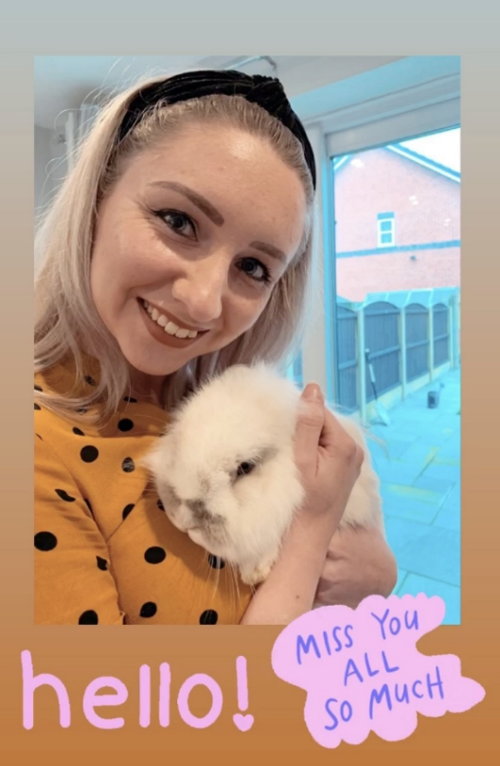

ENGLISH | MATHS
Reading – Read every day for pleasure for 15 minutes.  Comprehension tasks  - Before reading the book/watching the YouTube clip, look at the front cover (see below – prediction task) and write a detailed prediction of what you think the story is going to be about. Give reasons for your predictions.  - After reading the book/watching the clip, retell the story in as much detail as you can (verbally or written) to a family member.  - Emperor penguins non-fiction comprehension activity (see resource below)  Writing  - Make a poster to tell people that you have found a penguin, in case anyone has lost it. Either use the template (see resource below) or create your own.  - Make a list of things the boy and penguin might pack in their suitcase.  Spellings - Adding the suffixes -er or –est.  - Investigate if any root words need to be changed before adding the suffixes er or est. E.g harder/hardest = no change  happier/happiest = change the y for an i. (See below for some ideas)  - Practise using er and est words in sentences. | Basic Skill – Count forwards and backwards in 2s, 5s and 10s from any number up to 100.  e.g.  46, 48, 50, 52, 54  85, 80, 75, 70, 65  12, 22, 32, 42, 52  Have a look at the video task on this document:  https://www.twinkl.co.uk/resource/t-n-45387-missing-numbers-activity-sheet  White Rose Home Learning – Year 2 – Summer Term - Week 1 – 20/4/20 - Fractions and length  https://whiterosemaths.com/homelearning/year-2/  If your child finds this challenging, please look at the previous year’s home learning. Year 1 – Summer Term – Week 1 – 20/4/20 – Doubling, halving, grouping and sharing.  https://whiterosemaths.com/homelearning/year-1/
R.E. | OTHER
The theme is: Holidays and Holydays – Pentecost: The feast of the Holy Spirit  - Look at pictures of people on holiday. Talk about holiday experiences or watch the BBC Barnaby Bear programme about how Barnaby goes on holiday.  - https://www.youtube.com/watch?v=6qO0mu6YJW8  - This is just one example but there are lots of different ones to see.  - On a template of a suitcase cut out/draw things you would need to take with you for a holiday. (Template below if you wish).  - Make a list of things you like to do in holiday time.  - Listen to and learn the words to the Holydays and Holidays song (see word sheet below and the music in the file) | Science – Think about floating and sinking... Why does the row boat float? Can you test different objects from around the house? Make predictions first and give reasons for these predictions.  Geography – Find out about the South Pole... Try to find it on a globe. Where is it in relation to where you live? How far away is it? If you wanted to go there, how would you travel? What are the physical and human features of the South Pole?  https://www.twinkl.co.uk/resource/t-t-2544289-north-and-south-poles-song-powerpoint  https://www.bbc.co.uk/bitesize/topics/zyhp34j/articles/zjg46v4  DT – Create a boat the boy and penguin could use to travel on to the South Pole. Use materials from around your house. Can you make it float?  PSHE - Discuss how the boy might be feeling when the penguin first arrives at his door. Explore why the penguin follows the boy. What does he want?

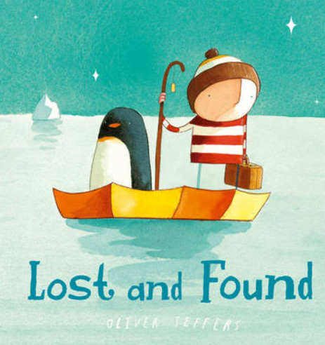
Lost and Found by Oliver Jeffers – Prediction activity
Questions to think about:
Who are the main characters?
Where is the story set?
What happens in the story? Why do you think that?
Which age group do you think this book is for?
Do you think this book is fiction or non-fiction? Why?
Do you think it is a happy or sad sorry?
Emperor Penguins
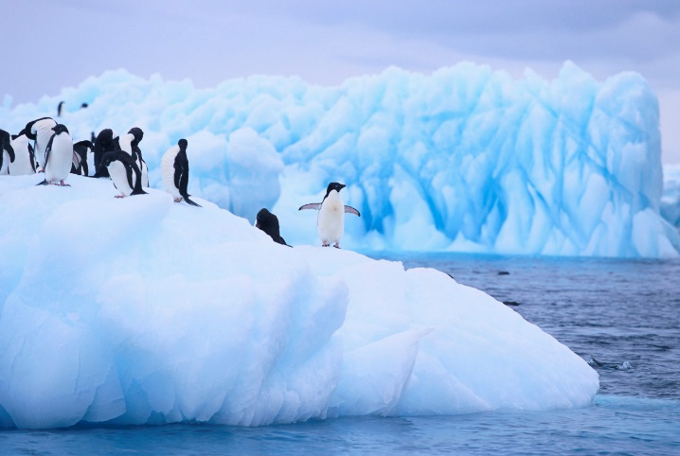
Do you want to be an expert on emperor penguins? Yes? Then read on to find out more.

Habitat
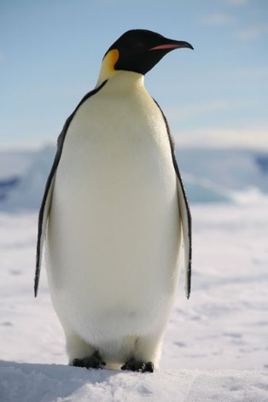
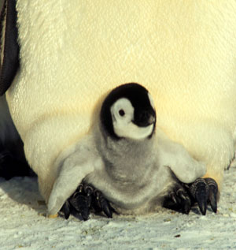
Emperor Penguins are large birds who live in Antarctica. They are warm blooded and they can survive in extremely cold temperatures. The baby starts its life on its father’s feet.

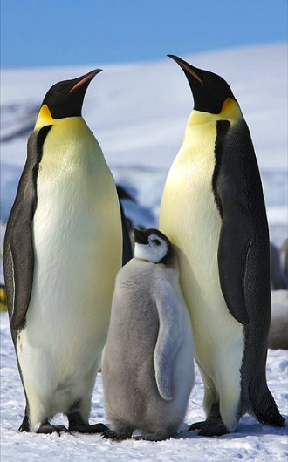
Appearance
Emperor penguins are the largest of all the penguins. They can grow up to the height of a 7 year old child. What a tall bird! Adult penguins are mainly black and white with some yellow on their necks. The babies are grey and fluffy but when they grow up their fur turns into feathers.
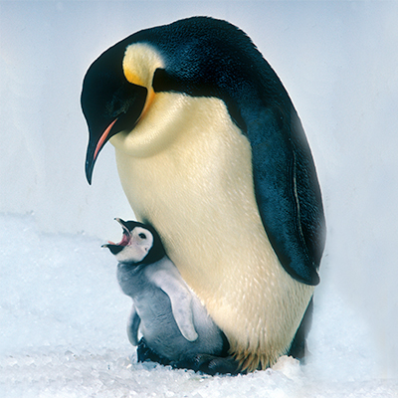
Diet
Penguins eat fish, krill and squid. Mother penguins hunt for food for their babies. Did you know, they eat their food and spit it back up into their babies mouths? How strange!

Threats
Penguins are hunted by predators like killer whales, seals and great white sharks. In some parts of Antarctica, penguins are finding it difficult to survive because there is not enough fish for them to eat. We humans need to make sure we don’t eat all their fish.
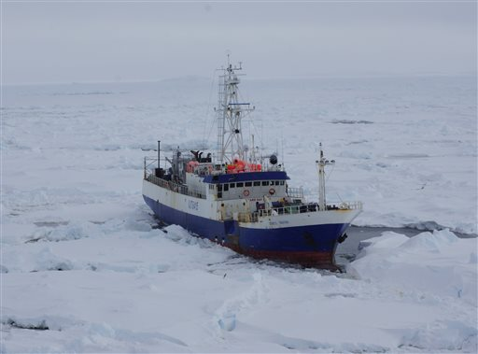

A fishing boat in Antarctica stealing all of the fish.

Emperor penguins

- Finish the sentence
Emperor penguins live in ____________________.

- Tick the correct word to finish the sentences.

Emperor Penguins eat ________, _________ and ________.

sweetcorn seals krill
fish sharks squid

Baby penguins are ________ and _________.
pink grey
fluffy scaly

- An adjective describes a noun. Circle the 2 adjectives in this sentence.
The babies are grey and fluffy but when they grow up their fur turns into feathers.

- How tall can an emperor penguin be?
__________________________________________

- Where do baby penguins live when they are first born?

__________________________________________

- Jonathon says “Fishing boats in Antarctica are bad for penguins.”
Why are fishing boats bad for penguins?
__________________________________________________
__________________________________________________
__________________________________________________

- Which of these animals hunt penguins? Tick 3.
Lions
Great white sharks
Crocodiles
Seals
Killer whales

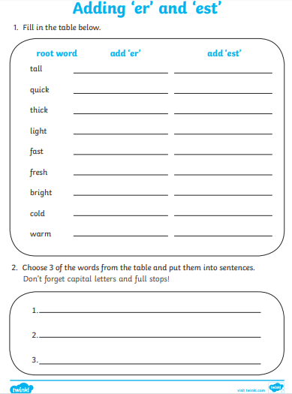
An example from Twinkl – more activities are available using the code CVDTWINKLHELPS

