WAGTAILS’ WEEKLY SUGGESTED HOME LEARNING – WB 4.5.20
Hi everyone! Did you all enjoy our new text, Lost and Found? It looked like you had lots of fun completing the activities – we have had so many brilliant photos sent to us. It’s great! Your activities this week are again based around the book with a few added VE Day activities to mark the day towards the end of WW2 when fighting came to an end. Please continue with all your hard work. Your attitude and commitment to learning during this unusual time is exceptional and you are making us all super proud.

Remember, there are several versions of Lost and Found read aloud on YouTube for you to access – here is one: https://www.youtube.com/watch?v=cRAAQ8EWzig

Continue tweeting and emailing us your lovely photos and work.
Stay Safe – Stay Positive
Miss Silver and Mrs Costello
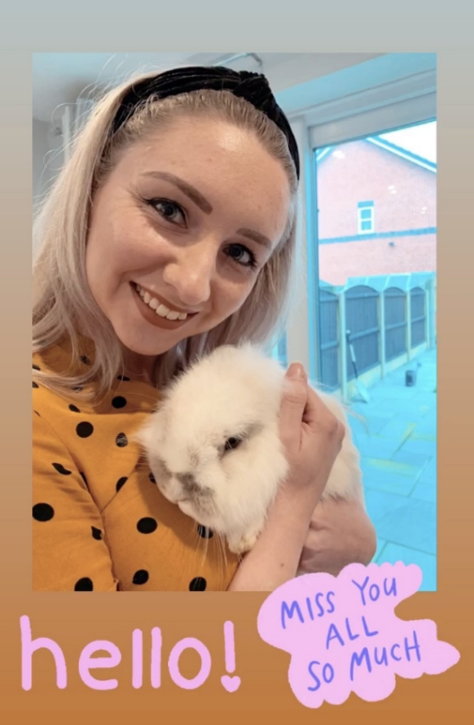
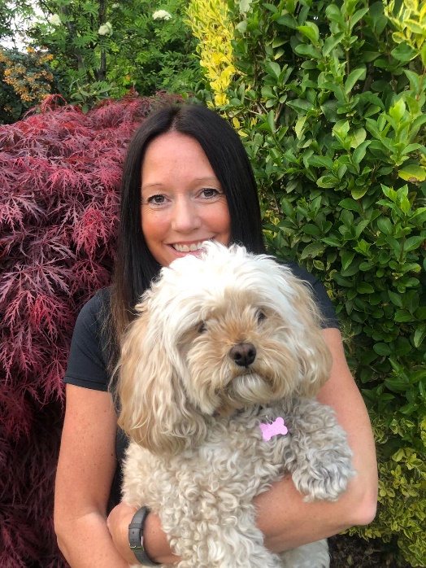
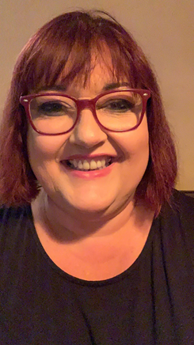

ENGLISH | MATHS
Reading – Read every day for pleasure for 15 minutes.  Comprehension tasks  - Write a detailed book review about the book, Lost and Found, to inform others who are considering reading the book. (See below for template)  - Read the fact file ‘Amazing Antarctica’, make notes of the important information and then answer the questions. (See resource below)  - Use this KS1 resource pack to find out all about VE Day (8th May). Watch the clip and read the information provided. https://www.mrtdoeshistory.com/ve-day-key-stage-1  Extra Challenge – Can you create a fact file or a poster about VE Day using the information you have read?  Writing  - Plan for a story which explains how the penguin got to the boy’s front door. Use the template provided to help you plan your story.  - Write your story, carefully following your plan. Remember, your story is a prequel (a story that happened before the book was written) explaining how the penguin got to the boy’s front door. Use the checklist below to make your story the best it can be.  - Proof read and edit your story. Produce a polished version of your story to share with us. This could be handwritten or typed on a computer.  Spellings – The ee sound spelt ey (see word bank below)  - Create a word search using some of these words and ask a family member to find them. Use the template provided if you wish.  - Draw pictures to match the words. | Basic Skill – Can you develop a rapid recall of the 2, 5 and 10 times tables?  Use BBC Supermovers to help you:  https://www.bbc.co.uk/teach/supermovers/ks1-maths-the-2-times-table-with-bridget-the-lioness/zrrx92p (2x)  https://www.bbc.co.uk/teach/supermovers/ks1-maths-the-5-times-table/zhbm47h (5x)  https://www.bbc.co.uk/teach/supermovers/ks1-maths-the-10-times-table-with-webster-the-spider/zm32cqt (10x)  https://www.bbc.co.uk/teach/supermovers/ks1-maths-the-times-tables-mash-up-with-monty-magpie-billy-the-badger/znxcpg8 (2x,5x and 10x)  White Rose Home Learning – Year 2 – Summer Term - Week 2 – 27/4/20 – Comparing lengths, ordering lengths, using the four operations with length and problem solving.  https://whiterosemaths.com/homelearning/year-2/  If your child finds this challenging, please look at the previous year’s home learning. Year 1 – Summer Term – Week 1 – 27/4/20 – Finding a half, a quarter and problem solving.  https://whiterosemaths.com/homelearning/year-1/
R.E. | OTHER
The theme is: Holidays and Holydays – Pentecost: The feast of the Holy Spirit  The word holiday comes from holyday. In times past the only holiday anyone had was a saint’s feast day or important feast days like Easter and Christmas. Some days of the year are ‘holy days’, when we celebrate these special times in the Church’s year.  May is the month of Mary.  - Complete the Hail Mary jigsaw puzzle (see resources)  - Decorate the Mary stained glass window. (template below) Create your own stained glass window if you wish. | Art – Draw and colour illustrations to go with your prequel to the story.  DT – Make puppets and a backdrop to act out your imaginative prequel. You could use paper, cardboard, old socks or anything spare around the house to create your puppets. When creating your backdrop, think about the setting of your story. Is it based in Antarctica? If so, use your Geography skills to recreate Antarctica as best as you can. You could use cotton wool as ice etc.  Science – When making your puppets and backdrop, think about the materials you are using. Which materials stretch, bend and twist? Can you describe the materials and their properties?  History - VE day task.docx Choose a couple of the suggested activities on this document to learn more about VE Day (8th May).

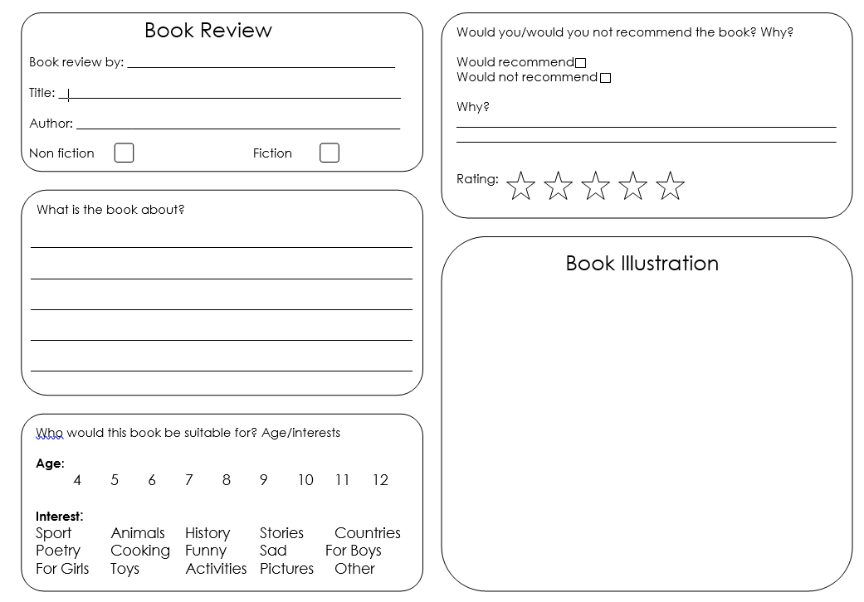
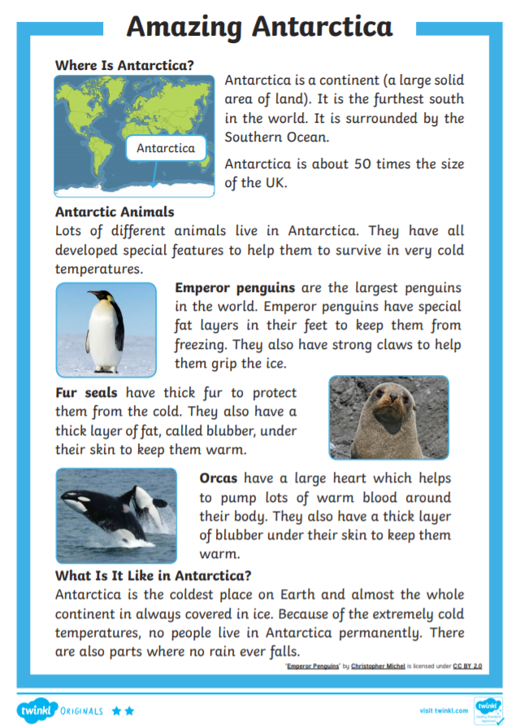
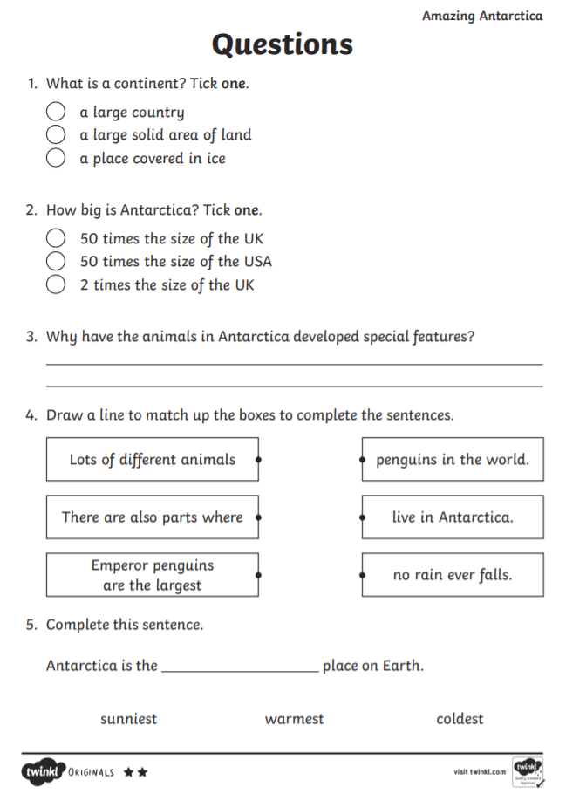

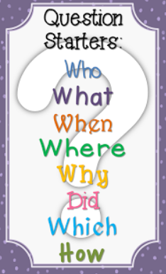
Reading Comprehension - Extra Challenge
Can you think of 10 questions based on the Lost and Found story to ask a family member? Use different question starters.
For example:
Who did the boy find at his front door?
What does the penguin begin to do?
How does the penguin feel?
Why does the boy think the penguin must feel this way?

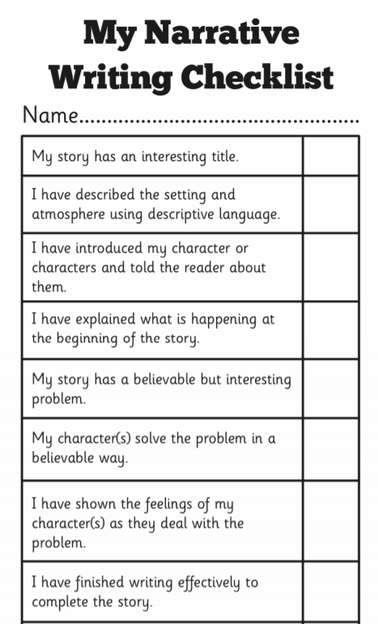

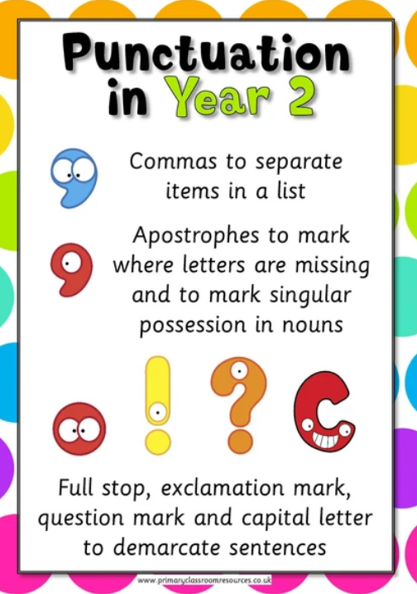

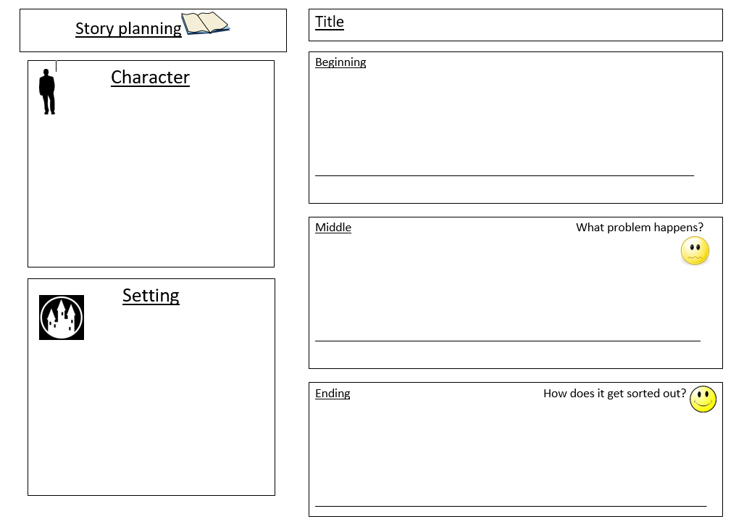
Spellings – ee sound spelt ey
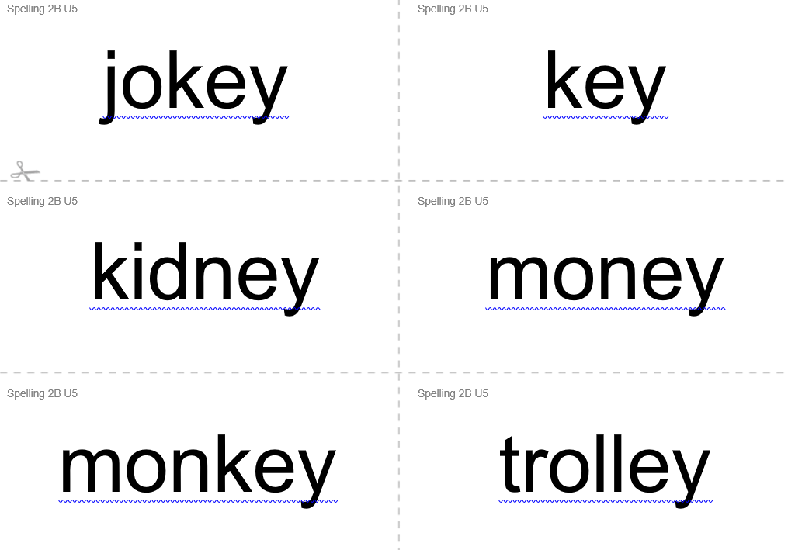
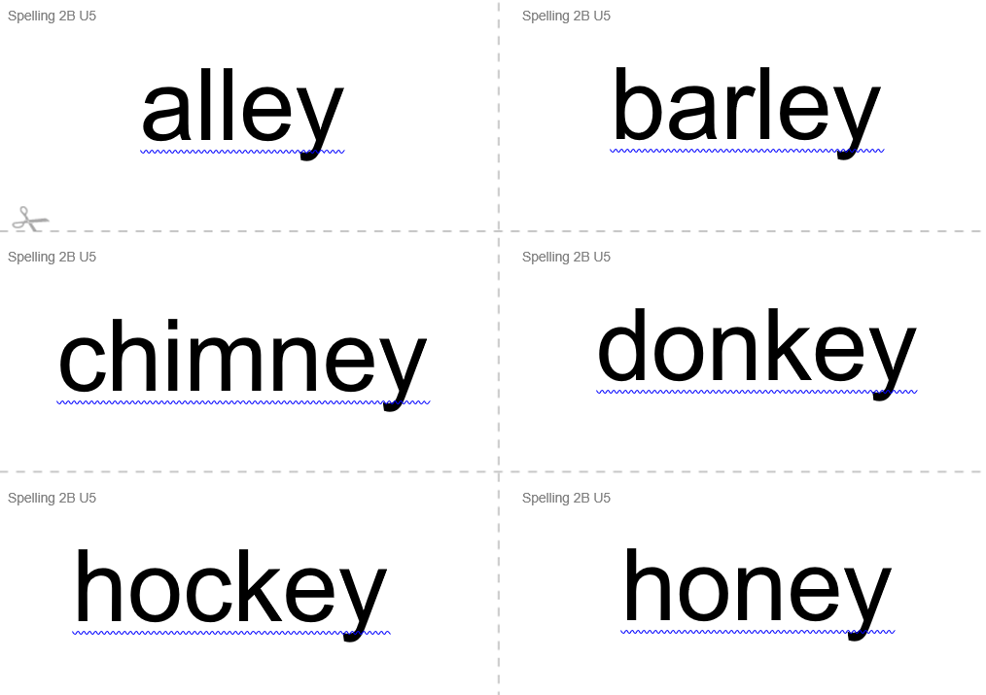

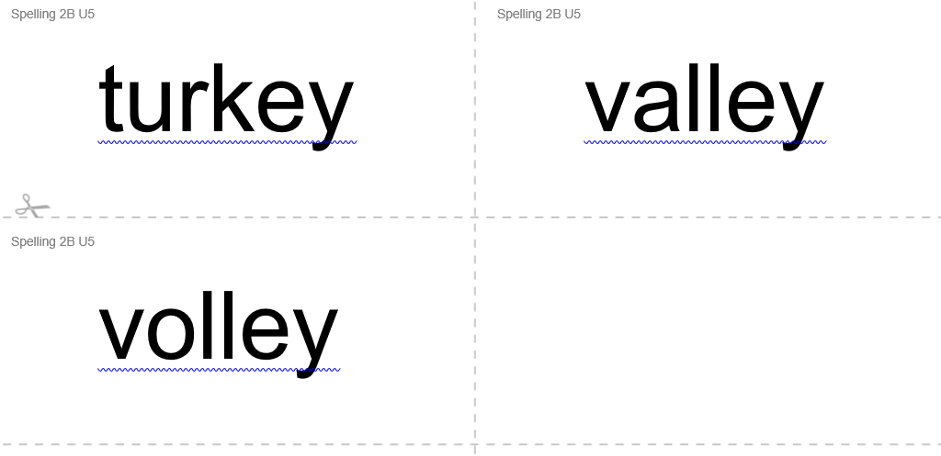

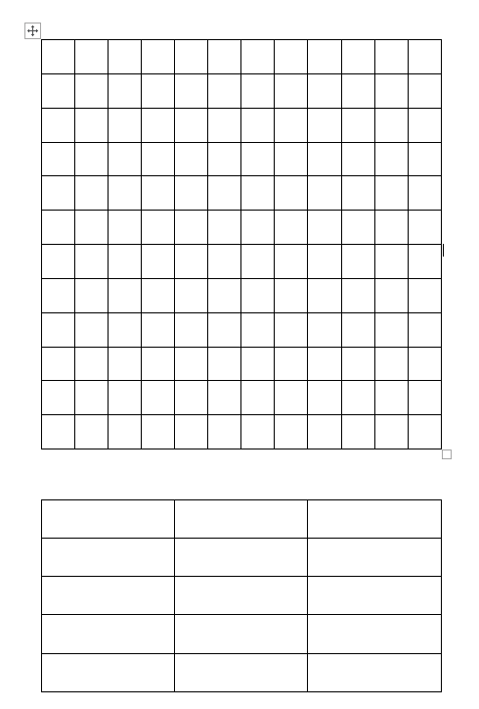
Create your own word search
