ROBINS’ WEEKLY SUGGESTED HOME LEARNING – WB 4.5.20
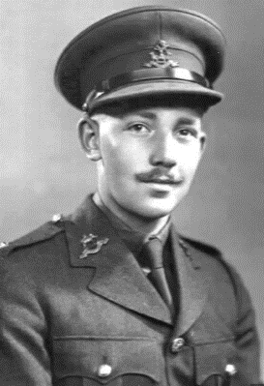
Hello Robins, we hope that you have enjoyed last week’s learning tasks. We have enjoyed reading and replying to your emails, please keep them coming it brightens our day to read them all.
Our focus this week is VE Day which is celebrated on Friday 8th May.
The month of May is national walking month – keep counting the miles that you are walking and tweeting/emailing the number of miles each week and by the end of May we can see where we have walked to. Don’t forget Captain Tom walked around his garden and he walked for miles. Missing you all. Stay Safe!
Mrs Fox, Mrs Davies and Miss Lea xxx
We’d love to see your work, so please Tweet @saintoswalds or send an email to enquiries@saintoswalds.wigan.sch.uk FAO Miss Lea.

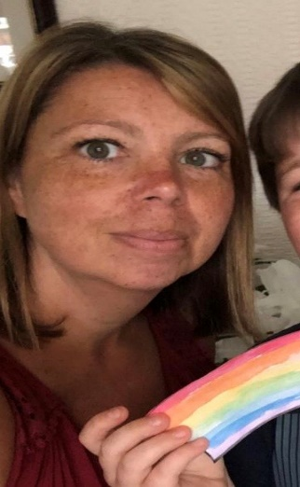

ENGLISH/HISTORY | MATHS
Reading – Read every day for pleasure for 15 minutes.  Comprehension  - Victory in Europe Day  - Captain Tom Moore  ‘Stay At Home’ Street Party  Read this article on Newsround and look closely at the photographs. How did people celebrate in 1945? Plan your own ‘stay at home’ street party.  What games could be played? What decorations would be put up? What food would be eaten? Who would be there? Is there anyone in your family who went to a VE Day party you could speak to?  Writing –  Year 1 - using all of the information that you have been given write a postcard to a friend telling them all about VE Day.  Year 2 – Write a diary entry as though you are a soldier and you have just found out that the war is over.  Use the writing skills attachment from last week’s learnings tasks  Phonics – Year 1 – Discovery Education Espresso  See attached notes  https://central.espresso.co.uk/espresso/primary_uk/subject/module/sub_modules_index/item72024/grade1/index.html?source=search-all-KS1-all-all&source-keywords=Phonics  Spellings – Year 2 Plural of nouns adding y Rules – Discovery Education Espresso  Watch the video and play the game  https://central.espresso.co.uk/espresso/primary_uk/subject/module/video/item743951/grade1/module735174/index.html  Attached is a sheet to complete to apply what you have been doing | Basic Skills: Count forwards and backwards in 1’s, 2’s, 5’s, and 10s to and from 100  Y1: White Rose home learning – Summer Term – Week 2 – 4.5.20  https://whiterosemaths.com/homelearning/year-1/  Y2: White Rose home learning – Summer Term – Week 2 – 4.5.20  https://whiterosemaths.com/homelearning/year-2/  If your child finds any of the tasks too challenging, go to the previous year group or look back at the Week 1 and Week 2 tasks above the Summer Term ones. It’s important that your child builds their confidence.  Extra challenge – what do you know about the number 75?  Is it odd or even? How many tens and ones?  What 2/3 numbers do you have to add together to make 75?  Find 8 different possibilities  What is one more/one less?  What is 10more/10 less?  Can you count in 5’s forwards and backwards from 75?  Can count in 2’s and 10’s to 75? Explain your reasoning  Which 2 numbers can be multiplied together to make 75?
RE
Our theme is: Holidays and Holydays  Reveal:  Ascension Day – When Jesus returned to his Father  You tube has lots of clips explain Ascension Day for children  SOME KEY QUESTIONS  - What happened on Ascension Day?  - Why were Jesus’ friends sad again?  - What was the promise Jesus gave to his friends?  - Who was the helper and guide?  - How did this make Jesus’ friends feel?  Pentecost – The Holy Day  Pentecost this year is 31st May. This week we are beginning to talk about the Holy Day –Pentecost.  We have attached some notes for you to share.  This is a you tube link that we would like you to watch about Pentecost Day.  https://www.youtube.com/watch?v=XOgKAAuEpcE  We have also attached a passage from the bible to share. Maybe you could read it to your grown-ups.  ‘The Holy Spirit bring us happiness.’ - We would like to know what brings you happiness. Draw a picture and write about all the things that bring you happiness.  We have attached a colour picture showing Pentecost Day  We have attached a song called ‘The Holy Spirit’ it is by John Burland who we used in school for collective worships and assemblies. The lyrics are attached at the bottom. This is one of our favourite songs to help us to learn about Pentecost – it is an upbeat song that makes us smile when we sing it. In you tube search for ‘The Holy Spirit.’ | Science: Spitfire Science  Design and make your own Spitfire. You could make it out of paper, wood, recycled materials, etc. Test out your design. How far does it glide?  Does the material used for a paper plane affect the distance it travels? Try using newspaper, card, tinfoil, etc and carry out a test. Remember, only change ONE thing to make it a fair test.  I have attached a spitfire glider for you to make and fly.  Happy flying!  Art  Continue to be creative with your rainbow-breasted robins.  DT/STEM  Design a VE day medal – see attachment  Use lego to make the union flag  Music VE Day Songs  Try and learn the Horrible Histories VE day song and perform it to your family.  Find and listen to the following wartime songs on you tube -  Run, rabbit, run!  Long way to Tipperary/Pack up your troubles  We’ll meet again  The white cliffs of Dover  Doing the Lambeth Walk  PE – National Walking Month – refer to twitter and the school website for further information  Dance  The Lindy Hop was a popular dance in the 1940’s. There is a ‘How to’ guide on you tube for you to follow.  Have a go! Don’t forget to share your funky moves with us.  Computing  We would like more of you to email us this week – thank you for those that have already shared what you have been up to – keep us posted!  Please type in an email what you have been getting up to and send it to our school email address with the subject being FAO Miss Lea.  Use your tablets/phones to take your own photographs and email them to us.

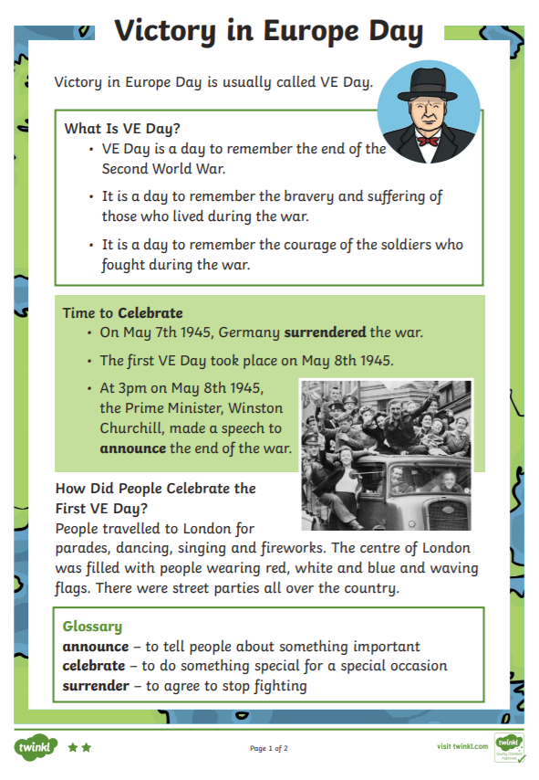

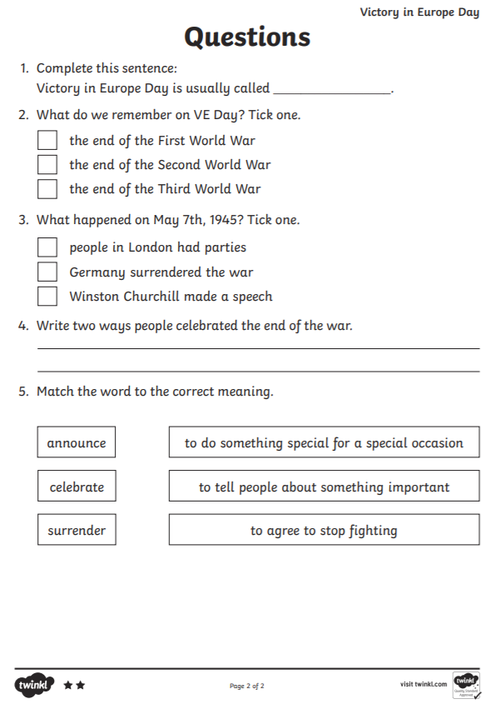
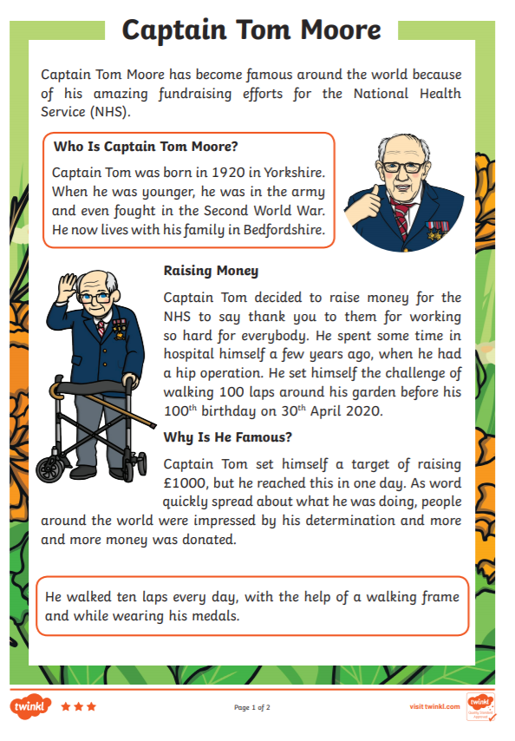
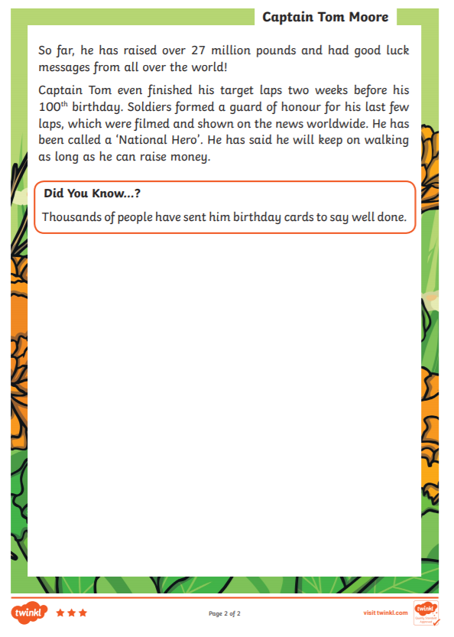
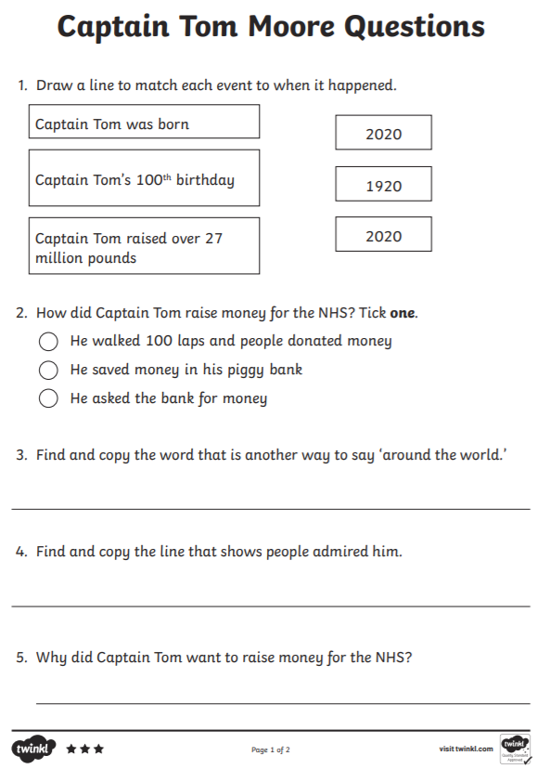
YEAR 1 PHONICS – FOCUS ‘ai’ sound
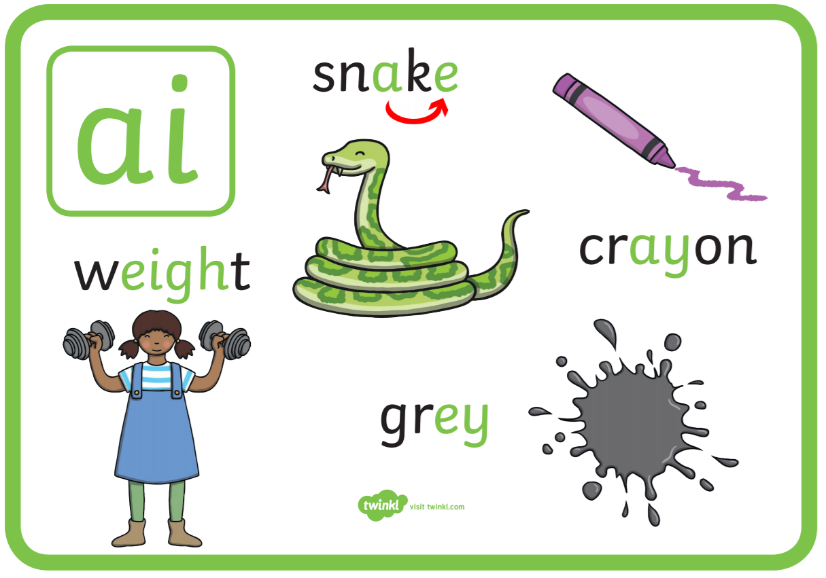
The following links will support you with the different ai spellings
Discovery Education Espresso – phase 2 – ai Phase 5 – ay, a_e (link above)Mr Thorne does Phonics – you tube -
Phab fonics – type in the title of the following song titles
Elaine the Snail -
Kay Stingray
Jake the Snake
Phonics play website

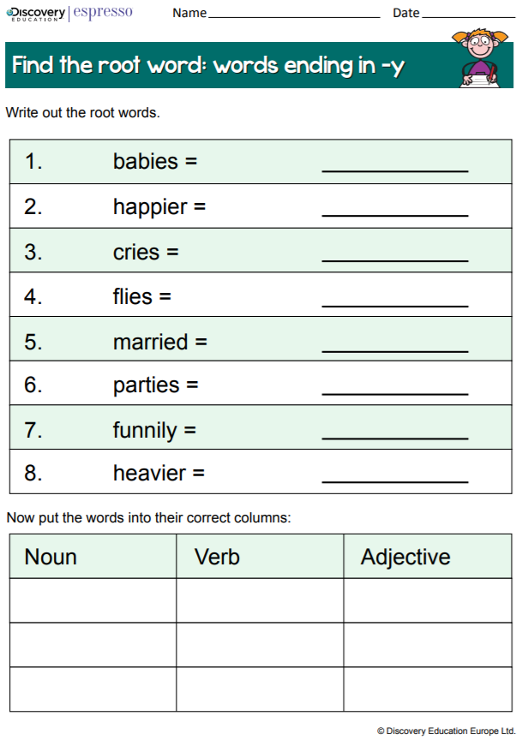
YEAR 2 SPELLING
Pentecost Day Notes

Talk about how the disciples were afraid when Jesus had left them and they had gathered together in one room. The coming of the Holy Spirit at Pentecost changed them. It is a holy day because this gift of the Holy Spirit is very special. The Holy Spirit helps and guides us in our lives just as happened to the disciples. The Holy Spirit appeared to Mary and the disciples like tongues of fire, giving them strength and courage to serve others.

SOME KEY QUESTIONS

- Who was in the room when the Holy Spirit came at Pentecost?
- What were the signs of the Holy Spirit?
- How do you think Mary and the disciples felt?
- Why do you think they felt like that?
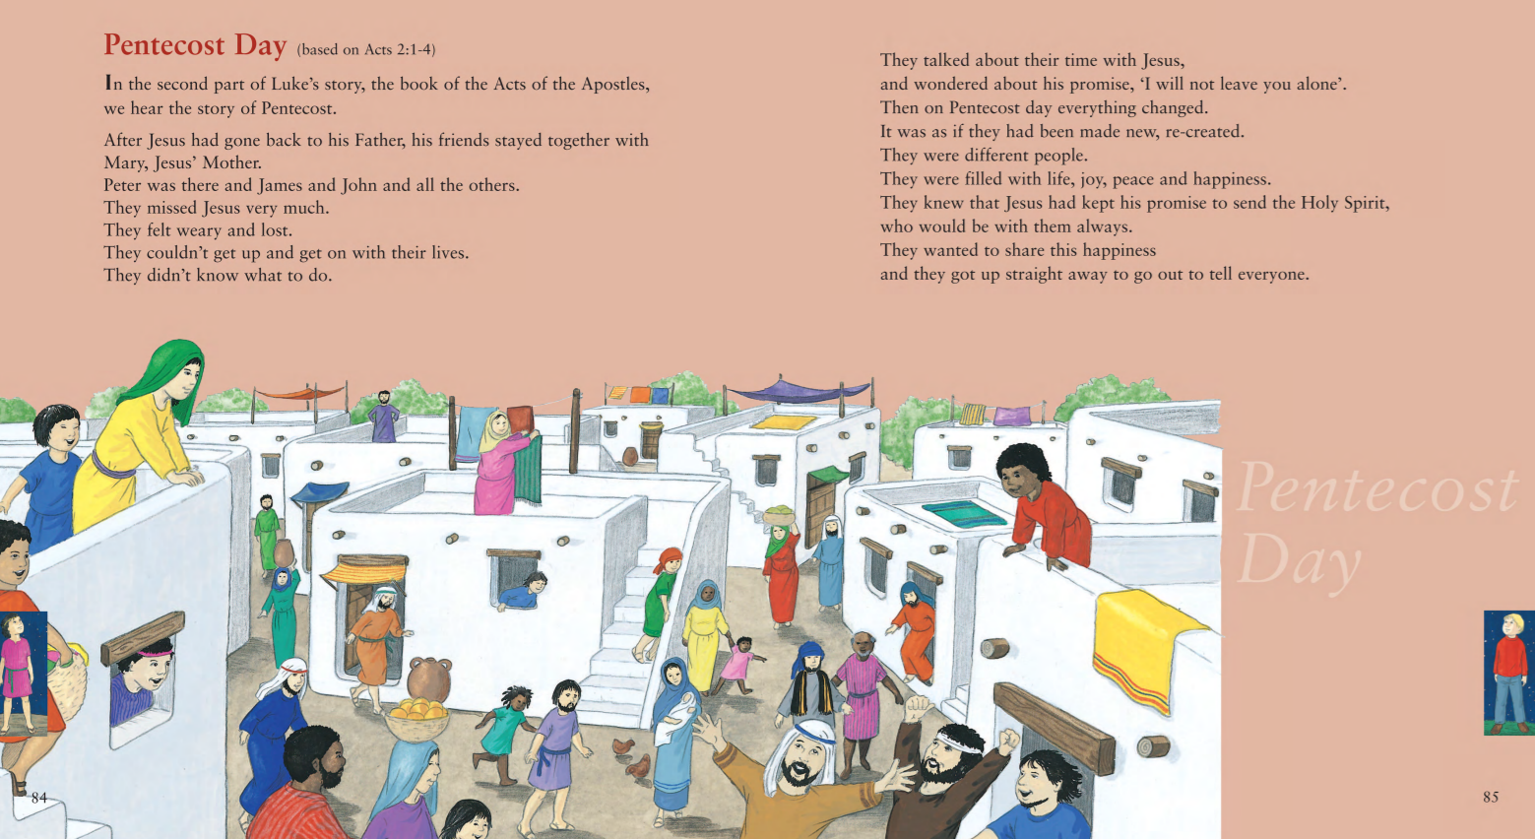

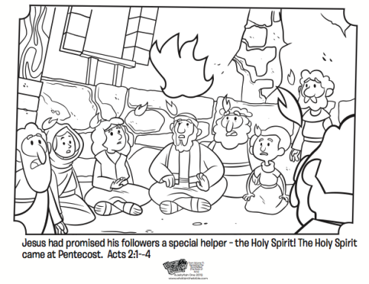
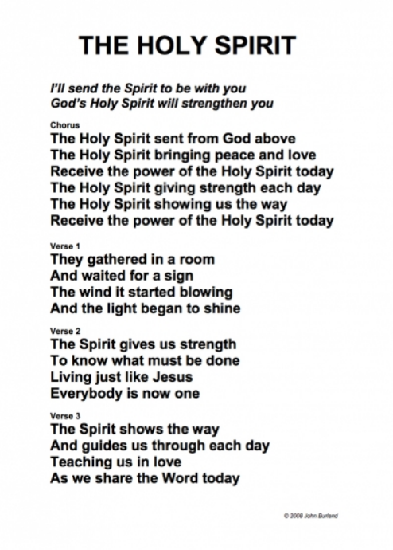
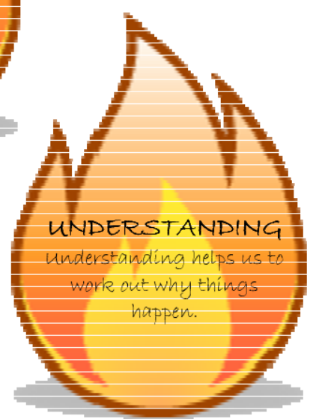

7
