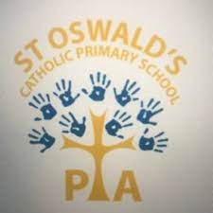
Dear Parent/Carer,
Thank you for your enquiry regarding Saint Oswald’s Hoodies.
Please find below the order forms required to place your order. Your order form needs to be emailed back once payment has been made. If you’re making your payment via online banking, please write your child’s name as the narrative. If you wish to pay by cash or cheque, please let us know in your email. Thank you.
BANK DETAILS: NATWEST BANK - SAINT OSWALD’S PTA
SORT CODE - 60-01-24 ACCOUNT NUMBER - 48716634
SCHOOL HOODIES ONLY
ITEM | SIZE | PRICE | QUANTITY | INITIALS | TOTAL COST
HOODIE | 3-4 YEARS | £18
HOODIE | 5-6 YEARS | £18
HOODIE | 7-8 YEARS | £18
HOODIE | 9-10 YEARS | £18
HOODIE | 11-12 YEARS | £18
HOODIE | 12-13 YEARS | £18

TOTAL AMOUNT | £

Y6 LEAVERS HOODIES ONLY

ITEM | SIZE | PRICE | QUANTITY | INITIALS | TOTAL COST
Y6 HOODIE | 7-8 YEARS | £24
Y6 HOODIE | 9-10 YEARS | £24
Y6 HOODIE | 11-12 YEARS | £24
Y6 HOODIE | 12-13 YEARS | £24

TOTAL AMOUNT

PLEASE NOTE THE DEADLINE FOR ORDERING A Y6 LEAVERS HOODIE IS DECEMBER 31ST.
Any enquiries regarding your order must be emailed using the email address, ozzieshoodies@gmail.com
Thank you for supporting your P.T.A

OFFICE NOTES: CUSTOMER NAME______________________________
PAYMENT ______________________________

