

‘May Christ be Seen in us’

Our Mission statement

This document outlines the calculation policy implemented and followed at St Patrick’s Catholic Primary
School.
Our School is a Christian community, where respect and care are prominent in everything we do. At St Patrick’s Primary School, we follow the ways of Jesus; using our talents and gifts to make our school special, and foster a safe and inspiring environment. During Mathematics lessons, we aspire to live out our school motto, ‘May Christ be Seen in us’, in all that we do. Children work together in a supportive environment, using praise to recognise one another’s achievements and encouragement to ensure all children feel confident in their work.
Mathematics is a tool for everyday life. It is a whole network of concepts and relationships which provide a way of viewing and making sense of the world. It is used to analyse and communicate information and ideas and to tackle a range of practical tasks and real-life problems.
Our calculation policy at St Patrick’s Catholic Primary School is designed to support the teaching of the National Curriculum (2014); to ensure the children are given the opportunity to develop their mathematical skills in all aspects of mathematics, ensuring progression is clear throughout each and every year group. And to assist teaching professionals in delivering effective and consistent methods, ensuring progression is clear throughout each year group.

AIMS OF THE POLICY
- To ensure consistency and progression in our approach to calculation and enable a smooth transition between year
groups and phases.
  - To ensure that children develop an efficient, reliable, formal written methods of calculation for all operations.
- To ensure that children can use these methods accordingly, and apply them accurately with confidence and understanding, with increasing independence.
- To ensure pupils understand important concepts and make connections within mathematics.
- To ensure pupils show high levels of fluency in performing written and non-recorded calculations.
- To ensure that pupils are ready for the next stage of learning and have been given strong foundations in non- recorded methods, the use of practical equipment, allowed to explore jottings in a range of forms and then to move onto more formal recording using a strong knowledge of place value, number lines labelled or blank, partitioning before eventually using compact recorded written methods.
- To ensure that pupils are competent in fluency, reasoning and problem solving; and can make informed and appropriate choices about the methods they wish to use (recorded and non-recorded) to solve mathematical problems efficiently and effectively.
- To promote resilience and independence in children’s approaches to solving problems, fostering a healthy growth
atmosphere with regards to facing adversity and challenges.

Introduction
This policy is set out into the four operations: Addition, subtraction, multiplication and division. Within each specific area there is a progression of skills, knowledge and layout for written methods that has been agreed by all staff. The calculation strategies being used will reflect this ideology – moving from concrete to pictorial and then abstract recording leading to more formal written methods. None recorded methods and strategies will work in partnership with these methods.
The school will adopt the term non-recorded to distinguish between operations calculated without the use of jottings or written calculations rather than the outdated and incorrect term ‘mental’ to avoid developing misconceptions within the function of mathematics and cognition.
It has been agreed by all staff that a variety of non-recorded calculation methods will be taught and that recall of facts will be taught in school and tested regularly. The progression of non-recorded methods and expectations will comply with the national curriculum statements 2014. (See Appendix 1).
The basis of our maths calculation policy is that both recorded and non-recorded methods are integral to each other and should not be seen as taking separate paths, nor being of different stature; but developed in conjunction with one another. It is envisaged that the development of non-recorded skills will lead to jottings, (which support abstract calculation) and then into more formalised jottings in the form of number lines and partitioning which in turn leads to expanded column methods and ultimately compact algorithms.
Promoting independent problem solving within learners using effective methods should not be discouraged, though knowing the next steps of learning ensures the calculation policy of St Patricks prepares children for the next phase of learning in the most complete and efficient way.

It is important to always show the links between the operations and not solely teach in isolation or without showing the relationships between subtraction and addition, and multiplication and division. These fact families taught at the earliest possible stage ensure for more minimal gaps in learning as children progress through our school.
This should also be shown in practical problem-solving activities and across all mathematical topics. Showing how these operations can be applied and then proved with reverse operations is integral to a develop a more complete understanding
It is important that staff always use correct mathematical language and encourage this from every pupil. This will take place in class discussions as well as through oral and written feedback, next steps and target setting.
We have chosen not to identify which year group should use which method because we wish staff and pupils to have the freedom to take the next steps on their mathematical journey when they are ready to do so and, providing the policy is followed, there will be no problem with progression as children transition and move through the school.
However, a word of caution should be given here. All staff have the responsibility to make sure that children have the depth of knowledge and experiences required to move onto the next stage of their development, rather than pushing them on too quickly. This, we have agreed, can lead to developing misconceptions and poor mathematical foundations and eventually, in later years, children will not be able to make the required progress.
Ultimately, we aim to enable children to make informed choices about the methods they use both recorded and non- recorded, and that the methods taught are the most efficient and impactful. (This includes recognised compact methods.)

Addition
Key Language: sum, total, parts and wholes, add, altogether, more, total, ‘is equal to’ ‘is the same as’

Objective and  Strategies | Concrete | Pictorial |  | Abstract
Combining two parts to make a whole: part- whole model | 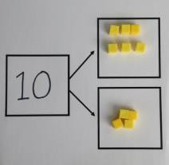  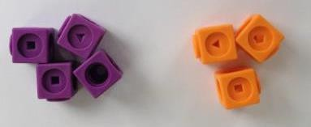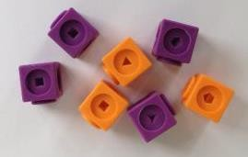  Use cubes to add | 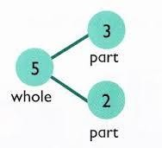 |  | 4 + 3 = 7  10= 6 + 4 |  | 5
 | two numbers together as a group or in a bar. |  | 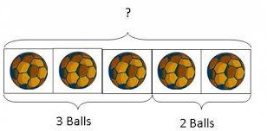  Use pictures to add two numbers together as a |  |  | 3
 |  |  | group or in a bar. |  | Use the part-part
 | 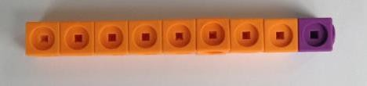 | 8 | 1 |  | whole diagram as shown above to move into the
Starting at the bigger number and counting on | Children to use bead strings, number lines or numicon. The children start with the larger number then add the smaller number on.  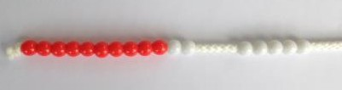 | A bar model which encourages the children to count on, rather than count all. |  | The abstract number line: What is 2 more than 4?  What is the sum of 2 and 4? What is the total of 4+2?  2+4?
Starting at the bigger number and counting on |  | 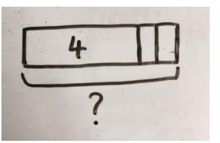

 | 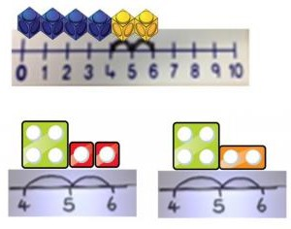
Regrouping to make 10. | Children to use bead strings, ten frames with counters/cubes or numicon.  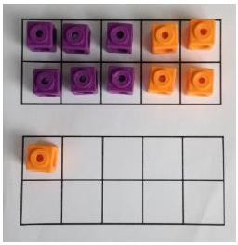  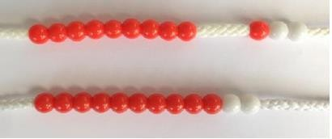  6 + 5 = 11  Start with the bigger number and use the smaller number to make 10.  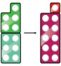 | Children to draw the ten frame and counters/cubes.  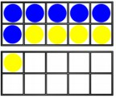 | Children to develop an understanding of equality  6+ =11  6+5=5+  6+5= +4

Adding three single digits | 4 + 7 + 6= 17  Put 4 and 6 together to make 10. Add  on 7.  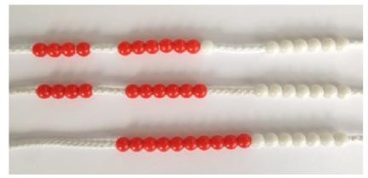  Following on from making 10, make 10 with 2 of the digits (if possible) then add on the third digit. |             + +          + +  Add together three groups of objects. Draw a picture to recombine the groups to make 10. | 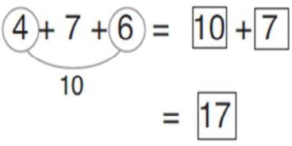  Combine the two numbers that make 10 and then add on the remainder.
TO+O using base 10. | Continue to develop understanding of partitioning and place value.  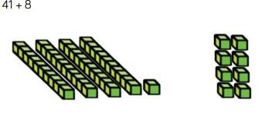 | Children to present the base 10 e.g. lines ffor tens and dot/crosses for ones.  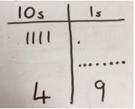 | 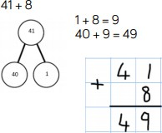

Column method- no regrouping | 24 + 15=  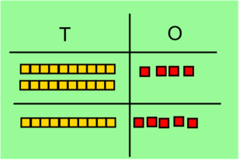  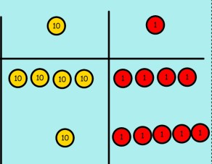  Add together the ones first then add the tens. Use the Base 10 blocks first before moving onto place value counters. | After practically using the base 10 blocks and place value counters, children can draw the counters to help them to solve additions or draw lines for tens and dot/crosses for ones.        T O  21+42= | 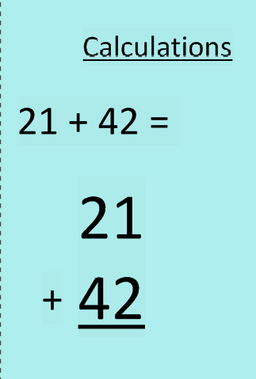

Column method- regrouping | Make both numbers on a place value grid.  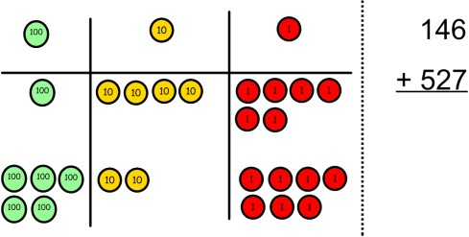  Add up the ones and exchange 10 ones for one 10.  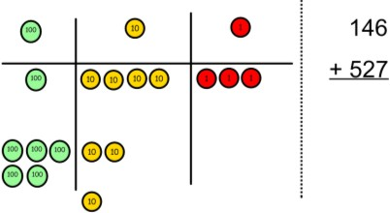  Add up the rest of the columns, exchanging the 10 counters/dienes from one column for the next place value column until every column has been added.  This can also be done with Base 10 to help children clearly see that 10 ones equal 1 ten and 10 tens equal 100.  As children move on to decimals, money and decimal place value counters can be used to support learning. | Children can draw a pictoral representation of the columns and place value counters to further support their learning and understanding.  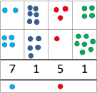 | Start by partitioning the numbers before moving on to clearly show the exchange below the addition.  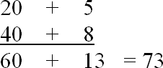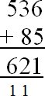  As the children move on, introduce decimals with the same number of decimal places and different. Money can be used here.  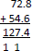  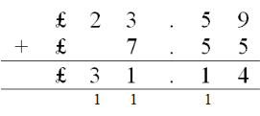  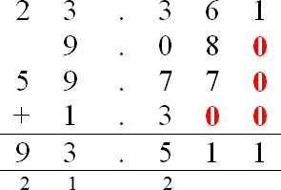

Conceptual variation; different ways to ask children to solve 21+34
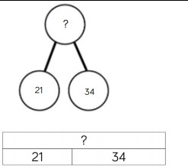 | 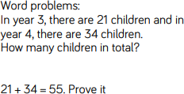 | 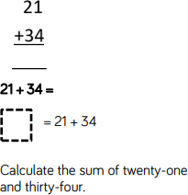 | 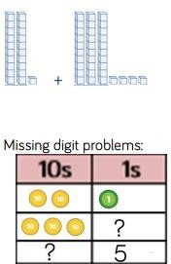

Subtraction
Key vocabulary: take away, less than, the difference, subtract, minus, fewer, decrease.

Objective and  Strategies | Concrete | Pictorial | Abstract
Taking away ones | Use physical objects, counters, cubes etc to show how objects can be taken away.      6 – 2 = 4 | Cross out drawn objects to show what has been taken away.  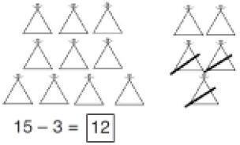 | 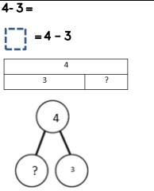
Counting back | 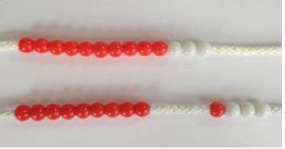  Make the larger number in your subtraction. Move the beads along your bead string as you count backwards in ones.  13 – 4  Use counters and move them away from the group as you take them away counting backwards as you go.  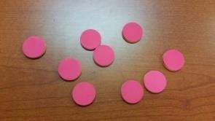 | Count back on a number line or number track  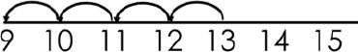  Start at the bigger number and count back the smaller number showing the jumps on the number line.  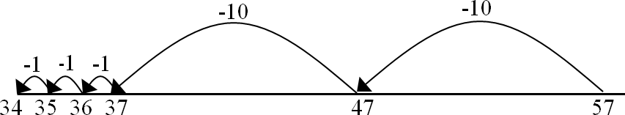  This can progress all the way to counting back using two 2 digit numbers. | 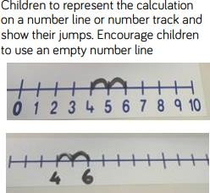  Put 13 in your head, count back 4. What number are you at? Use your fingers to help.

Use numicon and cover up the number you are taking away. Then count how many holes you can see remaining.

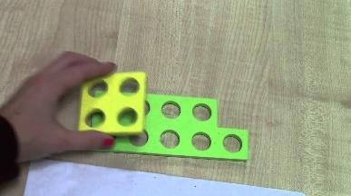
Find the difference | 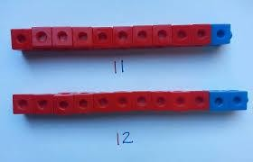  Compare amounts and objects to find the difference.  Use cubes to build towers or make bars to find the difference  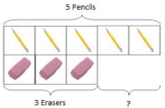  Use basic bar models with items to find the difference  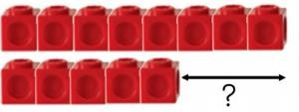 | Count on to find the difference.  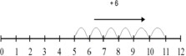  Draw bars to find  the difference between 2 numbers.  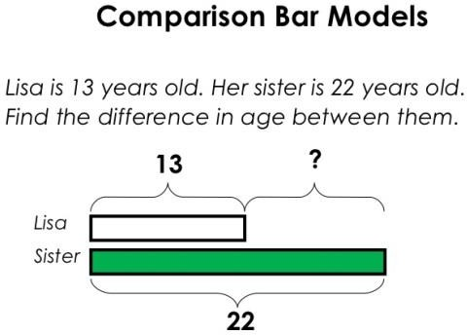  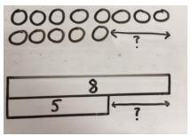 | Hannah has 23 sandwiches, Helen has 15 sandwiches. Find the difference between the number of sandwiches.  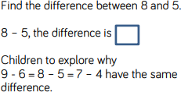

Part Part Whole Model | Link to addition- use the part whole model to help explain the inverse between addition and subtraction.  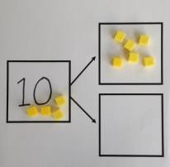  If 10 is the whole and 6 is one of the parts. What is the other part?  10 - 6 = |         Use a pictorial representation of objects to show the part part whole model. | 5  10  Move to using numbers within the part whole model.
Make 10 | 14 – 9 =  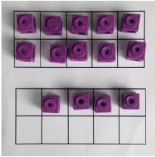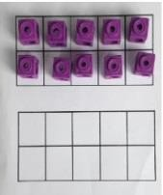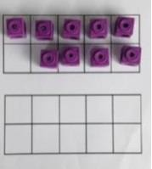  Make 14 on the ten frame. Take away the four first to make 10 and then takeaway one more so you have taken away 5. You are left with the answer of 9. | 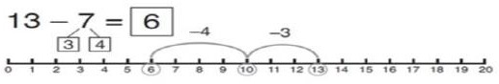  Start at 13. Take away 3 to reach 10. Then take away the remaining 4 so you have taken away 7 altogether. You have reached your answer. | 16 – 8=  How many do we take off to reach the next 10?  How many do we have left to take off?
Column method without regrouping | Use Base 10 to make the bigger number then take the smaller number away.  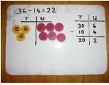  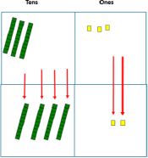  Show how you partition numbers to subtract. Again make the larger number first. | Draw the Base 10 or place value counters alongside the written calculation to  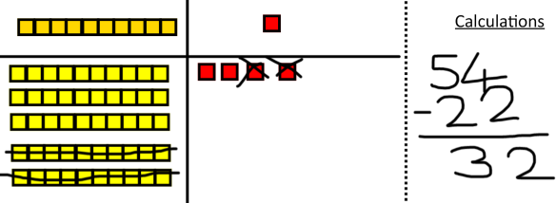  help to show working.  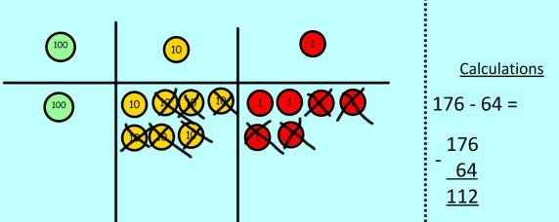 | 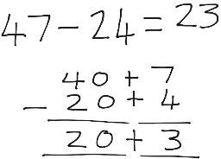  This will lead to a clear written column subtraction.  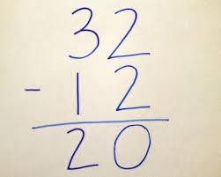

Column method with regrouping | Use Base 10 to start with before moving on to place value counters. Start with one exchange before moving onto subtractions with 2 exchanges.  Make the larger number with the place value counters  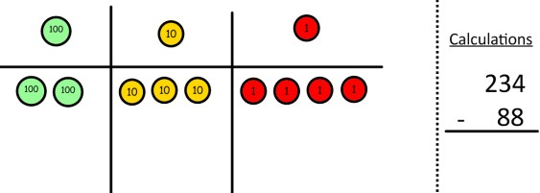  Start with the ones, can I take away 8 from 4 easily? I need to exchange one of my tens for ten ones.  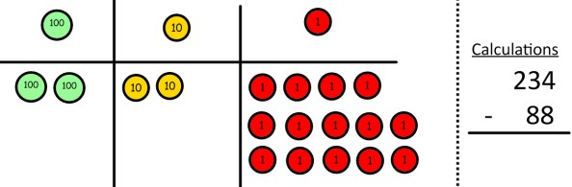  Now I can subtract my ones.  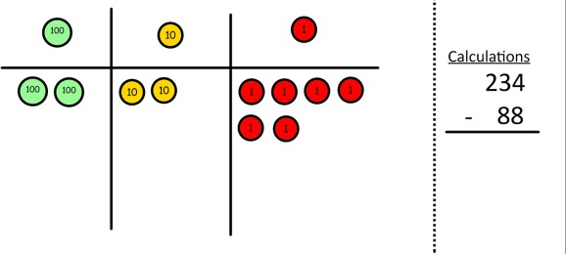  Now look at the tens, can I take away 8 tens easily? I need to exchange one hundred for ten tens. | 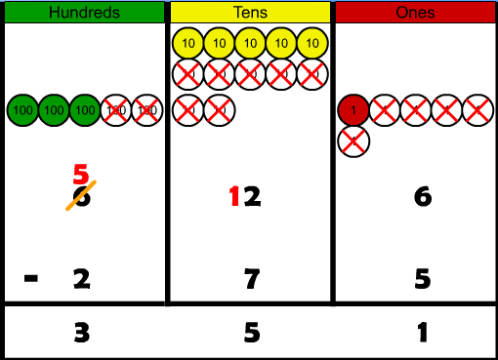  Draw the counters onto a place value grid and show what you have taken away by crossing the counters out as well as clearly showing the exchanges you make.  When confident, children can find their own way to record the exchange/regrouping.  Just writing the numbers as shown here shows that the child  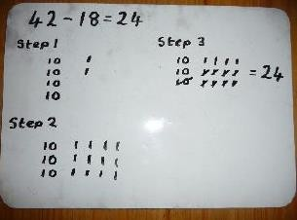  understands the method and knows when to exchange/regroup. | 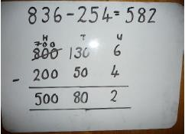  Children can start their formal written method by partitioning the number into clear place value columns.  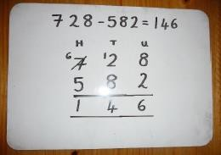  Moving forward the children use a more compact method.  This will lead to an understanding of subtracting any number including decimals.  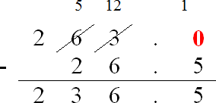

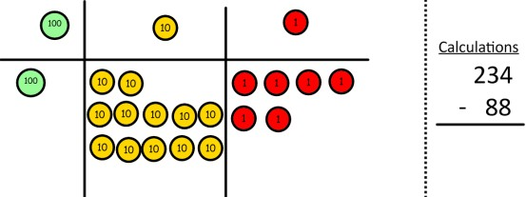
Now I can take away eight tens and complete my subtraction

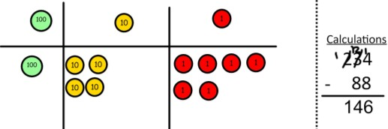
Show children how the concrete method links to the written method alongside your working. Cross out the numbers when exchanging and show where we write our new amount.
Conceptual variation; different ways to ask children to solve 391-186
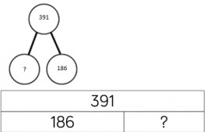 |  | 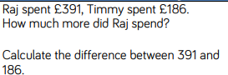 |  | 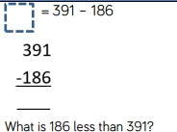 | 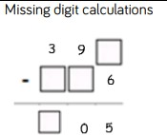

Multiplication
Key vocabulary: double, times, multiplied by, the product of, groups of, lots of, equal groups.

Objective and  Strategies | Concrete | Pictorial | Abstract
Doubling | 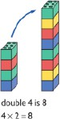  Use practical activities to show how to  double a number. | Draw pictures to show how to double a number.  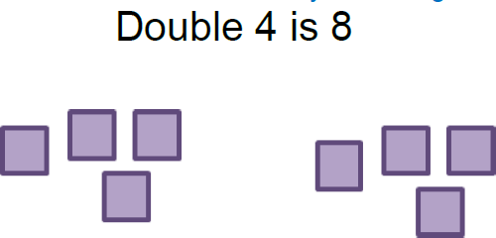 | 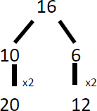  Partition a number and then double each part before recombining it back together.
Counting in multiples | 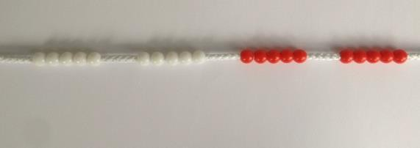  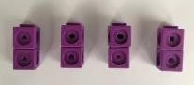  Count in multiples supported by concrete objects in equal groups. | 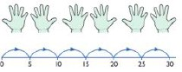  Use a number line or pictures to continue support in counting in multiples. | Count in multiples of a number aloud.  Write sequences with multiples of numbers.  2, 4, 6, 8, 10  5, 10, 15, 20, 25 , 30

Repeated addition | 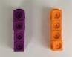  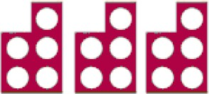  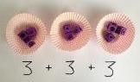  Use different objects to add equal groups. | 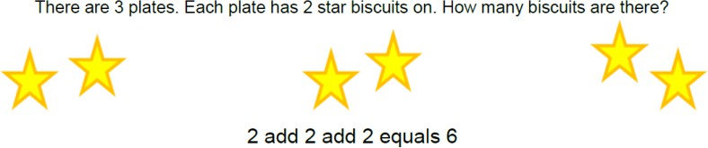  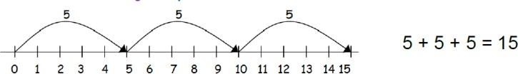  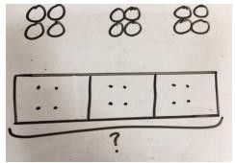 | Write addition sentences to describe objects and pictures.  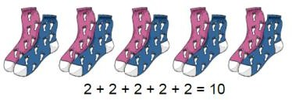  3x4=12  4+4+4=12
Number lines to show repeated groups | 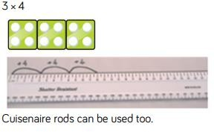 | 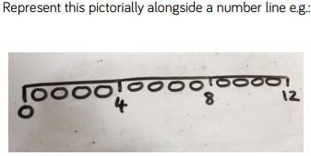 | 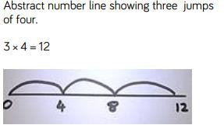

Arrays- showing commutative multiplication | Create arrays using counters/ cubes to show multiplication sentences.  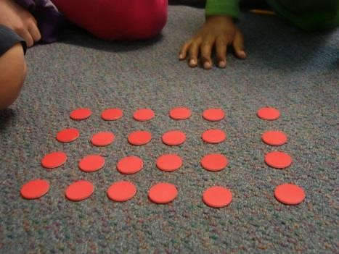  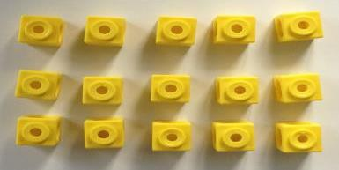 | 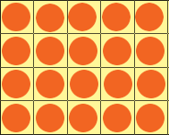  Draw arrays in different rotations to find commutative multiplication sentences.  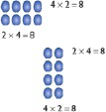  Link arrays to area of rectangles. | Use an array to write multiplication sentences and reinfoCatholice repeated addition.  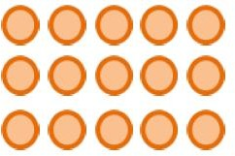  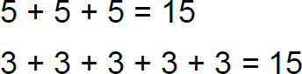
Partition to multiply using Numicon, base 10 or Cuisenaire rods. | 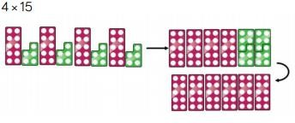 | 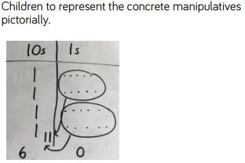 | 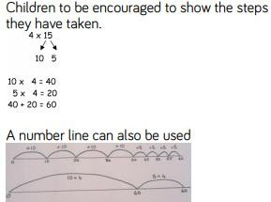

Grid Method | 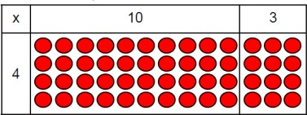  Show the link with arrays to first introduce the grid method.  4 rows of  10  4 rows of  3  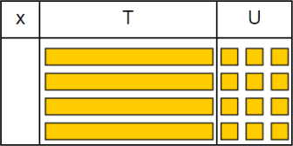  Move on to using Base 10 to move towards a more compact method.  4 rows of 13  Move on to place value counters to show how we are finding groups of a number.We are multiplying by 4 so we need 4 rows.  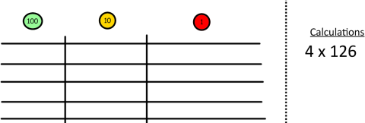  Fill each row with 126.  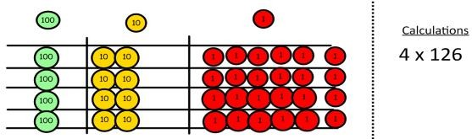  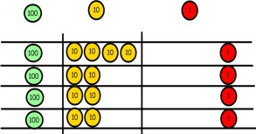  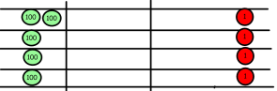  Add up each column, starting with the ones making any exchanges needed.  Then you have your answer. | Children can represent the work they have done with place value counters in a way that they understand.  They can draw the counters, using colours to show different amounts or just use ciCatholicles in the different columns to show their thinking as shown below.  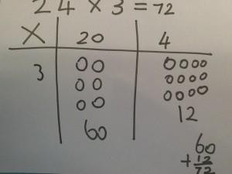 | Start with multiplying by one digit numbers and showing the clear addition alongside the grid.  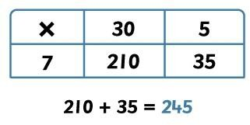  Moving forward, multiply by a 2 digit number showing the different rows within the grid method.  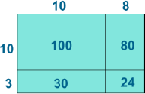  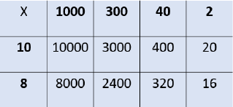

Column multiplication | Children can continue to be supported by place value counters at the stage of multiplication.  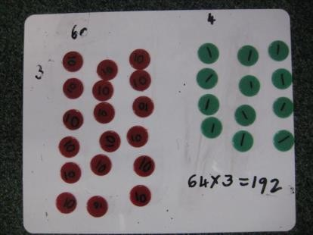  It is important at this stage that they always multiply the ones first and note down their answer followed by the tens which they note below. | Bar modelling and number lines can support learners when solving problems with multiplication alongside the formal written methods.  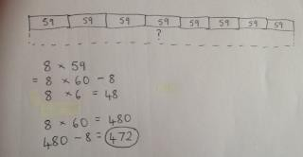  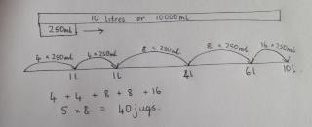 | Start with long multiplication, reminding the children about lining up their numbers clearly in columns.  If it helps, children can write out what they are solving next to their answer.  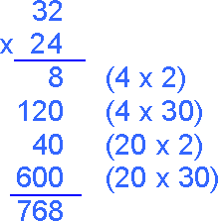  This moves to the more compact method.  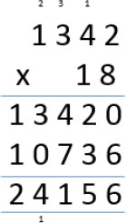  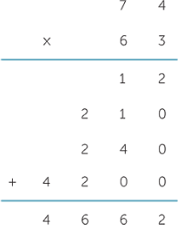

Conceptual variation; different ways to ask children to solve 6x23
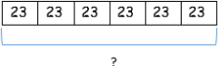 | 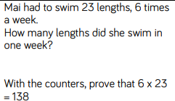 | 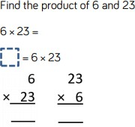 | 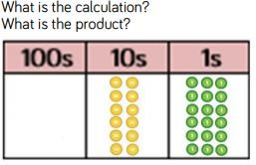

Key vocabulary: share, group, divide, divided by, half

Division

Objective and  Strategies | Concrete | Pictorial | Abstract
Sharing objects into groups | 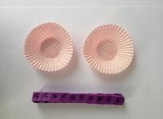  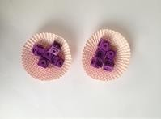  I have 10 cubes, can you share them equally in 2 groups?  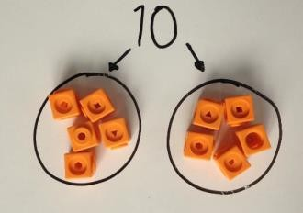 | Children use pictures or shapes to share quantities.    8 ÷ 2 = 4  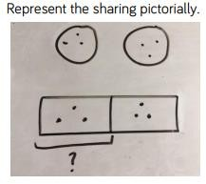 | Share 9 buns between three people.  9 ÷ 3 = 3  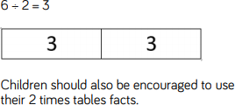

Division as grouping | Divide quantities into equal groups.  Use cubes, counters, objects or place value counters to aid understanding.  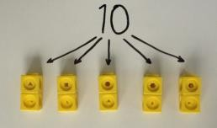  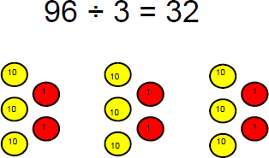   | Use a number line to show jumps in groups. The number of jumps equals the number of groups.  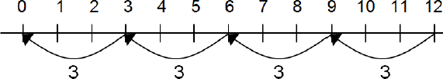  Think of the bar as a whole. Split it into the number of groups you are dividing by and work out how many would be within each group.  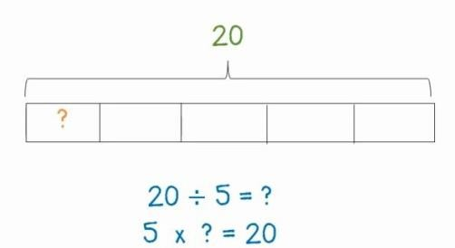 | 28 ÷ 7 = 4  Divide 28 into 7 groups. How many are in each group?
Division within arrays | Link division to multiplication by creating an array and thinking about the number  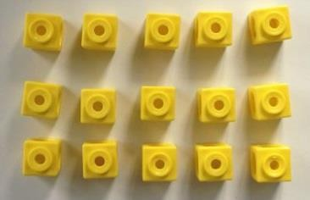  sentences that can be created.  Eg 15 ÷ 3 = 5 5 x 3 = 15  15 ÷ 5 = 3 3 x 5 = 15 | 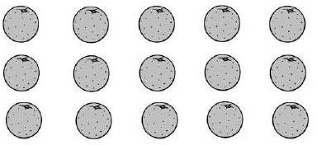  Draw an array and use lines to split the array into groups to make multiplication and division sentences. | Find the inverse of multiplication and division sentences by creating four linking number sentences.  7 x 4 = 28  4 x 7 = 28  28 ÷ 7 = 4  28 ÷ 4 = 7

Division with a remainder | 14 ÷ 3 =  Divide objects between groups and see how much is left over  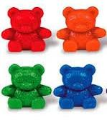   | Jump forward in equal jumps on a number line then see how many more you need to jump to find a remainder.  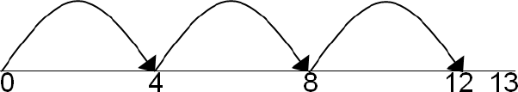  Draw dots and group them to divide an amount and clearly show a remainder.  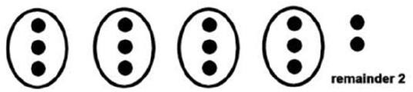 | Complete written divisions and show the remainder using r.  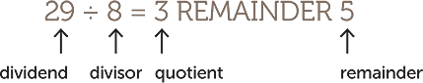
Short division | 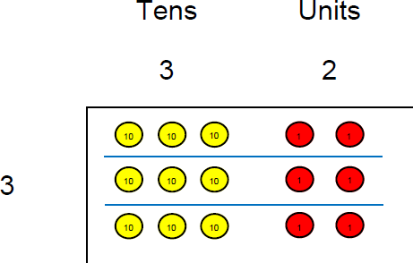  Use place value counters to divide using the bus stop method alongside  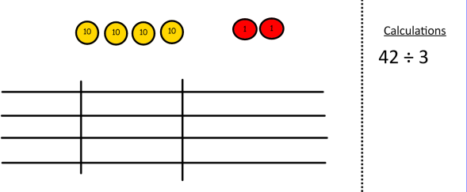  42 ÷ 3=  Start with the biggest place value, we are sharing 40 into three groups. We can put 1 ten in each group and we have 1 ten left  over. | 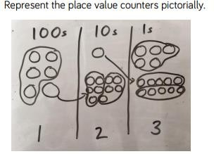 | 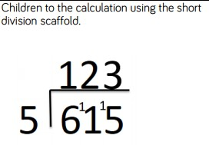

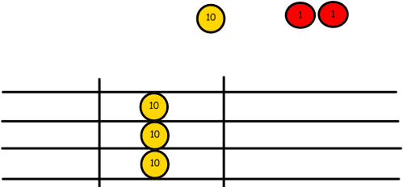
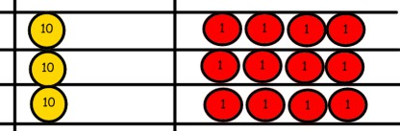
We exchange this ten for ten ones and then share the ones equally among the groups.

We look how much in 1 group so the answer is 14.
Long division using place value counters. | 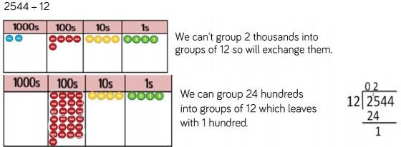

 | 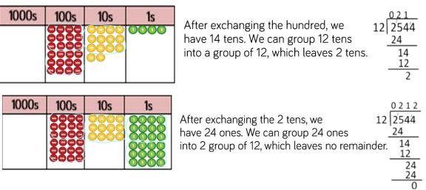
Conceptual variation; different ways to ask children to solve 615÷5
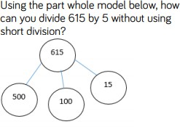 |  | 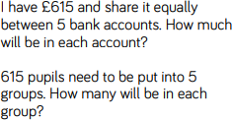 | 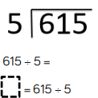 | 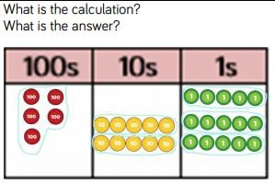

Glossary
- digit – a number with 2 digits like 23, 45, 12 or 60
- digit – a number with 3 digits like 123, 542, 903 or 561
Addition facts – knowing that 1+1 = 2 and 1+3 = 4 and 2+5 = 7. Normally we only talk about number facts with totals of 20 and under.
Array -An array is an arrangement of a set of numbers or objects in rows and columns –it is mostly used to show how you can group objects for repeated addition or subtraction.
Bridge to ten – a strategy when using number lines. Adding a number that takes you to the next ‘tens’ number.
Bus Stop Method - traditional method for division with a single digit divisor Concrete apparatus – objects to help children count – these are most often cubes (multilink) but can be anything they can hold and move.
Dienes (hundreds, tens and ones blocks), Numicon, Cuisenaire rods are also referred to as concrete apparatus.
Decimal number – a number with a decimal point.
Divisor – the smaller number in a division calculation. The number in each group for chunking.
Double – multiply a number by 2.
Exchanging – Moving a ‘ten’ or a ‘hundred’ from its column into the next column and splitting it up into ten ‘ones’ or ten ‘tens’ and putting it into a
different column.
Expanded Multiplication – a method for multiplication where each stage is written down and then added up at the end in a column.
Find the difference – A method for subtraction involving counting up from the smaller to the larger number.
Grid method – a method for multiplying two numbers together involving partitioning.
Half - a number, shape or quantity divided into 2 equal parts.
Halve – divide a number by 2.
Integer - a number with no decimal point.
Inverse – the opposite operation. Addition is the inverse of subtraction, multiplication is the inverse of division.

Long Multiplication – column multiplication where only the significant figures are noted.
Number bonds to ten – 2 numbers that add together to make ten, like 2 and 8, or 6 and 4.
Number bonds to 100 – 2 numbers that add together to make 100 like 20 and 80, or 45 and 65 or 12 and 88.
Number line – a line either with numbers or without (a blank number line). Children use this tool to help them count on for addition of subtraction and also in multiplication and division.
Number sentence – writing out a calculation with just the numbers in a line E.G. 2+4=6 or 35 ÷7 = 5 or 12 x 3 =36 or 32 – 5 = 27.
Ones- a single whole number. The right hand column in column methods is the ‘ones’ column
Partition – split up a larger number into the hundreds, tens and ones. E.G.342 – 300 and 40 and 2.
Place Value – knowing that in the number 342 – the ‘3’ means ‘3 hundreds’, the ‘4’ means ‘4 tens’ and the ‘2’ means ‘2’.
Quarter - a number, shape or quantity divided into 4 equal parts.
Recombine – for addition, once you have partitioned numbers into hundreds, tens and ones then you have to add then hundreds together, then add the tens to that total, and then add the ones to that total.
Remainder – a whole number left over after a division calculation.
Repeated addition – repeatedly adding groups of the same size for multiplication.
Significant digit – the digit in a number with the largest value. E.G in 34 – the most significant digit is the 3, as it has a value of ‘30’ and the ‘4’ only has a value of ‘4’.
Single digit – a number with only one digit. These are always less than 10.
Taking away – a method for subtraction involving counting backwards from the larger to the smaller number.
Tens number - a number in the ten times tables – 10,20,30,40 50, etc.
Unit – a quantity used as a standard measurement e.g. length. We teach the term ‘one’

Appendix One
