St Patrick’s Catholic Primary School – Universal Offer Statement
Universal provision isn’t where support begins – it’s where inclusion lives. ​
It is the daily, intentional practice of teachers who understand that outstanding teaching is outstanding intervention.​
At St Patrick’s Catholic Primary School, our mission, “May Christ be seen in us,” guides everything we do. We are committed to providing a high-quality, inclusive education for all pupils, ensuring that every child—regardless of background, ability or need—feels valued, supported and empowered to thrive. The power of our Universal Provision lies in its simplicity and consistency: when every member of education staff owns the strategy, every pupil benefits.​
By embedding these strategies across every classroom, we’re not only meeting needs – we’re pre-empting them.​
Our Universal Provision for all pupils includes:
- A nurturing and inclusive environment where diversity is celebrated and every child is encouraged to reach their full God-given potential.
- High-quality teaching and learning, underpinned by a broad and balanced curriculum that is accessible to all.
- Early identification of needs through ongoing assessment and observation, ensuring timely support and intervention.
- Scaffolding strategies embedded in classroom practice to support learners in accessing age-appropriate content and developing independence.
- Adapted instruction tailored to meet the varied learning styles and needs of all pupils.
- Social, emotional and mental health support, including pastoral care and wellbeing initiatives.
- Opportunities for spiritual development, prayer, worship and reflection, rooted in our Catholic ethos.
SEND and Inclusion
We recognise that some pupils may require additional support to access learning. Our Special Educational Needs and Disabilities (SEND) provision is guided by the SEND Code of Practice (2015) and includes:
- A graduated response to need, starting with universal provision and progressing to targeted and specialist support where necessary.
- Reasonable adjustments made to ensure full participation in school life, including physical access, communication aids, and adapted resources.
- A commitment to inclusive practice, ensuring pupils with SEND are educated alongside their peers wherever possible.
- Close collaboration with parents, carers, and external agencies to develop and review SEND Support Plans (Pupil Passports) and Education, Health and Care Plans (EHCPs).
- A designated SENDCo who oversees provision and ensures staff are trained and confident in supporting diverse needs.
Our Commitment to Equity and Excellence
We believe that every child has the right to succeed, and we work tirelessly to remove barriers to learning. Through inclusive teaching, reasonable adjustments, and scaffolded support, we ensure that all pupils—regardless of ability—can access the curriculum, develop resilience, and achieve their personal best

St Patrick’s Catholic Primary School’s Graduated Response
At St. Patrick’s Catholic Primary School, we are committed to ensuring that every child receives the support they need to thrive academically, socially, and emotionally. Our approach to Special Educational Needs and Disabilities (SEND) is rooted in the principles of inclusion, early identification, and tailored support. We follow a graduated response model, which allows us to meet the diverse needs of our pupils through a structured and responsive framework.
The Graduated Response: Three Waves of Provision
Our SEND provision is organised into three waves, each offering increasing levels of support:
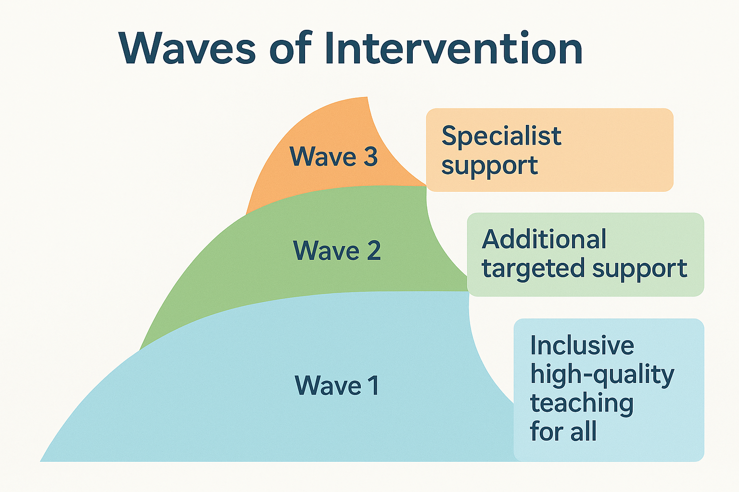
Wave 1
Wave 1 is the effective inclusion of all pupils in high-quality everyday personalised teaching. Such teaching will, for example, be based on clear objectives that are shared with the children and returned to at the end of the lesson; scaffolded and adapted to meet the individual needs of the pupils in each class; include pre-taught skills and vocabulary where necessary; carefully explained new vocabulary; use of lively, interactive teaching styles that make maximum use of visual and kinaesthetic as well as auditory/verbal learning and make use of regular opportunities to revisit prior learning, so that pupils can know more, learn more and remember more. Approaches like these are the best way to reduce, from the start, the number of children who need extra help with their learning or behaviour.
Wave 2 is a specific, additional and time-limited intervention provided for some children who need help to accelerate their progress to enable them to work at or above age-related expectations. Wave 2 interventions are often targeted at a group of children with similar needs.
Wave 3 is targeted provision for a minority of children where it is necessary to provide highly tailored intervention to accelerate progress or enable children to achieve their potential. This may include one to one or specialist interventions.
Each wave is broken down into 4 further categories of provision:
Cognition and Learning
Cognition is the umbrella term for a child’s learning skills. It is their ability to process information, reason, remember and relate.
Communication and Interaction
Communication and Interaction is the ability to communicate with others. This includes the use of speech sounds, language, gestures, facial expressions and body language.
Sensory and Physical
There are a wide range of sensory and physical difficulties that affect children and young people across the ability range.
Children and young people with a visual impairment (VI) or a hearing impairment (HI) may require specialist support and equipment to access their learning.
Some children and young people with a physical disability (PD) require additional on-going support and equipment to access all the opportunities available to their peers.
Social, Emotional and Mental Health
Children and young people who have difficulties with their emotional and social development may have immature social skills and find it difficult to make and sustain healthy relationships.
These difficulties may be displayed through the child or young person becoming withdrawn or isolated, as well as through challenging, disruptive or disturbing behaviour.
Our offer will include (but is not limited to):
Area of Need | Wave 1 | Wave 2 | Wave 3
Cognition and Learning | Inclusive Quality First Teaching  • Adapted curriculum planning and delivery  • In-class small-group TA support  • In-class targeted teacher support  •Pitched questioning  •Modelling of skills  • High expectations  • Increased visual aids / modelling etc  • Visual timetables  • Use of writing frames  • Access to ICT to support learning and presentation  •Literacy/Vocabulary Mats across the curriculum  • Spiritual, Moral, Social, Cultural focus in lessons  • Extra-curricular clubs  • Whole school reading  • Transition Processes  • Liaison with parents  Reading development  • Specific, timely class group support from LSA | • Multi-sensory tasks consistently modified to take account of literacy or recording difficulties by Class Teacher, Small Group Work, Trauma-informed or SEND-trained TA  • RWI or Fresh Start Interventions  • Focussed strategies for groups/classes  • Targeted catch up numeracy addressing misconceptions  • Targeted Homework Club  • Catch up programmes – Literacy and numeracy  • Learning mentors  • ICT support for keyboard skills and adapted technological resources | Small group or 1:1 literacy/ numeracy intervention  • Access Arrangements  • External Agency Support – Educational Psychologist, Specialist Teaching Services, CAMHS, SALT  • Personalised activities in curriculum areas
Communication and Interaction | Inclusive Quality First Teaching  •Pitched questioning  • Reduced pace of teacher talk  • Visual Support – check lists, literacy/vocabulary mats/books, aide memoirs, small white boards  Effective use of collaborative group  work  • Groups chosen sensitively to take  account of and include mixed abilities  and strengths of personality.  • Use of symbols  • Circle Time/PSHE, Speaking and  Listening  Pupil’s with sensory perceptual  differences seated in the best available  defined area, i.e. Away from  distractions, at the front of the class,  away from visual displays and windows.  • Checking out understanding of text by  encouraging pupil re-tell/re-phrase  story/text  • Structured school and classroom routines  • Visual timetables  • Personalised curriculum delivery • Certificates home • Assemblies reinforcing school ethos  • School Council  • After school clubs – sporting, academic, creative and social • Staff modelling and reinforcing appropriate behaviour  • Social Stories  • Whole school INSET with regular reinforcement for all staff  • Awareness by all staff of different particular needs  • Inclusive Development Programme for Staff INSET/Training for staff  • Provide Teacher Toolkits and monitor their use and impact  • Transition Process  • Liaison with parents | • In class support with focus on  supporting speech and language  • ICT – Clicker, In Print visuals software  • Social Communication Programme  • Multi-sensory activities to take account  of Speech and Language /ASD  associated difficulties  • Social skills groups  • BLAST (EY) or Talkboost (KS1 &2)  • Sensory kit activities  Sensory Circuit | • Individual work on: Narrative,  Vocabulary Enhancement, Social  Skills, Emotional Literacy, Zones of Regulation, Self-Awareness,  Memory, Literacy, Mathematics  and Life-skills  • Social Communication  Programme  • Multi-sensory activities to take  account of Speech and Language  /ASD associated difficulties  • Direct teaching to develop verbal  and non-verbal communications  • Use of visual cues to support  meaning – social stories  • Speech and Language support /  advice  • Visual timetables / now and next  resources  • Use of ICT to record and support  within the learning  • Advice from outside agencies to  develop programmes, strategies  and approaches in collaboration  with the school  • Referral to Speech, Language and  Communication Therapists, Educational Psychologist, THRIVE assessments and to CAMHS  - Use of quiet, sensory breakout rooms to aid regulation
Physical and Sensory | • Staff aware of implications of physical  impairment  • Writing slopes  • Standing Desks  • Pencil grips  Handwriting Tasks  • Extra time to complete tasks  • TA Support  • Accessibility of building and hygiene facilities  • Coloured Paper/overlays  • Large print  • Audio Books  • Seating Plans  • Awareness of background noise  • Use of school bulletin to regularly  update staff  • Teacher Toolkits  • Liaison with parents  • Sensory toys | • Additional keyboard skills training  • Additional fine motor skills practice such as peg boards, putty, dough disco, tweezers etc.  • In class support for supporting access and safety  • | • External Agency Involvement –  Sensory Support, Hearing and  Vision specialists, Range of hospital and medical staff, OT  • Adapting materials for pupils with  co-ordination difficulties  • Advice and/or support from an Occupational Therapist  • Advice and/or support from a Physiotherapist  • Advice & strategies for all staff.  • Individual support in class  • Wobble Cushion  • Ear Defenders
Social, Emotional and Mental Health | • Inclusive Quality First Teaching  Behaviour and relationships policy  Zones of Regulation  Feelings and Emotions cards  • Staff training - child protection, safeguarding and attachment/trauma including the PACE approach  • School nurse drop-ins  • Collaboration with local PCSOs and police  •Movement breaks  •Quiet reflection and prayer throughout the day  • Whole class strategies and advice to teachers from outside agencies e.g. OT  • Teacher presence at the gate at the start and end of each day  •Seating plans  • Whole school and class reward systems  promoting positive learning behaviour,  reward points and certificates  • RSE/PSHE Curriculum  • Additional Monitoring during unstructured times –  structured play activities  • Whole school/Class charters  • Whole school policy for behaviour management with graduated response  linked to waves of provision  • Break supervision to help manage free/unstructured time  • Assemblies/ Celebration of the Word  • Restorative behaviour management techniques  circulated to all staff  • Transition process  • Adaptations to class routines  • Daily timetables  • Liaison with parents/carers  • Key Stage mentors | •Nurture groups  • Rainbows support programme  • Temporary change of work location  • Temporary use of time out or regulation space  • Teaching of calming techniques  • Adaptation of curriculum to match needs.  • Suggested individualised classroom strategies from outside agencies e.g. OT  • Extra focus on personal and social education, e.g. strategies to manage  feelings, skills of friendship, self-awareness, relationships, conflict resolution – Social Stories  • Social skills group training | • 1:1 support for social skills  • Individual offer of counselling  • Individual reward system where appropriate  • Rainbows support programme  • Social skills training  • Emotional Resilience  • Advice from EP / Specialist  services  • Personalised Timetables  • Parent Meetings  • Support from External agencies  • Education Welfare Officer  • CAMHS  • Early Help Support  • in-school PSA  • Thrive Assessments

