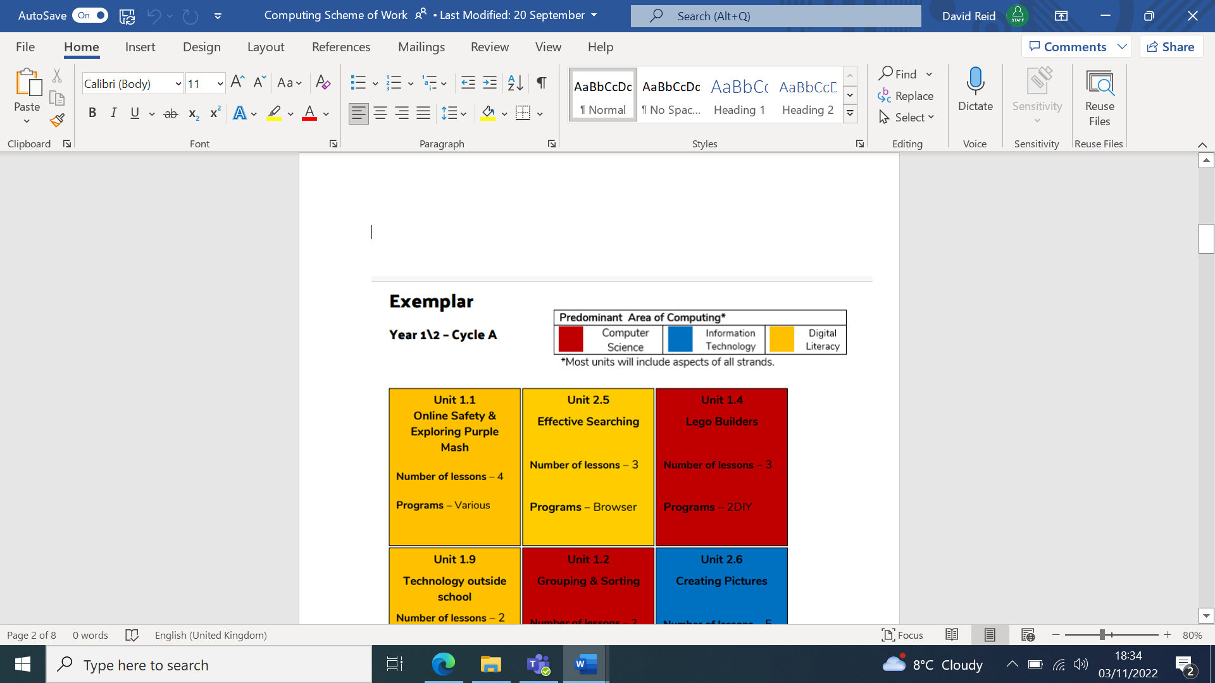**Year 1**

|  |  |  |  |  |
| --- | --- | --- | --- | --- |
| 1. understand what algorithms are, how they are implemented as programs on digital devices, and that programs execute by following precise and unambiguous instructions 2. create and debug simple programs 3. use logical reasoning to predict the behaviour of simple programs 4. use technology purposefully to create, organise, store, manipulate and retrieve digital content 5. recognise common uses of information technology beyond school 6. use technology safely and respectfully, keeping personal information private; identify where to go for help and support when they have concerns about content or contact on the internet or other online technologies | | | | |
| Topic 1  Grouping and Sorting  (2 weeks)  NC Statement- 1, 2 and 3 | Topic 2  Pictograms  (3 lessons)  NC Statement- 4 | Topic 3  Lego Builders  (3 weeks)  NC Statement-4 | Topic 4  Animated Story Book  (5 weeks)  NC Statement- 4 | Topic 5  Coding  (5 weeks)  NC Statements 1, 2 and 3 |

**Year 2**

|  |  |  |  |
| --- | --- | --- | --- |
| 1. understand what algorithms are, how they are implemented as programs on digital devices, and that programs execute by following precise and unambiguous instructions 2. create and debug simple programs 3. use logical reasoning to predict the behaviour of simple programs 4. use technology purposefully to create, organise, store, manipulate and retrieve digital content 5. recognise common uses of information technology beyond school 6. use technology safely and respectfully, keeping personal information private; identify where to go for help and support when they have concerns about content or contact on the internet or other online technologies | | | |
| Topic 1  Coding  (7 weeks)  NC Statement- 1, 2 and 3 | Topic 2  Spreadsheets  (5 weeks)  NC Statement- 4 | Topic 3  Effective Searching  (3 weeks)  NC Statement- 4 and 5 | Topic 4  Making music  (3 weeks)  NC Statement- 4 |

**Additional KS1 Class**

|  |  |  |  |  |
| --- | --- | --- | --- | --- |
| 1. understand what algorithms are, how they are implemented as programs on digital devices, and that programs execute by following precise and unambiguous instructions 2. create and debug simple programs 3. use logical reasoning to predict the behaviour of simple programs 4. use technology purposefully to create, organise, store, manipulate and retrieve digital content 5. recognise common uses of information technology beyond school 6. use technology safely and respectfully, keeping personal information private; identify where to go for help and support when they have concerns about content or contact on the internet or other online technologies | | | | |
| Topic 1  Maze Explorers  NC Statement- 1, 2 and 3 | Topic 2  Questioning  NC Statement- 4 | Topic 3  Presenting Ideas  NC Statement- 4 | Topic 4  Creating Pictures  NC Statement- 4 | Topic 5  Technology Outside School  NC Statement- 4 and 5 |

**Year 3**

|  |  |  |
| --- | --- | --- |
| 1. design, write and debug programs that accomplish specific goals, including controlling or simulating physical systems; solve problems by decomposing them into smaller parts 2. use sequence, selection, and repetition in programs; work with variables and various forms of input and output 3. use logical reasoning to explain how some simple algorithms work and to detect and correct errors in algorithms and programs 4. understand computer networks, including the internet; how they can provide multiple services, such as the World Wide Web, and the opportunities they offer for communication and collaboration 5. use search technologies effectively, appreciate how results are selected and ranked, and be discerning in evaluating digital content 6. select, use and combine a variety of software (including internet services) on a range of digital devices to design and create a range of programs, systems and content that accomplish given goals, including collecting, analysing, evaluating and presenting data and information 7. use technology safely, respectfully and responsibly; recognise acceptable/unacceptable behaviour; identify a range of ways to report concerns about content and contact | | |
| Topic 1  Coding  (7weeks)  NC Curriculum- 1, 2 and 3 | Topic 2  Spreadsheets  (5 weeks)  NC Curriculum- 6 | Topic 3  Email  (6weeks)  NC Curriculum- 4, 6 and 7 |

**Year 3/4**

|  |  |  |  |
| --- | --- | --- | --- |
| 1. design, write and debug programs that accomplish specific goals, including controlling or simulating physical systems; solve problems by decomposing them into smaller parts 2. use sequence, selection, and repetition in programs; work with variables and various forms of input and output 3. use logical reasoning to explain how some simple algorithms work and to detect and correct errors in algorithms and programs 4. understand computer networks, including the internet; how they can provide multiple services, such as the World Wide Web, and the opportunities they offer for communication and collaboration 5. use search technologies effectively, appreciate how results are selected and ranked, and be discerning in evaluating digital content 6. select, use and combine a variety of software (including internet services) on a range of digital devices to design and create a range of programs, systems and content that accomplish given goals, including collecting, analysing, evaluating and presenting data and information 7. use technology safely, respectfully and responsibly; recognise acceptable/unacceptable behaviour; identify a range of ways to report concerns about content and contact | | | |
| Topic 1  Coding  (7 weeks)  NC Curriculum- 1, 2 and 3 | Topic 2  Presenting  (5 weeks)  NC Curriculum- 4, 6 and 7 | Topic 3  Branching Databases  (4 weeks)  NC Curriculum- 6 | Topic 4  Graphing  (3 weeks)  NC Curriculum- 4 |

**Year 4**

|  |  |  |  |
| --- | --- | --- | --- |
| 1. design, write and debug programs that accomplish specific goals, including controlling or simulating physical systems; solve problems by decomposing them into smaller parts 2. use sequence, selection, and repetition in programs; work with variables and various forms of input and output 3. use logical reasoning to explain how some simple algorithms work and to detect and correct errors in algorithms and programs 4. understand computer networks, including the internet; how they can provide multiple services, such as the World Wide Web, and the opportunities they offer for communication and collaboration 5. use search technologies effectively, appreciate how results are selected and ranked, and be discerning in evaluating digital content 6. select, use and combine a variety of software (including internet services) on a range of digital devices to design and create a range of programs, systems and content that accomplish given goals, including collecting, analysing, evaluating and presenting data and information 7. use technology safely, respectfully and responsibly; recognise acceptable/unacceptable behaviour; identify a range of ways to report concerns about content and contact | | | |
| Topic 1  Coding  (6 weeks)  NC Curriculum- 1, 2 and 3 | Topic 2  Logo  (4 weeks)  NC Curriculum- 1, 2 and 3 | Topic 3  Writing for different audiences  (5 weeks)  NC Curriculum- 6 | Topic 4  Animation  (3 weeks)  NC Curriculum- 4 |

**Year 4/5**

|  |  |  |  |
| --- | --- | --- | --- |
| 1. design, write and debug programs that accomplish specific goals, including controlling or simulating physical systems; solve problems by decomposing them into smaller parts 2. use sequence, selection, and repetition in programs; work with variables and various forms of input and output 3. use logical reasoning to explain how some simple algorithms work and to detect and correct errors in algorithms and programs 4. understand computer networks, including the internet; how they can provide multiple services, such as the World Wide Web, and the opportunities they offer for communication and collaboration 5. use search technologies effectively, appreciate how results are selected and ranked, and be discerning in evaluating digital content 6. select, use and combine a variety of software (including internet services) on a range of digital devices to design and create a range of programs, systems and content that accomplish given goals, including collecting, analysing, evaluating and presenting data and information 7. use technology safely, respectfully and responsibly; recognise acceptable/unacceptable behaviour; identify a range of ways to report concerns about content and contact | | | |
| Topic 1  Coding  (6 weeks)  NC Curriculum- 1, 2 and 3 | Topic 2  Making Music  (4 weeks)  NC Curriculum- 6 | Topic 3  Effective Search  (3 weeks)  NC Curriculum- 4, 5 and 7 | Topic 4  Intro to AI  ( 5 weeks)  NC Curriculum- 6 |

**Year 5**

|  |  |  |
| --- | --- | --- |
| 1. design, write and debug programs that accomplish specific goals, including controlling or simulating physical systems; solve problems by decomposing them into smaller parts 2. use sequence, selection, and repetition in programs; work with variables and various forms of input and output 3. use logical reasoning to explain how some simple algorithms work and to detect and correct errors in algorithms and programs 4. understand computer networks, including the internet; how they can provide multiple services, such as the World Wide Web, and the opportunities they offer for communication and collaboration 5. use search technologies effectively, appreciate how results are selected and ranked, and be discerning in evaluating digital content 6. select, use and combine a variety of software (including internet services) on a range of digital devices to design and create a range of programs, systems and content that accomplish given goals, including collecting, analysing, evaluating and presenting data and information 7. use technology safely, respectfully and responsibly; recognise acceptable/unacceptable behaviour; identify a range of ways to report concerns about content and contact | | |
| Topic 1  Coding  (6 weeks)  NC Curriculum- 1, 2 and 3 | Topic 2  Spreadsheets  (6 weeks)  NC Curriculum- 6 | Topic 3  Word Processing (Microsoft Word)  (7 weeks)  NC Curriculum- 6 |

**Year 6**

|  |  |  |  |
| --- | --- | --- | --- |
| 1. design, write and debug programs that accomplish specific goals, including controlling or simulating physical systems; solve problems by decomposing them into smaller parts 2. use sequence, selection, and repetition in programs; work with variables and various forms of input and output 3. use logical reasoning to explain how some simple algorithms work and to detect and correct errors in algorithms and programs 4. understand computer networks, including the internet; how they can provide multiple services, such as the World Wide Web, and the opportunities they offer for communication and collaboration 5. use search technologies effectively, appreciate how results are selected and ranked, and be discerning in evaluating digital content 6. select, use and combine a variety of software (including internet services) on a range of digital devices to design and create a range of programs, systems and content that accomplish given goals, including collecting, analysing, evaluating and presenting data and information 7. use technology safely, respectfully and responsibly; recognise acceptable/unacceptable behaviour; identify a range of ways to report concerns about content and contact | | | |
| Topic 1: Coding  (6 weeks)  NC Curriculum- 1, 2 and 3  End Points: | Topic 2: Text Adventure  (5 weeks)  NC Curriculum-6  End Points: | Topic 3: Quizzing  (6 weeks)  NC Curriculum- 6  End Points: | Topic 4  Networks  (2 weeks)  NC Curriculum- 4 |