Cycle A Plan
Nursery | Rec
Autumn
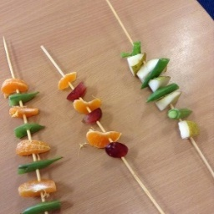
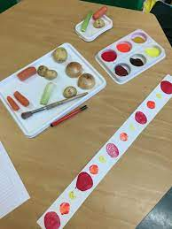
Pattern-Linked to our learning about repeating patterns in maths.

*Continuous provision staple.  Painting/Colour:  • Experimenting with and using primary colours  • Naming  • mixing (not formal) Learn the names of different tools that bring colour  • Use a range of tools to make coloured  • marks on paper  Sculpture & Collage:  • Start to use scissors appropriately to cut into materials.*  • Begin to cut and tear materials. *  • Stick and glue materials together.*  • Use junk objects to create their own designs.*  Printing:  • Awareness and discussion of patterns.  • Print with block colours  • Print with pre-made stamps and found objects. | Sculpture & Collage:  • Use scissors appropriately to cut into materials.*  • Cut and tear materials with increasing control.*  • Mould play dough or other soft materials, making round and flat shapes and adding texture.*  Painting/Colour:  • Use a brush or other tool to make marks with paint.  • Choose from a range of pre-mixed colours to create painted artworks.  • Paint simple shapes and images that can be recognised or explained by the child  Printing:  • Notice and continue simple patterns (ABAB/ ABBA)  • Simple symmetry.  • Print using pressing, rolling, rubbing and stamping using everyday objects, chosen to create a desired effect.
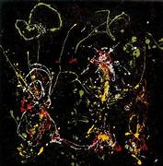
Jackson Pollock
Artwork based on ‘Firework’ by Jackson Pollock. Linking with the children’s experiences around Bonfire night.
Artist and Artwork Evaluation:  Can express their opinion  • Can identify generic features of an artwork. E.g. ‘it’s a flower’ ‘it’s blue’  Painting/Colour:  • Experimenting with and using primary colours  • Naming  • mixing (not formal) Learn the names of different tools that bring colour  • Use a range of tools to make coloured marks on paper | Artist and Artwork Evaluation:  Look at and discuss different artworks using simple sentences.  • Identify colours, objects and shapes in the artwork.  • Discuss their own artwork using simple language.  Painting/Colour:  • Use large muscle movements to paint and make marks.  • Use a brush or other tool to make marks with paint.  • Choose from a range of pre-mixed colours to create painted artworks.  • Paint simple shapes and images that can be recognised or explained by the child.
Christmas Crafts
Textiles:  • Handling, manipulating and enjoying using materials*  • Sensory experience*  • Thread beads onto a string.*  • Printing:  • Print with block colours  • Print with pre-made stamps and found objects.  Drawing:  • Begin to hold a pencil correctly and use it to make marks.  • Attempt to use other materials to make marks (crayons, felt tips, etc)  • Draw shapes that are beginning to be recognisable and appropriate e.g. a circle for a face.  •Represent their thoughts and feelings through art. * | Drawing:  • Begin to use a variety of drawing tools  • Use drawings to tell a story, Investigate different lines  • Explore different textures  • Encourage accurate drawings of people.  • Use drawing to tell a story.  • Investigate different lines.  Printing:  • Print using pressing, rolling, rubbing and stamping using everyday objects, chosen to create a desired effect.
Spring
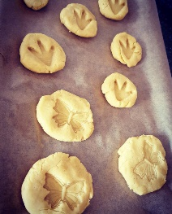
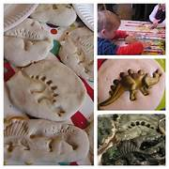
Fossils-Making fossils using either salt dough or biscuit dough. Making treats for our Dinosaur party.

Food & Nutrition:  •In small groups,Mix pre-prepared ingredients with the support of an adult, safely and hygienically.  Sculpture & Collage/Resistant Materials:  Handling, feeling, enjoying and manipulating materials  • Food Tech:  • In small groups, Mix pre-prepared ingredients with the support of an adult, safely and hygienically  • Understand that fruit and vegetables grow.  • Use a blunt knife to spread butter or jam (or alternative) on a cracker or bread. | Food & Nutrition:  • Mix pre-prepared ingredients with the support of an adult, safely and hygienically  • Use tools such as blunt knives or cookie cutters.  Sculpture & Collage/Resistant Materials:  Mould play dough or other soft materials, making round and flat shapes and adding texture  Food Tech:  • Understand that fruit and vegetables grow, and which ones are grown in the UK.  • Mix pre-prepared ingredients with the support of an adult, safely and hygienically  • Use tools such as blunt knives or cookie cutters.
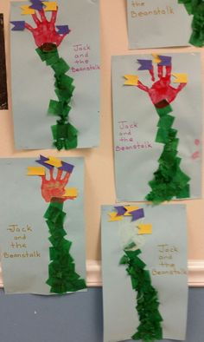
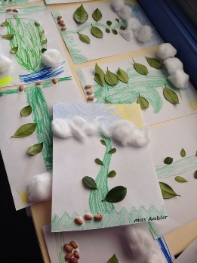
Up the Beanstalk -Painting/collage inspired by Traditional Tales.

Drawing:  Begin to hold a pencil correctly and use it to make marks.  • Attempt to use other materials to make marks (crayons, felt tips, etc)  • Represent their ideas and feelings through art.  • Draw shapes that are beginning to be recognisable and appropriate e.g. a circle for a face.  Painting/Colour:  • Experimenting with and using primary colours  • Naming  • mixing (not formal)  Learn the names of different tools that bring colour  • Use a range of tools to make coloured marks on paper  Sculpture/Collage:  • Handling, feeling, enjoying and manipulating materials  • Start to use scissors appropriately to cut into materials.  • Begin to cut and tear materials.  • Stick and glue materials together. | Drawing:  Begin to use a variety of drawing tools  • Use drawings to tell a story Investigate different lines  • Explore different textures  • Encourage accurate drawings of people  Painting/Colour:  Use a brush or other tool to make marks with paint.  • Choose from a range of pre-mixed colours to create painted artworks.  • Paint simple shapes and images that can be recognised or explained by the child. • Use large muscle movement to paint and make marks.  Sculpture/Collage:  Simple collages  • Use scissors appropriately to cut into materials.  • Cut and tear materials with increasing control.
Summer
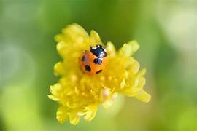
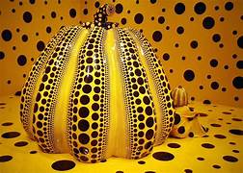
Yayoi Kusama Minibeasts!-Making spotty minibeasts inspired by Kusama’s spots.
Artist & Artworks:  • Can express their opinion  • Can identify generic features of an artwork. E.g. ‘it’s a flower’ ‘it’s blue’  Painting/Colour:  • Experimenting with and using primary colours  • Naming | Artist & Artworks:  • Look at and discuss different artworks using simple sentences.  • Identify colours, objects and shapes in the artwork.  • Discuss their own artwork using simple language.
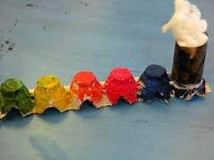
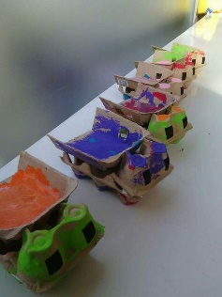
Up, Up and away -Making models using junk inspired by transport.
Design process:  • Understand items have different purposes.  • Make to create an outcome with guided support.  • Begin to explain why they chose their materials.  • Know what they have made. E.g ‘a tiger’  Sculpture/Collage:  •Handling, feeling, enjoying and manipulating materials  • Constructing: Building and destroying  • Start to use scissors appropriately to cut into materials.  • Begin to cut and tear materials.  • Stick and glue materials together.  • Use junk objects to create their own designs. | Design process:  • Discuss what a product does or needs to do  • Explore the qualities of a range of materials • Make to create an outcome.  • Explain why they chose their materials.  • Explain what they have made.  Sculpture & Collage:  • Simple collages  • Use scissors appropriately to cut into materials.  • Cut and tear materials with increasing control.  • Mould play dough or other soft materials, making round and flat shapes and adding texture.  • Constructing:  Building for a purpose and destroying  • Begin to consider how they join materials together.

Year 1 | Year 2
Autumn
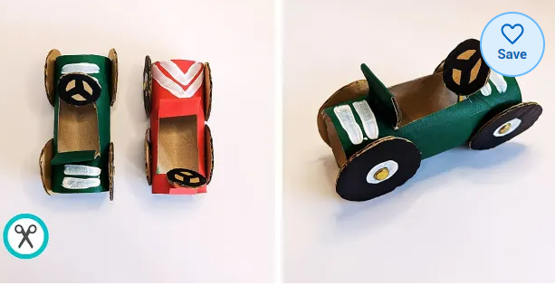
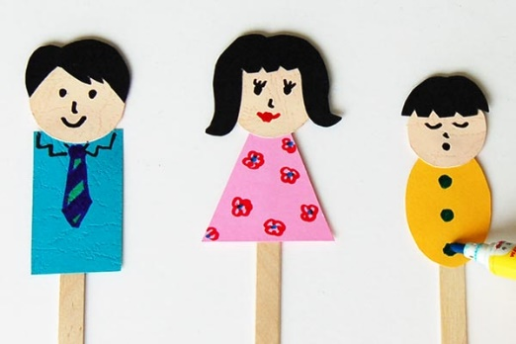
Toy Shop- designing and making basic toys to tie in with the ‘Toys from the past’ topic.
Some suggested products:
- Punch and Judy stick puppets.
- Push pin car.

https://www.twinkl.co.uk/resource/toilet-roll-car-craft-transport-crafts-t-tc-1683802951

Sculpture & collage:  • Make simple joins  • Begin to select materials and tools based on their properties. E.g. sellotape or glue.  - Use materials to make known objects for a purpose  Design process:  • As a group or class: work from a basic brief to generate ideas and design a simple product fit for purpose and audience.  • As a group or class: explore suitability of common materials before making a choice.  • Basic recording of ideas.  • Make a simple mock up as either individually or as a class. | Sculpture & Collage:  • Build structures, exploring how they can be made stronger, stiffer and more stable.  • Select materials and tools based on their properties.  Design process:  • Work from a basic brief to generate ideas and design a simple product fit for purpose and audience.  • Explore suitability of common materials before making a choice.  • Show awareness of some products similar to their design.  • Develop ideas, communicating and recording them in a suitable way (e.g. design book, design page, mind map)  • Make a simple mock-up. E.g. simplified paper version  • Make a final product.  • Evaluate their final product – what went well? Did they follow the brief?
Food Tech
• Cut soft foods safely and hygienically with support, using an appropriate tool.  • Measure using measuring cups and spoons.  • Combine ingredients with support to make a simple recipe. | • Cut soft foods safely and hygienically using an appropriate tool.  • Measure using scales with support.  • Assemble ingredients to make a simple recipe.
Christmas Crafts
Sculpture & Collage:  • Collage according to specific qualities. E.g. independently sorting blue scraps for the sky.  • More complex collages.  • Follow basic procedures for safety, e.g. walking sensibly with scissors.  • Construct:  • Use materials to make known objects for a purpose  • Begin to select materials and tools based on their properties. E.g. sellotape or glue.  Carve, pinch and roll slabs using a modelling media.  Painting/Colour:  • Use different sized paintbrushes appropriately with increasing control to make a range of marks with paint.  • Mix primary colours to make secondary colours.  • Begin to describe colours by objects | Sculpture & Collage:  • Overlapping and overlaying to create effects in collage.  • Follow basic procedures for safety.  • Select materials and tools based on their properties.  • Mould, carve and cut soft materials using appropriate tools.  Painting/Colour:  • Make as many tones of one colour as possible (using white)  • Darken colours without using black  • Use poster paints and watercolours on traditional surfaces.
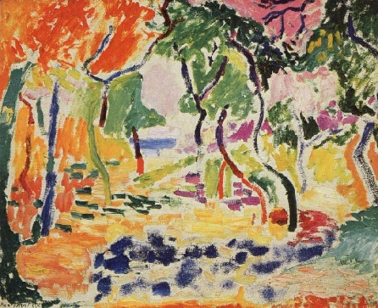
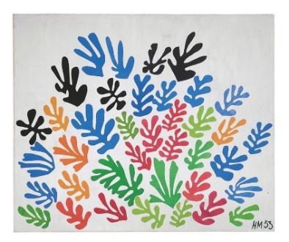
Matisse-Collage and landscapes.

Exploring Matisse- his printing/collage plus his landscapes.
Collage with paper for his block work and painting/colour for his landscapes.

Painting/Colour:  • Use different sized paintbrushes appropriately with increasing control to make a range of marks with paint.  • Mix primary colours to make secondary colours.  • Begin to describe colours by objects.  Sculpture & Collage:  • Collage according to specific qualities. E.g. independently sorting blue scraps for the sky.  • More complex collages.  • Follow basic procedures for safety, e.g. walking sensibly with scissors.  Artist & Artwork Evaluation:  • Look at and discuss different artworks using simple sentences, expressing a simple opinion about an artwork.  • Notice basic details/themes of an artist. E.g. ‘O’keefe likes flowers’. | Painting/Colour:  Make as many tones of one colour as possible (using white)  • Darken colours without using black  • Use poster paints and watercolours on traditional surfaces.  Sculpture & Collage:  • Overlapping and overlaying to create effects in collage.  • Follow basic procedures for safety.  • Mould, carve and cut soft materials using appropriate tools.  Drawing:  • Observe and draw landscapes.  Artist & Artwork Evaluation: Look at and discuss a range of artworks by artists, crafts people and designers across time, expressing a simple opinion about an artwork (no explanation).  •Notice details and familiar objects/ shapes/colours in an artwork including light and dark  •Make simple comparisons between artists and artworks.  •Begin to comment on how an artist/designer has used colour, pattern and shape.  Describe and discuss their own artworks, noting key details.
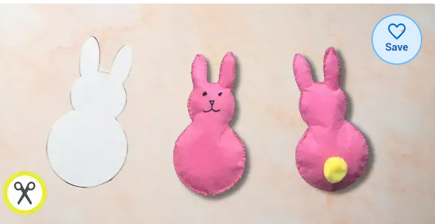
Easter Sewing

Making small felt bunnies or crosses for Easter. Drawing around a basic template before doing a running stitch around the outside leaving a small gap to leave room for stuffing to be poked through. To adapt you could use a pale pen to dot where to show where to poke through with the needle. This could be adapted further using thin foam and a hole punch for pre-prepared holes.

https://www.twinkl.co.uk/resource/easter-bunny-plushie-felt-template-sewing-activity-t-tc-1642599890
https://www.twinkl.co.uk/resource/cross-outline-t-tp-2549359

Textiles:  • Cut textiles using scissors and a basic template.  • Use a running stitch to join textiles using pre-prepared holes.  • Use large eyed needles or pre-threaded needles.  • Weaving using paper- Easter Baskets?  Design process:  • As a group or class: work from a basic brief to generate ideas and design a simple product fit for purpose and audience.  • As a group or class: explore suitability of common materials.  • Basic recording of ideas.  • Make a simple muck up either individually or as a class. | Textiles:  • Use a running stitch to join textiles either independently or with marked holes. E.g. attaching flaps of fabric to a sock to make bunny ears.  • Create simple weaving using paper or large strips of fabric.  • Use large eyed needles  Design process:  • Work from a basic brief to generate ideas and design a simple product fit for purpose and audience.  • Explore suitability of common materials before making a choice.  • Show awareness of some products similar to their design.  • Develop ideas, communicating and recording them in a suitable way (e.g. design book, design page, mind map)  • Make a simple mock-up. E.g. simplified paper version  • Make a final product.  Create simple weaving using paper or large strips of fabric.-Easter Baskets to put it in.
Summer
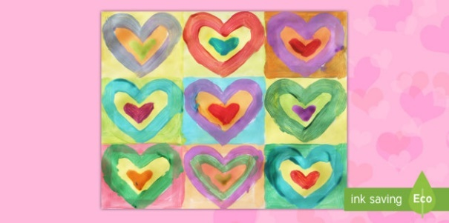
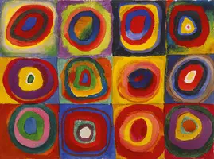
Colourful Kadinsky- Painting/Printing
Suggested activities could include:
• Artist study copying his work exactly using paint and brushes.
• Re-Imagining: favourite colours? Rainbow colour mixing versions. Different shape versions?
Printed version using a painted background and repeating stamping.
Artist & Artwork Evaluation:  • Look at and discuss different artworks using simple sentences, expressing a simple opinion about an artwork.  • Notice basic details/themes of an artist. E.g. ‘O’keefe likes flowers’.  Painting/Colour:  • Use different sized paintbrushes appropriately with increasing control to make a range of marks with paint.  • Mix primary colours to make secondary colours.  • Begin to describe colours by objects.  Printing/Pattern:  • Print with a growing range of objects  • Notice more complex patterns in nature and artworks, using this to create their own.  • Stencil printing using a pre- made stencil. | Artist & Artwork Evaluation: Look at and discuss a range of artworks by artists, crafts people and designers across time, expressing a simple opinion about an artwork (no explanation).  •Notice details and familiar objects/ shapes/colours in an artwork including light and dark  •Make simple comparisons between artists and artworks.  •Begin to comment on how an artist/designer has used colour, pattern and shape.  •Describe and discuss their own artworks, noting key details.  Painting/Colour:  • Explore how colour can portray mood and emotion. -How does her work make us feel with all the bright colours?  • Paint from observation and imagination.  • Make as many tones of one colour as possible (using white)  • Darken colours without using black  • Use poster paints and water colours on traditional surfaces.  • Use resist techniques.e.g. white crayon and water colour.  Printing/Pattern:  • Create simple mono prints (marbling, shaving foam, drawing on plastic/acetate).  • Make and use simple stencils to print  • Create pattern for purposes
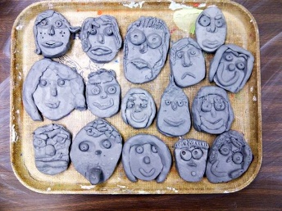
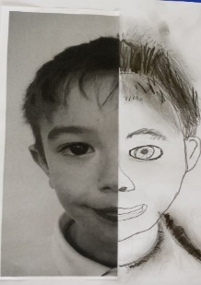
Portraits-Multimedia.
Creating self-portraits using various mediums for each portrait. E.g. a charcoal portrait, a collage portrait, Clay tile portrait.
• Drawing:  • Hold a pencil appropriately, making a range of marks and lines.  • Extend the variety of drawings tools. E.g. charcoal  • Record their work.  Observe anatomy (faces, limbs)  • Explore different textures  • Observe patterns  Sculpture & Collage:  • Collage according to specific qualities. E.g. independently sorting blue scraps for the sky.  • More complex collages.  • Follow basic procedures for safety, e.g. walking sensibly with scissors. | Drawing:  • Hold a pencil appropriately, making a range of marks and lines with a pencil and different materials, with control and awareness, using appropriate vocabulary to describe them.  • Record their work.  • Draw to express emotion using mark making (e.g. angry, happy).  • Discuss use of shadows, use of light and dark  Sculpture & Collage:  • Overlapping and overlaying to create effects in collage.  • Follow basic procedures for safety.  • Select materials and tools based on their properties.  • Mould, carve and cut soft materials using appropriate tools.

Year 3 | Year 4
Autumn
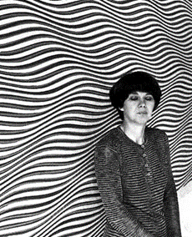
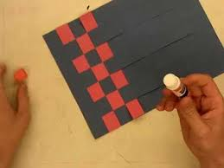
Bridget Riley- pattern/printing
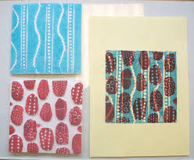
Repeated printing and paper weaving to mimic the style of Bridget Riley.
Artists & Artwork Evaluation:  • Begin to develop their knowledge of artists and artworks, expressing an opinion about an artwork, giving simple reasons why  • Make basic comparisons with between artists and artworks using formal elements language.  • Make links between their artwork and an artist.  • Basic analysis of an artwork using 1 formal element. e.g. looking solely at the line-work.  • Ask questions about artworks either individually or as a class.  Printing/Pattern  • Find and copy patterns from nature and architecture.  • Make and use more complex stencils to print.  Textiles:  • Create simple weaving using paper or smaller strips of fabric. | Artists & Artwork Evaluation:  • Continue to develop their knowledge of artists and artworks, expressing an opinion about an artwork, giving simple reasons why.  • Make comparisons with increasing confidence between artists and artworks, using the language of the formal elements studied.  • Make links between their work and the work of more than one artist.  • Discuss when and where an artwork was created (timeline and map).  • Analyse an artwork, commenting on the use of formal elements (line, shape, texture, pattern)  • Ask their own questions about artworks.  Printing/Pattern  • Find and copy more complex patterns from nature and architecture.  • Make and use stencils to print to create effect. E.g. 1 stencil to create basic shape and 1 stencil for detail.  • Design prints  Textiles:  • Basic weave using a cardboard loom.  Painting/Colour:  • Use more resist techniques-e.g. tape and ink.
Food Tech
• Cut foods safely and hygienically using an appropriate tool.  • Measure ingredients using scales. | • Cut foods safely and hygienically using an appropriate tool.  • Measure ingredients using scales or jugs.  • Follow recipes, starting to use techniques such as peeling, chopping, slicing, mixing, spreading, baking or kneading.  • Use a pan or oven with adult supervision and support.
Christmas Crafts
Painting/Colour:  • Introduce different types of brushes  • Mix shades and tints.  • Beginning to be able to match colours effectively to portray their subject or mimic an artist.  • Use cold and warm colours.  Drawing:  • Use felt tips, chalk pastels and oil pastels to add colour to their drawings.  • Hold a pencil and make marks with control.  • Initial sketches as a preparation for painting | Painting/Colour:  • Colour mixing and matching; tint, tone, shade.  • Use poster paints and watercolours with confidence to blend, wash, and create a range of effects.  • Use different brushes and marks to gain a desired effect (e.g. large brush for large area).  • Mix with purpose and accuracy an increasing range of colours from primary and secondary colours.  Drawing:  • Scale and proportion accurate drawings of whole people including proportion and placement.
Spring
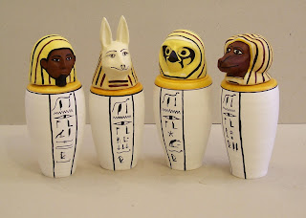
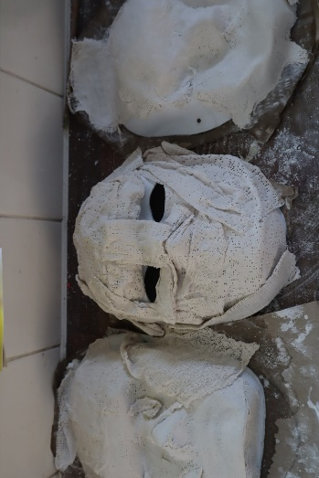
Ancient Egyptians- Masks/Canopic jars
Designing and creating ancient Egyptian death masks or canopic jars.
Sculpture & Collage/Resistant Materials:  • Independently follow basic procedures for safety.  • Choose appropriate materials by testing their properties either in small groups or as a class, using a prototype.  • Explore tools for a product based on their functional properties and aesthetics.  • Begin to explore how to strengthen, stiffen and reinforce a product using suitable materials.  • Shape, form, model and construct (malleable and rigid materials)  Design Process:  • Develop an idea, communicating and recording in a basic way (e.g. labelled drawing)  • Research products similar to their own.  • Make a mock-up. E.g a paper version of their mask. | Sculpture & Collage/Resistant Materials:  • Independently follow basic procedures for safety.  • Choose appropriate materials by testing their properties using a prototype.  • Choose appropriate tools for a product based on their functional properties and aesthetics.  • Strengthen, stiffen and reinforce a product using suitable materials.  • Sculpture clay and other materials with precision.  Design Process:  • Work from a brief to design an appealing, functional product fit for purpose and audience.  • Show awareness of products similar to their own.  • Develop an idea, communicating and recording it in a suitable way (e.g. annotated design page, diagrams, IT)  • Make a mock-up. E.g a paper version of their mask.  • Create a final idea and translate this into a final product which fits the brief.  • Evaluate their final product – what went well? Did they follow the brief? How could they improve their design?
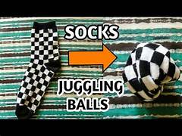
Juggling Balls

Testing, designing, and making juggling balls. Testing what filling to use inside or what material to make the ball out of.

Sculpture & Collage/resistant materials:  • Independently follow basic procedures for safety.  • Choose appropriate materials by testing their properties either in small groups or as a class, using a prototype.  • Explore tools for a product based on their functional properties and aesthetics.  • Begin to explore how to strengthen, stiffen and reinforce a product using suitable materials.  Design process:  • Work from a basic brief to design an appealing, functional product fit for purpose and audience.  • Explore some possible materials. With support, conducting a simple test to ensure suitability before making a choice.  • Research products similar to their own.  • Develop an idea, communicating and recording in a basic way (E.g. labelled drawing)  • Make a mock-up  • With support, create a final idea and translate this into a final product which fits the brief. Either individually or as a guided class design.  • Basic evaluate their final product – what went well? Is it fit for purpose? | Sculpture & Collage/resistant materials:  • Independently follow basic procedures for safety.  • Choose appropriate materials by testing their properties using a prototype.  • Choose appropriate tools for a product based on their functional properties and aesthetics.  • Strengthen, stiffen and reinforce a product using suitable materials.  Design Process:  • Perform basic tests, make simple prototypes/pattern pieces as appropriate. E.g. stitching prototypes.  • Work from a brief to design an appealing, functional product fit for purpose and audience.  • Show an awareness of products similar to their own.  • Develop an idea, communicating and recording it in a suitable way (e.g. annotated design page. Diagrams, IT)  • Create a final idea and translate this into a final product which fits the brief.  • Make a mock-up.  • Evaluate their final product – what went well? Did they follow the brief? How could they improve their design?
Summer
Holbein
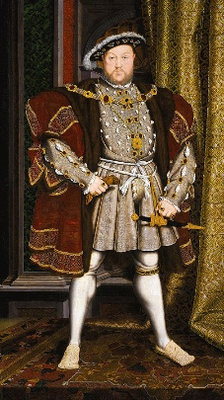
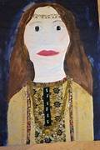
Artist study based on Holbeins Henry VIII portraits. Some suggested activities could include artists copies using different mediums-paint or oil pastel.
Painting/drawing self-portraits in the style of Holbein.

Drawing:  • Hold a pencil and make marks with control.  • Experiment with the potential of various pencils.  • Use felt tips, chalk pastels and oil pastels to add colour to their drawings.  • Close observation  • Draw both the positive and negative shapes  • Initial sketches as a preparation for painting  • Accurate drawings of people – particularly  • Faces  • Use sketchbooks to practice techniques and skills.  Painting/Colour:  • Colour mixing:  • Make detailed colour wheels  • Introduce different types of brushes  • Mix shades and tints.  • Beginning to be able to match colours effectively to portray their subject or mimic an artist.  • Use cold and warm colours.  Artist & Artwork Evaluation:  • Begin to develop their knowledge of artists and artworks, expressing an opinion about an artwork, giving simple reasons why.  • Ask questions about artworks either individually or as a class.  • Make basic comparisons between artists and artworks using formal language elements.  • Make links between their artwork and an artist  • basic analysis of an artwork using 1 formal element. E.g. looking solely at the linework. | Drawing:  • Shade, blend and add highlights to show dimension using a range of pencil grades.  • Use sketching strokes to draw and add texture, movement and depth.  • Identify and draw the effect of light  • Scale and proportion accurate drawings of whole people including proportion and placement  • Make more detailed observational drawings, beginning to capture facial expression.  • Record their work and add it to their sketchbook.  • Consider the placement and composition when drawing.  Painting/Colour:  • Colour mixing and matching; tint, tone, shade  • Use poster paints and watercolours with confidence to blend, wash, and create a range of effects.  • Use different brushes and marks to gain a desired effect (e.g. large brush for large area).  • Mix with purpose and accuracy an increasing range of colours  from primary and secondary colours.  Artist & Artwork Evaluation:  • Continue to develop their knowledge of artists and artworks, expressing an opinion about an artwork, giving simple reasons  why.  • Discuss when and where an artwork was created (timeline and map).  • Make comparisons with increasing confidence between artists and artworks, using the language of the formal elements studied.  • Make links between their work and the work of more than one artist.  Analyse an artwork, commenting on the use of formal elements (Line, shape, texture, pattern)  • Ask their own questions about artworks, developing them and sharing in class discussion.
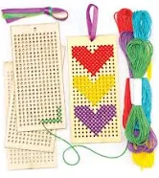
Bookmarks- Textiles Project
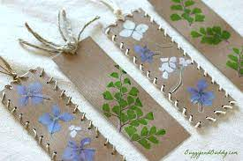
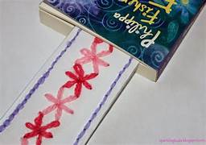
Designing and making a simple product, using embroidery and sewing to decorate.

Textiles:  • Use a running stitch to join textiles  • Cut textiles with scissors safely.  • Cut textiles with safety scissors.  • Use smaller eyed needles and finer threads  Design process:  • Work from a basic brief to design an appealing, functional product fit for purpose and audience.  • With support, create a final idea and translate this into a final product which fits the brief. Either individually or as a guided class design.  • Basic evaluate their final product – what went well? Is it fit for purpose? | Textiles:  • Decorate textiles using stamping, printing and simple embellishment.  • Thread a needle and tie a knot. Independently or with support.  Design Process:  • Work from a brief to design an appealing, functional product fit for purpose and audience.  • Create a final idea and translate this into a final product which fits the brief.  • Evaluate their final product – what went well? Did they follow the brief? How could they improve their design?

Year 5 | Year 6
Autumn
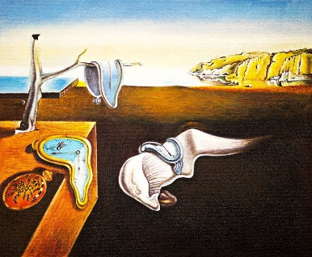
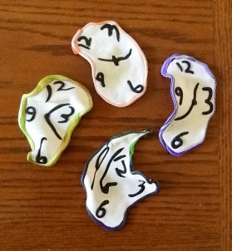
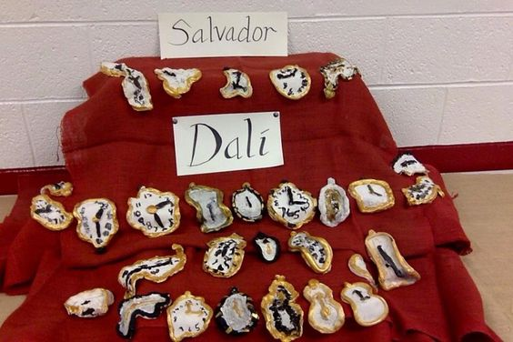
Salvador Dali- Clay

Designing and making clay ‘tiles’ inspired by the painting ‘Persistence of Memory’.
Artist/Artwork Evaluation:  • Basic analysis of an artwork, commenting on the use of formal elements (line, shape, texture, pattern) and comparing with other another artwork.  • Begin to describe and discuss their own artworks, justifying  their choices with appropriate vocabulary.  • Begin to discuss a range of key artists and artworks, expressing an opinion about an artwork, support with reasons.  • Compare 2 or more artworks and recognize patterns and key concepts between art movements.  • Understand links between their work and where techniques have been inspired from. E.g. Used dots because of looking at Yayoi Kusama.  Sculpture & Collage/Resistant Materials:  • Follow procedures for safety with a wider range of tools and processes.  • Cut and shape materials based on their design with developing accuracy.  • Sculpt clay and other materials with precision, including joining clay parts.  Design process:  • Develop and make a final product, which meets the brief criteria.  • Evaluate their final product, assess their product against the brief and consider improvements. | Artist/Artwork Evaluation:  • Analyse an artwork, commenting on the use of formal elements (line, shape, texture, pattern) and comparing with other artworks.  • Describe and discuss with confidence their own artworks,  justifying their choices with appropriate vocabulary.  • Can discuss a range of key artists and artworks with increasing confidence, expressing an opinion about an artwork, support with reasons.  • Compare multiple artworks and recognize patterns and key concepts between art movements.  • Make clear links between their work and the work of others, noting specific influences and techniques.  Sculpture & Collage/Resistant materials:  • Follow procedures for safety with a wider range of tools and processes.  Cut and shape materials based on their design with increasing accuracy.  • Combine techniques and materials to create 3D sculptures.  • Choose appropriate tools and methods to cut and form a wide range of materials.  • Design process:  • Research products similar and different to their own to inform their own design.  • Develop a design idea, communicating and recording it via a plan and a labelled diagram.  Painting/Colour:  • Paint on non-conventional surfaces.
Food Tech
• Measure ingredients with a degree of accuracy using an appropriate measuring device.  • Design their own simple savoury recipes and test them individually or collectively.  • Use a wider range of baking and cooking techniques | • Accurately measure ingredients with a appropriate measuring device.  • Design their own simple savoury recipes and test them.  • Use a range of baking and cooking techniques with increasing confidence (e.g. boiling, frying, baking, grilling, steaming, roasting, microwaving)
Christmas Crafts
Sculpture & Collage/resistant materials:  • Choose appropriate tools and methods to cut and form a wider range of materials, either guided or independently.  • Combine techniques and materials.  • Choose appropriate tools and methods to cut and form a wider range of materials, either guided or independently.  • Use a wider range of joining methods | Sculpture & Collage/Resistant materials:  • Choose appropriate tools and methods to cut and form a wider range of materials.  • Use a wider range of joining methods on a wide range of materials. E.g. textiles
Spring
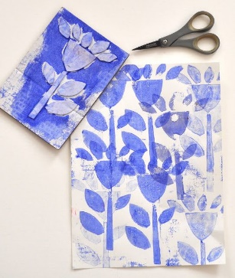
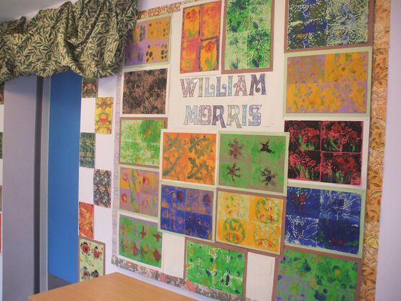
William Morris-Repeated printing

Designing and creating repeated printing using foam or other materials to create William Morris inspired prints.
Artist/Artwork Evaluation:  • Basic analysis of an artwork, commenting on the use of formal elements (line, shape, texture, pattern) and comparing with other another artwork.  • Begin to describe and discuss their own artworks, justifying  their choices with appropriate vocabulary.  • Begin to discuss a range of key artists and artworks, expressing an opinion about an artwork, support with reasons.  • Compare 2 or more artworks and recognize patterns and key concepts between art movements.  • Understand links between their work and where techniques have been inspired from.  Printing:  • Make increasingly complex stencils and use them to print in multiple layers and colours.  • Combine prints and pattern  • Design more complex prints  Drawing:  Record their work and add it to a sketchbook, annotating with  detailed analysis and evaluation  Sculpture & Collage/Resistant Materials:  • Follow procedures for safety with a wider range of tools and processes.  • Cut and shape materials based on their design with developing accuracy.  Painting/Colour:  • Colour mixing: hue, tint, tone, shades and mood  • Mix with increasing purpose and accuracy a wide range of colours. | Artist/Artwork Evaluation:  • Analyse an artwork, commenting on the use of formal elements (line, shape, texture, pattern) and comparing with other artworks.  • Describe and discuss with confidence their own artworks,  justifying their choices with appropriate vocabulary.  • Can discuss a range of key artists and artworks with increasing confidence, expressing an opinion about an artwork, support with reasons.  • Compare multiple artworks and recognize patterns and key concepts between art movements.  • Make clear links between their work and the work of others, noting specific influences and techniques.  Printing:  • Print onto a range of materials to explore texture and layers.  • Builds up images of whole or parts of items using various  techniques  • Create own abstract pattern. E.g. tessellating patterns  Drawing:  Record their work and add it to a sketchbook, annotating with detailed analysis and evaluation, using it to demonstrate their development of key skills  Sculpture & Collage/Resistant materials:  • Follow procedures for safety with a wider range of tools and processes.  • Cut and shape materials based on their design with increasing accuracy.  • Combine techniques and materials to create 3D sculptures  Painting/Colour:  • Colour mixing: hue, tint, tone, shades and mood  • Choose the appropriate medium and tools to paint for purpose (e.g. watercolour for washes and a soft brush, palette knives for texture, sponges for mottled effect).
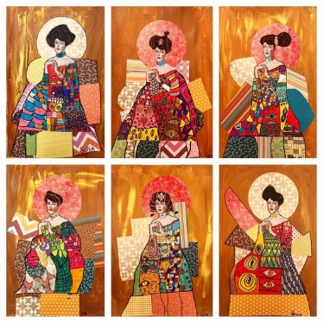
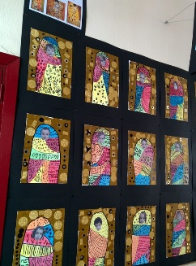
Gustav Klimt- Collage

Layering scraps of magazine or recycled paper to create the background and/or outfit based on ‘Woman in Gold’ by Gustav klimt. You could print out the head and shoulders of the original woman or a photo of the children to make it a self portrait.

Artist/Artwork Evaluation:  • Basic analysis of an artwork, commenting on the use of formal elements (line, shape, texture, pattern) and comparing with other another artwork.  • Begin to describe and discuss their own artworks, justifying  their choices with appropriate vocabulary.  • Begin to discuss a range of key artists and artworks, expressing an opinion about an artwork, support with reasons.  • Compare 2 or more artworks and recognize patterns and key concepts between art movements.  • Understand links between their work and where techniques have been inspired from. E.g. Used dots because of looking at Yayoi Kusama.  Sculpture/Collage:  Follow procedures for safety with a wider range of tools and processes.  • Cut and shape materials based on their design with developing accuracy.  • Choose appropriate tools and methods to cut and form a wider range of materials, either guided or independently.  • Choose appropriate materials by testing their properties using prototypes, justifying their choices. Either individually or in small groups.  • Combine techniques and materials.  Painting/Colour:  • Use a wider range of paints such as acrylic to layer, build texture and re-work ideas.  • Used mixed media to make collages including paint. | Artist/Artwork Evaluation:  • Analyse an artwork, commenting on the use of formal elements (line, shape, texture, pattern) and comparing with other artworks.  • Describe and discuss with confidence their own artworks,  justifying their choices with appropriate vocabulary.  • Can discuss a range of key artists and artworks with increasing confidence, expressing an opinion about an artwork, support with reasons.  • Compare multiple artworks and recognize patterns and key concepts between art movements.  • Make clear links between their work and the work of others, noting specific influences and techniques.  Sculpture/Collage:  Follow procedures for safety with a wider range of tools and processes.  • Cut and shape materials based on their design with increasing accuracy.  • Combine techniques and materials to create 3D sculptures  • Choose appropriate tools and methods to cut and form a wider range of materials.  • Choose appropriate materials by testing their properties using prototypes, justifying their choices.  Painting/Colour:  • Increasingly confident with matching colours effectively to portray their subject or mimic an artist.  •Explore the use of a limited colour palette and the effect of this.
Summer
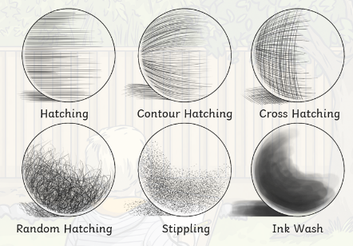
Observational Sketching
Looking closely at daily objects and people taking care to look at small details and shading.

https://www.twinkl.co.uk/resource/cfe-t2-a-021-ks2-art-drawing-techniques-lesson-teaching-pack

Drawing:  •Draw with precision and control.  • Shade, blend and add highlights to describe light and dark, contrast and shadow.  • Create texture using a single medium.  • produce increasingly accurate drawings of people  • Explore and begin to understand perspective.  • Record their work and add it to a sketchbook, annotating with detailed analysis and evaluation. | Drawing:  • Effect of light on objects and people from different directions  • Interpret the texture of a surface  • Continue to develop the concept of perspective and forced perspective.  • Record their work and add it to a sketchbook, annotating with detailed analysis and evaluation, using it to demonstrate their development of key skills.  • Make increasingly accurate observational drawings, using formal elements.  • Select an appropriate drawing media, which is fit for purpose (e.g. pencil, chalk pastel).  • Draw human bodies, showing movement and emotion.
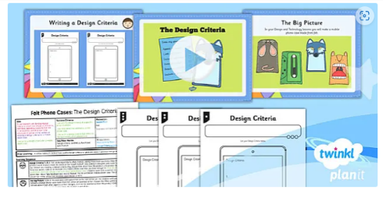
Phone pouches-Dt/Textiles Project
Designing, testing and creating phone pouches.
https://www.twinkl.co.uk/resource/tp2-d-047-planit-dt-uks2-felt-phone-cases-lesson-1-developing-the-design-criteria-lesson-pack
Textiles:  • Use a basic pattern/template to mark and cut fabric into a  specific shape  • Explore back stitch and cross stitch.  • Weave using a carboard loom with a basic pattern.  • Sew a button or bead.  • Thread a needle and tie a knot.  Sculpture & Collage/Resistant Materials:  • Follow procedures for safety with a wider range of tools and processes.  • Cut and shape materials based on their design with developing accuracy.  • Sculpt clay and other materials with precision, including joining parts.  • Choose appropriate tools and methods to cut and form a wider range of materials, either guided or independently.  • Choose appropriate materials by testing their properties using prototypes, justifying their choices. Either individually or in small groups.  • Combine techniques and materials  • Use wider range of joining methods.  Design process:  • Work from a brief with a simple problem to solve, to design an appealing, functional product.  • Research a small number of products similar to their own to inform their own design.  • Develop a design idea, communicating and recording it via a basic plan and a basic labelled diagram.  • Research a range of materials, conducting tests as appropriate before selecting the best choice. Either individually or in groups.  • Test ideas using basic prototypes/creating pattern pieces. E.g. practicing how to make a specific hinge or join.  • Develop and make a final product, which meets the brief criteria.  • Evaluate their final product, assess their product against the brief and consider improvements. | Textiles:  • Use seam allowance and back stitch to join textiles to create a simple product (e.g. A cushion or soft toy).  • Use a pattern/template to mark and cut fabric into a specific shape  • Weave using a variety of materials.  • Sew a button or bead onto a project.  • Thread a needle and tie a knot, including finishing a thread and starting a new one within a project.  Design Process:  • Work from a brief with a simple constraint (e.g. audience / purpose) to design an appealing, functional product.  • Research a range of materials, conducting tests as appropriate before selecting the best choice.  • Research products similar and different to their own to inform their own design.  • Develop a design idea, communicating and recording it via a plan and a labelled diagram.  • Test ideas using prototypes/creating pattern pieces and where relevant computer aided design.  • Develop and make a final product, based on testing, which meets the brief criteria.  • Evaluate their final product, including discussion amongst peers to assess their product against the brief and consider improvements.  Sculpture & Collage/Resistant materials:  • Follow procedures for safety with a wider range of tools and processes.  • Cut and shape materials based on their design with increasing accuracy.  • Combine techniques and materials to create 3D sculptures  • Choose appropriate materials by testing their properties using prototypes, justifying their choices.  • Choose appropriate tools and methods to cut and form a wide range of materials.  • Use a wider range of joining methods on a wide range of materials. E.g. textiles.

