**St Patricks RC primary School**



**Our Prayer Book.**

We hope you enjoy praying with your children at home as much as we do within our school community. We have included the main prayers we say in school as well as some additional prayers and ideas on praying at home with your child and as a family.

We believe that prayer is a shared experience, a conversation with God. We all have our own way of 'talking and listening to God'. There is no right or wrong way to pray.

We believe the traditional prayers we say regularly in our school parish community are important to pass on to our children.

Please help your child to become familiar with the prayers and enjoy the experience of praying together at home.

# The Sign of the Cross

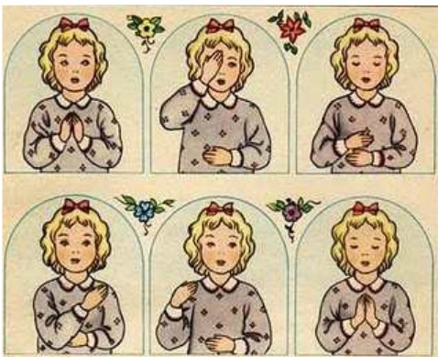

## In the name of the Father

## And of the Son

And of the Holy Spirit,

Amen.

# 

# T:\Early Years\MRS STEVENSON\prayers\images043CDKIW.jpg

# Morning Prayer

Jesus friend of little children at the start of this

New day, be thou my guide

And helper,

In my work and in my play

Amen

# 

# 

# T:\Early Years\MRS STEVENSON\prayers\hands-21427660.jpg Prayer before Meals

Bless us 0 God,

As we sit together

Bless the food we eat today. Bless the hands that make the food,

Bless us 0 God,

Amen.

# 

# 

# Prayer after Meals



Thank you Lord for the food we have eaten,

Thank you Lord for all my friends

Thank you Lord for everything,

Thank you Lord.

Amen.

**The Lord's Prayer**

Our Father who art in heaven, hallowed be thy name.

Thy kingdom come,

thy will be done,

on earth as it is in heaven.

Give us this day our daily bread,

And forgive us our trespasses

as we forgive those who trespass against us,

And lead us not into temptation,

But deliver us from evil.

Amen

**Hail Mary**

Hail Mary, full of grace the Lord is with thee.

Blessed art thou amongst women,

and blessed is the fruit of thy womb, Jesus.

Holy Mary, Mother of God,

pray for us sinners, now

and at the hour of our death,

Amen.

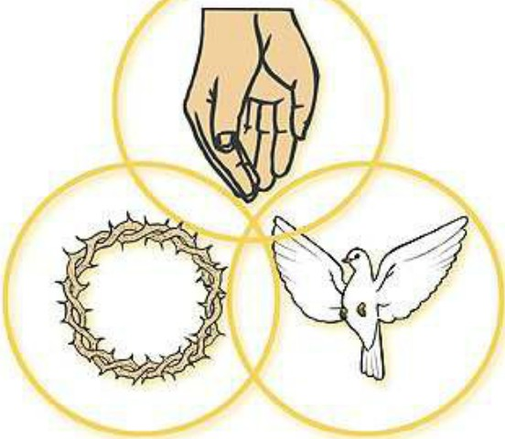**Glory Be ...**

Glory be to the Father,

and to the Son,

and to the Holy Spirit.

As it was in the beginning,

is now and ever shall be,

world without end.

Amen.

### Act of Sorrow

0 my God,

Because you are so good,

I am very sorry that I have sinned against you

And by the help of your grace I will not sin again.

Amen.

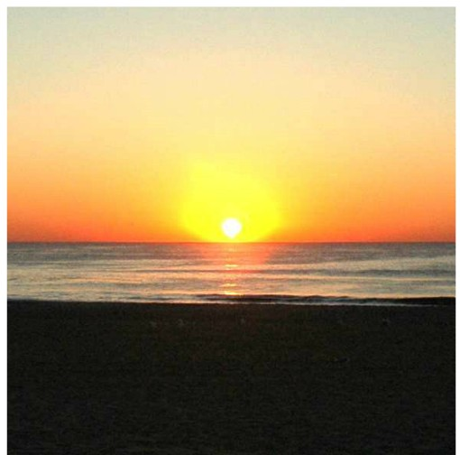

### A Blessing

**Home Time Prayer**

God our Father, I come to say,

Thank you for your love today.

Thank you for my family and all the friends you give to me. Guard me in the dark of night and in the morning send your light.

Amen.

 O dear Lord Jesus

Bless me now with Your grace.

Bless my memory that it will never forget You Bless my mind that it may always think of You

Bless my will that it may try to please You

Bless my body and all its actions

Bless my heart and everyone it loves

Bless me now and at the hour of my death

Bless us all and bring us safe to heaven

To be happy with You for ever.

Amen

**Guardian Angel**

Angel of God, my guardian dear,

to whom God's love commits me here,

ever this day (or night) be at my side,

to light and guard, to rule and guide,

Amen

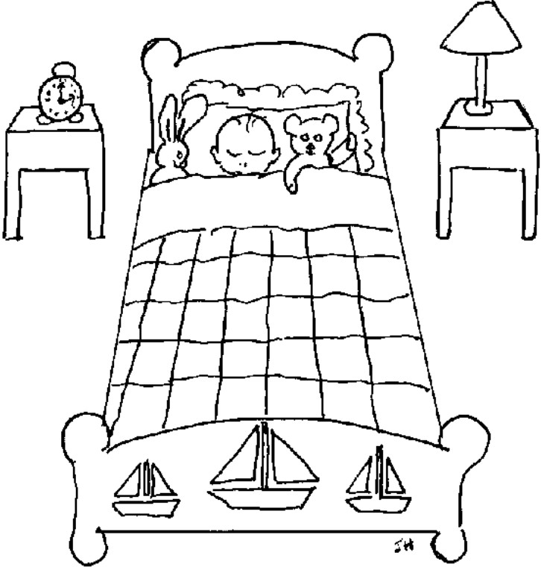

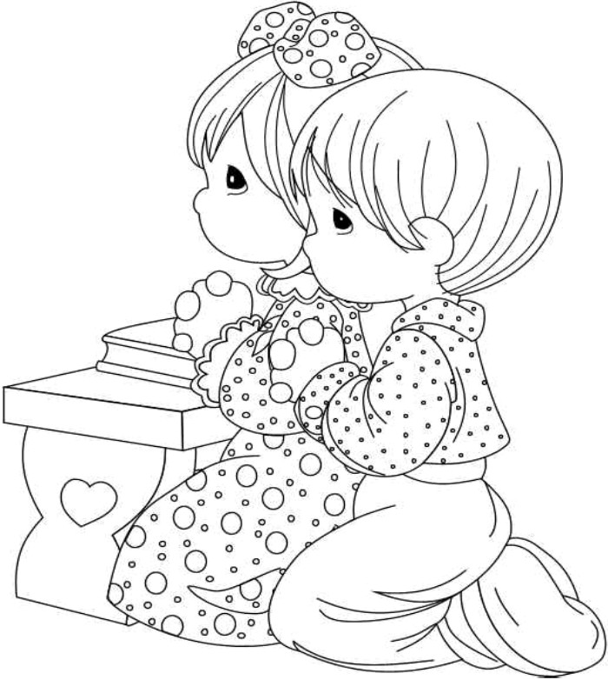

**God Hear My Prayer**

God in heaven hear my prayer,

Keep me in thy loving care.

Be my guide in all I do,

Bless all those who love me too.

Amen.

C:\Users\Clark Family\AppData\Local\Microsoft\Windows\Temporary Internet Files\Content.IE5\D0EC0W72\MC900445678[1].wmf**Eternal Rest** (to remember those dear to us that have died)

Eternal rest give unto them O Lord

And let perpetual light shine upon them.

May they rest in peace.

Amen.

C:\Users\Clark Family\AppData\Local\Microsoft\Windows\Temporary Internet Files\Content.IE5\K4M7DGUU\MC900232885[1].wmfNight time prayer is important too. The end of the day is an opportunity to share a quiet time with your child or children and to thank God for the challenges of the day. Encourage your child to talk to God about whatever is on his or her mind. God loves to hear prayers for bike rides, a frog in the garden or even a successful tea party with dolls. We hope you enjoy the experience of praying with your child.

Prayers Giving Thanks

C:\Users\Clark Family\AppData\Local\Microsoft\Windows\Temporary Internet Files\Content.IE5\ZQPQBZSQ\MC900155356[1].wmf

Sunshine brings happiness.

It makes the sea sparkle.

It makes the world shine.

It makes us smile.

Father, your love is like the sunshine.

It fills our lives with happiness.

It makes the whole world glad

Amen.

Thank you, lord, for your world.

There is so much to discover…

So much to see…so much to do.

Your world is exciting.

Thank you Lord.

Amen.

C:\Users\Clark Family\AppData\Local\Microsoft\Windows\Temporary Internet Files\Content.IE5\280J08PA\MC900438221[1].wmf

Thank you for the world so sweet,

Thank you for the food we eat,

Thank you for the birds that sing.

Thank you God for everything.