SEND Information Report
Approved on:
July 2023
Next review:
June-July 2024
St Paul’s Catholic Primary School

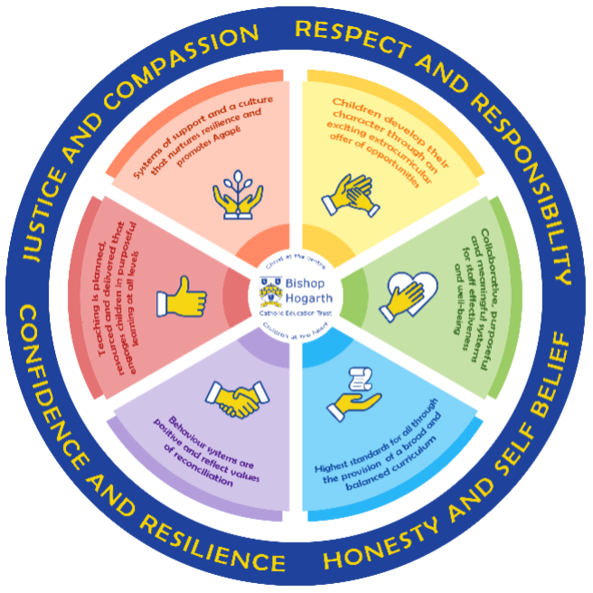

As part of the family of Bishop Hogarth Catholic Education Trust, our school has at its core, the virtues, and values of:
Respect for others and themselves, recognising that we are all created in the image of God and therefore must be compassionate towards others, especially the vulnerable. ​
Confidence in their own abilities, knowing that their talents are gifts from God and resilience to persevere when things become difficult. ​
Honesty in regard to the world around them and themselves and the ability to take responsibility for the times we may fall short of the mark. ​
Gratitude for all the amazing gifts from God and willingness to share their gifts both personal and material. ​

As an inclusive school, all teachers are teachers of pupils with Special Educational Needs & Disabilities. We deliver a curriculum and create an environment that meets the needs of every pupil within our school. We ensure that every pupil with Special Educational Needs and / or disabilities makes the best progress possible. We foster and promote effective working partnerships with parents / carers, pupils, and outside agencies. We consider the ‘whole’ child and strive to ensure that all our SEND pupils are prepared for adulthood.​

Our school’s approach to supporting pupils with SEND
At St Paul’s we recognise that some pupils require more support than others and will need additional help throughout their time in school. We strive to identify and remove barriers to learning to ensure all pupils are able to achieve their full potential.
We aim to create an inclusive environment where children are nurtured and provided with a framework for living where sound relationships can be established and everyone has dignity and is valued.
If there is any information that you would like to know that is not on the website then please do not hesitate to contact Mrs Peacock (DHT/SENCO).

Teachers are responsible for the progress of ALL pupils in their class. High quality teaching is personalised to meet every child’s need. This is the first step in supporting pupils who may have SEND (Special Educational Needs and Disabilities).
All children are challenged to do their very best.
All children are taught a broad and balanced curriculum; where children require extra support, specialist resources or additional materials, these will be provided wherever possible.
All children are known well by their class teacher, who develops strong relationships with them.
Children can express their views in several ways, these include speaking to a trusted adult, through the Student Council or via our Pupil Voice system.
We manage medical needs by working closely with parents and healthcare professionals. We listen to, and act on their advice, providing staff training when needed.
We run a wide range of extra curricular clubs including football, netball, multi-sports, French and Dance.
There is also an SEN governor who has particular involvement with SEND policy and provision.

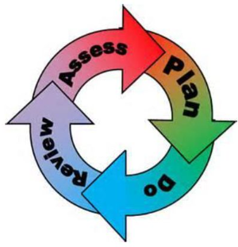
How will the school staff support my child?
The graduated response-Identifying, planning for and supporting pupils with SEND
Where a pupil is identified as having a special educational need, School will follow a graduated approach which takes the form of cycles of ‘Assess, Plan, Do, Review’. ​
• Assess a child’s special educational need. ​
• Plan the provision to meet your child’s aspirations and agreed outcomes. ​
• Do put the provision in place to meet those outcomes. ​
• Review the support and progress.

How does the school know if children need extra help and what do I do if I think my child has special educational needs?

- Assess
It is important that we identify any difficulties as early as possible. Children are identified as having SEN and/or a disability if they have significantly greater difficulty in learning than the majority of children of the same age or if they have a disability preventing or hindering the use of educational facilities provided for children of the same age within the Local Education Authority.
After a period of monitoring, if a child is not making expected progress this will be discussed with parents, class teacher and Mrs Peacock (SENDCO). Any possible barriers to learning will be discussed and the effectiveness of interventions and additional resources that may be in place. If required, input from specialist services may be sought with parents’ permission. During this time, a child may be noted as a Cause for Concern on the SEN Register.
Once a need has been identified the child is added to the SEN register and a Support Plan is created to ensure the child’s needs are understood by all staff working with the child and specific strategies are in place to support their needs.
An EHCP (Education, Health and Care Plan) will be requested when a child’s needs are deemed more complex and require the input from a range of outside agencies. This could be in the form of Educational Psychologists, Occupational Therapists or other professionals with an area of expertise, e.g. Autism.
Mrs Peacock can be contacted in school on 01642 360022.

- Plan
Class teachers deliver Quality First Teaching by adjusting their planning, activities and by using appropriate resources to support learning to ensure individual needs are met. Lessons are exciting and engaging to support all learning styles.
Small group or 1:1 sessions ensure children’s individual needs are met and they are able to learn confidently with a high level of support. As well as academic support, children are offered small group interventions in social and emotional skills, occupational and sensory therapy and physical development. The SENCO oversees the programmes monitoring the children’s progress.
If appropriate, specialist equipment may be given to the pupil. These include the use of i-pads, writing slopes, concentration cushions, coloured overlays, pen/pencils grips, easy to use scissors, and fiddle tools.
Outside agencies including Occupational Therapy, Speech and Language Therapy, Specialist Learning Team and Educational Psychologists deliver interventions to support children within school. In addition, they can train staff on suitable intervention programmes and then oversee the progress the child makes towards their targets.
The SENCO keeps up to date with current legislation around SEND. This is shared with staff.
Staff are directed to appropriate training to meet the needs of our school population. Staff followed a Recovery Curriculum following the pandemic to support the emotional needs of children. This continues to be a focus for the school.

We ensure that information about a child’s SEND or EHC plan is shared and understood by
teachers and all relevant staff who come into contact with that child
Information includes
- Appropriate historic information
- SEND needs –primary and secondary needs
- Child’s strengths and areas of difficulty
- Short and long-term targets in EHCP and provision required to achieve them, including interventions, strategies and resources
- Previous and current outside agency involvement
- Dates of key meetings –Annual Reviews, Team around the Family meetings

The school is an Enhanced Mainstream School (EMS) for the Local Authority to support children with Social, Emotional and Mental Health difficulties. The expertise of managing children with SEMH issues is consistent across the school. Mrs Davies is qualified to degree level in managing the behaviours of SEND pupils and offers advice and resources for staff.
The SENCO attends regular SEND briefings (Trust led and Local Authority) and has completed the National Award for SENCOs (a national requirement).
The school is also recognised as an ‘Attachment Aware’ school following the SENCO’s completion of training from Brighton University.
The SENCO has completed the Advanced Mental Health Lead Training for Senior Leaders. (Level 4 Certificate in Mental Health Aware Leadership (Education)).
The school was recognised for the emphasis placed on supporting the mental health and wellbeing of staff during the Coronovirus pandemic. We achieved the Teachwell Alliance Award.
The SENCO attends the Personal Development Network Meetings covering all aspects of mental health and wellbeing for children in schools and ensures the appropriate information is shared amongst staff.

- Do

Our teachers are skilled at adapting teaching and learning to meet the diverse needs in each class. ​
Daily planning considers individual children’s needs and requirements and is annotated and adapted according to need. Explicit reference is made in the teacher’s planning to the needs of those children identified with SEND. ​
Adaptive teaching is approached in a range of ways to support access to the curriculum and ensure that all children can experience success and challenge in their learning. ​Some examples of this are:
- Grouping arrangements consider the different skills and abilities of each child. This ensures that learning is maximised. ​
- Changing the way children are taught: e.g. giving instructions in a different way, breaking down tasks or simplifying reading books etc.
- Specific teaching, where appropriate in small groups or 1.1.
- Support from a teacher or teaching assistant.
- Access to additional resources or equipment including visual resources.
- Access to specialist Computer programs or equipment
- Referral to other outside agencies (for example a health professional or an educational psychologist)

Additional adults support groups and individual children with the long-term goal of developing independent learning skills. The class teacher monitors this support to avoid children becoming over reliant on this. ​
We fully encourage parental support and offer opportunities for individual meetings with parents/carers to provide clarity and recommendations on how they can support their child at home.

- Review
SEND children’s progress is reviewed termly in line with the school’s assessment process. Their Support Plan is reviewed and updated. This is discussed with parents and targets and next steps are agreed jointly.
Each term, teachers meet with the Senior leadership team to discuss all childrens’ progress.
The SENCO monitors the progress that SEND children are making, including a brief overview of the child’s strengths, barriers and next steps. If it is felt additional support is needed, further advice will be obtained from the Local Authority. This could involve requesting specialist advice or support, additional funding to deliver a specific intervention or to access a particular resource. This is allocated as High Needs Funding.
Children on the SEN Register have a Support Plan that is reviewed termly. See below.

How will the curriculum at our school be matched to my child’s needs?
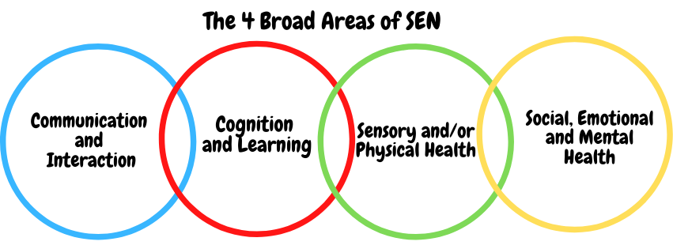SEN needs are classified under four broad areas of need. Below are the strategies, in class support and interventions that school may put in place to support your child.
Communication and Interaction Strategies to support children with these needs include:
- Curriculum is adapted to ensure it is accessible to the needs of the child/young person
- Short, clear instructions/simple vocabulary/broken down tasks
- Frequent repetition and reinforcement.
- An awareness to use the child’s name to engage and interact.
- The most appropriate seating in the classroom to access the board and adult support
- Access to small group and/or individualised interventions to develop skills in communication, interaction, emotional awareness, self-care, flexible thinking
- Speech and Language Therapy monitored by school staff to learn strategies.
- Enhanced access to visual approaches – use of visual time-table and now and next cards.
- Opportunities to express feelings or communicate with adults using visual prompts.
- Access to low stimulus area within and outside of the classroom
- Flexible approaches to timetable and modifications to lunch/break times where needed
- Enhanced access to additional aids
- Access to technology (use of classroom computers, laptops / tablets)
- Explicit teaching of generalising skills from one context to another
- Careful planning of transitions – enhanced plan for key stage changes
- Mentoring and/or buddy system
- BLAST (EYFS)
- Access to Mabel our wellbeing dog to help encourage good listening and interactions with others. She encourages responsibility and good social skills.

Cognition and Learning
Strategies to support children with these needs include:
- Curriculum is adapted to adapted to ensure it is accessible to the needs of the child/young person.
- Short, clear instructions/simple vocabulary/broken down tasks.
- Frequent repetition and reinforcement.
- The most appropriate seating in the classroom to access the board and adult support.
- A range of teaching activities/methods to suit different learning styles.
- Regular, individually focused intervention – Maths, reading, spelling, comprehension.
- Practical aids for learning e.g. table squares, time/number lines, pictures, photos, accessible reading material suited to age, Numicon, coloured overlays, individual copies of texts, spellcheckers.
- Appropriate interventions to support learning; Read Write Inc (phonic development), Numicon (practical Maths apparatus), Better Reading Scheme, Reading Eggs, PhonicsPlay, Times-tables Rockstars, specific apps for i-pad use. Games to promote recall/memory.
- Access to Mabel, our wellbeing dog to stimulate memory, problem solving and game-playing skills. She also provides an audience for story-telling.

Sensory/Physical
Strategies to support children with these needs include:
- Appropriate practical resources to support full integration in lessons and the classroom environment (specialist seating, hearing aids)
- Modifications to lessons to ensure full engagement e.g. alternative recording devices, modified PE curriculum.
- The use of Thrive activities linked to programmes of support for individual children.
- Sensory equipment to meet individual children’s needs; ear-defenders, weighted blankets/toys, wobble cushions, fiddle tools, chew tools, therapy balls, trampolines.
- An awareness of child’s sensory overload; fears/triggers.
- Access to calm space to alleviate over-stimulation in busy environment.
- Access to support for personal care, intimate care plans where needed.
- The services of Future Steps, Occupational Therapy, as part of our EMS provision, to provide individualised programmes of support for specific children needing therapeutic support. The programmes are delivered by our specialist TA’s.
- Interaction with Mabel, our wellbeing dog helps to reduce blood pressure, provide tactile stimulation, assist with pain management and give motivation to walk and move.
- Individual resources (use of ICT)
- Additional support provided for out of school activities.
Social, Emotional and Mental Health
Strategies to support children with these needs include:
- The expertise of staff in our Enhanced Mainstream Provision with qualifications in SEMH.
- Access to time out/individual work area inside and outside of the classroom.
- A key adult and team around the child to develop positive relationships with and to share successes.
- The use of The Thrive Approach, for individuals or groups to address emotional needs.
- Individualised rewards system appropriate to sensitivities of the child
- Access to Mabel, our wellbeing dog. This is known to support children’s self-esteem, develop compassion for others and reduce anxiety. They can also support children who may be suffering from loss or bereavement.
- Access to counselling services – CAHMS / Alliance Psychology Service
- Increased access to additional adults in the classroom
- Alternative curriculum opportunities
- Opportunities to develop health and well-being through PSHE
- Interventions to develop social skills; Thrive, Lego Therapy, Theraplay, social games.
- A range of practical resources to focus attention and develop memory.
- Visual timetables and other visual resources to offer reliability and reassurance. (expressing emotions)
- A well-structured lunchtime routine to promote positive play and interactions including a range of activities to suit all needs.

What training is provided for staff supporting children with SEND?
First Aid
All staff are trained to provide First Aid including emergency and paediatric first aid.
Staff are trained in the administration of Epi-pens and have attended training by the school nurse service to raise awareness of asthma. Staff also complete allocated training sessions from iHASCO on a range of medical conditions including asthma and diabetes. We have a comprehensive policy covering the administration of medicines in school. Children who have more severe medical conditions have detailed care plans which are devised in consultation with parents, school staff and medical professionals.
Specific conditions
Staff attend training offered by Speech and Language, Alliance, CAMHS and other specialists including the Local Authority. Training is provided to meet the specific needs of children within each cohort and advice and guidance based on evidence based resources.

How do we support transition in our school?

Transition within classes/key stages: ​
Early transition in the Summer Term supports the move from classes and across Phases. Younger children are greeted by staff to get to know them. They practise putting coats onto different pegs and become more familiar with a different classroom environment with short visits and stories read by their new classroom staff. A full morning of transition takes place in the summer term during the Y6 Transition Days to their Secondary schools. This gives an opportunity to get to know the staff and learn about the year ahead.
Transition to Secondary settings: ​
The SENCO follows the Local Authority’s Transition process and holds meetings with the SENCO of the receiving school. The discussion involves the following:
- Primary and secondary needs
- Strengths and difficulties
- Strategies used and support currently in place
- Outside agency involvement
- Assessment –class teacher and outside agency
- Proposed ongoing support needed
For some children, those with HNF or an EHCP, an enhanced transition plan may be created. This outlines the support needed to ensure a smooth transition and may involve additional visits to the setting and meeting of staff.

Where can I get further information about services for my child?
The Local Offer
Further information:
Paula Allison is our SEND Information Advice and Support Partner. She can be contacted by e-mail SENDIASS@Stockton.go.uk
or 01642 527158
- The recognised Parent Carer Forum can be contacted on
07985 245668 info@stocktonparentcarerforum.co.uk
Their website can be viewed here:
- Stockton Parent Carer Forum
SEND Code of Practice –
for more information please go to
SEND_Code_of_Practice_January_2015.pdf (publishing.service.gov.uk)
Special Educational Needs and Disabilities: A guide for parents and carers
http://www.gov.uk/government/publications/send-guide-for-parents-and-carers|
Stockton on Tees – Local Offer - for more information – please click the following link Local Offer

What key school documents refer to support and provision for pupils with SEND?

- SEND Policy​
- Admissions Policy​
- Supporting Pupils with Medical Needs Policy​
- Accessibility Plan​

Accessibility
How we ensure all pupils can participate in the school’s curriculum, facilities and wider services offered by the school.

The school is accessible to all children, parents/carers and visitors with:
A disabled toilet facility
Disabled parking
Access ramp
Single floor site

Specific curriculum adjustments that are made for children/young people with SEND

At St. Paul’s we have a duty to ensure that any child with SEND are identified, assessed and supported throughout their time in school and that their progress is regularly evaluated and monitored within the classroom. They have full entitlement to all aspects of the National Curriculum and we ensure that we enable these children to progress.
A range of reasonable adjustments are made depending on the need of the child. These are identified in the four primary areas of need above.
Children’s specific support arrangements and adaptations as well as their targets, current progress and views are recorded on their individual Support Plan.
Resources are provided to support specific needs; ie dyslexic learners, visual resources for pupils with ASD; electronic devices and sensory equipment.
Staff are provided with appropriate training to ensure they understand the needs of their pupils and to how to use any specific equipment and resources.

Activities Outside of School​
St Paul’s School is a fully inclusive school where all children have the opportunity to take part in a wide range of extra-curricular activities. This enables them to learn new skills, improve existing skills and have the opportunity to mix socially with different children.
We have a range of different clubs including, netball, football, art, French, Forrest School and dance. All children regardless of need, have access to extra-curricular activities including off-site visits and residential
trips. School will offer the adjustments needed to ensure all children can participate in such events.

What to do if you have a complaint, a compliment, or a query.

The school details and relevant contacts
Any complaints with regards to SEND provision should be referred to the Head-Teacher and Governing Body following the complaints procedure established by the school. (Please see school’s complaints policy)

Advice and support could also be obtained from our SEND Information Advice and Support Partner, Paula Allison. She can be contacted by e-mail SENDIASS@Stockton.go.uk or by phone 01642 527158

Special Educational Needs and Disability Information, Advice and Support Service (SEND IASS)
Support can be obtained from Stockton Parent Carer Forum 07985 245668
info@stocktonparentcarerforum.co.uk

​
Name of school SEND governor.
Mr Carlos Dos Santos

