Darwen Saint Peter’s Church of England Primary School

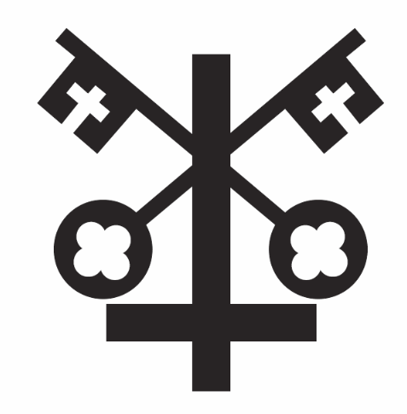

Charging and Remissions Policy

Sowing the seeds of tomorrow
Matthew 13:1-23
love, respect, trust, truthfulness, forgiveness

Date of Policy: September 2022
Updated: October 2023, September 2025
Review Date: September 2027

Christian Vision

As a Christian family at St Peter’s School, we create a unique place of learning, nurturing the gifts that God in his awesomeness has given us. We encourage every child and prepare them for life’s journey, inspiring them to fulfil their potential, their dreams and their aspirations.
Sowing the seeds of tomorrow
Matthew 13:1-23

Rationale
The Governing Body of St. Peter’s Church of England Primary School recognises the valuable contribution that the wide range of additional activities, including trips, clubs and residential experiences can make towards pupils' education. They also acknowledge the significant impact that additional activities during the school day can have on the enrichment of our curriculum.
The Governing Body aims to promote and provide such activities both as part of a broad and balanced curriculum for the pupils of the school and as additional optional activities.

Charges
The governing body reserves the right to make a charge in the following circumstances for activities organised by the school:
School trips in school hours
- Appropriate coach fees for trips in school hours.
- Entry payments/ tickets for visits to particular attractions in school hours.

Activities outside school hours
- The full cost to each pupil of all approved activities deemed to be optional extras taking place outside school hours.
Specialist activities inside school hours
- A donation may be requested for activities within school hours designed to enrich the curriculum e.g. workshops delivered by external providers, visiting artists, musicians etc.

Individual instrumental tuition
- The cost to the pupil for providing any instrumental tuition taking into account the remitted fees aspect from within the local authority.
Charging in kind
- The cost of materials, ingredients, equipment (or the provision of them by parents) for the following subjects: DT, Science, Art/Craft.
The Governing Body reserves the right to charge for ingredients and materials or require them to be provided if the parents have indicated in advance that they wish to own the finished product.
St Peter’s uses a ‘ParentPay’ cashless system where all trips and visits, as well as school dinners and breakfast club should be paid for electronically. Every parent/carer has their own login details to access and pay through their own private account.

General
The Governing Body may from time to time, amend the categories of activity for which a charge may be made. Nothing in this policy statement precludes the Governing Body from inviting parents to make a voluntary contribution towards the cost of additional activities which take place in school time. Parents may be advised that the continuance of an activity may depend upon voluntary contributions, but once it has been decided to run such an activity no qualifying child will be excluded on the grounds of voluntary contributions.

Remissions
The Governing Body may wish to remit in full or in part the cost of activities for particular groups of parents, for example, in the case of family hardship or when a child is in receipt of pupil premium. When arranging a chargeable activity such parents will be invited in confidence for the remission of charges in full or in part. Authorisation for such remission will be made by the Headteacher in consultation with the Chair of Governors.

Signed: (Headteacher) Date:

Signed: (Chair of Governors) Date:

