Darwen Saint Peter’s Church of England Primary School

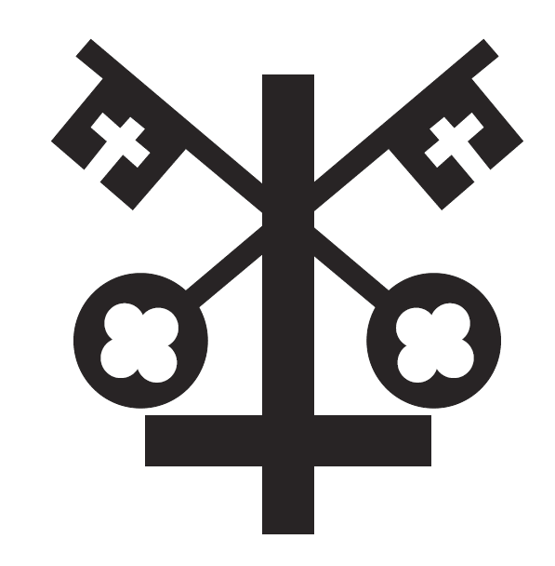

Freedom of Information Policy
Sowing the seeds of tomorrow
Matthew 13:1-23
love, respect, trust, truthfulness, forgiveness

Date of Policy: September 2022
Updated: October 2024
Review Date: September 2027
Christian Vision
As a Christian family at St Peter’s School, we create a unique place of learning, nurturing the gifts that God in his awesomeness has given us. We encourage every child and prepare them for life’s journey, inspiring them to fulfil their potential, their dreams and their aspirations.
Sowing the seeds of tomorrow
Matthew 13:1-23

The Freedom of Information Act 2000 provides public access to information held by public authorities.

It does this in two ways:

- Public authorities are obliged to publish certain information about their activities; and
- Members of the public are entitled to request information from public authorities.

The Act does not give people access to their own personal data (information about themselves). If a member of the public wants to see information that a public authority holds about them, they should make a subject access request under the Data Protection Act 1998.

Publication Scheme
As well as responding to requests for information, public authorities must publish information proactively. The Freedom of Information Act requires every public authority to have a publication scheme, approved by the Information Commissioner’s Office (ICO), and to publish information covered by the scheme.

The scheme sets out our commitment to make certain classes of information routinely available, such as policies and procedures, minutes of meetings, annual reports and financial information. The school has adopted the ICO’s model publication scheme and this is available in full in Appendix 1.

Written Requests
The main principle behind freedom of information legislation is that people have a right to know about the activities of public authorities, unless there is a good reason for them not to. This is sometimes described as a presumption or assumption in favour of disclosure. The Act is also sometimes described as purpose and applicant blind. Anyone can make a freedom of information request – they do not have to be UK citizens, or resident in the UK. Freedom of information requests can also be made by organisations, for example a newspaper, a campaign group, or a company.
The Act covers any recorded information that is held by a public authority in England, public authorities include schools. Recorded information includes printed documents, computer files, letters, emails, photographs, and sound or video recordings.
For a request to be valid under the Freedom of Information Act it must be in writing. Freedom of Information requests must either be submitted electronically to office@stpetersdarwen.blackburn.sch.uk or in writing to St Peter’s CE Primary School, Turncroft Road, Darwen, BB3 2BW. Responses made under the Act will be issued within 20 working days following the date of receipt, excluding any day which is not a school day (this effectively equates to a period of 20 school days).
A requester may ask for any information that is held by a public authority. However, this does not mean the school is always obliged to provide the information. In some cases, there will be a good reason why we should not make public some or all of the information requested. The school can refuse an entire request under the following circumstances:
- It would cost too much or take too much staff time to deal with the request.
- The request is vexatious.
- The request repeats a previous request from the same person.
In addition, the Freedom of Information Act contains a number of exemptions that allow the school to withhold information from a requester.

- Fees and Charges
Where it would not exceed the appropriate limit to comply with a request, and a public authority wishes to charge a fee, it can only include the charges it reasonably expects to incur in:

- Informing the requestor whether it holds the requested information (even if the information will not be provided), and
- Communicating that information to the requestor.

This generally means that a public authority can only charge for expenses actually incurred, for example, photocopying or postage. It must issue a fees notice advising the requestor of the amount it will charge.

Environmental Information
The Environmental Information Regulations 2004 provide public access to environmental information held by public authorities. The Regulations are derived from European law. The Regulations give people a right of access to information about the activities of public authorities that relate to or affect the environment, unless there is good reason for them not to have the information. Any request for environmental information will be dealt with under the Environmental Information Regulations 2004.

Complaints
If the applicant wishes to make a complaint or request a review of the school’s decision, they should write to the Chair of Governors at office@stpetersdarwen.blackburn.sch.uk or St Peter’s CE Primary School, Turncroft Road, Darwen, BB3 2BW.
If they are not content with the outcome of their complaint, they may apply directly to the Information Commissioner for a decision. Generally, the ICO cannot make a decision unless you have exhausted the complaints procedure provided by the school. The ICO can be contacted at The Information Commissioner’s Office, Wycliffe House, Water Lane, Wilmslow, Cheshire SK9 5AF or telephone 0303 123 1113.

Further Information and other policies
Further information on the schools obligations under the act can be found at:
- www.ico.org.uk.
- FOI Act available at http://www.legislation.gov.uk/ukpga/2000/36/contents
- EIR Regulations available at http://www.legislation.gov.uk/uksi/2004/3391/made.
- Data Protection Policy
- CCTV in Schools Policy
Signed: (Headteacher) Date:

Signed: (Chair of Governors) Date:

Appendix 1 – Publication Scheme
The scheme commits an authority:
- To proactively publish or otherwise make available as a matter of routine, information, including environmental information, which is held by the authority and falls within the classifications below.
- To specify the information which is held by the authority and falls within the classifications below.
- To proactively publish or otherwise make available as a matter of routine, information in line with the statements contained within this scheme.
- To produce and publish the methods by which the specific information is made routinely available so that it can be easily identified and accessed by members of the public.
- To review and update on a regular basis the information the authority makes available under this scheme.
- To produce a schedule of any fees charged for access to information which is made proactively available.
- To make this publication scheme available to the public.
- To publish any dataset held by the authority that has been requested, and any updated versions it holds, unless the authority is satisfied that it is not appropriate to do so; to publish the dataset, where reasonably practicable, in an electronic form that is capable of re-use; and, if any information in the dataset is a relevant copyright work and the public authority is the only owner, to make the information available for re-use under the terms of the Re-use of Public Sector Information Regulations 2015, if they apply, and otherwise under the terms of the Freedom of Information Act section 19. The term ‘dataset’ is defined in section 11(5) of the Freedom of Information Act. The term ‘relevant copyright work’ is defined in section 19(8) of that Act.
Classes of Information
Who we are and what we do.
Organisational information, locations and contacts, constitutional and legal governance.
Description of Information | Location | Charge
Instrument of Government / Articles of Association
School prospectus and curriculum
Governing Body
School session times and term dates
Location and Contact Information
What we spend and how we spend it.
Financial information relating to projected and actual income and expenditure, tendering, procurement and contracts.
Description of Information | Location | Charge
Annual budget plan and financial statements
Capital funding
Financial audit reports
Procurement and contracts
Pay policy
Staff allowances and expenses
Staff pay and grading structures
Governors’ allowances

What our priorities are and how we are doing.
Strategy and performance information, plans, assessments, inspections and reviews.
Description of Information | Location | Charge
Performance data supplied to the government
Latest Ofsted report
Performance management information
The school’s future plans
Safeguarding and child protection
How we make decisions.
Policy proposals and decisions. Decision making processes, internal criteria and procedures, consultations.
Description of Information | Location | Charge
Admissions policy / decisions
Minutes of meetings of the governing body and its committees
Our policies and procedures.
Current written protocols for delivering our functions and responsibilities.
Description of Information | Location | Charge
School policies and other documents
Records management and personal data policies
Equality and diversity
Policies and procedures for the recruitment of staff
Charging regimes and policies
Lists and Registers.
Information held in registers required by law and other lists and registers relating to the functions of the authority.
Description of Information | Location | Charge
Curriculum circulars and statutory instruments
Disclosure logs
Asset register
Any information the school is currently legally required to hold in publicly available registers
The Services we Offer.
Advice and guidance, booklets and leaflets, transactions and media releases. A description of the services offered.
Description of Information | Location | Charge
Extra-curricular activities
Out of school clubs
School publications
Services for which the school is entitled to recover a fee, together with those fees
Leaflets, booklets and newsletters
The classes of information will not generally include:
- Information the disclosure of which is prevented by law, or exempt under the Freedom of Information Act, or is otherwise properly considered to be protected from disclosure.
- Information in draft form.
- Information that is no longer readily available as it is contained in files that have been placed in archive storage, or is difficult to access for similar reasons.
In exceptional circumstances some information may be available only by viewing in person. Where this manner is specified, contact details will be provided. An appointment to view the information will be arranged within a reasonable timescale.
Information will be provided in the language in which it is held or in such other language that is legally required. Where an authority is legally required to translate any information, it will do so.
Obligations under disability and discrimination legislation and any other legislation to provide information in other forms and formats will be adhered to when providing information in accordance with this scheme.
Charges & Fees
Charges which may be made for Information published under this scheme. The purpose of this scheme is to make the maximum amount of information readily available at minimum inconvenience and cost to the public. Charges made by the authority for routinely published material will be justified and transparent and kept to a minimum.
Charges may be made for actual disbursements incurred such as:
- photocopying
- postage and packaging
- the costs directly incurred as a result of viewing information
Charges may also be made for information provided under this scheme where they are legally authorised, they are in all the circumstances, including the general principles of the right of access to information held by public authorities, justified and are in accordance with a published schedule or schedules of fees which is readily available to the public.
Charges may also be made for making datasets (or parts of datasets) that are relevant copyright works available for re-use. These charges will be in accordance with the terms of the Re-use of Public Sector Information Regulations 2015, where they apply, or with regulations made under section 11B of the Freedom of Information Act, or with other statutory powers of the public authority.
If a charge is to be made, confirmation of the payment due will be given before the information is provided. Payment may be requested prior to provision of the information.
Written Requests
Information held by a public authority that is not published under this scheme can be requested in writing, when its provision will be considered in accordance with the provisions of the Freedom of Information Act.

