PE Funding

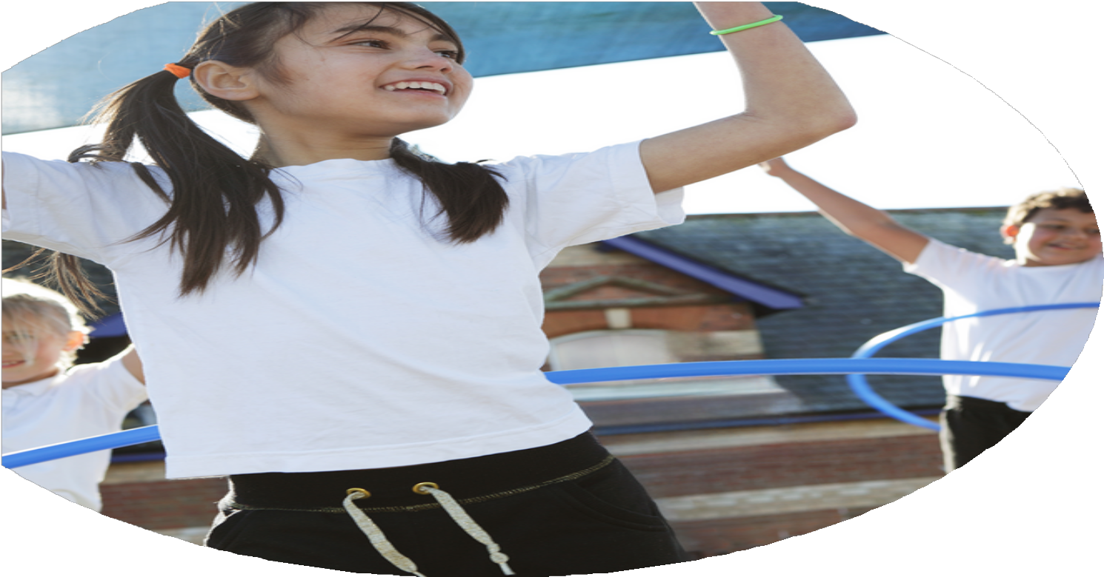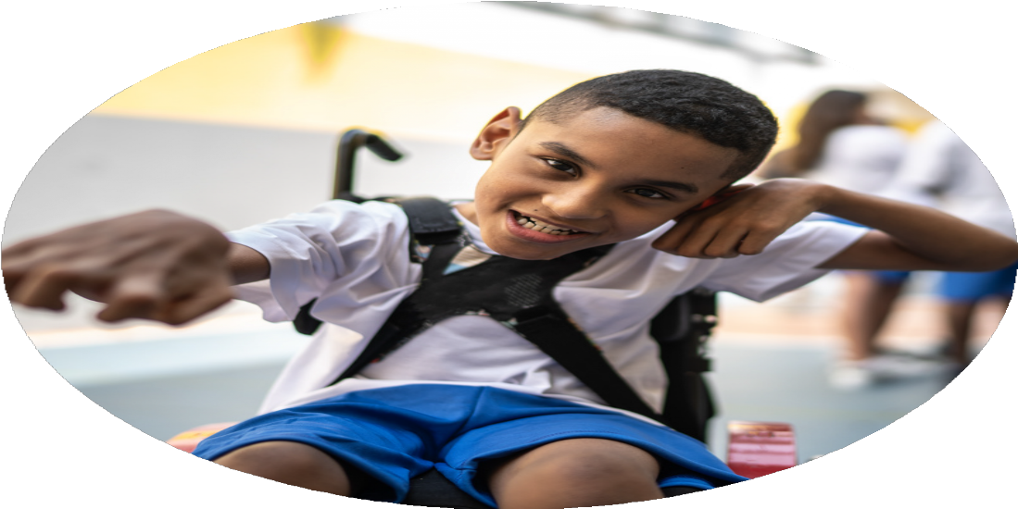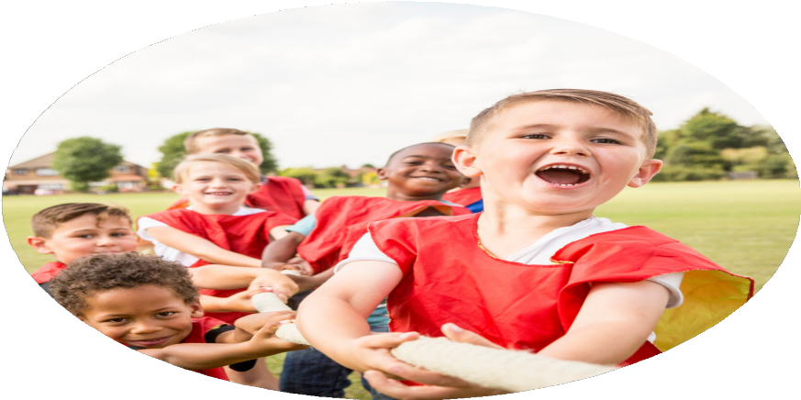

Evaluation Form Darwen St Peters 24-25

**Commissioned by**

**Created by**

Images courtesy of Youth Sport Trust

**PE Funding Evaluation Form**

 It is intended that this template should be used as preparation for the completion of the statutory digital reporting tool being introduced this academic year. You can upload data (including swimming) from this template onto this platform once it becomes accessible.

 Before you decide how you are going to use the funding for this academic year you should reflect and evaluate the impact of your use of the funding in 2023/24.

 All spending of the funding must conform with the terms outlined in the Conditions of Grant document.  The template is a working document that you can amend/update during the year.

 Based on your evaluation of last year’s funding you should decide what you intend to do this academic year, how you will do it, and what impact you expect it to have.

It is important that the funding is used effectively and based on your school’s needs.

 You must use the funding to make additional and sustainable improvements to the PE and sport in your school.  You must develop and add to the PESSPA activities that your school already offers.

*Summative digital reporting from June 2025 will continue to include swimming and water safety information therefore funding can be used to provide top-up lessons where necessary to ensure pupils meet national curriculum swimming requirements.*

Poor attendance into invite only specific after school clubs.

Engaging non- active children/SEND/PP children into different PE and sporting activities

EYFS – Physical 79% GLD

EYFS – Literacy – 73% GL

Whole school data - 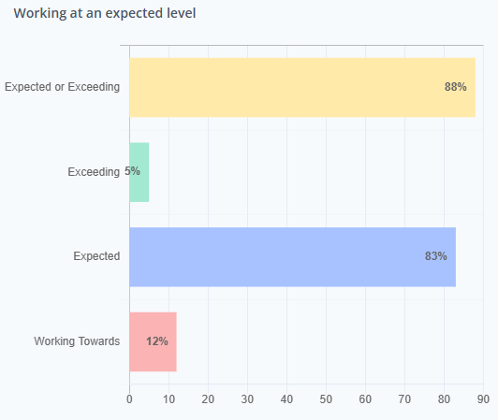

Working with school sports partnerships to provide Intra school games, afterschool clubs, team- teach curriculum time.

Planning a yearly festival and competition calendar to participate in school games events.

CPD for PE passport app for all staff – Staff now confident with planning and assessment for PE using the app.

Breakfast club and school sports partnership introducing activities for extra active 60 minutes. Introduction of playground trolleys and resources to engage children with active play.

Well being focus days /activities throughout the year for staff and children.

Achieving the school games gold award

Fine & Gross Motor skills development and targeted pupils in Reception and KS1.

Engaging Pupils in regular Physical Activity

Creating a stimulating environment for active physical activity to take part in.

Introducing 60 active minutes

Promoting health and well being in school

Preparing Children for competitions/festivals and events.

What are your plans for 2024/25?

Intent

How are you going to action and achieve these plans?

Implementation

Work with MACS school sports partnership to provide daily playtime and lunchtime activities. Offering CPD to ALL staff on play/lunch duties.

Work with Little Lions School sports partnership to provide Intra school games for KS2 classes.

Continue to work with Little lions school sports partnership to offer CPD/ Team teaching skills to create high quality PE lessons.

Offer LPDS courses if needed. Provide CPD with Little lions school sports partnership through team teaching.

Work with sporting NRG to broaden sporting experiences, offering activities such as archery and canoeing. Offer Adventure day for year 5 as an introduction to activities for Robinwood in year 6.

School Games competition package – yearly completion and festival calendar created for participation and opportunities to represent school throughout the school year.

To continue with all of the above to sustain Gold award for another year and working towards ‘Platinum award’

To provide a stimulating and exciting extra active 60 minute into the school day.

To continue to engage pupils in regular physical activity.

To continue to develop school sports partnerships to create a stimulating environment for active physical activity to take part in.

To provide CPD for staff where and when needed.

To broaden sporting experiences.

To offer children the opportunity to represent school in either a competition or a festival.

To ensure children has basic water safety skills when leaving primary school.

To work toward achieving, the school games ‘Platinum Award’ (Sustaining Gold Award staus)

What impact/intended impact/sustainability are you

expecting?

How will you know? What **evidence** do you have or

expect to have?

Less behavioral issues due to engagement.

Participation register/ Pupil questionnaires/Pupil voice

Lesson Observations/ Assessment evidence/data on the PE passport App

School Games Dash board – Gold Award sustained/Platinum Aceived

Yearly planned clubs linked to yearly competitions and festivals.

Pupil voice

Staff to be able to run after school clubs, provide active and engaging activities at play/lunchtimes.

Children to be active and engaged during playtimes and lunchtimes.

Children to enjoy playtimes and developed and enjoyment for physical activity.

High quality ‘Good’ PE lesson Observations – Using the PE passport App for planning and Assessment

Opportunities for children to attend festivals and competitions throughout the year.

After school club opportunities and experiences for different sporting opportunities.

Broadening children sporting opportunities. Children to take part in activities that they wouldn’t normally have available to them.

Working with the various school sports partnerships to provide CPD for ALL staff.

What **impact/sustainability** have you seen?

What **evidence** do you have?

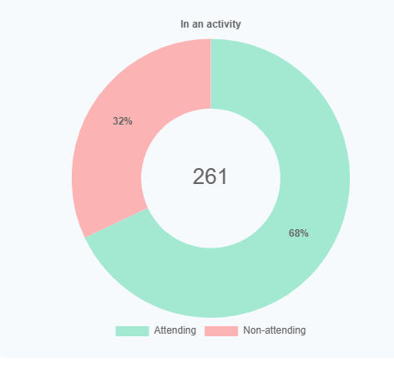

After school club data for the clubs attended.

68% of children attending after school clubs

96% of clubs take place after school. Non sporting clubs have also started in summer term.

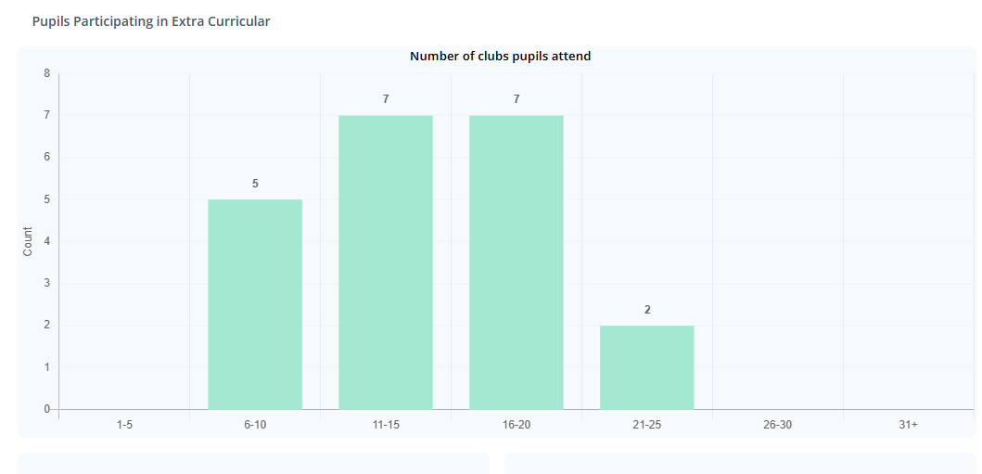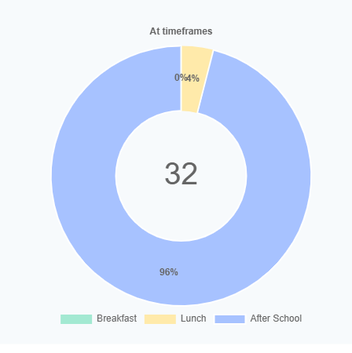

Teacher voice – positive playtimes, children ready to learn in the classroom environment, less behavior issues to deal with. Positive impact on teaching and learning.

Raising the profile of physical activity with the different school sports partnership. Working with Little lions, Macs Academy and Dance coach.

Broadening experiences with activities offered through the school games – such as cricket, SEND Festivals, Ten pin bowling, Scooters, BMX Biking and skateboarding.

Catch up swimming lesson to support swimming and water safety.

Attending Festivals and competitions throughout the academic year and providing a range of after school clubs across the school year groups to help maintain the Gold award standard or reach the platinum award.

Year 5 Adventures days broaden the children’s experiences and support with the transition onto the year 6 residential.

Teacher CPD – School sports partnership (Little lions offered expertise teaching for ECT to gain confidence in teaching PE lessons. Other staff teach to provide expert skill knowledge and delivery in teaching and support with PE evidence and tracking of the children using the PE passport app.

Teacher voice – PE passport app use for planning and assessment – Staff confidence in use the and adapting the plans

* School Games Award – Gold Award Achieved
* Equal Access for girls award achieved 24-25
* Year 6 swimming Data –add to Reporting PE and sport Premium grant expenditure Digital form.
* Success in school competitions led to 4 children representing the district

( Blackburn with Darwen) in a cross country race.

* SEND Team won a Pentathlon Festival and then went to represent the Bourough in a completion in Blackpool.
* PE App assessment show good quality PE lessons being taught. 80% of the school working at Expected or above.

