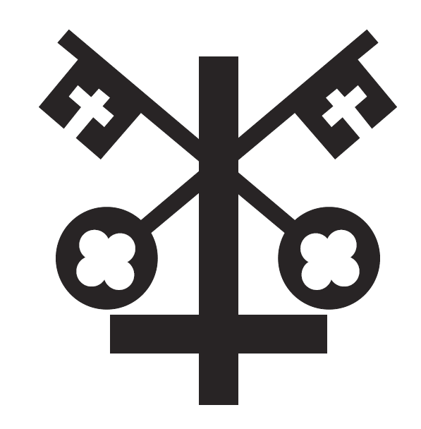

St Peter’s C.E. Primary School

First Aid
Policy

September 2020

Christian Vision

As a Christian family at St Peter’s School, we create a unique place of learning, nurturing the gifts that God in his awesomeness has given us. We encourage every child and prepare them for life’s journey, inspiring them to fulfil their potential, their dreams and their aspirations.
Sowing the seeds of tomorrow
Matthew 13:1-23

Overview

From time to time whilst children are in our care they will get injured or become unwell and they need first aid. Every member of staff is in ‘loco parentis’ and will act accordingly to offer the care and help that could reasonably be expected of a ‘caring parent’ in those circumstances.
We have in school, members of staff who have been trained in First Aid and so the help of one of these staff should be sought as soon as possible. First Aid equipment is available in school and it should be used in the child’s best interest and with great care.
Where it is judged necessary the emergency service should be called or the child should be escorted to hospital. Parents should be kept fully informed whenever a child has received first aid.

Objectives

- To provide safe and appropriate care for children and staff if they are in need of first aid.
- To ensure that we have sufficient trained first aid staff available to care for children or adults if the need arises.
- To ensure that we have at least two members of staff with paediatric first aid training to be available for the care of EYFS pupils at all times of the day.
- To ensure that all staff know what to do if a child needs first aid treatment and how they should respond in those circumstances.
- To ensure that any child with known severe allergic reactions (anaphylaxis) is recognised by staff and where they have an EpiPen, it is available in the classroom and staff know how to use it in an emergency. ( see appendix 1)
- To ensure that we have appropriate first aid kits easily available in school with portable kits to take when children go off site on visits, trips and sporting events.
- To ensure that members of staff are given training and that those with first aid certificates are kept up-to-date. A list of all first aid trained staff is available in every first aid kit, in the staffroom and the office.
- To ensure that all staff know how to involve the emergency services if they are needed.
- To ensure that appropriate medical support/attention and treatment is given to children for all but minor injuries.
- To keep parents and carers fully informed and involved if their child has been given first aid treatment. (see appendix 2)

Strategies

- To seek qualified medical and emergency assistance quickly for all but minor injuries – using the ‘better safe than sorry’ principle and always erring on the cautious i.e. if there is any doubt – seek qualified medical/emergency service (999) support or arrange for the child to be escorted to the nearest casualty facility.
- If an injury is sustained whilst the child is on a visit or other off site activity the senior member of staff present must notify the school as soon as the child’s needs are met.
- To have members of staff who have undertaken appropriate first aid training available at all times on site and when children are on visits.
- To have appropriate first aid equipment available on site at all times.
- To have portable first aid kits to accompany them, when pupils are off site.
- To provide access to certified first aid training and updated first aid training for members of staff.
- To contact parents to involve them as early as possible if their child needs medical assessment/treatment.
- To notify parents in writing, using the school accident report slip, of any head injury or injury of a serious nature that their child has suffered. This should be done on the same day that the injury was received.
- To enter the details of the accident and resulting injury, the treatment given and the member of staff who dealt with the accident in the school accident log which is kept with the first aid kit.
- If an injury/accident is caused by a defect in any part of the school building/grounds, this will be reported to the site supervisor.
- Should a child be displaying symptoms of Covid -19, contact with a parent or carer will be made and the child will await collection in a room where they can be isolated behind a closed door, (depending on the age and needs of the child and with appropriate adult supervision if required). The symptomatic pupil should be tested for Covid-19. Correct hygiene procedures will be followed as per the school risk assessment.

Outcomes

Children and adults in this school will be kept safe but on the rare occasion when they need first aid treatment, the school will see that appropriate treatment is given by members of staff with appropriate levels of training and knowledge of first aid . Where medical and emergency treatment is needed, medical help will be sought quickly. All staff will carry out their duty of care professionally at all times and parents will be kept fully informed if their child has needed first aid treatment.
The Headteacher will ensure that all first aid training is up to date and reviewed at the appropriate times.
The Health and Safety governor will check that procedures adhere to this policy on an annual basis.

The governing body will review this policy every three years. However it may be reviewed earlier if new government regulations are introduced, or if the governing body receives recommendations on how the policy might be improved.

Signed: Date:

Review due: September 2023

Appendix 1

Anaphylaxis

Anaphylaxis is a serious life-threatening type of allergic reaction. It usually develops suddenly and gets worse very quickly.
The symptoms include:
- feeling lightheaded or faint
- breathing difficulties – such as fast, shallow breathing
- wheezing
- a fast heartbeat
- clammy skin
- confusion and anxiety
- collapsing or losing consciousness
There may also be other allergy symptoms, including an itchy, raised rash (hives), feeling or being sick, swelling (angioedema), or stomach pain.

What to do if someone has anaphylaxis
Anaphylaxis is a medical emergency. It can be very serious if not treated quickly.
If someone has symptoms of anaphylaxis, you should:
- Call 999 for an ambulance immediately – mention that you think the person has anaphylaxis
- Remove any trigger if possible – for example, carefully remove any wasp or bee sting stuck in the skin
- Lie the person down flat – unless they're unconscious, pregnant or having breathing difficulties
- Use an adrenaline auto-injector if the person has one – but make sure you know how to use it correctly first
- Give another injection after 5-15 minutes if the symptoms don't improve and a second auto-injector is available
- Keep the child lying down or seated and have someone stay with them until they have been assessed by a paramedic.
- Unconscious patients should be placed in the recovery position

Guide to Using An EpiPen®

- There is no need to remove clothing to use an EpiPen®, but make sure the orange end will not hit buckles, zips, buttons or thick seams on clothes.
- To remove EpiPen® from the carry case. Flip open the lid on the carry case. Tip the carry case and slide the EpiPen® out of the carry case.
- Lie the child down with their legs slightly elevated to keep their blood flowing or sit them up if breathing is difficult.
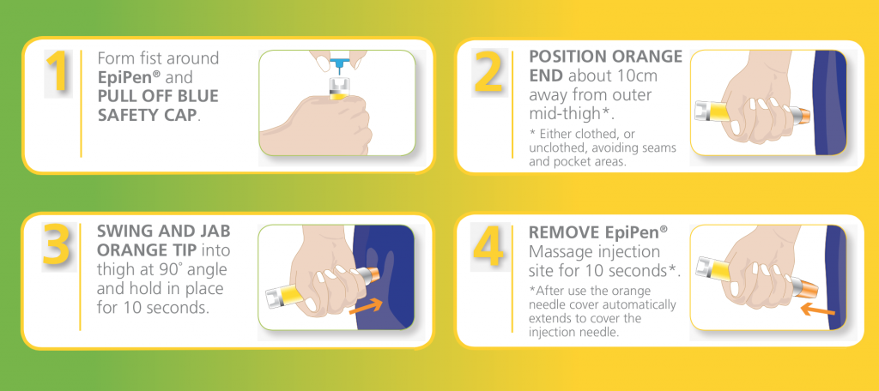
Each EpiPen® can only be used once. If symptoms don’t improve, you can administer a second EpiPen® after 5-15 minutes.
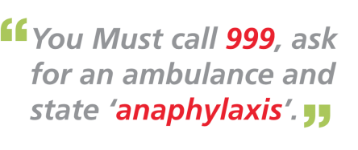

Appendix 2

First Aid Forms
Is the injury to the face or head?
─

No
Yes
In ALL cases:
Once first aid has been administered

- Please fill in the normal accident forms AND top section only of a bump-to-the-head letter.

- All forms to go to teacher to sign at end of day

- Teacher to send pink copy and bottom section to the office at the end of day (once child has been OK for rest of day)
Was the injury caused deliberately?
No
Yes
Once first aid has been administered

- Please fill in the normal accident forms detailing the injury

- Paperwork to teacher to sign at end of day

- Conversation with classteacher for them to inform parent of incident and to give any consequences to perpetrator
Once first aid has been administered

- Please use the new stickers

- Give a sticker to the child

- Fill in the date and your initials on the incident record next to the child’s name (inside the first aid folder)

