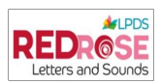
Reading, Phonics and Spelling

We use Red Rose Letters and Sounds to teach Phonics. In EYFS and KS1 children are taught daily phonics lessons. We use a range of books from:
Big Cat Phonics
Phonics Book Bug Club
Alphablocks

Fast Track Phonics and Bounce Back Phonics are used where necessary to support children who have not made age related expectations at the end of Year 1.
In EYFS and KS1 we have updated our reading books to closely match our new synthetic phonics program and these are organised in phonics phases. We aim to send between 2- 4 books home per week, in order to consolidate the learning from phonics. Children take home books linked to their learning in school. They also take home a book to share with their parent or guardian as we believe in fostering a love for reading. Children in EYFS and KS1 also have access to library books from our recently revamped Key Stage One Library, these can again be shared with their trusted adults at home. We encourage children to be reading at least three times per week to an adult.
All children are provided with a reading record which we encourage parents to fill in to show they have listened to their child read at home. We expect reading bags to be brought to school every day.
In year 2, once children have achieved the expected standard in their phonics screening check they move to the banded books. Children in year 2 will also move onto No Nonsense spelling programme once secure with their phonics.
Key Stage Two

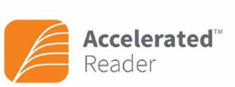
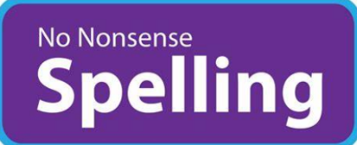
Once children move into Key Stage Two (years 3 – 6) they continue to develop their English skills through No Nonsense Spelling. This is taught between 2 and three times weekly and is used to help our children develop their knowledge of common spelling patterns, homophones and other key spelling skills.

Accelerated Reader (AR) is used to continue to develop children’s reading skills. This is a system that helps teachers manage and monitor our children’s independent reading practice and progress. Your child will take a short quiz which generates a reading range. This enables children to pick books at their own level to read and enjoy at their own pace. When finished, your child will take a short quiz on our class iPads which will help gage your child’s understanding of what they have read. This is done in the classroom at a time designated by the class teacher. Passing the quiz (with a score of 85% or more) is an indication that your child understood what was read. AR gives children and teachers feedback based on the quiz results which the teacher then uses to help set your child targets and goals and to direct ongoing reading practice and book choice.

Fostering a love for reading is our primary goal and so alongside the teaching of reading we encourage our children to select books from our well stocked Key Stage Two library to read either independently or share at home. Children continue to have books read to them by their class teacher throughout key stage two, exposing them to a range of genres, authors and poets. We also take the children for visits to our local library for story times, research work and to enable them to borrow books, we hope this will encourage them to develop a passion for reading and a lifelong love of books.

