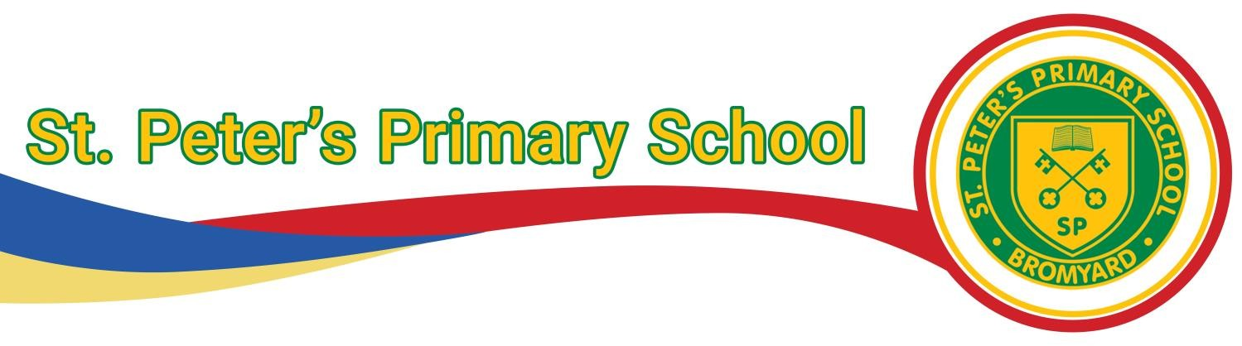
Head of School : Heather Yarnold Cherry Tree Close, Bromyard, Herefordshire, HR7 4UY Email: hyarnold@st-peters.hereford.sch.uk Tel: 01885 483237 Email: admin@st-peters.hereford.sch.uk

ST PETER’S PRIMARY SCHOOL
Assessment Policy STP2
Duty-Holder: | Mrs H. Yarnold
Responsible person(s): | Mrs H. Yarnold
Plan approved on: | January 2026
Review Date: | January 2028

Introduction
We believe that effective assessment is an essential element of effective teaching and learning, and provides crucial information without which teaching cannot be appropriately focused on the needs of learners. We use two different but complementary types of assessment: assessment for learning and assessment of learning.

Assessment for Learning (AfL) is a type of formative assessment, in that it involves a judgement about what the pupil has successfully learned and what the next developmental steps in their learning should be. It therefore informs and directs the teacher’s planning, and is used in the classroom to raise pupils’ achievement. The sharing of learning objectives with pupils is an important part of AfL, and is based on the idea that pupils will learn most effectively if they understand the aim of their learning, how they have progressed towards that aim, and what they need to learn next in order to achieve it. This principle applies equally to all learners.

Assessment of Learning refers to summative assessment and involves judging pupils' learning and attainment against their own and national standards. Teachers may make these judgements at the end of a unit of work, at the end of each term, and at the end of a key stage. Tests are a straightforward form of summative assessment, though teachers’ ongoing assessments of pupils’ progress in terms of National Curriculum expectation.

We give our children regular feedback on their learning so that they understand what it is that they need to improve or to learn next. Such feedback will be both oral and written (marking). Research has shown that pupils’ involvement in the process of assessing their own learning (self-assessment) raises standards and empowers pupils to take action towards improving their achievement.

Aims and objectives
The purpose of assessment in our school is:
▪ to enable teachers to plan work that accurately addresses the learning needs of each pupil, by ascertaining what they need to learn next;
▪ to enable teachers to record the attainment and progress of pupils;
▪ to increase pupils’ motivation by celebrating their learning achievements and enabling them to understand what they have learned and what they need to learn next;
▪ to help pupils recognise the standards they are aiming for, and to understand the criteria of effective learning and achievement;
▪ to enable teachers to provide regular information for parents and carers about their child’s progress in learning and enable them to support their child’s education;
▪ to provide the Leadership team and governors with information that allows them to make judgements about the effectiveness of teaching and learning in the school.

Assessment and Recording
- Teachers use assessment for learning (AfL) to provide on-going assessment, through the use of focused marking and/or observations of children’s work against learning objectives. This information is then used to assess progress towards meeting learning targets and to identify and set next step targets for each child. Teachers take part in live markings in the majority of lessons, enabling in the moment, instant feedback to pupils, allowing the learning to be tailored to the individual’s needs.
- Formative Assessment is made by class teachers and other adults involved with each child to record other important information about the progress of children in the class.
- A variety of tests are timetabled throughout the school year. These assessments are used to assess age related attainment, progress and gaps in learning.
- The SEND Register and Interventions ensure that children with identified special educational needs and those children not making expected progress are supported appropriately and their needs assessed regularly. Children with personalised plans (with or without an EHCP), have their outcomes tracked and evaluated. This ensures progress is made and suitable next steps of learning are planned. See the SEND policy for further details for children on the SEND register. Specific assessments are carried out with children to identify additional needs.
- Assessment is recorded on INSIGHT.

Assessment and reporting to parents
We undertake termly (whole school) assessments in reading, writing, grammar and punctuation
and maths. Results are recorded on INSIGHT.
We hold Parents’ Evenings in the Autumn and Spring terms. Class teachers are required to complete a brief report proforma for these. Teachers write more comprehensive reports in the Summer term. If relevant, class teachers will communicate with parents about pupils’ progress in between these times.

St Peters Year Group Summative Assessment Requirements

By Year Group | Assessment Requirements | When | Statutory  Requirements
Nursery | Teachers in the Early Years Foundation Stage (EYFS) will plan and assess children’s learning against Development Matters and the Early Learning Goals, and use the EYFS Profile to assess children’s achievements and progress. RWI Assessments half termly. | Continuous. Logged  termly  Termly
Reception | As above plus ‘Reception baseline’ | Once  induction is complete  (within first  6 weeks) | LA informed of outcome November
Year 1 | Reading – RWI assessments/Nfer  Maths – Whiterose 2 papers (arithmetic and reasoning)  End of block assessments  Writing – Whole school independent focus piece marked against end of year expectations; The Write Stuff end of unit independent writing tasks  Spelling 20 question test/Nfer | Termly | June Y1 Phonics Screening
Year 2 | Reading – Nfer  Half Termly Accelerated Reader diagnostic test and quizzes as appropriate  Maths – Whiterose 2 papers (arithmetic and reasoning)  End of block assessments  Writing – Whole school independent focus piece marked against end of year expectations; The Write Stuff end of unit independent writing tasks  Spelling 20 question test/Nfer | Termly | Phonics retakes
Year 3 | Reading – Nfer  Half Termly Accelerated Reader diagnostic test and quizzes as appropriate  Maths – Whiterose 2 papers (arithmetic and reasoning)  End of block assessments  Writing – Whole school independent focus piece marked against end of year expectations; The Write Stuff end of unit independent writing tasks  Spelling 20 question test/Nfer | Termly
Year 4 | Reading – Nfer  Half Termly Accelerated Reader diagnostic test and quizzes as appropriate  Maths – Whiterose 2 papers (arithmetic and reasoning)  End of block assessments  Writing – Whole school independent focus piece marked against end of year expectations; The Write Stuff end of unit independent writing tasks  Spelling 20 question test/Nfer | Termly | June:  Multiplication  Check
Year 5 | Reading – Nfer  Half Termly Accelerated Reader diagnostic test and quizzes as appropriate  Maths – Whiterose 2 papers (arithmetic and reasoning)  End of block assessments  Writing – Whole school independent focus piece marked against end of year expectations; The Write Stuff end of unit independent writing tasks  Spelling 20 question test/Nfer | Termly
Year 6 | Reading – Nfer/SATS  Half Termly Accelerated Reader diagnostic test and quizzes as appropriate  Maths – Whiterose 2 papers (arithmetic and reasoning)/ SATS  End of block assessments  Writing – Whole school independent focus piece marked against end of year expectations; The Write Stuff end of unit independent writing tasks  Spelling 20 question test/Nfer | Half Termly | May:  SATS  LA and Gov.UK informed of results

