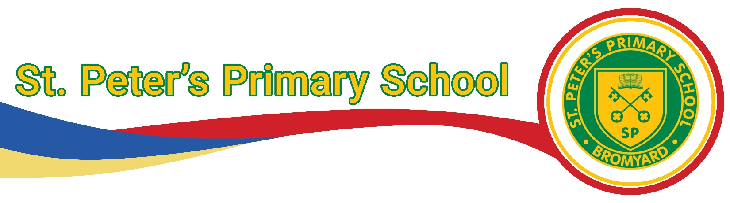
Early Years Food and Nutrition Policy
STP5

Date Policy written: January 2026
Review date: January 2028

Signed by:
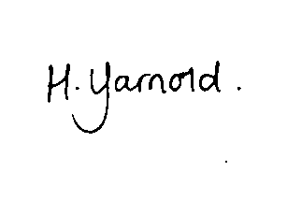
Head of School 7.1.2026

Chair of Local Governing Board

1.0 Policy Statement

At St Peter’s Preschool Nursery, we are committed to promoting healthy eating and ensuring food safety in accordance with:
- Early Years Foundation Stage (EYFS) statutory framework
- Health and Safety regulations including food hygiene regulations and safe storage practices
- The Eatwell Guide - NHS
- Early Years Foundation Stage nutrition guidance
- The NHS Children's food: safety and hygiene
We aim to support children's health, development, and well-being by encouraging balanced, nutritious meals and maintaining a safe and inclusive environment for all dietary needs.

2.0 Aims
This policy is in place to:
- Provide guidelines for parent/carers on the expectations for packed lunches brought from home
- Ensure packed lunches brought from home provides children with healthy, balanced
and nutritious food, which meets their needs to be physically active, to learn, grow well, and be healthy.
- Comply with food hygiene and safety regulations.
- Meet EYFS requirements for nutrition, independence and self-care.
- Protect children with allergies and dietary needs.
- Align with the Herefordshire Healthy Schools Initiative.

3.0 Packed Lunch Guidelines

Drink, such as water and milk, will be available for your child during the day. If providing a drink, we encourage that only water, milk or unsweetened calcium enriched dairy alternative should be given.

Parents are encouraged to be mindful of appropriate portion sizes for their child’s age and stage of development. Food should be provided in manageable pieces that are not a choking hazard.

A healthier packed lunch contains a portion of one of the four main food groups:
- One or two portions of starchy foods: Provide variety across the week and at least one wholegrain starchy food each week. This includes bread, wrap, chapatti, bagels, pasta, rice, noodles, couscous or potatoes. This should form part of the main meal and can be part of the dessert
- At least one portion of vegetables and/or one portion of fruit: Provide a variety of different vegetables and fruit each week. This includes carrot, cucumber, celery stick, chopped tomato and fresh, tinned, frozen, dried fruit such as sliced apple, chopped grapes, raisins (but remember, dried fruit is not suitable as a snack). Aim for your child to have 5 different vegetables and fruit across the day
- One portion of beans, pulses, fish, eggs, meat and other proteins: Provide a variety of different foods each week. This includes kidney beans, chickpeas (hummus), lentils (dahl), tofu, quorn, egg, sliced meat or poultry in sandwiches
- One portion of dairy or an unsweetened calcium enriched alternative: This includes cheese in a sandwich, milk to drink, unsweetened yoghurt or fromage frais, rice or semolina pudding

Parents are provided with the Early Years Foundation Stage Nutrition Guidance for a more extensive list.

As outlined in this guidance, we encourage parents to avoid:

✖ Sugary foods (chocolate and sweets, such as chocolate buttons, chocolate biscuit, cereal bar, processed dried fruit product).
✖ Overly processed snacks high in salt or fat. (snack items such as crisps, puffs, pulse or grain-based crisps, coated or flavoured dried vegetables).

The following items are strictly prohibited in packed lunches:
✖Sugary drinks (fizzy drinks, energy drinks).
✖Nuts or nut-based products (strictly prohibited due to allergies).

4.0 Safe Storage & Handling of Packed Lunches
The safe storage of food inside packed lunches is the responsibility of the parent.
To ensure compliance with food safety:
- All packed lunches must be provided in a clearly named, insulated lunchbox.
- Parents/Carers are advised to bring packed lunches in suitable lunch boxes which should include ice packs to keep perishable food fresh.
- Refrigeration is not available; therefore parents/carers should pack food that remains safe at room temperature. We will provide a storage area for packed lunch bags.
- We are unable to heat/ re-heat food for food hygiene purposes. Children can bring hot food in a suitable thermos flask or container.
- Staff will monitor lunches for compliance with food safety and healthy eating standards.
- Any unsafe or unsuitable food will be returned home, and parents/carers will be informed.
- Children are only allowed to eat their OWN food.

5.0 Waste and Disposal
Staff will, within reason, send any uneaten packed lunch food items back home. This is so that parents/carers can also monitor what their child has consumed during the day and then raise any concerns over their child’s food intake with the members of staff.

6.0 Parental Notification (Food Allergies)
- Parents/Carers must notify the setting in writing of any food allergies, intolerances, or dietary requirements. We recognise that some children may require a special diet. In this case parents/carers should notify the setting.
- Packed lunches should be stored on our designated packed lunch trolley at drop-off to ensure compliance with our policy.
- Staff will monitor lunchboxes to ensure adherence to food safety and allergy guidelines.

7.0 Allergy & Food Safety Policy Compliance
- We operate a strict NO-NUT policy—any nut-based products will be removed and returned to parents.
- All food must be safely prepared and stored at home following food hygiene guidelines.
- Parents/Carers must ensure food is fresh and appropriate for their child's dietary needs.
- Any concerns about a child's diet or food safety will be discussed with parents/carers.
8.0 Snacks provided by our setting
Children will be provided with healthy, balanced snacks that comply with the Early Years Foundation Stage Framework and the DFE’s Early Years Foundation Stage Nutrition Guidance. Children will be given access to milk outlined in the Government’s Early Years Milk Scheme and their bottles will be refilled with water only.

9.0 Celebrations or special occasions
If parents wish to mark or celebrate special occasions or birthdays, they will be encouraged to swap traditional sweet treats for those that match our healthy eating guidelines. Or non-edible items such as stickers, bubbles, or friendship bracelets, as an alternative to food. Allergen checks will need to be carried out on any edible items that are brought in to share.

If parents do send edible items that do not comply with our nutrition policy, these will not be consumed in our setting.

10.0 Support for Parent/Carers
We will provide parents with an annual information evening to discuss our policy and supporting guidance, along with a parental information pack with examples of what a healthy lunchbox should include.

If parents and carers need further support in providing a healthy packed lunch, they should speak to a member of staff and we will happily offer further guidance.

Parents and carers can also access guidance and ideas by visiting the following websites:
https://www.firststepsnutrition.org/eating-well-early-years https://healthforunder5s.co.uk/sections/preschool/preparing-the-perfect-packed-lunch/

11.0 Non-Compliance & Right to Refuse Packed Lunches To safeguard all children
Parents/Carers must adhere to our allergy, food hygiene, and healthy eating guidelines.
If we have concerns about the contents of a packed lunch, we reserve the right to:
- Raise these concerns with parents/carers.
- Send home unsuitable food items.
- Report ongoing non-compliance as a safeguarding concern, in line with EYFS regulations.

If a child comes without a packed lunch, we will call families to bring one in.

Monitoring and review
This policy will be reviewed periodically by the Local Governing Board and the Head of School.
Any changes made to this policy will be communicated to all relevant stakeholders.
All members of staff directly involved with the EYFS will be required to familiarise themselves with all processes and procedures outlined in this policy as part of their induction.
The next scheduled review date for this policy is January 2028.
Signed by:
 | Executive Headteacher/CEO | Date:
 | Chair of the Trust Board | Date:

