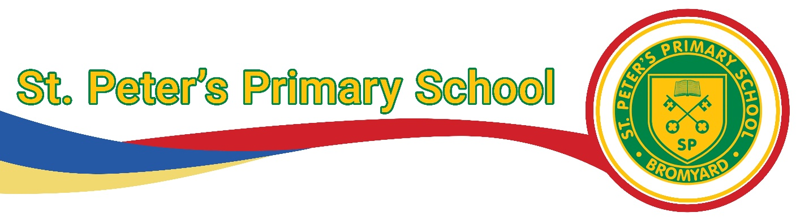

St Peters Primary School

PSHE Policy

Policy created: September 2025

Agreed by Staff and Governors: September 2025

**Statutory requirements:**

PSHE is a non-statutory subject. However, there are aspects of it we are required to teach.

* We must teach relationships education under the Children and Social Work Act 2017, in line with the terms set out in statutory guidance
* We must teach health education under the same statutory guidance
* We must teach Relationships education and our governors have agreed that we will teach Sex Education (See Relationships and Health Education Policy).
* Our teaching must take due regard of the Equality Act 2011 This policy also complies with the terms of our funding agreement.

**Intent:**

At St Peter’s we use Twinkl Life’s PSHE and Citizenship scheme of work aims to equip children with essential skills for life; it intends to develop the whole child through carefully planned and resourced lessons that develop the knowledge, skills and attributes children need to protect and enhance their wellbeing. Through these lessons, children will learn how to stay safe and healthy, build and maintain successful relationships and become active citizens, responsibly participating in society around them. Successful PSHE curriculum coverage is a vital tool in preparing children for life in society now and in the future. Lessons in this scheme of work have their foundations in seeing each and everybody’s value in society, from appreciation of others in units such as Diverse Britain, to promoting strong and positive views of self in Think Positive and Be Yourself. Twinkl Life PSHE and Citizenship units aim to cover a wide range of the social and emotional aspects of learning, enabling children to develop their identity and self-esteem as active, confident members of their community. The themes and topics support social, moral, spiritual and cultural development and provide children with protective teaching on essential safeguarding issues, developing their knowledge of when and how they can ask for help. Twinkl Life’s PSHE and Citizenship resources are fully in line with the Learning Outcomes and Core Themes provided by the PSHE Association Programme of Study which is widely used by schools in England and is recommended and referred to by the DfE in all key documentation relating to PSHE provision in schools. This scheme of work covers all of the required objectives and follows the three core areas of Health and Wellbeing, Relationships and Living in the Wider World. The scheme of work fulfils the requirements of 2020 Statutory Relationships and Health Education, setting these learning intentions in the context of a broad and balanced PSHE curriculum

**Implementation:**

Twinkl Life’s PSHE scheme of work is designed to be taught in thematic units, which consist of six lessons, each with supporting materials including a Planning Overview, assessment statements, Learning Journey Record and display materials. It is suggested that these units are taught in a spiral curriculum that revisits each theme every two years. This enables children to recall and build upon previous learning, exploring the underlying principles of PSHE education regularly at a depth that is appropriate for the age and stage of the child. Lessons also signpost key words, building a rich vocabulary to develop understanding. Twinkl Life’s PSHE units are designed to be delivered in a creative manner, using many approaches such as role play, discussion and games with groups of various sizes. These activities enable children to build confidence and resilience. Resources are also provided for communicating with parents and carers about how and why each theme is covered and suggestions for extending the learning at home. Assessment for learning opportunities are built into each lesson and enhanced by the Learning Journey Records included in each unit, which enable self-evaluation and reflective learning and allow teachers to evaluate and assess progress. Each lesson begins with a discussion of children’s existing knowledge and experience, providing an opportunity for baseline assessment. Each lesson ends with an opportunity to consolidate and reflect upon learning. Tools are provided for summative assessment, allowing progress to be recorded and tracked

As stated above, we are required to cover the content for relationships and sex education, and health education, as set out in the statutory guidance (linked to above). Refer to our relationships and sex education policy for details about what we teach, and how we decide on what to teach, in this subject. This policy can be found on our school website.

Classrooms should have a worry monster with available paper to write on. In Key stage 1 worry monster pots are used as a morning check in and in Key stage 2 worry monster tabletop strips are to be used.

In the EYFS, PSHE is is taught through the Early Learning Goals: communication and language, personal; social and emotional development; physical development; understanding of the world. In Key stage one and two children should learn about :

**Health and Wellbeing** lessons will explore physical wellbeing, healthy lifestyles, mental health, growing and changing, keeping safe and drugs, alcohol and tobacco.

**Relationships** lessons will explore families and close positive relationships, friendships, managing hurtful behaviour and bullying, safe relationships and respecting self and others.

**Living in the Wider World** lessons will explore our shared responsibilities, communities, media literacy and digital resilience and economic wellbeing (money and aspirations, work and career) and British Values

Twinkl Life’s PSHE units are designed to be delivered in a creative manner, using many approaches such as role play, discussion, computing and games with groups of various sizes. These activities enable children to build confidence and resilience. Resources are also provided for communicating with parents and carers about how and why each theme is covered and suggestions for extending the learning at home.

PSHE will be taught in half termly blocks with more of a focus on discussion, practical work and role play. Some lessons will be recorded in books documenting the sessions and the learning taking place.

**Enrichment and Cultural Capital**

We have visits from local police officers, delivering information sessions and the STAR programme. Hands up for the planet deliver environmental awareness workshops to pupils in Y3 and Y5.

**Inclusion:**

For most children with special educational needs, it will be appropriate for them to study the same curriculum as the rest of the class. Recording methods may need to be differentiated. There are additional materials, which can be used alongside the main teaching materials that have been specially designed to support children with Special Educational Needs: PSHE Education Planning Framework for Pupils with SEND. This Framework also supports schools to provide a comprehensive PSHE programme that integrates, but is not limited to, this new statutory content.

**Impact**

Twinkl Life’s PSHE scheme of work provides schools with an effective curriculum for wellbeing. Children are enabled to develop the vocabulary and confidence needed to clearly articulate their thoughts and feelings in a climate of openness, trust and respect, and know when and how they can seek the support of others. They will apply their understanding of society to their everyday interactions, from the classroom to the wider community of which they are a part. Twinkl Life’s PSHE scheme of work supports the active development of a school culture that prioritises physical and mental health and wellbeing, providing children with skills to evaluate and understand their own wellbeing needs, practise self-care and contribute positively to the wellbeing of those around them. Successful PSHE education can have a positive impact on the whole child, including their academic development and progress, by mitigating any social and emotional barriers to learning and building confidence and self-esteem. Evidence suggests that successful PSHE education also helps disadvantaged and vulnerable children achieve to a greater extent by raising aspirations and empowering them with skills to overcome barriers they face. The Twinkl Life PSHE and Citizenship scheme of work can be used as a whole-school approach to positively impact wellbeing, safeguarding and SMSC outcomes. This can ensure that all children are able to develop the knowledge, skills and attributes they need to succeed at school and in the wider world

**Monitoring and Review:**

Each lesson begins with a discussion of children’s existing knowledge and experience, providing an opportunity for baseline assessment. Each lesson ends with an opportunity to consolidate and reflect upon learning.

Teachers will assess each child during the group session and record in their book whether they have met the objective or not. These will be used to assess the children against the unit requirements at the end of each term using the five key questions.

The subject will be monitored termly by the subject coordinator to ensure the correct materials are being used and that teachers are assessing against the five key questions. Classroom environments will also be checked.