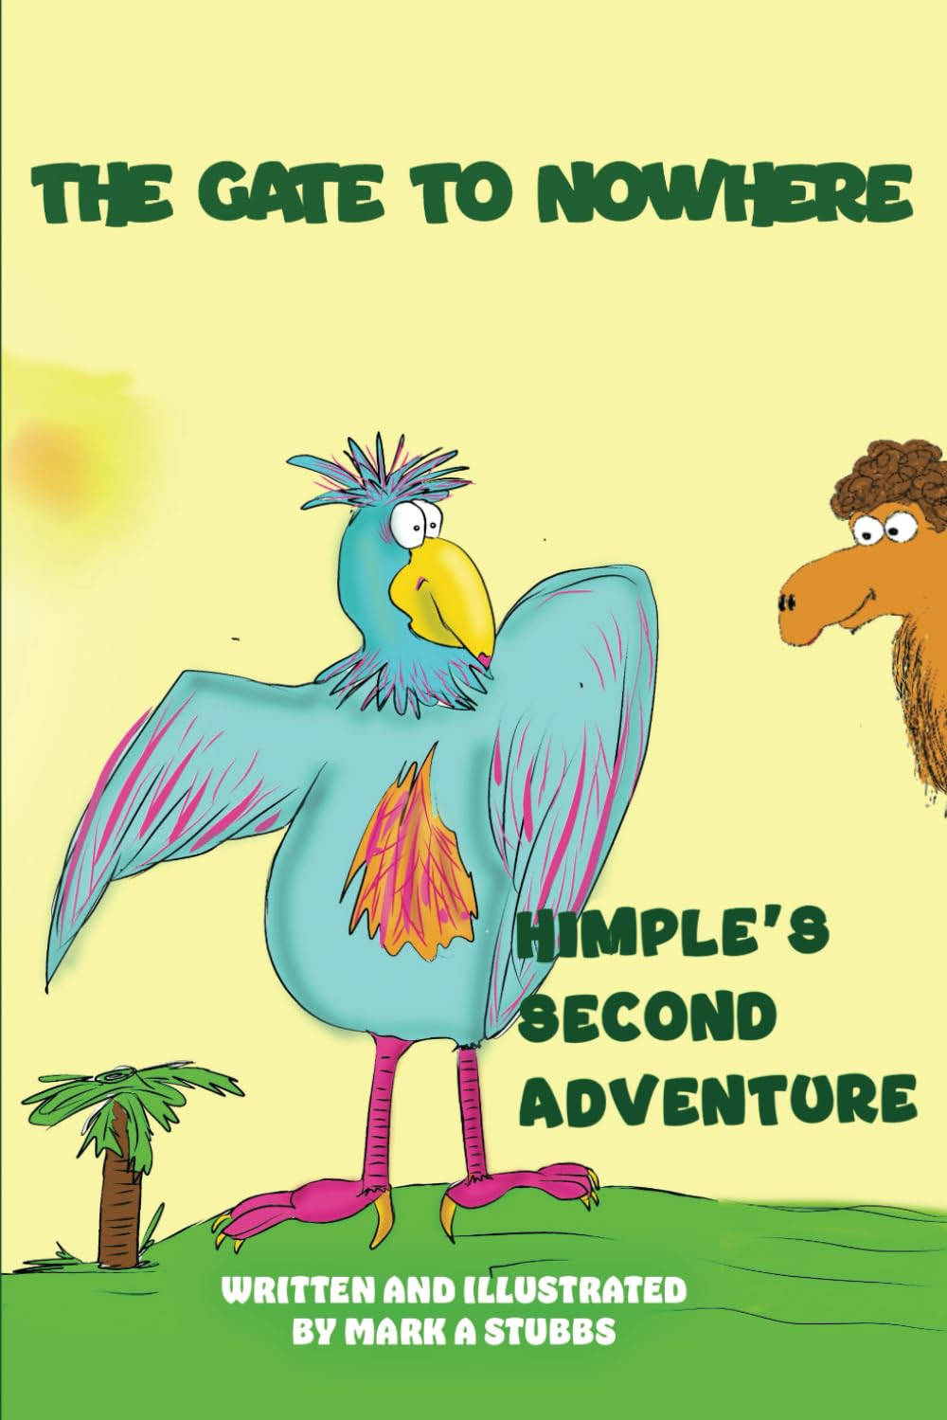
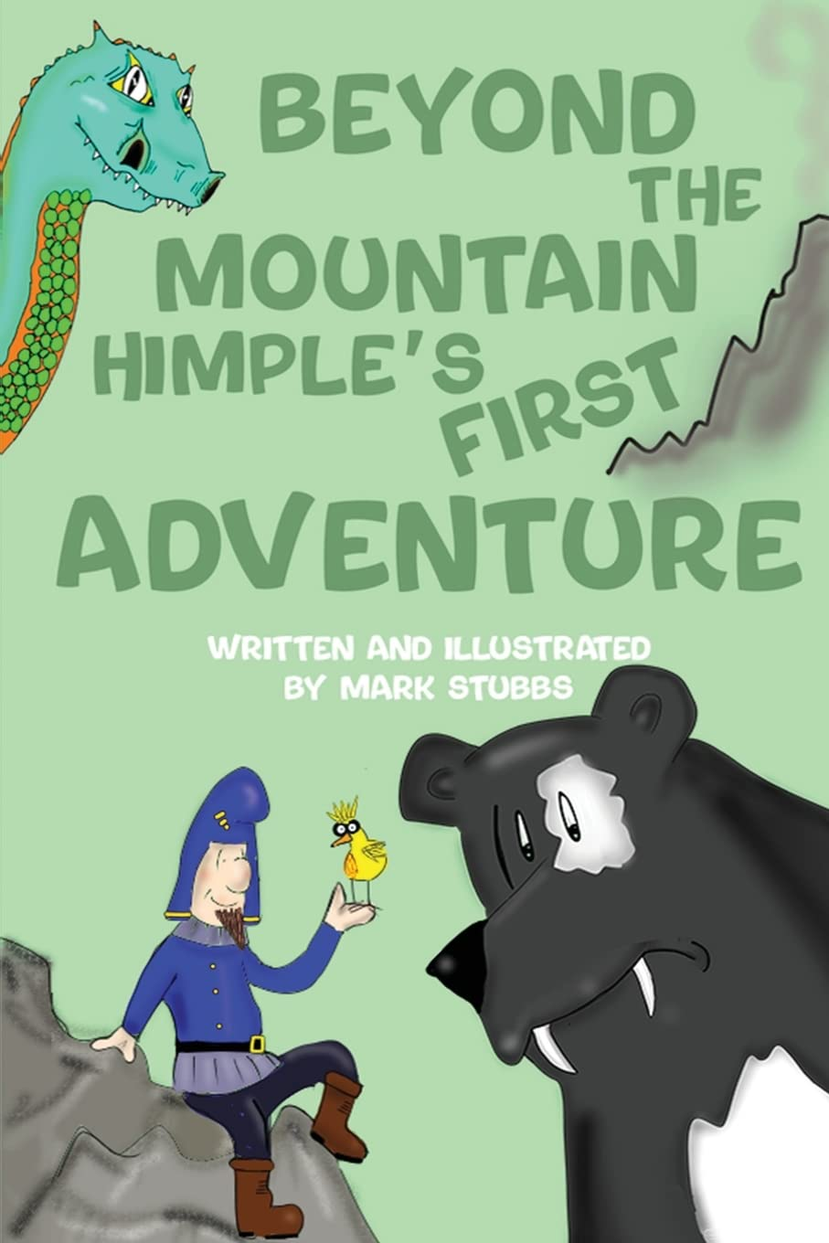

Visiting Author

Dear Parents/Carers,

As part of Reading Week here at St Peter’s, we are very lucky to have a visiting author in school on Thursday 19th September! Mark Stubbs will be in school to deliver workshops to all of the children over the course of the day. This is such an exciting opportunity for the children and we’re sure that they will all enjoy it.

Mark will also be bringing some signed copies of his books with him for the children to buy at a reduced price of £7.50. If your child wishes to purchase a book, please can they bring £7.50 in an envelope with their name on.

Yours sincerely,

Mrs H. Makins
Y6 Teacher and Reading Coordinator

