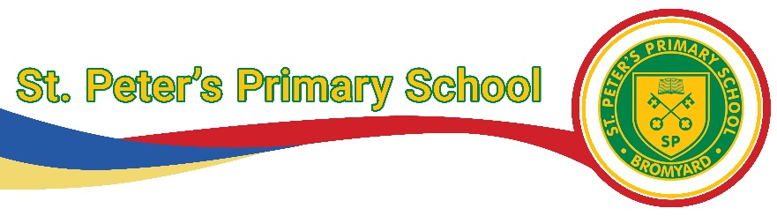
Art and Design Policy
Intent:
At St Peter’s primary school our intent is to provide children with a creative, carefully planned and progressive art and design curriculum where they develop their own art skills and also build an appreciation and knowledge of a wide variety of artists. Art and design will be used to create a stimulating environment for children to learn, including celebrating art from a variety of cultures and countries. Therefore, it will play a vital role in supporting children’s social and cultural development. Providing children with a variety of art experiences will equip pupils with the knowledge and cultural capital they need to succeed in life. We will ensure children develop the knowledge and understanding of the concepts outlined in the National Curriculum and are given opportunities to acquire the relevant skills. Furthermore, we will provide children with the ability to use these skills throughout the curriculum. They will be encouraged to have confidence to use their art skills to express themselves and to celebrate a variety of religious, community and cultural events.
Aims:
EYFS
Pupils should be taught:
- Safely use and explore a variety of materials, tools and techniques, experimenting with colour, design, texture, form and function.
- Share their creations, explaining the process they have used.
- Make use of props and materials when role playing characters in narratives and stories.
Key stage 1
Pupils should be taught:
- To use a range of materials creatively to design and make products.
- To use drawing, painting and sculpture to develop and share their ideas, experiences and imagination.
- To develop a wide range of art and design techniques in using colour, pattern, texture, line, shape, form and space.
- About the work of a range of artists, craft makers and designers, describing the differences and similarities between different practices and disciplines, and making links to their own work.
Key stage 2
Pupils should be taught:
- To develop their techniques, including their control and their use of materials, with creativity, experimentation and an increasing awareness of different kinds of art, craft and design.
- To create sketch books to record their observations and use them to review and revisit ideas.
- To improve their mastery of art and design techniques, including drawing, painting and sculpture with a range of materials (for example, pencil, charcoal, paint, clay)
- About great artists, architects and designers in history.

Through studying and celebrating a wide variety of artists and techniques, we will encourage children to understand that there is no ‘right’ way of producing art. Sketch books will be used to help develop children’s confidence in art and allow them to experiment and develop their ideas without worrying about making mistakes.
Teachers will support children by modelling art techniques and providing examples for them to base their own work from. Some children may need extra support or time to develop their cutting and pencil skills.
As part of our aim to develop all children’s cultural capital, where possible teachers will give children opportunities to visit real and virtual art galleries, take part in art workshops and work with artists and craftspeople. This will give all children opportunities to experience things they may not normally, regardless of their social, cultural and economic background.
Implementation:
Art is to be taught for a minimum of 60 minutes per week if being taught weekly. If being blocked or taught half termly, teachers are to ensure that the amount of art being taught is equivalent to a minimum of 6 hours per unit.
St Peter’s Progression of Skills in Art and Design documents are used to inform planning alongside the use of Twinkl units of work as appropriate. This means all staff are clear on what they must teach in their year group, the steps before and where the learning will continue. Staff should refer to the school progression document so that they are sure of what pupils have covered previously and what they will cover in the future. The curriculum is cumulative so once art skills have been taught, they will be revisited. Art content to be covered is documented on the Long-Term overview for the subject and or the school curriculum as a whole and is available as a separate document.
Where enrichment activities are used, such as educational visits, visits from artists or celebration events, this should be shown on medium term plans and the annual ‘Enrichment Overview document.’
Staff create a small step planning document from the detailed progression document. This document also records pupil achievement for the end of each unit of work - recorded as WTS or ARE.
Art is often linked to what children are studying in history, science, geography and R.E. Art is also used to celebrate events such as World Book Day and Christian festivals as well as those from other religions.
When they are planning for the year, teachers should ensure they provide children with opportunities to use a range of media such as chalks, oil pastels, collage, clay, printing, paint and textiles. Children should also have opportunities to study a variety of artists through their time at St Peter’s. These should include contemporary artists, significant artists from history, local artists, illustrators, architects, sculptors, potters, film makers, environmental artists and graffiti artists. They will also have the opportunity to learn about art from a variety of different cultures and historical periods, and this will form an important part of their understanding and appreciation of different cultures, religions and societies.

Inclusion:
At our school, we teach art and design to all children, whatever their ability and individual needs. Through our art and design teaching, we provide learning opportunities that enable all pupils to make good progress, considering cognitive challenge which is demonstrated within each lesson, as well as how learners will be supported in line with the school’s commitment to inclusion. We strive to meet the needs of those pupils with special educational needs, those with disabilities, those who are higher level thinkers, and those learning English as an additional language, and we take all reasonable steps to achieve this. We believe that the curriculum should be accessible to all children.

Impact
A high-quality art and design education should engage, inspire and challenge pupils, equipping them with the knowledge and skills to experiment, invent and create their own works of art, craft and design. By the time children leave our school they will:
- Have mastered the Art skills and techniques appropriate to their age.
- Produce creative artwork using a variety of mediums.
- Evaluate their own work and the work of others.
- Be confident, happy children that are willing to have a go, be creative and produce work that they are pleased with.
- Be self-motivated.
- Support each other.

Assessment
Teachers will assess children’s work and skills.
At St Peter’s, all lessons begin with a recall session. This recall might be from a previous lesson in the unit being studied or from a previous year group. This method allows children the opportunity to constantly revisit learning. A variety of formative assessment methods are used including quizzes, matching vocabulary to definitions, and practising skills. The aim of this is to consolidate and embed knowledge, skills and vocabulary. Feedback is given to the children as soon as possible and is guided by the school's marking policy.

Enrichment and Cultural Capital
Some of the enrichment activities at St Peter’s include:
- Community art involvements, such as: The Scarecrow Festival, Christmas Tree Festival, Bromyard Christmas Lights Lantern Parade, and the Bromyard Art Exhibition.
- Visits to local galleries.
- School art exhibition.
- Expressive Arts week.

Role of the Art and Design Co-ordinator
The art and design co-ordinator leads the maintenance and development of the subject.
They are responsible for assuring quality and standards in the subject by:
- Taking the lead in the development, evaluation and amendment of schemes of work as and when necessary.
- Identifying training needs of staff through monitoring and performance management review.
- Acting as a consultant to colleagues on resources, fieldwork possibilities, curriculum changes, classroom teaching ideas.
- Monitoring and evaluating pupils’ work, colleagues’ planning and classroom teaching.

