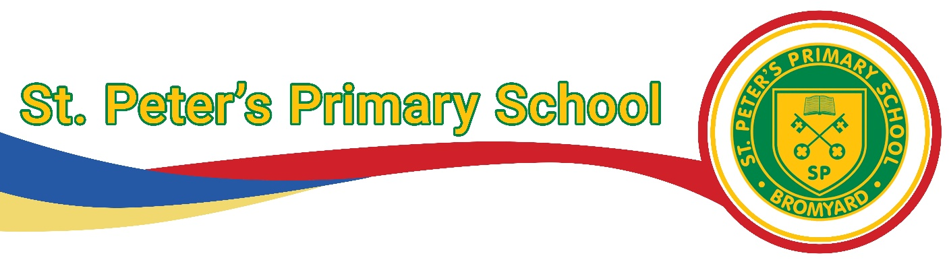

St Peters Primary School

R.E. Policy

Policy created: September 2025

Agreed by Staff and Governors: September 2025

To be reviewed: In five years in line with the Herefordshire RE curriculum update.

**Intent:**

*‘The principal aim of religious education (RE) is to explore what people believe and what difference this makes to how they live, so that pupils can gain the knowledge, understanding and skills needed to handle questions raised by religion and worldviews, reflecting on their own ideas and ways of living.’ (Herefordshire RE Curriculum 2025 – 2026)*

We believe that RE has an important part to play in promoting the spiritual, moral, social, cultural and intellectual development of our pupils and in helping them to gain a greater understanding of themselves and a more sympathetic awareness of the needs of others. This enables pupils to be better equipped to cope with the responsibilities and experiences of adult life.

To promote the ideas of our school vision we believe that education in RE should be a child centred, exciting journey. Pupils will learn to understand the world and their place in it, know that all members of the school community show respect and tolerance for others and develop a better cultural awareness.

**Implementation:**

Our objectives for the teaching of RE are derived from Herefordshire Agreed Syllabus for R.E 2025 - 2030:

The Herefordshire Agreed Syllabus 2025 asserts the importance and value of religious education (RE) for all pupils, with on-going benefits for an open, articulate and understanding society. The following purpose statements underpin the syllabus which is constructed to support pupils and teachers in fulfilling them:

• Religious education contributes dynamically to children and young people’s education in schools by provoking challenging questions about meaning and purpose in life, beliefs about God, ultimate reality, issues of right and wrong and what it means to be human.

• In RE pupils learn about religious and non-religious worldviews in local, national and global contexts, to discover, explore and consider different answers to these questions.

• Pupils learn to weigh up the value of wisdom from different sources, to develop and express their insights in response and to agree or disagree respectfully.

• Teaching therefore should equip pupils with systematic knowledge and understanding of a range of religious and non-religious worldviews, enabling them to develop their ideas, values and identities.

• RE should develop in pupils an aptitude for dialogue so that they can participate positively in our society, with its diverse religions and beliefs.

• Pupils should gain and deploy the skills needed to understand, interpret and evaluate texts, sources of wisdom and authority and other evidence. They should learn to articulate clearly and coherently their personal worldviews – the way in which they encounter, interpret, understand and engage with the world – while respecting the right of others to be different.

Our teaching and learning styles in RE enable children to build on their own experiences and to extend their knowledge and understanding of religious traditions. We aim to use a variety of active teaching and learning strategies in RE. For the very young, this will be achieved by respecting their natural ways of learning through sense experience, exploration, conversation and play. Older children will investigate, discuss, evaluate and explore through a variety of active learning strategies such as drama, role play, freeze frame; interpretation of posters, pictures, artefacts; use of computers, etc.

**In the EYFS** we follow the Herefordshire curriculum but also include Personal, Social and Emotional development- building relationships and Understanding the world- past and present and People and communities.

**Impact**

Religious Education at St Peter’s Primary School develops pupils':

* knowledge and understanding of, and their ability to respond to, Christianity, other principal world religions, other religious traditions and world views;
* understanding and respect for different religions, beliefs, values and traditions (including ethical life choices), through exploring issues within and between faiths;
* understanding of the influence of faith and belief on individuals, societies, communities and cultures;
* skills of enquiry and response through the use of religious vocabulary, questioning and empathy;
* skills of reflection, expression, application, analysis and evaluation of beliefs, values and practices, and the communication of personal responses to these.

**The legal position of Religious Education**

As required by law, we provide RE for all pupils in accordance with the Herefordshire Agreed Syllabus for Religious Education. In order to meet the requirements of the syllabus we devote no less than 45 minutes a week of curriculum time for RE. This is in addition to the time allocated there is also a half-termly worship led by the vicar from St Peter’s Church.

**Rights of withdrawal**

We firmly believe that RE is an important subject in children’s learning.

We fully recognise the legal right of parents to withdraw their children from all or any part of RE

on the grounds of conscience. The school asks parents/carers to contact the Head teacher if they

have any concerns about RE provision and practice at the school.

To support our teaching and delivery of RE we use the agreed Herefordshire Syllabus for Religious Education. We implement the teaching and learning approach making sense of beliefs, making connections and understanding the impact.

Our teaching and learning styles in RE enable children to build on their own experiences and to extend their knowledge and understanding of religious traditions. We aim to use a variety of active teaching and learning strategies in RE. For the very young this will be achieved by respecting their natural ways of learning through sense experience, exploration, conversation and play. Older children will investigate, discuss, evaluate and explore through a variety of active learning strategies such as drama, role play, freeze frame; interpretation of posters, pictures, artefacts; use of computers, etc.

Resources are available for the different faiths in storage boxes in Acorns.

**Enrichment and cultural capital**

We also take the opportunities teach R.E. through religious festivals from a wide range of religions around a calendar of religious festivals.

We regularly visit our local church and the vicar visits school to lead assembly monthly.

Where possible visits are organised for children to attend to different places of worship and for visitors from different faiths to visit our school.

**Inclusion:**

At our school, we teach RE to all children, whatever their ability and individual needs. RE forms part of the school's curriculum policy to provide a broad and balanced education to all children. Through our RE teaching, we provide learning opportunities that enable all pupils to make good progress. We strive hard to meet the needs of those pupils with special educational needs, those with disabilities, those with special gifts and talents, and those learning English as an additional language, and we take all reasonable steps to achieve this. For further details, see separate policies: Special Educational Needs; Disability Discrimination; Gifted and Talented Children; English as an Additional Language (EAL).

We value the opinions, beliefs and practices of all, and handle with sensitivity minority groups and/or opinions. We help children to recognise that not all members of a particular religion will believe and practice the same things by using the phrase some

Christians/Muslims/Jews etc. We try to use resources reflecting a range of cultures and

traditions. Teachers should be alert to the fact that some children have special and deep experience of religion through family practice. All pupil’s beliefs and values, religious or otherwise are affirmed and valued.

When progress falls significantly outside the expected range, the child may have special educational needs. Our assessment process looks at a range of factors – classroom organisation, teaching materials, teaching style, and differentiation – so that we can take some additional or different action to enable the child to learn more effectively. This ensures that our teaching is matched to the child's needs.

We enable all pupils to have access to the full range of activities involved in RE. Where children are to participate in activities outside the classroom (a visit to a local place of worship, for example, that involves a journey), we carry out a risk assessment prior to the activity, to ensure that the activity is safe and appropriate for all pupils.

**Monitoring and Review:**

Teachers will assess each child during the group session and record in their books (Reception through a floor book) whether they have met the objective or not. These will be used to assess the children against the unit requirements at the end of each term.

The RE subject leader monitor’s the progress of pupil’s work in every year group throughout the year through pupil voice, book trawls, pupil questionnaires.

Individual religions are studied in each unit; at the end of the year the unit spends time comparing the religions studied before.

Each unit has learning outcomes where teachers can use this to assess children’s knowledge and understanding on a half termly basis.

The coordination and planning of the RE curriculum are the responsibility of the subject leader, who also:

* + - supports colleagues in their teaching, by keeping informed about current developments in RE and providing a strategic lead and direction for this subject;
    - uses specially allocated regular management time to review evidence of the children's work, and to observe RE lessons across the school.
    - Liaises with the HOS in pertinent matters