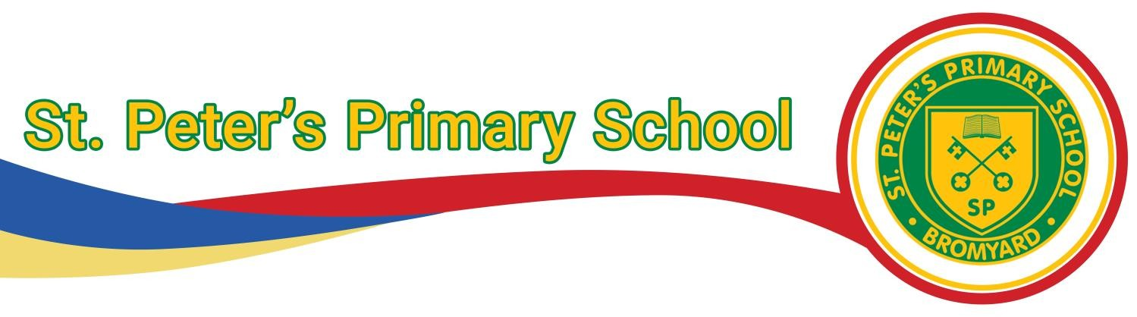

Head of School : Heather Yarnold Cherry Tree Close, Bromyard, Herefordshire, HR7 4UY
Email: hyarnold@st-peters.hereford.sch.uk Tel: 01885 483237 Email: admin@st-peters.hereford.sch.uk

ST PETER’S PRIMARY SCHOOL
Uniform Policy

Duty-Holder: | Mrs H. Yarnold
Responsible person(s): | Mrs H. Yarnold
Plan approved on: | January 2026
Review Date: | January 2028

Uniform is an important part of a school’s identity. It reinforces who we are as a community and helps allow pupils to feel pride in their school. It also ensures students are not put under any pressure because of the type of clothes they wear and all are treated equally. School uniform shows that the children are ready to learn, respectful and safe.

It is our school policy that all children wear school uniform when attending school, or when participating in school-organised events outside normal school hours. We ask children to take a pride in their personal appearance. Our uniform is smart, practical, safe and affordable.

Monitoring and Review
The governing body monitors and reviews the school uniform policy by: • ensuring uniform is readily available at a reasonable cost; • considering, with the Head of School, any requests from parents for individual children to have special dispensation with regard to school uniform.

The Role of Parents and Staff
We believe that one of the responsibilities of parents is to ensure that their child has the correct uniform and PE kit and that it is clean, in good repair and that the child’s name is written on all items.
It is the responsibility of all staff to ensure that the school uniform policy is adhered to. Children without the correct uniform will be given a school jumper to wear for the day. Parents and carers of pupils that do not wear the correct uniform will be contacted to discuss the situation
There may be good reasons why a pupil is not wearing school uniform. In this case, parents and carers should share the reasons with the class teacher either in person or via Seesaw. The school will always be considerate and discrete in trying to establish why a pupil is not wearing the correct uniform.

Equal Opportunities
All children have equal access to wearing school uniform regardless of their culture, race, religion, gender, disability or ability. We ensure that the set uniform respects other policies such as equality, race relations and sex discrimination. St. Peter’s Primary School is committed to creating a positive climate that will enable everyone to work free from racial intimidation and harassment and to achieve their full potential. Minor adjustments to the standard school uniform are accepted for religious reasons but these should be discussed the Headteacher in the first instance

Buying uniform
Some items of uniform can be bought with the St. Peter’s School logo on, whilst other plain items are easily available, at competitive prices, at local shops including supermarkets. Second-hand uniforms can benefit all parents. In addition, by extending the life of garments, it is more sustainable. We hold pre-used uniform sales in school or please ask at the office.

A complete list of the items needed for school uniform and for P.E. is included in this policy.

Jewellery and make up
Make-up is not allowed. Pupils are not allowed to wear nail polish or false nails. Pupils may wear a watch (with no sound effects, cameras or games) and may wear one pair of small, stud earrings which must be worn in the lower ear lobe. All studs must be removed for PE by the pupil or taken out at home. Studs earrings that cannot be removed by the pupil for PE lessons need to be covered with a plaster or tape supplied from home. Please note, staff are not allowed to remove earrings. If your child is planning to have their ear(s) pierced, please could this be done at the beginning of the Summer holiday.
Please note that the school will be unable to take any responsibility for any watches or jewellery that are lost.

Footwear
All pupils are required to wear flat, plain black shoes (not trainers) without logos that they can take on and off themselves. These should be closed in with no toes visible. If boots are worn these should also be flat and plain black. For health and safety reasons, we do not allow pupils to wear shoes with platform soles or high heels. Sandals and flip-flops are not permitted.

Lost Property
Please could ALL uniform items be clearly marked with your child's name.
All mislaid items are placed in a property bins outside the main entrance. Parents and children should look here for missing items. We endeavour to return all named property. All unclaimed lost property is put out for parents periodically throughout the term. At the end of every term, all unclaimed items of uniform will be disposed of.

Hairstyles
Pupils’ hair should be neatly groomed and tidy at all times. Long hair on both girls and boys should be tied back neatly. Pupils may not wear designs or words cut into their hair or permanent or temporary coloured hair.

St Peter’s Primary School uniform:
- Yellow polo shirt
- Green jumper, sweatshirt or cardigan
- Black or grey trousers, tailored shorts, pinafore or skirt. (Please note – leggings or jeans are not to be worn in place of trousers. Shorts and skirts should be knee length and allow children to sit comfortably on the floor.)
- Black, sturdy shoes (no trainers or multi-coloured shoes)
- Grey, black or white socks or grey or black tights
- Summer – green checked dresses or black or grey tailored shorts
- Long hair should be tied up
- No jewellery, nail varnish or make-up (except plain ear studs which must be removed for PE)
Sweatshirts, cardigans, polo shirts, coats and book bags can be purchased from school. We often have preloved school uniform for sale in school. Please speak to Mrs Unwin to see what is currently available.

St Peter’s Primary School PE kit:
Children need a change of clothing and footwear for PE for health and hygiene reasons.
- Plain, black shorts or jogging bottoms for colder weather
- PLAIN white t-shirt or polo shirt
- Black pumps or trainers
- A school jumper for colder weather (no other colours or logos)

