Subject | Autumn 1 | Autumn 2 | Spring 1 | Spring 2 | Summer 1 | Summer 2
Core Value | Enthusiasm | Respect | Compassion | Perseverance | Integrity | Enthusiasm
Personal and Social Development | Select and use activities and resources, with help when needed. This helps them to achieve a goal they have chosen, or one which is suggested to them.  Remember rules without needing an adult to remind them. | Become more outgoing with unfamiliar people, in the safe context of their setting.  Talk with others to solve conflicts.  Talk about their feelings using words like ‘happy’, ‘sad’, ‘angry’ or ‘worried’. Understand gradually how others might be feeling. | Develop their sense of responsibility and membership of a community.  Make healthy choices about food, drink, activity and toothbrushing.  Be increasingly independent in meeting their own care needs, e.g brushing teeth, using the toilet, washing and drying hands thoroughly. | Become more outgoing with unfamiliar people, in the safe context of their setting.  Remember rules without needing an adult to remind them.  Develop appropriate ways of being assertive.  Make healthy choices about food, drink, activity and toothbrushing. | Find solutions to conflicts and rivalries. For example, accepting that not everyone can be Spider-Man in the game, and suggesting other ideas  Increasingly follow rules, understanding why they are important.  Develop appropriate ways of being assertive. | Show more confidence in new social situations Play with one or more other children, extending  and elaborating play ideas.  Talk with others to solve conflicts.  Make healthy choices about food, drink, activity and toothbrushing.
RSHE Scheme |  | 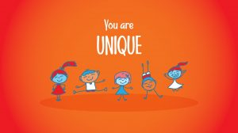  Me, my body, my health  Religious Understanding  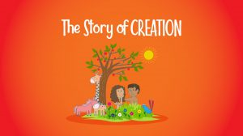 | 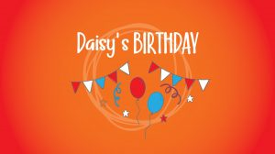  Emotional well-being  Life cycles  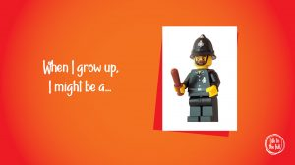 | 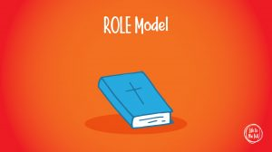  Religious understanding  Personal relationships  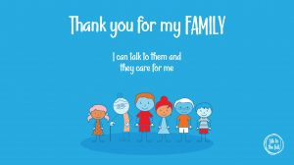 | 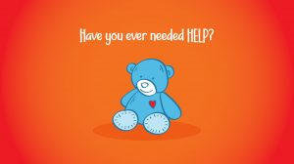  Keeping safe  Personal relationships | Religious understanding  Living in the wider world  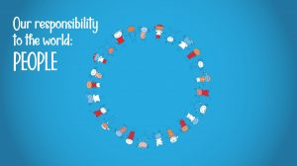
Physical Development | Go up steps and stairs, or climb up apparatus, using alternate feet.  Use large-muscle movements to wave flags and streamers, paint and make marks.  Use one-handed tools and equipment, for example, making snips in paper with scissors. | Use large-muscle movements to wave flags and streamers, paint and make marks.  Collaborate with others to manage large items, such as moving a long plank safely, carrying large hollow blocks.  Use one-handed tools and equipment, for example, making snips in paper with scissors.  Show a preference for a dominant hand. | Skip, hop, stand on one leg and hold a pose for a game like musical statues.  Match their developing physical skills to tasks and activities in the setting. For example, they decide whether to crawl, walk or run across a plank, depending on its length and width  Use one-handed tools and equipment, for example, making snips in paper with scissors.  Show a preference for a dominant hand. | Continue to develop their movement, balancing, riding (scooters, trikes and bikes) and ball skills.  Match their developing physical skills to tasks and activities in the setting. For example, they decide whether to crawl, walk or run across a plank, depending on its length and width.  Choose the right resources to carry out their own plan. For example, choosing a spade to enlarge a small hole they dug  with a trowel. | Continue to develop their movement, balancing, riding (scooters, trikes and bikes) and ball skills.  Use one-handed tools and equipment, for example, making snips in paper with scissors.  Use one-handed tools and equipment, for example, making snips in paper with scissors.  Show a preference for a dominant hand. | Be increasingly independent as they get dressed and undressed, for example, putting coats on and doing up zips.  Start taking part in some group activities which they make up for themselves, or in teams.  Increasingly able to use and remember sequences and patterns of movements which are related to music and rhythm.

Communication and Language | Use talk to organise themselves and their play: “Let’s go on a bus... you sit there... I’ll be the driver.”  Use longer sentences of four to six words | Understand a question or instruction that has two parts, such as “Get your coat and wait at the door”.  Develop their communication, but may continue to have problems with irregular tenses and plurals, such as ‘runned’ for ‘ran’, ‘swimmed’ for ‘swam’. | Pay attention to more than one thing at a time, which can be difficult.  Sing a large repertoire of songs.  Know many rhymes, be able to talk about familiar books, and be able to tell a long story.  Develop their pronunciation but may have problems saying: - some sounds: r, j, th, ch, and sh - multisyllabic words such as ‘pterodactyl’, ‘planetarium’ or ‘hippopotamus’ | Use talk to organise themselves and their play: “Let’s go on a bus... you sit there... I’ll be the driver.”  Use a wider range of vocabulary.  Develop their pronunciation but may have problems saying: - some sounds: r, j, th, ch, and sh  - multisyllabic words such as ‘pterodactyl’, ‘planetarium’ or ‘hippopotamus’ | Use talk to organise themselves and their play: “Let’s go on a bus... you sit there... I’ll be the driver.”  Sing a large repertoire of songs.  Start a conversation with an adult or a friend and continue it for many turns.  . | Enjoy listening to longer stories and can remember much of what happens.  Understand ‘why’ questions, like: “Why do you think the caterpillar got so fat?”  Start a conversation with an adult or a friend and continue it for many turns.  Be able to express a point of view and to debate when they disagree with an adult or a friend, using words as well as actions.
Literacy | Look at and enjoy print and digital books independently.  Listen to and join in with stories and poems, when reading one-to-one and in small groups.  Join in with repeated refrains and anticipates key events and phrases in rhymes and stories.  Enjoy drawing freely.  Sometimes give meaning to marks as they draw and paint.  Ascribe meaning to marks they see in different places. | Enjoy drawing freely.  Sometimes give meaning to marks as they draw and paint.  Ascribe meaning to marks they see in different places.  Understand we read English text from left to right and from top to bottom.  Understands the names of the different parts of a book. | Make marks on pictures to stand for their name.  Use some of their print and letter knowledge in their early writing. For example: writing a pretend shopping list that starts at the top of the page;  Recognise rhythm in spoken words, songs, poems and rhyme.  Count or clap syllables in a word during sound play.  Show awareness of alliteration.  Begin to be aware of the way stories are structured, and to tell own stories.  Talk about events and principal characters in stories and suggests how the story might end. | Make marks on pictures to stand for their name.  Use some of their print and letter knowledge in their early writing. For example: writing a pretend shopping list that starts at the top of the page;  Recognise rhythm in spoken words, songs, poems and rhyme.  Count or clap syllables in a word during sound play.  Show awareness of alliteration.  Begin to be aware of the way stories are structured, and to tell own stories.  Talk about events and principal characters in stories and suggests how the story might end. | write ‘m’ for mummy.  Write some or all of their name.  Write some letters accurately.  Engage in extended conversations about stories, learning new vocabulary.  Recognise familiar words and signs such as own name and advertising logos.  Understand print has meaning.  Understand print can have different purposes. | write ‘m’ for mummy.  Write some or all of their name.  Write some letters accurately.  Engage in extended conversations about stories, learning new vocabulary.  Recognise familiar words and signs such as own name and advertising logos.  Understand print has meaning.  Understand print can have different purposes.

Power of Reading texts: | 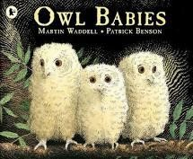  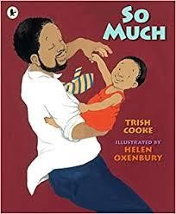  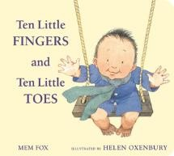 | 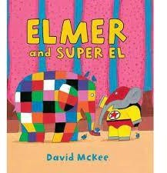  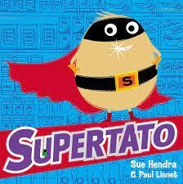 | 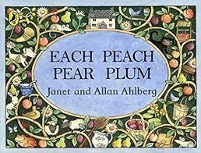  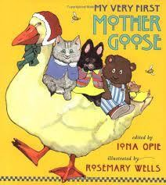 | 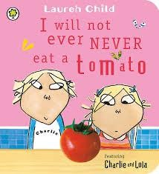  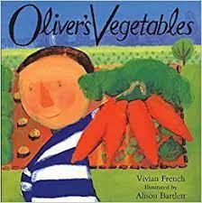  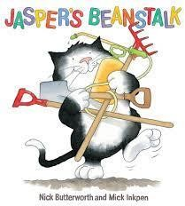 | 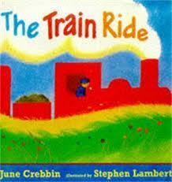  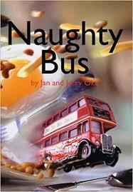 | 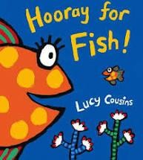  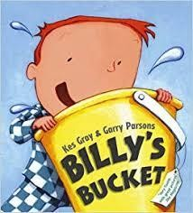  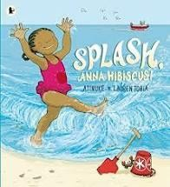
Genres/ Other texts: | Fiction: Starting school  Poetry:  A great big cuddle | Fiction:  Harry and the Dinosaurs  Non- Fiction: Police: busy day  Firefighters busy day | Poetry: Puffin Nursery Rhymes | Fiction:  Titch  Non- Fiction:  From egg to chicken | Fiction:  All aboard for the Bobo road | Fiction: Tiddler Sharing a shell Rainbow fish Bright stanley  Information: Surprising sharks

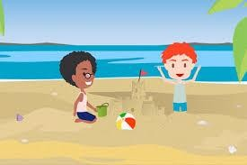
Maths | Recite numbers past 5.  Show ‘finger numbers’ up to 5.  Use some number names and number language within play ,may enjoy counting verbally as far as they can go.  Begin to recognise that each counting number is one more than the one before.  Predict, move and rotate objects to fit the space or create the shape they would like.  Chooses appropriate items based on their shape for a specific purpose. | Say one number for each item in order: 1,2,3,4,5, point or touch each item.  Link numerals with amounts up to 5 and maybe beyond.  Enjoy partitioning and combining shapes to make new shapes with 2D and 3D shapes.  In meaningful contexts, find the longer or shorter, heavier or lighter and more/less full of two items.  Attempt to create arches and enclosures when building, using trial and improvement to select blocks.  Extend and create ABAB patterns – stick, leaf, stick, leaf. | Develop fast recognition of up to 3 objects, without having to count them individually (‘subitising’).  Compare quantities using language: ‘more than’, ‘fewer than’.  Talk about and explore 2D and 3D shapes (circles, rectangles, triangles and cuboids) using informal and mathematical language: ‘sides’, ‘corners’; ‘straight’, ‘flat’, ‘round’.  In meaningful contexts, find the longer or shorter, heavier or lighter and more/less full of two items.  Talk about and identify the patterns around them, using informal language like ‘pointy’, ‘spotty’, ‘blobs’.  Notice and correct an error in a repeating pattern. | Recall a sequence of events in everyday life and stories.  Begin to use understanding of number to solve practical problems in play and meaningful activities.  Make comparisons between objects relating to size, length, weight and capacity.  Show awareness of shape similarities and differences between objects.  Create their own spatial patterns showing some organisation or regularity.  Begin to describe a sequence of events, using words such as ‘first’. | Know that the last number reached when counting a small set of objects tells you how many there are in total (‘cardinal principle’).  Compare two small groups of up to five objects, saying when there are the same number of objects in each group.  Understand, respond to and use language of position and direction.  Describe a familiar route.  Discuss routes and locations, using words like ‘in front of’ and ‘behind’ | Experiment with their own symbols and marks as well as numerals.  Separate a group of three or four objects in different ways, beginning to recognise that the total is still the same.  Make comparisons between objects relating to size, length, weight and capacity.  Join in with simple patterns in sounds, objects, games and stories dance and movement, predicting what comes next.
RE  Come and see | Myself | Welcome  Birthdays | Celebrations | Gathering  Growing | Good News | Friends  Our World
Topic | 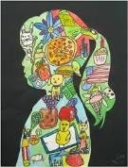  All about me | 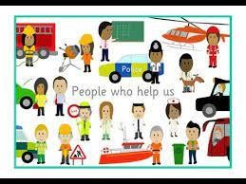  People who help us | 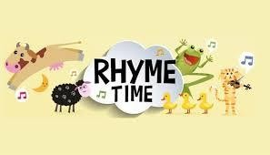  Rhyme Time | 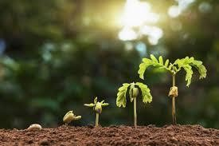  Growing | 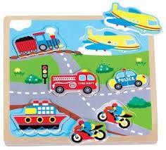  Journeys | Seaside
Enrichment Parental involvement | Traditional clothes day  Owl visit | Parents – talking about occupations Police visit | Mini zoo Rhyme/ song show | Class pet- caterpillars Picnic with food grown Easter egg hunt | Walking bus journey Park visit | Class Pet- fish End of year show/ Graduation!

Understanding of the World | Know some of the things that make them unique and talk about some of the similarities and differences in relation to friends or family.  Talk about family customs and routines or family or friends.  Use all their senses in hands on exploration of natural materials. | Show interest in the lives of people who are familiar to them.  Show interest in different occupations and ways of life indoors and outdoors.  Explore and talk about different forces they can feel. | Remember and talk about significant events in their own experience  Begin to make sense of their own life-story and family’s history.  Explore collections of materials with similar and/or different properties. | Develop positive attitudes about the differences between people.  Talk about what they see, using a wide vocabulary.  Talk about some of the things they have observed such as plants, animals, natural and found objects.  Plant seeds and care for growing plants.  Understand the key features of the life cycle of a plant and an animal. | Know that there are different countries in the world and talk about the differences they have experienced or seen in photos.  Begin to understand the effect their behaviour can have on the environment.  Talk about why things happen and how things work.  Talk about the differences between materials and changes they notice. | Recognise and describe special times or events for family or friends.  Comment and ask questions about aspects of their familiar world such as the place where they live or the natural world.  Begin to understand the need to respect and care for the natural environment and all living things.
EAD | Explore materials to develop ideas about how to use them and what to make.  Join different materials and explore different textures.  Explore colour and how colours can be changed.  Use various construction materials, e.g., joining pieces, stacking vertically and horizontally, balancing, making enclosures and creating spaces.  Use tools for a purpose. | Explore materials to develop ideas about how to use them and what to make.  Join different materials and explore different textures.  Explore colour and how colours can be changed.  Use tools for a purpose.  Being Imaginative and Expressive  Use available resources to create props or creates imaginary ones to support play.  Create sounds, movements, drawings to accompany stories. | Develop an understanding of using lines to enclose a space and begins to use drawing to represent actions and objects based on imagination, observation and experience.  Draw with increasing complexity and detail.  Make imaginative ‘small worlds’ with blocks and construction kits.  Remember and sing entire songs. Tap out simple repeated rhythms.  Develops an understanding of how to create and use sounds intentionally.  Create their own songs or improvise a song around one they know. | Draw with increasing complexity and detail.  Make imaginative ‘small worlds’ with blocks and construction kits.  Remember and sing entire songs.  Tap out simple repeated rhythms.  Develops an understanding of how to create and use sounds intentionally.  Sing the melodic shape (moving melody, such as up and down, down and up) familiar songs.  Play instruments with increasing control to express their feelings and ideas.. | Begin to develop complex stories using small world.  Experiment and create movement in response to music, stories and ideas and to express ideas and feelings.  Join in with moving, dancing and ring games and explore moving in a range of ways.  Show different emotions in their drawings and paintings, like happiness, sadness, fear etc.  Being Imaginative and Expressive  Tap out simple repeated rhythms. | Begin to develop complex stories using small world.  Experiment and create movement in response to music, stories and ideas and to express ideas and feelings.  Join in with moving, dancing and ring games and explore moving in a range of ways.  Show different emotions in their drawings and paintings, like happiness, sadness, fear etc.  Tap out simple repeated rhythms.

