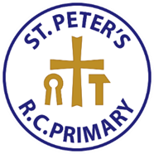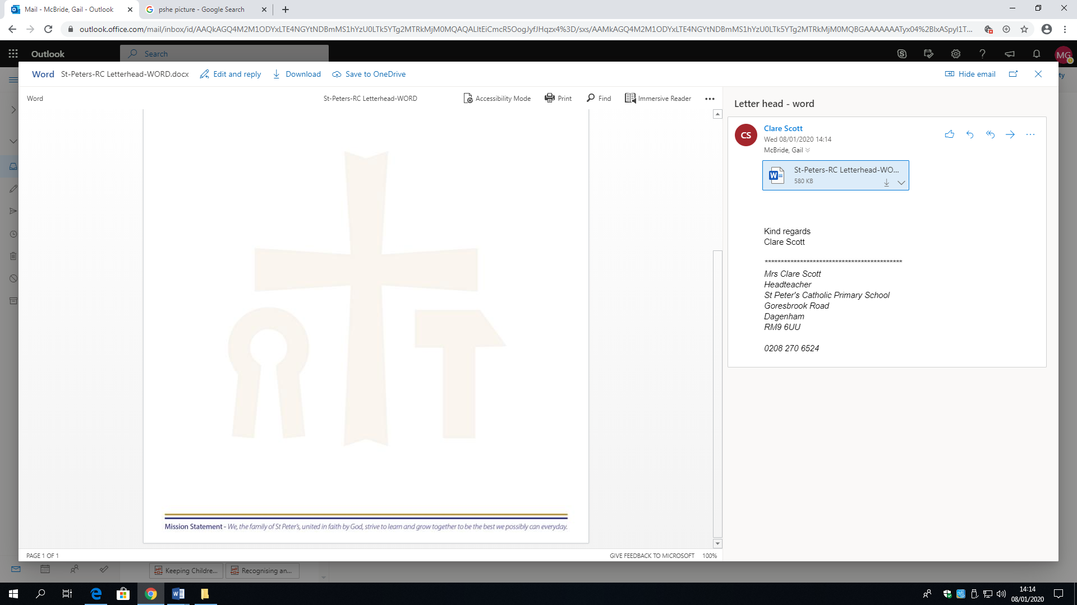

*At St. Peter’s Catholic Primary School, our pupils will gain a coherent knowledge and understanding of Britain’s past and that of the wider world. As our pupils progress as historians, they will develop the enquiry skills required to ask perceptive questions; the analysis skills needed to think critically and evaluate source-based evidence; and the problem-solving skills necessary for them to build their own judgements on past events and people. Through an engaging curriculum, our pupils will understand the complexity of people’s lives; the process of change; the diversity of societies and relationships between different groups; and how the events of the past have shaped our own lives.*

*At St. Peter’s, we aim to use social history as a way of accessing the people and events of the past, so that children can use their skills of understanding people and societies learned in subjects such as RE and PSHE to gain further insight when studying sources in history lessons. Our history curriculum intends to create a stimulating environment which provides opportunities and experiences for our pupils. At St Peter’s, we recognise how fortunate we are to learn in such a vibrant and richly-multicultural setting. We aim to inform students of the rich history and ever-evolving nature of our community.*

*In History lessons, we motivate, engage and challenge the pupils to think for themselves, to make their own judgements and form their own opinions about the past grounded in source-based evidence. Our aim is to promote analysis and problem-solving skills, as well as the ability to form opinions and provide reasons for these. These transferable skills will serve them not only in their endeavours as historians, but also in their everyday lives.*

***History Statement of Intent***