Newsletter Number 6 Friday 11th October 2019

Dear Parents and Friends,

Brexercise
Thank you to all the parents and children who joined us for the Brexercise event on Monday. Great fun was had by all and we will be running this event again soon.

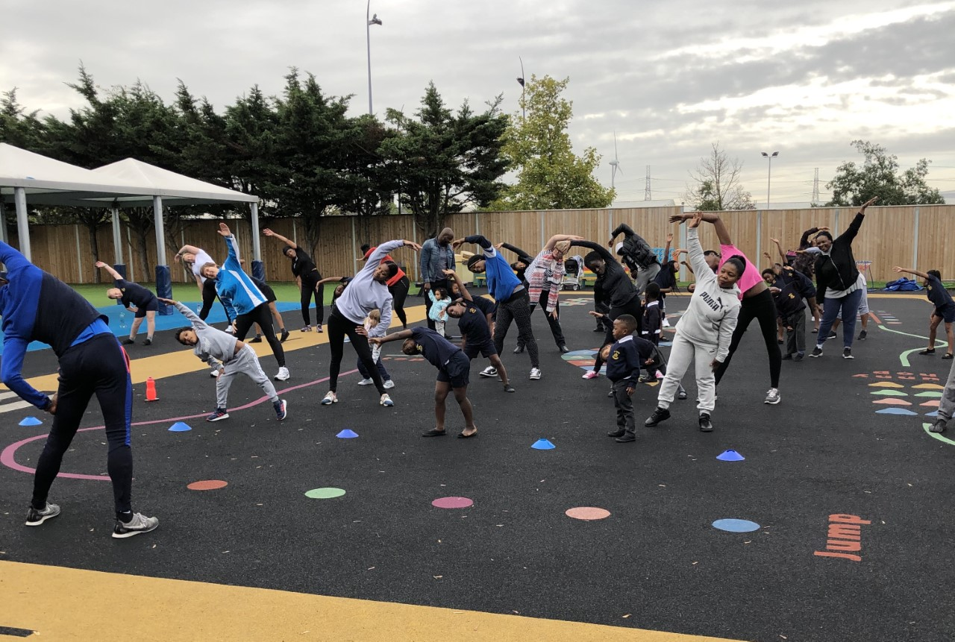

Football News
Our boys have a match this afternoon and girls have a match tonight, so we wish them all the best as they represent the school.

World Mental Health Day
On Thursday we celebrated World Mental Health Day, the school was brightened up with splashes of yellow on the staff and the pupils. The children took part in activities in class to raise awareness and develop understanding of mental wellbeing.

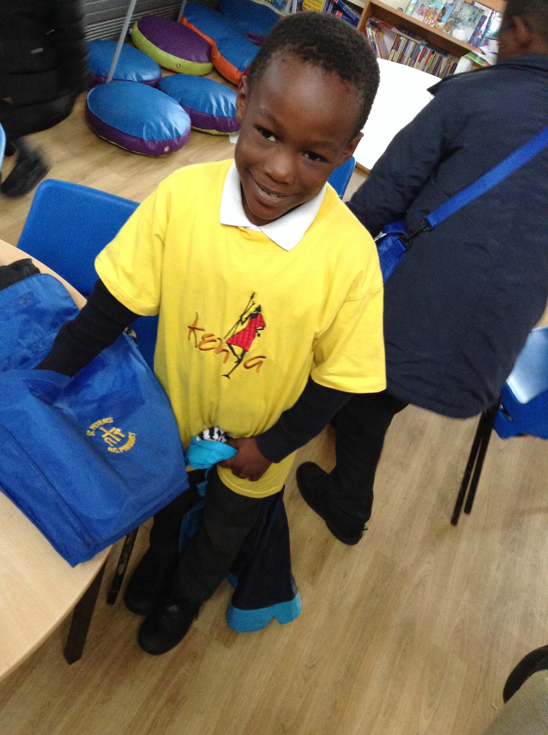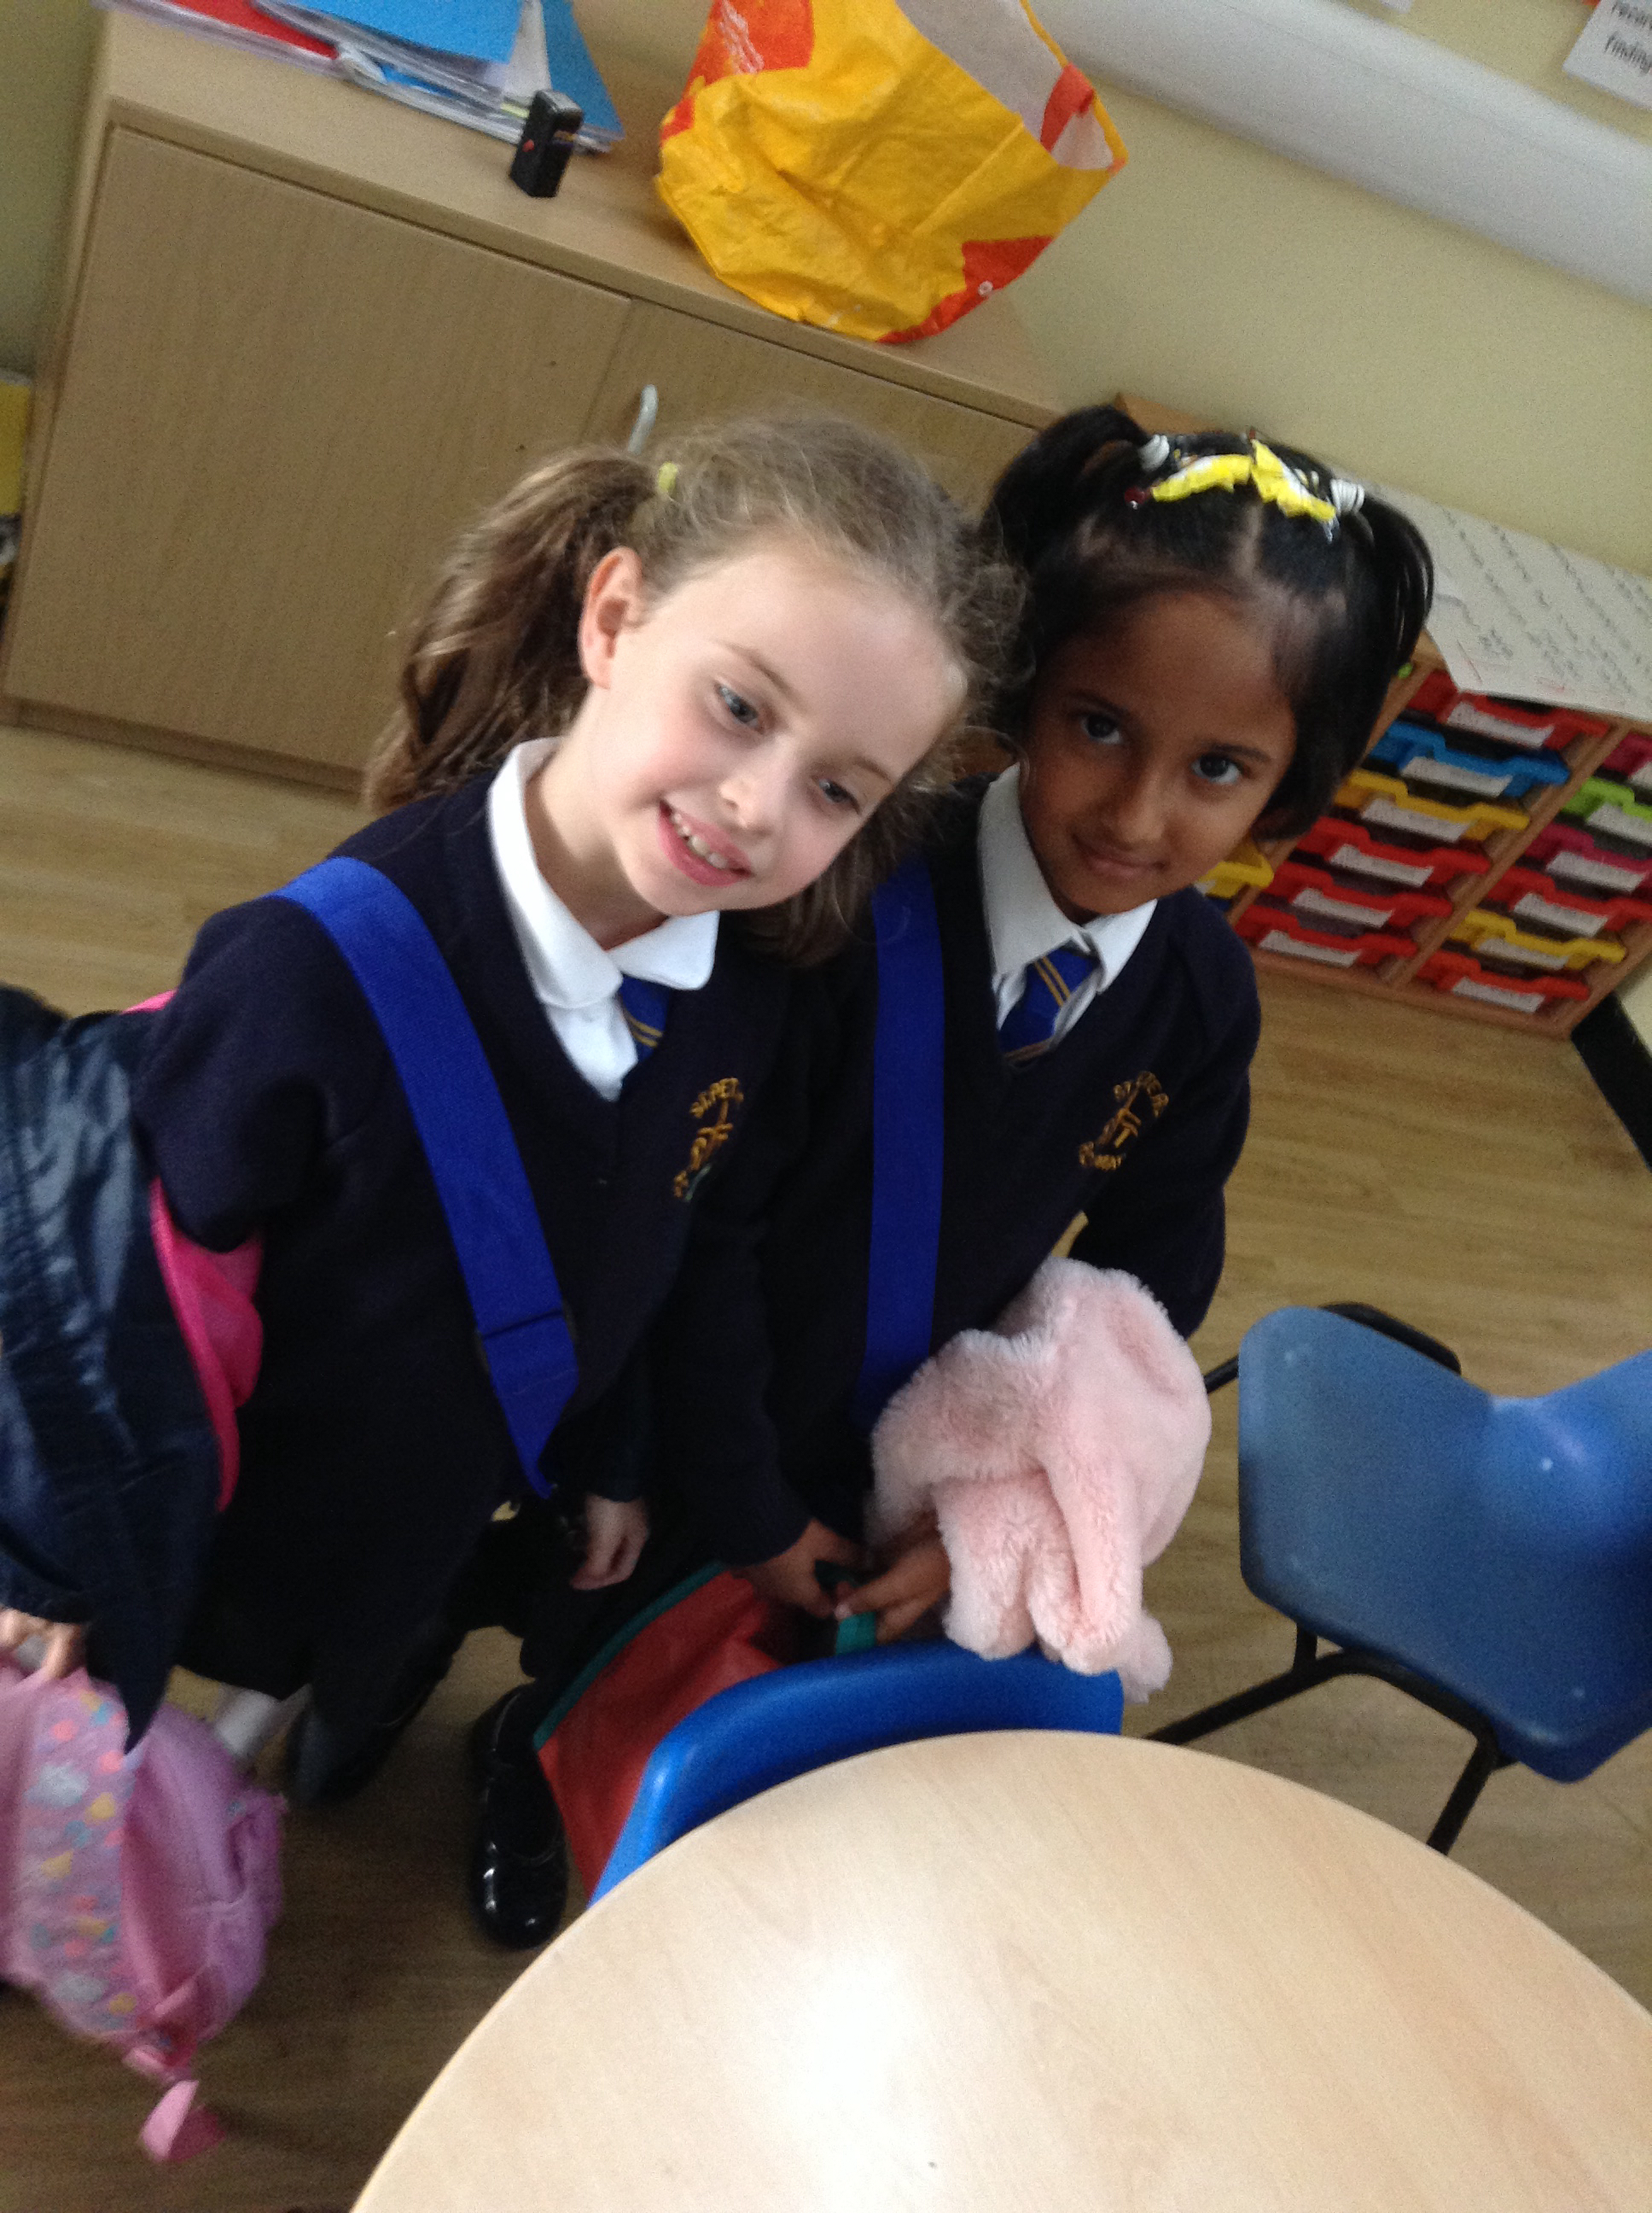

Parent’s Evening
We are having two evenings next week when parents can come along and speak to their child’s/children’s teachers.
Tuesday 15th October, 3.30pm – 6pm and
Thursday 17th October, 3.30pm – 5pm and 6pm – 7.30pm.
Please see your child’s class teacher to sign up if you haven’t done so already.

VE Day Party
Year 6 will be celebrating their World War 2 project with a VE Day party on Friday 18th October. The children need to come to school in red, white and blue and can expect to experience true 1940’s style lindy hop music and games. All other year groups are expected to wear their full school uniform.

School Uniform
Please note, this half term children may wear their summer or winter uniform. Winter uniform must be worn after the October half term. We have been made aware that some parents had difficulty getting a new book bags over the summer from Jo Richardson. They are in stock at Premier Schoolwear.

Attendance & Punctuality
At St Peter’s, the children’s attendance is very good and above the national expectation of 95%. However, punctuality is not as high. This year, we will be striving to make the punctuality just as good. We do understand sometimes this is sometimes out of your control. We need your help in making sure your child/children arrive at school on time. Thank you to all the parents whose children arrive on time each day.

Child Absence
If your child is not coming into school, please call the school office by 10am on the first day they are absent and let us know the reason.

Lunch Boxes
As we have children in the school with severe nut allergies, please do not put any nut products in your child’s lunch box.

London Marathon 2020
Brentwood Catholic Children’s Society has a number of Gold Bond Charity places for runners in the LONDON MARATHON taking place on SUNDAY 26t^{h} April 2020. If you are an experienced runner or someone who would value the opportunity to participate in this renowned event please contact Libby Phillips for further details on 01268 784544 / lphillips@bccs.org.uk. The closing date for completed applications is Friday 15th November and please note that there is a minimum sponsorship requirement of £1600 (excluding Gift Aid). If you have been lucky enough to secure your own running place through the ballot, we would invite you to join us and run for Brentwood Catholic Children’s Society. The London Marathon is a unique opportunity to raise much needed funds for the Diocesan Children’s Society and perhaps achieve a lifetime ambition at the same time.

Best Class Attendance & Best Class Punctuality of the Week
Each week we will be informing you of the classes that have the highest attendance and the best punctuality

Class with the Best Attendance | Class with the Best Punctuality
6A 100% | RS 0 Lates

Well Done to our Core Value Ambassadors

Perseverance | Respect | Integrity | Compassion | Enthusiasm
Kevin | Mary | Gabriella | Riley | Blessing

Workers of the Week
Congratulations to the following children who are this week’s Workers of The Week!

Reception | Year 1 | Year 2 | Year 3 | Year 4 | Year 5 | Year 6 | Nazareth Rooms
RG | 1B | 2B | 3O | 4B | 5D | 6A | Carlton
Toluwalase  Elizabeth | Elliott  Sofia | Ashley  Ethan | Ted  Nicholas | Vinaya  Clinton | Joshua  Jim | Sonia  Abdul
RS | 1F | 2J | 3S | 4H | 5M | 6H
Julienne  Joseph | Aurelie  Raphael | Osa  Levi | Hazel  Quan | Hannah  Jaden | Darius  Evergreen | Chinomso  Patricia

Dates for your Diary
Mon 14th October | 6H Assembly 9.15am all welcome  3.15pm – 4.30pm Year 6 Football  3.15pm – 4.05pm Rec/Year 1 Football
Tues 15th October | 8am – Year 1/2 Judo  8am – Year 3 Multisports  3.15pm – 4.30pm Year 4/5 Football  Parents Evening 3.30-6pm by appointment only
Wed 16th October | 8am – Year 4 Multisports  3.15pm – 4.05pm Year 2/3 Football
Thurs 17th October | 8am – Year 5 Multisports  3.15pm-4.15pm Nursery and Reception Multisports  Parents Evening 3.30-5pm and 6-7.30pm by appointment only
Friday 18th October | 8am – Year 3/4/5 Judo  8am – Year 5/6 Girls Football  9am – 4B & 2B Mass in Church  2.45pm - WOW celebration assembly – parents welcome  Break up for Half Term

Birthdays 7th October – 13th October
Elena 8; Ethan 6; Melvin 10;
Ashley 7; Lily 6; Taiba 7; Ethan 7.

28th Sunday in Ordinary Time

God Bless,
CScott

Mrs Clare Scott
Headteacher

