Subject | Autumn 1  8 weeks | Autumn 2  7 weeks | Spring 1  6 weeks | Spring 2  6 weeks | Summer 1  6 weeks | Summer 2  7 weeks
English Core Text and Genre | 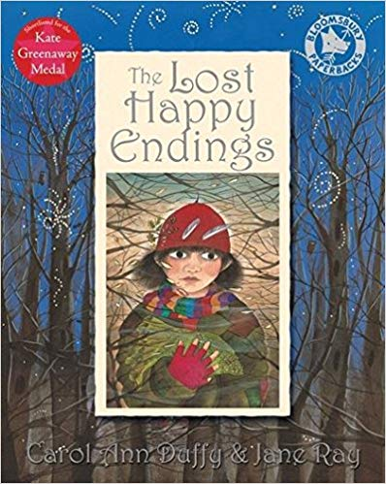  The Lost Happy Endings  Carol Ann Duffy  Genre: Fiction – fairy-tale  Support texts: A range of classic fairy-tales  Bat Loves the Night by Nicola Davies and illustrated by Sarah Fox-Davies  Writing Outcomes  Narrative non-fiction  Newspaper report  Diary entry  Poetry Week: Text TBC | 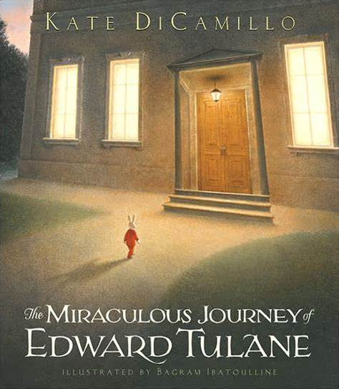  The Miraculous Journey of Edward Tulane  Kate Di Camillo  Genre: Fiction - adventure  Non-Fiction information texts: a range of information books will be used in the teaching of USA.  Writing Outcomes  Non-chronological report  Diary entry  Play-script  Soliloquy  Narrative – alternate ending: building suspense and tension  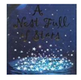  A Nest Full of Stars  A collection of poems by James Berry  Genre: Poetry  Dialect VS Standard English  Writing process  Performance poetry  Themes and features of individual poets  Landscape and culture | 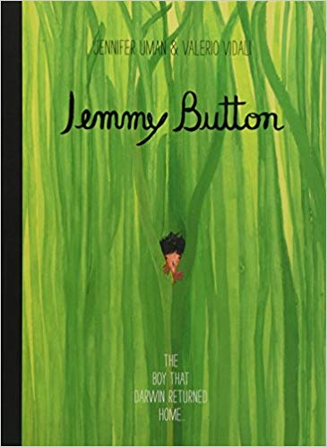  Jemmy Button  Valerio Vidali  Genre: Hybrid – historical fiction  Support texts: Windrush Child by John Agard and other poetry with the theme of ‘voyage’  Genre: Historical fiction – picture book  Writing Outcomes  Setting description  Balanced argument  Poetry  Diary entry  Characterisation and developing setting  Narrative – a story with a clear theme and structure | 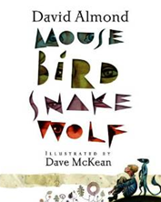  Mouse Bird Snake Wolf  David Almond  Genre: Fiction – graphic novel  Writing Outcomes  Balanced argument  Line poetry/kennings  Writing in role  Writing graphic novels  Newspaper report: Are humans responsible for the destruction of the earth?  Mama Miti. Wangari Maathai and the Trees of Kenya  Donna Jo Napoli  Illustrated by Kadir Nelson  Genre: Biography  Writing Outcomes  Information leaflet  Speech writing  Biography  Letter of advice | 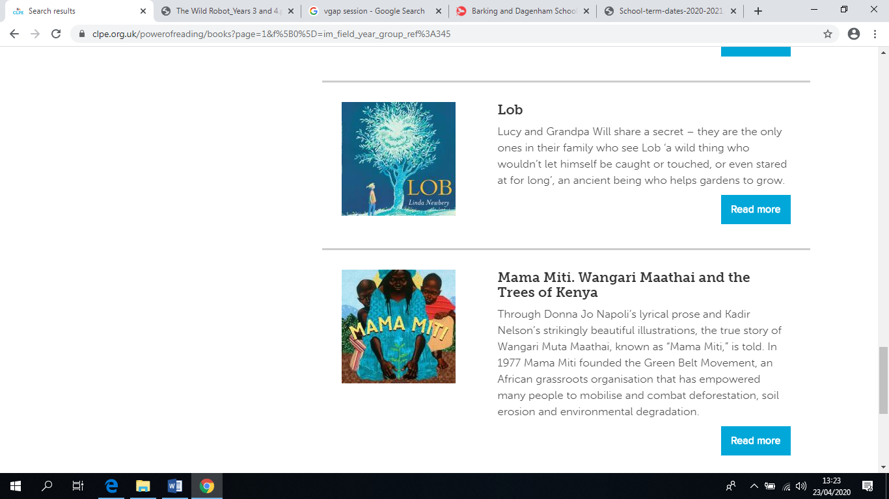  Mama Miti. Wangari Maathai and the Trees of Kenya  Donna Jo Napoli  Illustrated by Kadir Nelson  Genre: Biography  Writing Outcomes  Information leaflet  Letter of advice  Speech writing  Biography  NEED TO ORDER | 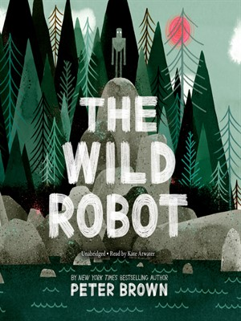  The Wild Robot Peter Brown  Genre: Fiction – fable like tale  Writing Outcomes  Fact file & Nature documentary script  Survival log (instructions)  Letter of advice  Debate writing  Narrative – action/climax  Poetry: Seasons  Persuasive writing
Grammar | Nouns  Adjectives  Paragraphs  Conjunctions adverbs and prepositions to express time and cause  Articles and determiners  clauses  Inverted commas for speech | Noun Phrases  Adverbial Phrases Conjunctions  Prepositions  Present and Past Tense  Verb Agreement  Confusing Words | Negatives  Capital Letters and Full Stops  Question Marks  Exclamation Marks  Commas  Inverted commas for speech | Apostrophes  Speech  Present and Past Tense  Verb Agreement  Confusing Words.  Adverbs, imperative verbs | Prefixes and  Suffixes  Recap of Grammar | Word Endings  More Confusing Words  Hard and Soft Sounds  Homophones
Maths | Number: place value, addition and subtraction. | Number: multiplication and division. Measurement: length and perimeter.  Time. | Recap Number Number: Multiplication and division. Measurement: area. Fractions | Fractions and decimals.  Reasoning skills and problem-solving related to fractions and decimals. | Decimals  Measurement: money.  Statistics | Geometry: properties of shape, position and direction.
RE | People/  Called | Hinduism  Judaism  Gift | Community/  Giving and receiving | Giving and Receiving/Self-Discipline | New Life/Building Bridges | God’s People
Geography and History | 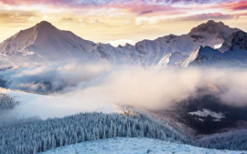  Misty Mountain  Sierra  Explanation text – How mountains are formed  The UK, the Alps and the Andes.  Physical geography, including volcanoes. | 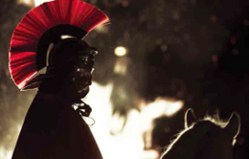  I am Warrior!  Soliloquy  Recounts  Commentary (play script)  A study of key events and daily life in the Roman era. | Road Trip USA!  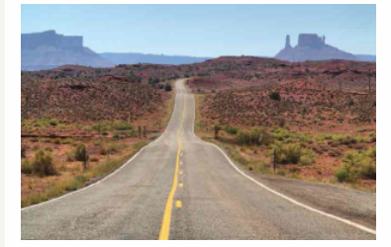  Non-chronological report  Locating places, Human and physical geography | 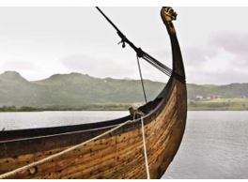  Traders and Raiders  Non – Chronoligal report/ information texts  Narrative  Anglo-Saxons and Vikings. | 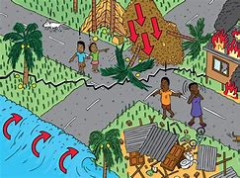  Disaster! – Earthquakes and Tsunamis | 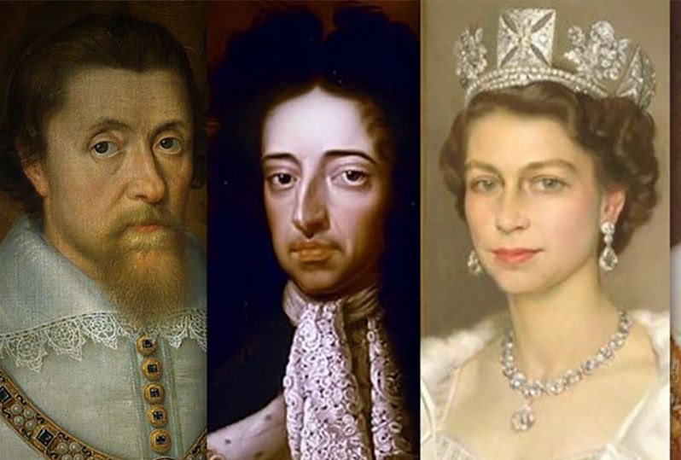  Ruthless Royals  Monologue  Debate writing (comparing sources)  Letter writing  Monarchs through the ages, analysing historical sources
Science | States of matter  The water cycle  Non-chronological report | Sound  Non-chronological report  Electricity | Electricity  Non-chronological report  Human Nutrition | Human Nutrition  Explanations  Non-chronological report  Dangers to Living Things | Dangers to Living Things  Persuasive letters (helping/ save animals)  Non-chronological report  Sound | Grouping Living Things  Non-chronological report
Art/ Design Technology | Art  Drawing: Studying light and tone.  Painting: Paul Cezanne’s paintings of mountains.  , | DT  Electrical Systems Simple programming and control 1  Making a night light  Did not complete making the product. | Art  Painting:  3D & textiles:  Textiles: Making Native American totem poles  Not completed | DT  Mechanical Systems  Pneumatics  Making a product using mechanical motions from recycled products.  Food  A healthy diet - to be taught in Science  Food  Understand a range of cooking terms.  peeling, chopping, slicing, grating  Food  Sweet VS savoury  Food  Understand that food can be fresh, processed, dried, frozen tinned etc.  Food  Knife skills and food Hygiene  Designing/making and evaluating coleslaw products for lunch no peanuts or celery). Check for Gluten intolerance  Food  When do you need/not need a heat source?  What sort of heat source? Gas, electrical/water/fire  What can you not eat raw? | Art  Printing, collage and textiles | DT  Mechanical Systems  Pneumatics  Making a product using mechanical motions from recycled products.  Food  Understand a range of cooking terms.  peeling, chopping, slicing, grating  Food  Sweet VS savoury  Food  Understand that food can be fresh, processed, dried, frozen tinned etc.  Food  Knife skills and food Hygiene  Designing/making and evaluating coleslaw products for lunch no peanuts or celery). Check for Gluten intolerance  Food  When do you need/not need a heat source?  What sort of heat source? Gas, electrical/water/fire  What can you not eat raw?
Computing | Coding | Online Safety | Spreadsheets  Writing for different audiences | Writing for different audiences  Spread sheets | Logo  Animation | Effective Search  Hardware Investigators
PSHE | Being Me in My World | Celebrating Difference | Dreams and Goals | Healthy Me | Relationships | Changing Me
P.E. | OAA Communication and Tactics  Basketball | Gymnastics - bridges  Football | Netball  Dance – Space | Tennis  Hockey | Swimming  Tag Rugby | Athletics  Swimming
MFL | All Around Town | Greetings | Animals  Je m’apelle | Je voudrais | The connective ‘mais’  Aussi  C’est | Age  Number
Music | 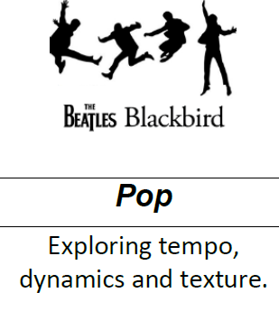 | 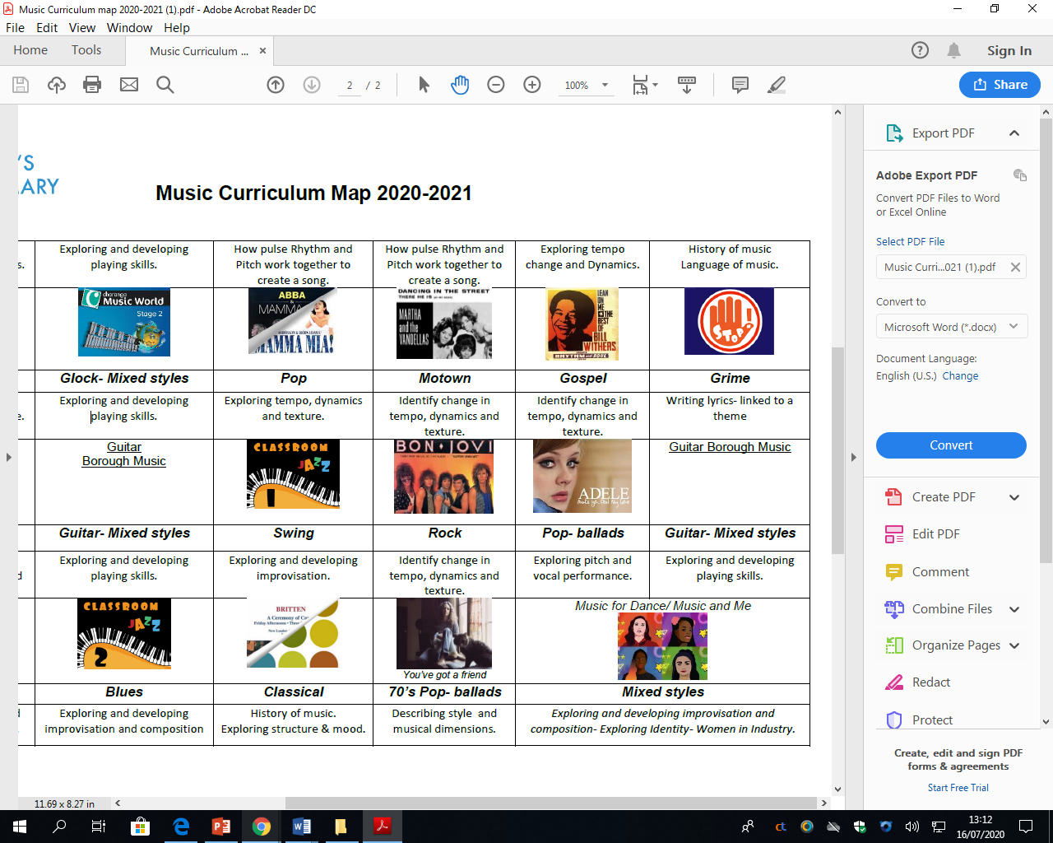
Educational Visits

Skills and Content to be revisited in future years.
English | Debate writing – using causal and contrasting conjunctions  Formal tone – Newspaper and non-chronological reports.
Science | Planning a fair test.  Changing variables
DT | Making joints and attachments  Pneumatics
Maths | Division (taught online but will need revisiting)

