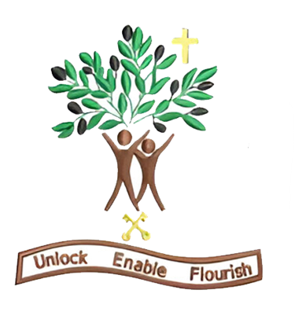

Year 5
Autumn Term 1 - 2026

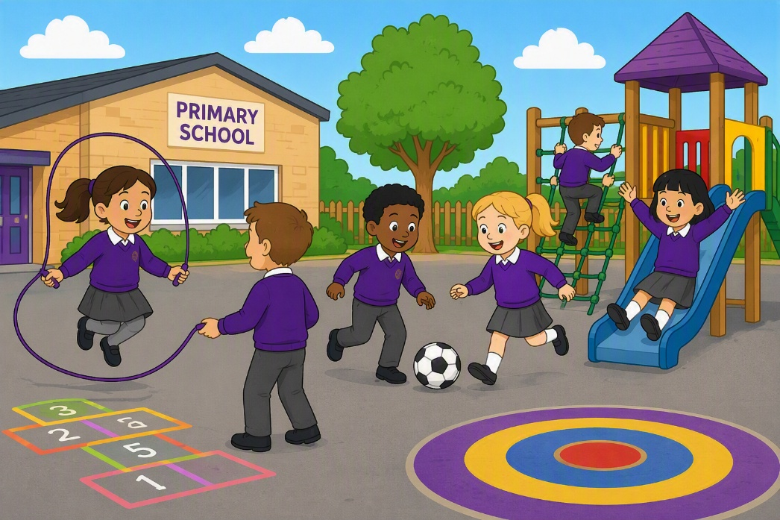

Dear Parents and Carers,

Welcome to our newest year 5 newsletter. We have an inspiring and varied half‑term ahead, filled with creativity, curiosity and new challenges. I cannot wait to get started with your lovely children, I feel so lucky that to be teaching them this year.

English – Bridging unit- The Lion, The Witch and The Wardobe
This half‑term, we will be studying the novel ‘The Lion, The Witch and The Wardrobe’ by C.S Lewis. We will be using this novel to get immersed in the time of WW2 when children were evacuated. We will study the magical snowy setting of Narnia and how the author creates atmosphere. We will study the blending of action, description and dialogue between the children and the mythical create, the faun. The children will be an innovated chapter where the main character enters the new land and meets a mythical creature. This mythical creature will be that of which the children will have written a non-chronological report on within this integrated unit of fiction and non-fiction.

Maths – Place value, addition, subtraction, multiplication and divison
This half term in White Rose Maths, Year 5 will be developing their understanding of place value and strengthening their skills in addition, subtraction, multiplication and division. The children will take part in a range of varied fluency, reasoning challenges and problem-solving tasks to help deepen their mathematical understanding. We look forward to seeing them build their confidence and apply their skills.

Science – Life Cycles
This half term in Science, Year 5 will be learning about the life cycles of living things, including plants. The children will recap the types of animals including mammals, insects, bird, amphibians and study the life cycle of these. The focus will be then on comparing these life cycles, identifying similarities and differences. They will then be taught the life cycle of plants, including sexual and asexual reproduction.

Geography - The United Kingdom
This half term in Geography, Year 5 will be learning about counties. They will study the counties of the UK, discussing their location in the United Kingdom using compass points. They will then learn about economy within the United Kingdom including the three sectors, primary, secondary and tertiary. They will explore different job roles within these sectors within the UK, thinking about the location of where these sectors are most commonly found.

Art- Drawing
This half term in Art, Year 5 will be completing a drawing unit, with a focus on the work of Henri Rousseau. The children will explore the many grades of H and B pencils, exploring the effect of using these different pencils including when cross hatching. They will use viewfinders to develop their observational skills, learning the difference between drawing technically and sketching. They will then explore how to create form to a drawing, using tone.

PSHE – Getting on with others
This half term in PSHE, Year 5 will be exploring emotions when it comes to relationships with friends and family. They will explore healthy versus unhealthy relationships. They will then look into understanding stereotyping and explore the impact of this on others and how this could make others feel. We will also then explore the term extremism.
PE – Invasion games and gymnastics
This half term in PE, Year 5 will be taking part in invasion games and gymnastics. In invasion games, the children have been exploring their attacking and defending skills including tactics on how to outwit the defenders. They have applied their skills to invasion games with a focus on netball where they have been using chest pass and shoulder pass. In gymnastics, the children have been exploring balance, jumping and rolling and using these skills to create a sequence.

RE –
This half term in RE, Year 5 will be using the Questful unit “Why are sacred texts so important to people” to explore the significance og holy books in a range of religions. We will understand how they are a way of guided those of particular faiths through stages of life. We look forward to seeing the children make thoughtful comparisons and deepen their understanding of different holy books within different faiths.

Thank you for your continued support. We look forward to a joyful and inspiring half term with your children!

Warm wishes,
Miss Coar

