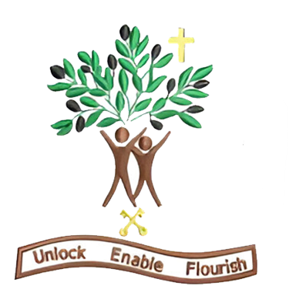

Year 6
Autumn Term 1 - 2026

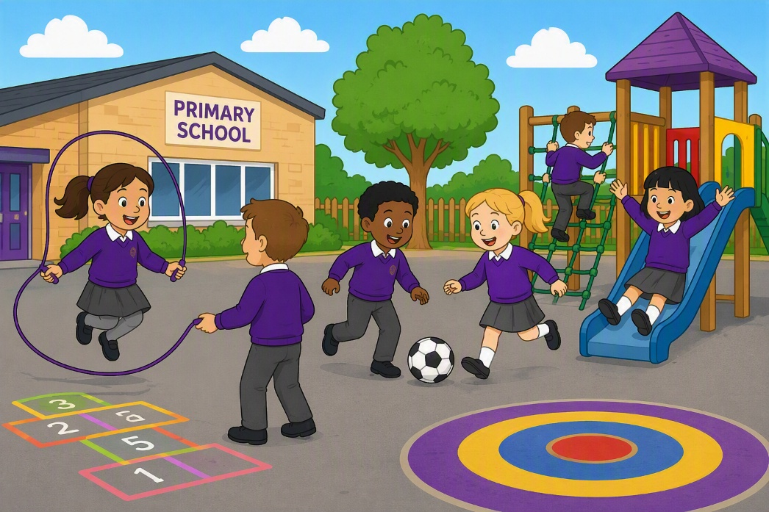

Dear Parents and Carers,

Welcome to our newest year 6 newsletter. We have an inspiring and varied half‑term ahead, filled with creativity, curiosity and new challenges. I cannot wait to get started with your lovely children, I feel so lucky that I have been able to teach them for another year.

English – Bridging unit- Magic
This half‑term, we will be studying the novel ‘The Nowhere Emporium’ by Ross MacKenzie. We will be using this novel to get immersed in a world where magic exists and revisit our skills from year 5. We will be revisiting -ing opening clauses, relative clauses and action, dialogue and description. Our final piece will be an innovated story before we move onto our non-fiction unit. In this unit, we will be researching and writing a discussion debate about the use of animals in the circus.

Maths – Place value, addition, subtraction, multiplication and divison
This half term in White Rose Maths, Year 6 will be developing their understanding of place value and strengthening their skills in addition, subtraction, multiplication and division. The children will take part in a range of practical activities, reasoning challenges and problem-solving tasks to help deepen their mathematical understanding. We look forward to seeing them build their confidence and apply their skills to increasingly complex questions.

Science – Electricity
This half term in Science, Year 6 will be learning about electricity and investigating how electrical circuits work. The children will explore different components, such as bulbs, switches and buzzers, and will predict, test and explain what happens in a variety of circuits. We are looking forward to seeing them develop their scientific enquiry skills and make exciting discoveries through hands-on investigations.

History- The Vikings
This half term in History, Year 6 will be exploring the exciting enquiry question: “Is it fair to describe all Vikings as brutal invaders?” We will investigate what Viking longboats and chess pieces can tell us about Viking life before learning about Viking migration and settlement in Britain. Through a range of historical sources, the children will develop their skills as young historians and discover that there is much more to the Vikings than raids and battles!

DT- Bread
This half term in Design and Technology, Year 6 will be making their own bread while exploring how bread is enjoyed in different cultures around the world. The children will investigate a variety of breads, learn about their origins and ingredients, and develop their cooking skills by mixing, kneading and baking. We are excited to see them discover new traditions and create some delicious bread of their own!

PSHE – Global policing
This half term in PSHE, Year 6 will be welcoming Global Policing into school to teach the children about how to be good and responsible citizens. Through engaging workshops and discussions, pupils will learn about making positive choices, staying safe and showing respect for others in their community. We are looking forward to giving the children the opportunity to learn from real professionals and develop the skills they need to become responsible members of society.
PE – Dance and rugby
This half term in PE, Year 6 will be taking part in dance and rugby. In dance, the children will explore the theme “Food Glorious Food”, using movement and teamwork to create imaginative performances inspired by different foods and meals. In rugby, they will develop their passing, tackling and teamwork skills through a range of fun games and activities. We look forward to seeing the children grow in confidence, creativity and sportsmanship throughout the term!

RE – Life as a journey
This half term in RE, Year 6 will be using the Questful unit “Life as a Journey” to explore how religion can guide people through different stages of life. The children will learn about the beliefs and practices of Christians, Sikhs, Muslims and Hindus, discovering how journeys, pilgrimages and important life events shape their faith. We look forward to seeing the children make thoughtful comparisons and deepen their understanding of different religions and worldviews.

Thank you for your continued support. We look forward to a joyful and inspiring half term with your children!

Warm wishes,
Miss Rigby and Mrs Zaman

