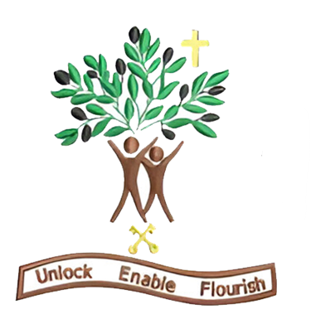

Year 5
Autumn Term 2 - 2026

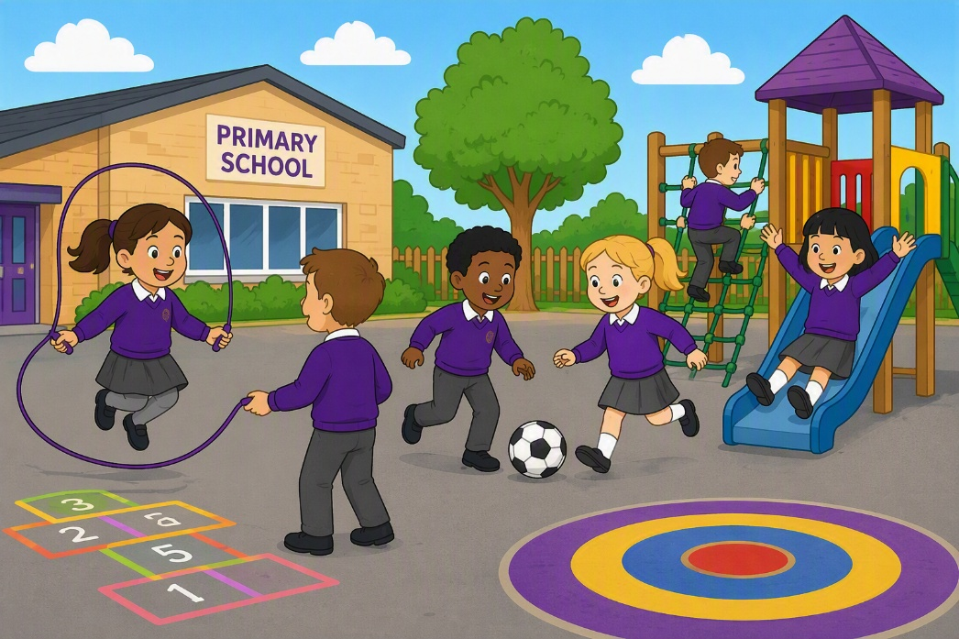

Dear Parents and Carers,

Welcome to our newest year 5 newsletter. We have an inspiring and varied half‑term ahead, filled with creativity, curiosity and new challenges. I cannot wait to get started with your lovely children, I feel so lucky that to be teaching them this year.

English – Legends
This half‑term, we will be studying the legend, ‘The Legend of Gelert’. Children will explore a range of different legends and the vocabulary used within them. The children will explore the grammar skills of ‘ed’ opening clauses and relative clauses. The outcome of the unit is to write their own adapted version of The Legend of Gelert.

Maths – Place value, addition, subtraction, multiplication and division
This half term in White Rose Maths, Year 5 will be developing their multiplication and division skills, through learning common multiples, common factors, prime, square and cube numbers and how to multiply and divide by 10, 100 and 1000. They will also learn how to convert improper fractions to mixed numbers. They will compare and order fractions and add and subtract fractions. The children will take part in a range of varied fluency, reasoning challenges and problem-solving tasks to help deepen their mathematical understanding. We look forward to seeing them build their confidence and apply their skills.

Science – Forces
This half term in Science, Year 5 will be learning about forces. They will be able to explain that unsupported objects fall towards the Earth because of the force of gravity acting between Earth and the falling objects
They will identify the effects of air resistance, water resistance and friction that act between moving surfaces.
They will recognise that some mechanisms, including levels, pulleys and gears, allow a smaller force to have greater effect.

History – Tudors
This half term in History, the children will learn about how the Tudor reign began. They will explore Henry VIII becoming King and him having six wives due to wanting male heirs. They will explore the impact of the Monarchy on religion in England. They will learn that under Elizabeth 1, the church became protestant.

Design Technology – Food
This half term in DT, the purpose of this unit is to teach children how to cook and to apply the
principles of nutrition and healthy eating. As a school, we want to instil a love of cooking in pupils and to express themselves creatively.

PSHE – Managing feelings, identifying and expressing feelings
This half term in PSHE, the children will explore understanding the link between thoughts, feelings and behaviour, including how worry and rumination (repeated negative thinking) can affect mental wellbeing.
They will explore how to recognise when thoughts or worries are becoming unhelpful and use strategies to manage or move on from them. They will discuss and know a range of strategies to manage emotions and support wellbeing, including relaxation, problem-solving, distraction and seeking support. Finally, they will understand how internal and external distractions can affect focus and wellbeing, and to develop strategies to manage attention.

PE – Invasion games and gymnastics
This half term in PE, Year 5 will be taking part in invasion games and gymnastics. In invasion games, the children have been exploring their attacking and defending skills including tactics on how to outwit the defenders. They have applied their skills to invasion games with a focus on hockey where they will be learning the skills of dribbling and passing the ball with a hockey stick. In gymnastics, the children will perform balances. They will explore the difference between counter balance and counter tension with a partner. They will create a sequence with these.

RE – Christmas
This half term in RE, Year 5 will be using the Questful unit “How does the birth of Jesus fit into God’s Big Story”. This unit will increase pupils’ knowledge and understanding of the Christian concept of incarnation (God in human form). It will increase pupils’ knowledge and understanding that a person’s perspective on a story affects the way they tell it. The pupils will know that Christians believe that the birth of Jesus fulfilled Old Testament prophecy and that Christians believe that Jesus is the promised Messiah who came to save everyone and mend the broken relationship between God and his people (God’s Big Story). Finally, they will be able to identify connections between the Christian beliefs about the birth of Jesus and the ways in which Christmas is celebrated.

Thank you for your continued support. We look forward to a joyful and inspiring half term with your children!

Warm wishes,
Miss Coar

