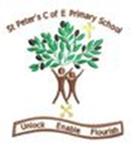

Year 1 and 2
Autumn Term 1 - 2026
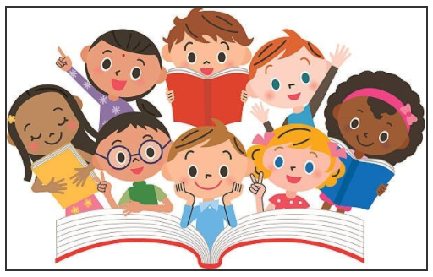
🍂 Autumn 1 Learning – Year 1 and 2
Dear Parents and Carers,
Welcome back to school! We’re diving into a fun-filled half term packed with creativity, exploration, and learning. Here's a snapshot of what your child will be discovering and enjoying in the coming weeks as a mixed class.

English – The Highway Rat!
We’ll be exploring the exciting world of The Highway Rat by Julia Donaldson! Children will enjoy reading and writing their own imaginative narratives inspired by this mischievous rat. We will also be writing some non-fiction posters about rats!
Maths
Children will continue building their confidence with:
- Place Value
- Addition and Subtraction
- Shape (Geometry)
We’ll be using practical activities and games to make maths meaningful and enjoyable.

Science - Outdoor Learning
This term we will be focusing on learning about plants that we have in our school grounds and how they will change through autumn. We will also be observing the weather and changes of day and night through the seasons.

History – Queen Elisabeth 11 and King Charles 111
How did Queen Elizabeth help the young children throughout the war and how does King Charles help youths now?

Art – Drawing Skills
This term we’ll be focusing on drawing. Children will experiment with lines, shapes, and textures to create expressive artwork inspired by their surroundings and stories.

PSHE – How can we show kindness?
We’ll be discussing kindness, respect, and how to recognise and respond to bullying. Our aim is to help children feel safe, confident, and empowered to speak up.

Computing – Creating Pictures & Online Safety
Children will use technology to create digital art and learn about staying safe online. We’ll explore how to use devices responsibly and creatively.

Music – Exploring Pulse and Rhythm
Through singing, clapping, and playing instruments, children will explore rhythmic patterns and learn how music can express feelings and tell stories.

PE – Fundamental Movement
We will be working on fundamental movement skills. Rolling, throwing, catching accurately.

RE –Sacred Texts
We will be reflecting about why sacred texts are important to people of different faiths.

Please listen to your child read daily and record this in their reading record. This includes the comprehension questions from the back of the book. Year 2 children can be encouraged to write the answers down to the questions.

Please feel free to message me on Class Dojo if you have any questions.
Thank you for all your support from home,
We’re looking forward to a happy and inspiring half term. Thank you for your continued support – together we’ll help every child flourish!
Mrs Mooring

