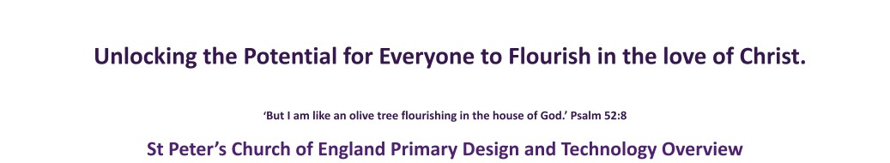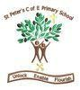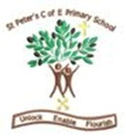

Year Group | Autumn Term | Spring Term | Summer Term
Reception | In EYFS we focus on the basic skills to enable children to flourish with the rest of the curriculum.  - Sculptures  - Structures  - Food and nutrition  - Different joining techniques  - Fine motor skills  - Textiles  - Mechanisms
Year 1 / Year 2  Cycle A | Mechanisms  (Wheels and Axles)  Cars  Mary Anderson | Food  (Preparing and Combining)  Fruit kebabs  Jamie Oliver | Structure  (Stability and Strength)  Playground equipment  Isambard Kingdom Brunel
Year 1 / Year 2  Cycle B | Mechanisms  (Pop ups and simple levers) Moving pictures | Food  (Healthy Diets)  Sandwiches  Teresa Cutter | Textiles  (Stitches)  Puppets  Harry Corbett

1

Year 3 | Food  (Simple Dishes)  Pasta salad  George Washington Carver | Mechanisms  (Levers and linkages)  Moving Pictures  Friedrich Wilhelm Fuchtner | Structure  (Frame structure)  Pencil pots  Stephanie Kwolek
Year 4 | Textiles  (seams and fastenings) Money containers  Gideon Sundback | Electrical systems  (Circuits)  Night lights  Lewis Howard Latimer | Food  (Savoury food and cooking techniques) Pitta pizzas  Hugh Fearnley- Whittingstall
Year 5 | Food  (Food from other  Cultures)  Soup  Andrew Zimmern | Mechanical systems  (Cams, pulleys and gears)  Automaton  Jacques De Vaucanson | 3D Textiles  (Combining fabrics)  Teddy bears  Morris Mitchtom
Year 6 | Food  (Design food from other cultures)  Bread  Michael Caines | Structures  (House Shelter)  Bird home  Fazlur Rahman Khan | Mechanical Systems (Fairground rides) Fairground rides  Thomas Bradshaw

2

