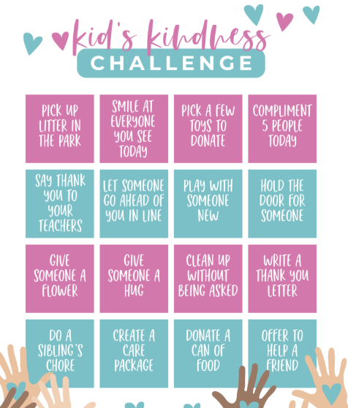
This month we are supporting the NSPCC Kindness Challenge. Children who show acts of kindness will receive awards around school.
Dates for your diary
1st Oct Kindness Challenge Month
3rd Oct Football Club
6th Oct Black History Month Launch
7th Oct SATs Meeting for Y6 Parents
8th Oct Fitness Van Y5/6
14th Oct Photographer
15th Oct Kurling Club
16th Oct Excited for English Mount Carmel
17th Oct Harvest Festival 2pm
Football Club
24th Oct Finish for half term

We are within the season of harvest within the Church calendar. We will be celebrating by holding a special harvest worship. This will take place on 17th October at 2pm and all parents are welcome to join us. We are accepting harvest donations which we will distribute to the local food bank.
Harvest


Sports Games Gold Award
We are so proud to announce we have been awarded GOLD for the school games for the third year! This gives your children the opportunity to flourish in different sports throughout the year. Well done everyone and a massive thank you to Mrs Rogers for all the hard work that goes into organising this.
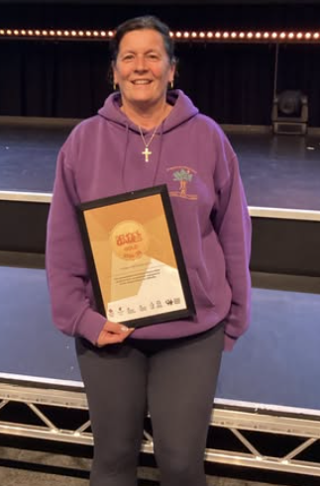

Pantomime
In order to keep costs down for parents, we have booked for a theatre company to come and perform a pantomime in school on 8th December. We will be asking parents for a small donation of £9 towards this to enable it to go ahead.
.

If your child is in Year 6 then you need to apply for their secondary school place by 31st October. www.lancashire.gov.uk/schools

Phonics
Thank you to all parents who attended our phonics workshops.
Links to resources can be found here
https://www.littlewandlelettersandsounds.org.uk/resources/for-parents/

Staffing Changes
We are sad to announce that Mrs Shafiq will be leaving the school at the end of term. The Governors have decided to cover the vacancy with our current staff to ensure that your children receive the highest quality education. Therefore Miss Wise will be moving to Year 6, Miss Rigby will be moving to teach Year 5 and Mrs Mooring will teach Year 1 and 2 in a mixed age class. All teachers know the children well and have been busy planning to ensure that the highest quality teaching remains.

SATs Meeting
We will be holding a meeting for parents of children in Year 6 regarding the SATs tests that they will take in May 2026. The meeting will take place in school at 3pm on 7th October.

Mini Medics
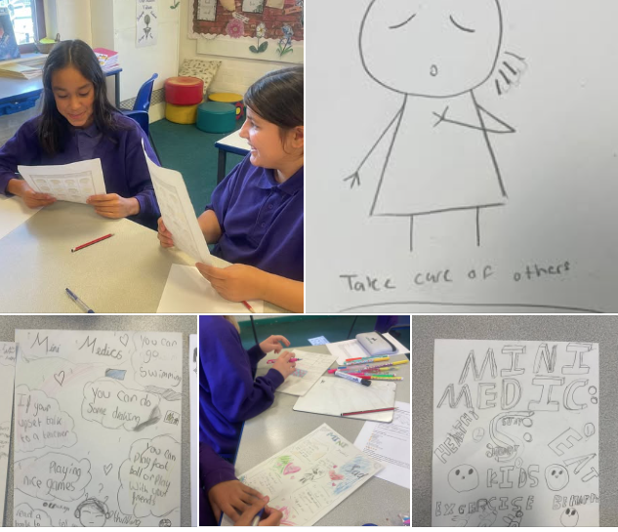
We had the pleasure of introducing week one of the Mini Medics Mental Health Programme to Year 5 at St Peter’s Church of England Primary School last Thursday. The children impressed us with their maturity when suggesting solutions to common worries and challenges we might face.
They particularly enjoyed playing “Guess the Emotion” and creating posters designed to support other pupils in the school. The class engaged brilliantly in discussions about both physical and mental health, and we look forward to working with them over the coming weeks as we explore strategies for resilience and ways to look after ourselves and each other.
#minimedics #sisstrengthinstruggles #kidsmentalhealth #MentalHealthAwareness #mentalhealthmatters #livedexperience #resilience

OPAL
We are pleased to announce that we have been accredited as a Gold OPAL school. Many thanks to the parents who helped with the project and to those who attended our award assembly.
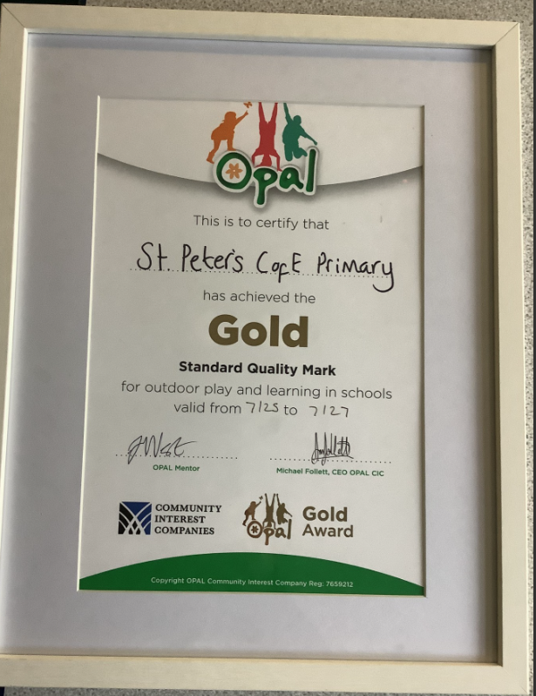

Well done to all the staff for their hard work and to Miss Rigby, Mrs Turner and Mrs Saddique for leading the project.

Poetry

To promote a love of reading and rhymes we participated in National Poetry Day celebrations by holding a Year 5 and 6 poetry competition. The entries have been sent to Accrington Stanley and we eagerly await to see if we have any winners!



Black History Month
This October, we’re proud to celebrate Black History Month—a time to honour the incredible achievements, stories, and contributions of Black people throughout history and today.
At school, we’ve been learning about inspiring figures like Rosa Parks, who stood up for fairness on a bus, and Mary Seacole, a brave nurse who helped soldiers during the war. We’ve explored music, art, inventions, and powerful stories that show how Black history is part of everyone’s history. The children will be leading worship on Black History.


Attendance links to Safeguarding!
At St Peter’s, we believe that every school day counts. Regular attendance is essential for children to make the most of their education, build friendships, and develop routines that support lifelong learning.
Why Attendance Is Important
Children who attend school regularly:
- Achieve better academic outcomes
- Develop stronger social skills
- Build confidence and resilience
- Are more likely to enjoy school and feel part of the community
Missing even a few days can disrupt learning and make it harder for children to keep up with their classmates and affect friendship groups.
Support for Families
Cath Smith and Julie Dawes have responsibility for improving attendance at St Peter’s.
We are here to help. If you’re experiencing challenges that affect your child’s attendance—such as health issues, anxiety, or family circumstances—please speak to Cath Smith our Pastoral Support Worker. We offer:
- Attendance support plans
- Home visits
- Referrals to external services
- Emotional wellbeing support
- Support from our Well- Being Warriors, Courageous Advocacy Group.

Our Attendance Management Strategy
We monitor the attendance of all children and make first response calls to absentees.
We will inform you if your child’s attendance is being monitored for concern.
Home visits may be carried out.
If your child’s attendance does not improve then we will call you in for a meeting and agree an action plan with supportive actions.
We may use attendance contracts if the case needs formalising.
If attendance is causing significant concerns and all options of support have been exhausted then we will take legal action.

We have started the Park and stride Scheme!

Meet us in Bullough Park at 8:30am each morning and walk into school as a group.

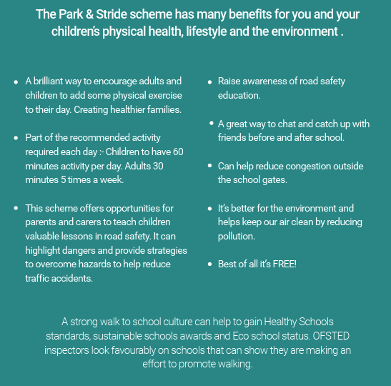

Your child can join us for Wake and Shake in the school hall at 8:40am.

Safeguarding is Everyone’s Responsibility
All staff, governors, volunteers, and visitors share the responsibility of keeping children safe. If you have any concerns about a child’s welfare, please contact our Designated Safeguarding Lead immediately
DSL: Emma Moss, Headteacher
Deputy DSLs: Lucy Turner, Deputy Headteacher
Cath Smith, Pastoral Support Worker
Safeguarding Governor: Peter Williams

If you have immediate concerns for the welfare of a child please contact Social care support for children and families - Lancashire County Council Call 0300 123 6720 or out of hours 0300 123 6722.

