

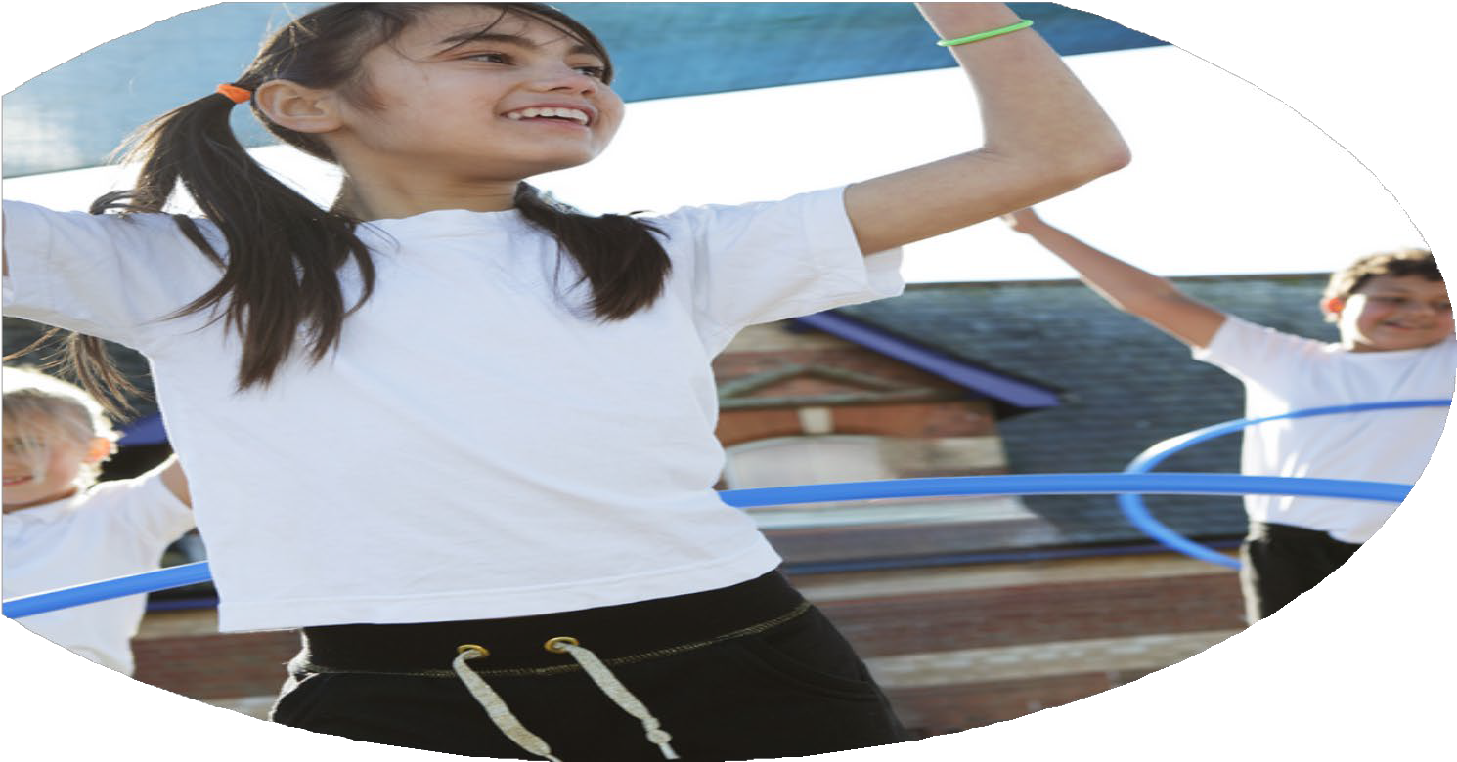
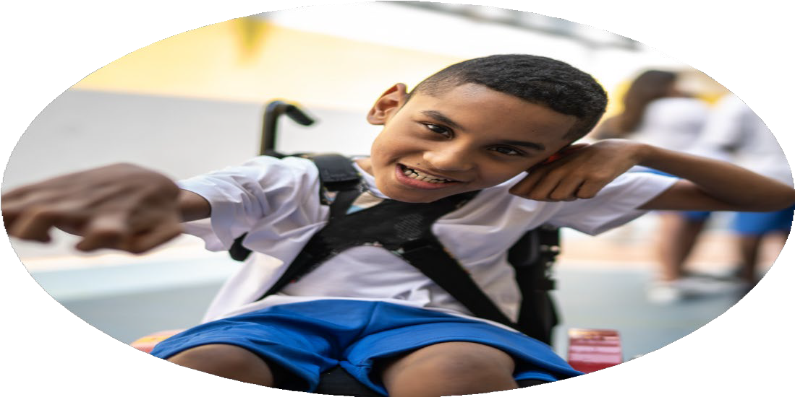
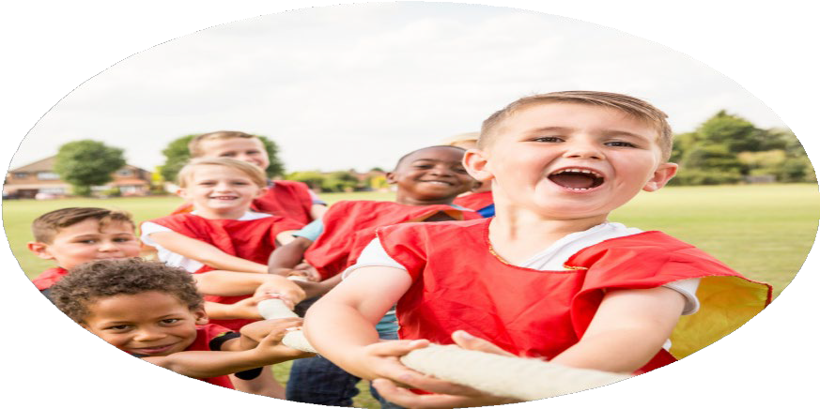



PE Funding

Evaluation Form

2024-2025
Commissioned by

Created by

Images courtesy of Youth Sport Trust

PE Funding Evaluation Form

It is intended that this template should be used as preparation for the completion of the statutory digital reporting tool being introduced this academic year. You can upload data (including swimming) from this template onto this platform once it becomes accessible.
Before you decide how you are going to use the funding for this academic year you should reflect and evaluate the impact of your use of the funding in 2023/24.
All spending of the funding must conform with the terms outlined in the Conditions of Grant document. The template is a working document that you can amend/update during the year.
Based on your evaluation of last year’s funding you should decide what you intend to do this academic year, how you will do it, and what impact you expect it to have.

It is important that the funding is used effectively and based on your school’s needs.
You must use the funding to make additional and sustainable improvements to the PE and sport in your school. You must develop and add to the PESSPA activities that your school already offers.

Summative digital reporting from June 2025 will continue to include swimming and water safety information therefore funding can be used to provide top-up lessons where necessary to ensure pupils meet national curriculum swimming requirements.

We recommend that you start by reflecting on the impact of current provision and reviewing your previous spend

What went well? | How do you know? | What didn’t go well? | How do you know?
Top-up swimming | Good progress of children previously not reaching N.C requirements. | High percentage of children were still not achieving the National requirements. | Data from the class teacher.
Introduction of PE Passport App for assessment to ensure consistency. | All staff have access to the same APP and same form of assessment. | Technical difficulties with the app made staff lack confidence when using it. | Staff discussions.
Introduction of OPAL playground ensured children were more active and behaviour incidents reduced on the playground. | More children are engaging with the resources on the playground to move their bodies.
We engaged with the sports Partnership to ensure children have opportunities to compete in a wide range of activities. | Registers kept demonstrated that a wide range of children across the school were engaging in the events during sports partnership.

What are your plans for 2024/25? | How are you going to action and achieve these plans?
Intent | Implementation
Provide CPD for specific staff members to ensure that that subject leaders are secure with opportunities for adventurous activities and the subject. Provide CPD so that staff can deliver bikability. | Subject lead to attend PE conferences and Lancashire Training for Outdoor Adventurous activities training and to feedback this to staff to ensure staff are providing this for children. HLTA to attend Go Vello balancability training for EYFS children as a cost efficient strategy.
Increase participation in after school clubs by getting in a range of different professionals for Football and dancing. | Use the services of Dave and Joel Pilkington and Eleve Dance Ltd to encourage a wide range of children to get involved in after school clubs.
Provide top-up swimming for children in years 4-6 who have not yet met the National Curriculum requirements. | Subject Leader and Y4 Class Teacher to plan top-up swimming and arrangements for those children who have not met the National Curriculum minimum standards.
Increase participation and access for all for children to compete in healthy sporting competition with other schools in the local area. | Use the Hyndburn and Ribble Valley school games cluster to attend a wide range of events (competitive and non-competitive) and monitor registers to ensure a wide range of children attend.
PE as a tool for whole-school improvement and wider skills such as team work, communication, resilience, patience and determination which will support children’s learning across the curriculum. | Continue with the use of PE Passport scheme and make clear links to the character value that each lesson focuses on.  CPD led by subject leader to ensure that assessment is being used effectively.  OAA games to be introduced and CPD delivered to staff by the subject leader to improve cooperation and resilience.
Continue with the OPAL (Outdoor Play and Learning) journey and provide resources to ensure children are having more opportunities to be active throughout the day. | OPAL Curriculum Leader and SLT to work collaboratively to discuss future plans and adapt the playground when necessary.  Work with local companies and ask for resources and donations to provide a wide range of different resources.  Speak to children and see what they would like on the playground to support them.

What impact/intended impact/sustainability are you  expecting? | How will you know? What evidence do you have or  expect to have?
Staff will be skilled up and EYFS children will have more opportunities to develop their balance. Children will have opportunities for OAA. | Teacher assessment through the balancability. Engagement from children through pupil voice and during their sessions.
More children will be active and find an enjoyment for sports through being provided with a range of different ones with specialist. | Registers from club to see if more pupils are engaging. Pupil voice to see what clubs they have enjoyed.
More children will have improved water confidence and improved knowledge of water safety through having extra opportunities. | Children to be monitored during the swim sessions and this being feedback to the subject leader.  Improved data for those who are at the national requirement level.
Children will have more opportunities to apply their skills learnt in PE lessons to different competitive scenarios and develop their character value skills. They will be able to feel confident to represent St Peters at the events. | The level of attendance to the number of events offered across the whole year.  School games award should reflect how well we have engaged with the cluster events.
Children will demonstrate improved ability, coordination and character values in PE. Children will have a wide range of skills and there will be a consistent curriculum and assessment across the school. | Children will be able to apply the character skills gained to events and more competitive games.  Teachers will be able to see assessment clearly from using the apps.
Children will have extra opportunities to develop physically on the playground through different forms of movement. | An award for completing the OPAL programme.  Pupil voice to see the children’s opinions.

What impact/sustainability have you seen? | What evidence do you have?
Reception engaged with balancability which has supported them with other areas of their learning.  Each class took part in an OAA task. | Teacher assessment which has been feedback to the subject leader.  Photographs from the OAA tasks that were feedback and given to the subject leader.
More children are engaging with the sports afterschool club. This is for children across the whole schools. | The paper registers that have been taken during the clubs show that more children are engaging with after school clubs. This has been monitored by the subject leader and the head teacher.  Children have voiced their opinions about which clubs they would like to do.
Top up swimming provided interventions for focus children who had previously not met the National Curriculum minimum standard. This enabled these children to have more confidence in water safety. | An extra 4 children were able to meet the national requirement after top up swimming.  Children reported to the subject leader that they enjoy swimming and they feel more confident in the water. The class teacher who took the children swimming fed the data back to SLT and the subject leader.
Children have shown more enthusiasm towards representing the school during the Hyndburn and Ribble Valley cluster competitions. They have been more engaged in PE as a result of this. | The level of events that children have attended have increased. Registers show that a wide range of children have attended these events.  We achieved the GOLD award in the School Games which demonstrates the amount of events and enthusiasm towards PE.
Through the PE Passport children have been more engaged in PE and children are becoming more secure with their fundamental movement skills.  Teachers are becoming more confident at assessing the children in PE. | Children have been seen engaging within PE lessons which has been monitored by teachers and subject leaders and pupil voice from children is positive.  The teachers have feedback to the subject leader about PE through professional and evaluative conversations.  Children have demonstrated the character values and improved coordination through the competitive and noncompetitive events through the school games.
The playground equipment has increased so that children are engaging with a variety of different resources on the playground. Examples of things that have been added are swings, crates for den building, scooters, bikes and mud kitchen.  Children have engaged with this greatly and it has been transformative for physical development. | As a school, we achieved the OPAL Gold award as a result of our contributions to supporting children with their outdoor play and learning. The feedback from the OPAL mentor showed that we have made huge progress in supporting children with their physical and holistic development on the playground.  Pupil voice allowed children to list some of the things they would like and it demonstrated that children loved engaging with the resources on the playground.

