PSHE – Relationships and Health Education Policy

Intent of PSHE – Health and Relationships Education

PSHE intent statement
At St. Peter’s our vision for PSHE is that all children develop the knowledge and skills they need to keep themselves healthy, safe and prepared for life in our ever-changing world. We aim to develop children’s confidence and resilience to enable them to make positive choices in their lives.
Our PSHE curriculum is tailored to meet our children’s needs and through the topics -
Relationships
- Families and close positive relationships
- Friendships
- Managing hurtful behaviour and bullying
- Safe relationships
- Respecting self and others
Health and wellbeing
- Healthy lifestyles (Physical wellbeing)
- Mental health
- Ourselves, growing and changing
- Keeping safe
- Drugs, alcohol and tobacco
Living in the wider world
- Shared responsibilities
- Communities
- Media literacy and digital resilience
- Economic wellbeing: Money
- Economic wellbeing: aspirations, work and career

Through these topics children will have the opportunities to explore their attitudes, values and beliefs about issues. They are taught skills, language and strategies that they will need to manage these issues if they ever need to.
Our School Mission statement
Our vision is to create an environment where we all feel loved and have a sense of belonging. We ensure that our Christian values are constantly visible in a place where we all always seek to serve God and treat one another with love and respect. We aspire for our children to be courageous advocates, who endeavour to make a positive difference to the future of our world. Through the provision of a broad and balanced curriculum, we aim to empower the whole of our school family with wisdom, knowledge and skills and unlock the God given talents of every individual. Our purpose is to enable our whole school family to flourish, inspiring our children to be life-long learners, thankful to God for the opportunities that they have been given. Aiming to provide spiritual guidance, we see every individual as one of God’s children. We leave no stone unturned in enabling everyone to become the best that they can be and the person God created them to be.
To summarise we developed the following mission statement.
‘Unlocking the potential for everyone to flourish in the love of Christ.’
We remember this with our three words
‘Unlock, enable, flourish’
What values will underpin this policy?
Our whole school values are belonging, kindness, peace and courage, we encourage our children to think about these values in every aspect of school life. Our curriculum also promotes the spiritual, moral, social, cultural, mental and physical development of pupils. We promote values by ensuring that right from EYFS the children are familiar with SMSC and British Values. These values are displayed and referred to regularly at any part of the school day or in any lesson when they might arise. These values will also be covered extensively through the PSHE curriculum.

How will we ensure the curriculum is relevant to our pupils?
Building on the foundations laid in Early Years where the focus will be on three main areas self-confidence and self-awareness, managing feelings and behaviour and relationships. The curriculum in KS1 and KS2 follows the question-based model produced by the PSHE Association. We used resources from the PSHE association alongside quality assured resources from 1Decision to plan lessons.

Our curriculum builds on prior learning by ensuring that teachers are familiar with the learning that has taken place in previous years. The curriculum prepares Years 5 and 6 pupils for the transition to high school by ensuring that lessons are tailor made to give children the support they need to help them at this time of change.

While promoting the values above and meeting statutory requirements, we will ensure that pupils are offered a broad and balanced curriculum designed to meet their needs by using relevant local data and school information (CPOMS and attendance) related to Relationships/Health/PSHE Education to inform planning and to address the identified needs of the whole school community e.g. Health Needs Assessment Survey, Health LSIP, which includes the school's NCMP weighing and measuring data for Reception and Year 6 pupils, along with Public Health data on road traffic accidents, attendance at A&E, alcohol and drug use, social deprivation, family life, career and life chances.

Creating a safe and supportive learning environment
We will create a safe and supportive learning environment by:
- providing a safe, secure learning environment for PSHE – Health Education and Relationship Education that enables children to gain accurate knowledge, develop their own values and attitudes, and learn the skills to grow into happy confident successful adults
- ensuring all members of staff are role models for positive interpersonal relationships by offering training or support if needed.
- ensuring Group agreements (ground rules) are negotiated with classes on an individual basis at the beginning of the academic year and are used to create and maintain a safe learning environment for staff and pupils throughout. They are regularly revisited to ensure a consistent approach each half term.
- using distancing techniques to remove the risk of sharing personal information such as role play, scenarios and moral dilemmas

We will answer pupils' questions honestly and accurately within an agreed developmentally appropriate framework in school. Questions will arise due to their developmental stage and/or from the planned content of lessons. The asking of questions requires a consistent clearly understood way of responding respectfully. This includes:
- All classrooms have an 'ask it' basket all the time as questions may be linked to any topic
- If a question is believed to be intended to embarrass or to push the boundary, the response needs to ensure pupils are not discouraged from asking questions. The response needs to thank the pupil for the question and to check there is a clear understanding of what exactly is being asked. This is to ensure safeguarding concerns are not missed but also that questions are not misinterpreted. E.g. a question about touch may not be inappropriate touch, it may be about the invasion of personal space.
- If the teacher or visitor (link to Visitor Policy) is unsure whether or not to answer a question for whatever reason, the response is that it is not going to be answered now but the teacher "will get it answered for you as soon as possible". Ask the pupil to write it down and put it in the basket. This may need to be supported by an adult with the pupil still placing it in the basket.
- If a pupil asks a question, it needs to be addressed as soon as possible because they want to know the answer. If it is not provided in the safe learning environment of a classroom, there is a risk they will search for the answer using unreliable sources on the internet or other people.
- Depending on the question, the member of staff delivering or with the visitor, needs to know who to refer the question to which is a school decision e.g. PSHE Lead, SLT/DSL. The decision may be:
- The question falls within the school's agreed framework of what will be answered in class and can be followed up in the next lesson.
- Taking any safeguarding issues into consideration, the decision may be to contact home to share the question with parents and carers to ask if they would like to answer it, or school staff to answer it or to answer it together in partnership.
- There needs to be a safeguarding response.
- A record of questions asked and how they were dealt with will be kept for safeguarding reasons or to inform future curriculum planning.

SEND, inclusion, equality and diversity
We recognise the right for all pupils to have access to PSHE – Health Education and Relationship Education learning which meets their needs. We ensure that pupils will receive this through carefully planned lessons which will be adapted to allow pupils to access the curriculum and make good progress.

Teaching takes into account the ability, age, development and cultural backgrounds of our children and those with English as a second language to ensure that all can fully access the PSHE curriculum through personalised lessons. We promote social learning and expect our pupils to show a high regard for the needs of others by following the school and class rules and the values that underpin everything we do in school.

We use PSHE Health Education and Relationship Education as a vehicle to address diversity issues and to ensure equality for all by giving children opportunities to learn to celebrate being a unique individual and respecting others who are different from them. The needs and interests of all pupils, irrespective of sex, gender identity, family, faith, culture, sexual orientation, ability or aptitude are addressed and respected by all. PSHE is taught in a non-biased way respecting everybody as individuals.

We will assess children at the beginning and end of a lesson or a series of lessons and use this to inform next steps when planning. We respect pupils’ unique starting points by providing learning that is suitable for them to access and move their learning on to ensure they make good progress.

We ensure that pupils with special educational needs receive access to PSHE Health Education and Relationship Education through carefully planned lessons and activities that cater for their individual needs and ensure that they make good progress. For our more able pupils we will provide a challenge in each lesson to encourage further questioning and discussion about the topic.

Implementation of PSHE – Relationship and Health Education

DfE statutory guidance states that from September 2020, all Primary Schools must deliver Relationships Education
KS1 & 2 Five Topics:
- Families and people who care for me
- Caring Friendships
- Respectful relationships
- Online relationships
- Being safe

DfE statutory guidance states that from September 2020, all Primary Schools must deliver Physical Health and Wellbeing Education (Health Education)
KS 1 & 2 Eight Topics:
- Mental wellbeing
- Internet safety and harms
- Physical health and fitness
- Healthy eating
- Drugs, alcohol and tobacco
- Health and prevention
- Basic first aid
- Changing adolescent body

We will do this by using the question-based model from the PSHE Association to cover the following topics:

Relationships
- Families and close positive relationships
- Friendships
- Managing hurtful behaviour and bullying
- Safe relationships
- Respecting self and others

Health and wellbeing
- Healthy lifestyles (Physical wellbeing)
- Mental health
- Ourselves, growing and changing
- Keeping safe
- Drugs, alcohol and tobacco

Living in the wider world
- Shared responsibilities
- Communities
- Media literacy and digital resilience
- Economic wellbeing: Money
- Economic wellbeing: aspirations, work and career

These topics have been mapped to the statutory guidance to ensure full coverage across Key Stage 1 and 2. In addition to statutory content, we include non-statutory topics that support the personal development and wellbeing of our pupils.
As a school, we have chosen not to teach sex education beyond the statutory requirements. If questions arise, they will be addressed in an age-appropriate manner, following a discussion with parents to determine whether they prefer to answer the question at home or would like the school to respond.

PSHE – Relationship and Health Education Curriculum
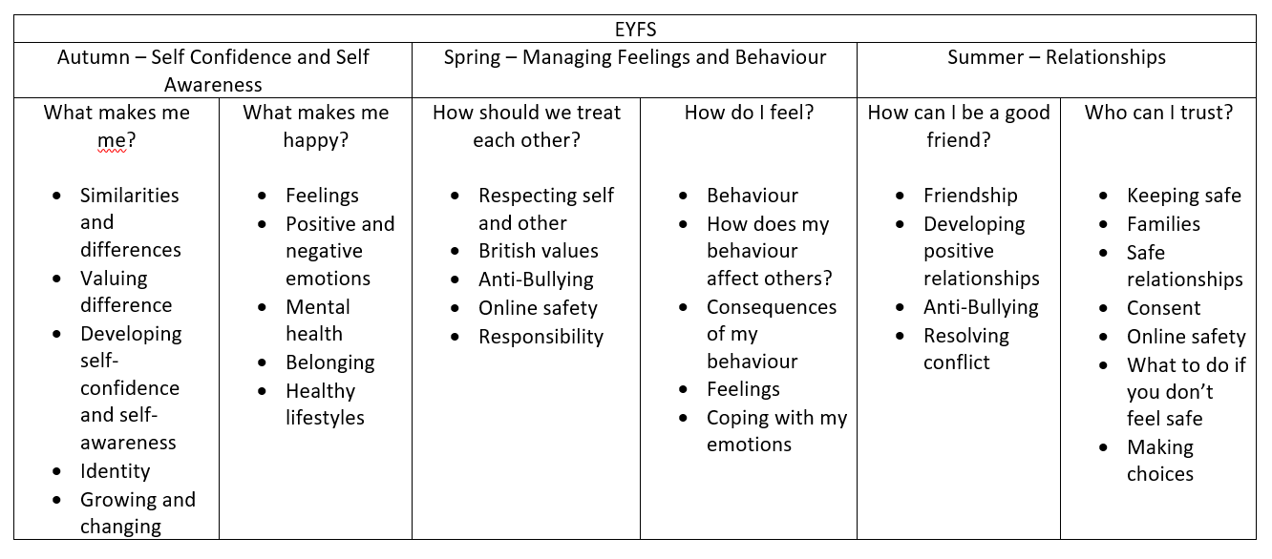
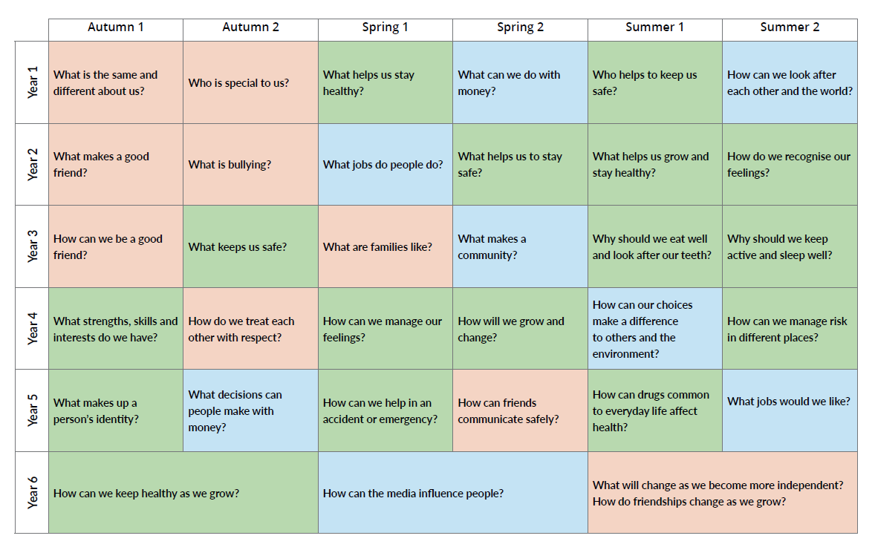
Relationship Education is highlighted in pink
Health Education is highlighted in green
Living in the Wider World is highlighted in blue

Some of the objectives from Health Education and Relationship Education overlap in these topics but the colour indicted the main focus of the topic.

See documents – PSHE Key Stage 1 Overview, PSHE Key Stage 2 overview to see how the objectives are covered in each year group

See document – How PSHE links to statutory guidance to see how the objectives from the question-based model from the PSHE Association link to the statutory objective and what year groups cover them.

We recognise that our school community is continually evolving, and we are committed to addressing any relevant topics, issues or concerns that may arise. PSHE will remain flexible and responsive, ensuring children are supported to understand and navigate the challenges and opportunities of an ever-changing world. Therefore, topics may move or be changed depending of the needs of each cohort.

Parental Engagement
Parents and carers have been informed about and consulted on the policy through parent discussion with one family and then a consultation letter that was sent out which they were asked to respond to.

The policy is available to parents and carers through the school website. Parent and carer information meetings and updates will be planned when appropriate. Parents and carers are informed of the content of the lessons by having access to the policy and curriculum overviews on the school website. There is no right to withdraw from Relationships Education curriculum or Health Education as this content is statutory.

Timetabling PSHE – Relationship and Health Education
We allocate 1 hour per week curriculum time to PSHE – Health Education and Relationship Education. This takes place as a stand-alone lesson however PSHE Health Education and Relationship Education could take part at any time of the school day. When PSHE topics have been discussed at other times they will be recorded in the class book.

Our PSHE Health Education and Relationship Education provision is further enriched by theme days, school trips, enrichment activities, breakfast club, after school clubs, Worship and all areas of the curriculum. Where appropriate evidence of this can be shown in the class book.

Who will be responsible for the curriculum?
The PSHE Health Education and Relationship Education curriculum will be led by Katy Gardner, the PSHE lead. It is taught by the class teachers, where possible. It is supported by Teaching Assistants, where possible.

The school supports staff delivering PSHE Health Education and Relationship Education to access appropriate CPD. We have a service level agreement with Lancashire which allows the PSHE lead to attend three network meetings per year and have support from the PSHE Consultant. The information from these courses and support is then shared with staff at staff meetings or as one to one support if needed.

Impact of PSHE – Relationship and Health Education

How will we assess this learning?
We assess pupils’ learning through activities at the beginning of a lesson or a series of lessons to establish their baseline and then their endpoint to show individual progress. This is evidenced by work or photographs in the class books or by work in children’s individual journals. We may also carry out assessment-based questions at the end of each unit that can be discussed as a whole class or carried out in smaller groups. This assessment can also be used to inform next steps in planning.

How will we involve and consult pupils?
Pupils have been involved in the creation of this policy through discussions in PSHE lessons with their class teachers and questionnaires that have been discussed with KS2 classes. Pupils' needs and issues they are facing will be identified by knowing our families and what needs they have. Also using data about health etc. and from CPOM as mentioned above. Pupils' views of what is currently being taught and how, will help to inform the curriculum when the assessment-based questions are discussed at the end of each unit.

Pupils have opportunities to review and reflect on their learning during lessons through questioning and discussing the work they have completed in their journals. There journals will show assessment at the start of a lesson or series of lessons and then the endpoint.

Pupils in KS2 have said that in PSHE lessons they want to learn more about:
- Keeping safe online
- Mindfulness
- Growing up and changing
- Media influence and how it influences online bullying
- Careers
- Finance/Money
- Mental Health
- Health
- How to accept other people
- How to respond to bullying
All these topics will be covered in our curriculum.

Monitoring, reporting and evaluation
The Head Teacher/SLT and PSHE lead will look at class books and individual journals with the pupil’s permission. Support will be given to staff with planning and resources. All staff have access to the PSHE Association and the quality assured resources they provide. The PSHE lead will carry out staff and pupil questionnaires to ensure staff are confident and comfortable teaching the topics and pupils know what PSHE is, what it covers and they can talk about their progress in the subject.

All staff are to use the question-based model from the PSHE Association as their long-term plan. They also have access to the KS1 and KS2 overview documents and the document that links the statutory guidance to the question-based model. New staff or supply staff will be given this information to ensure the correct curriculum is delivered.

Responsibility for the implementation of this policy.
Key Governor
Head teacher – Emma Moss
PSHE Lead – Katy Gardner
Teachers

Appendix - documents referenced
- DfE Statutory Guidance on Relationships Education, Relationships and Sex Education (RSE) and Health Education (2019)
- Equality Act (2010)
- Keeping Children Safe in Education (2025)
- PSHE Association documents
- Programme of Study
- Programme Builders
- PSHE Lead's Pack KS 1 and 2, Handling Complex Issues safely in the PSHE Education classroom
- A Guide to Assessment in Primary PSHE Education.

