Pupil premium strategy statement St Peter’ CE Primary School
This statement details our school’s use of pupil premium (and recovery premium) funding to help improve the attainment of our disadvantaged pupils.
It outlines our pupil premium strategy, how we intend to spend the funding in this academic year and the outcomes for disadvantaged pupils last academic year.

School overview
Detail | Data
Number of pupils in school | 131
Proportion (%) of pupil premium eligible pupils | 52%
Academic year/years that our current pupil premium strategy plan covers (3 year plans are recommended – you must still publish an updated statement each academic year) | 2024/25, 25/26, 26/27
Date this statement was published | December 2024
Date on which it will be reviewed | July 2025
Statement authorised by | Emma Moss, Headteacher
Pupil premium lead | Emma Moss, Headteacher
Governor / Trustee lead | Hannah Rigby

Funding overview
Detail | Amount
Pupil premium funding allocation this academic year | £ 103 600
Pupil premium funding carried forward from previous years (enter £0 if not applicable) | £ 0
Total budget for this academic year  If your school is an academy in a trust that pools this funding, state the amount available to your school this academic year | £ 103 600

Part A: Pupil premium strategy plan

Statement of intent
Our belief is - and research evidence shows (e.g. from The Sutton Trust, EEF, John Hattie, Ofsted, DfE Reports, Michael Barber) - that quality of teaching and learning is the most important factor in the achievement of all pupils. This is particularly true for pupils from areas with a high deprivation indicator. Children attending St Peter’s CE Primary School come from the highest quintile of deprivation. The development of a high quality, wide and progressive curriculum, with opportunities for personal development, is central to the School Improvement Plan. This provision will have the biggest positive effect on our most disadvantaged pupils; ensuring the gap closes between the most disadvantaged and the most advantaged pupils in our school community. Our focus on providing high quality continuous profession development ensures that all staff members are supported in developing the skillsets needed to enable our children to make rapid progress from low starting points and secure levels of high attainment, across all year groups and at the end of each Key Stage. The drive for continuous improvement ensures that children access a high quality education. While we know that enriching classroom experiences are paramount in the Early Years, we also know that providing enhancements and enrichments to the curriculum are just as important. Experiencing the broader world is a crucial factor before joining it. In addition, some children will need more time and/or support to ensure they are able to fulfil their potential. In these cases, additional targeted intervention and support strategies are provided and the impact of these is reviewed regularly.

Challenges
This details the key challenges to achievement that we have identified among our disadvantaged pupils.
Challenge number | Detail of challenge
1 | On entry assessments to our Reception class in the last three years show that the vast majority of our disadvantaged pupils start school with well below age related expectations. The gap narrows but remains significant in each of the core subjects to the end of Key Stage 2.
2 | 33% of children in receipt of the Pupil Premium grant have Special Educational Needs. A further 35% have emotional or attendance needs. Assessments show that, on average Pupil Premium children with no identified special needs are achieving in line with national averages across the core subjects in reading and maths but not in writing.
3 | Assessments, observations and discussions indicate underdeveloped oral language and vocabulary gaps among many disadvantaged children. This is evident across the school and impacting on reading, writing and maths with attainment in writing being the most greatly affected.
4 | Internal and external assessments show that reading, writing and maths attainment amongst disadvantaged pupils with SEND is significantly lower than that of no disadvantaged pupils and there are fewer achieving greater depth.
5 | Our attendance data over the last year indicates that attendance rates among disadvantaged children has been 92%, which is lower than the school target of 96%. 28% of children receiving the Pupil Premium grant have attendance lower than 90% and are therefore persistent absentees.
6 | Our assessments, observations and discussions with families have identified social and emotional issues for many pupils as well as a lack of enrichment opportunities. These challenges particularly affect disadvantaged pupils.

Intended outcomes
This explains the outcomes we are aiming for by the end of our current strategy plan, and how we will measure whether they have been achieved.
Intended outcome | Success criteria
Improved oral language skills and vocabulary among disadvantaged pupils. | Assessments and observations indicate improved oral language and understanding among disadvantaged pupils. This is evidence when triangulated with other sources of evidence, including lesson observations, book scrutiny and formative assessment.
Improved reading attainment among disadvantaged pupils. | KS2 reading outcomes in 2025/26 show more than 70% of disadvantage pupils met the expected standard with over 14% achieving Greater Depth.
Improved maths attainment among disadvantaged pupils. | KS2 reading outcomes in 2025/26 show more than 70% of disadvantage pupils met the expected standard with over 14% achieving Greater Depth.
Improved writing attainment among disadvantaged pupils | KS2 writing outcomes in 2025/26 show more than 70% of disadvantage pupils met the expected standard with over 14% achieving Greater Depth.
To achieve and sustain improved well-being for our pupils in our school particularly our disadvantaged pupils. | Sustained high levels of wellbeing by 2024/25 demonstrated by:  Pupil Voice data  A reduction in behaviour incidents.  An increase in participation in enrichment activities, particularly among disadvantaged pupils.
To achieve and sustain improved attendance for all pupils, particularly our disadvantaged pupils. | Sustained high attendance by 2025/26 demonstrated by:  The overall absence rate for all pupils being no more than 6%.  The PA rate to be no more than 8%. The rate of absenteeism is lower for PP children than non PP children.

Activity in this academic year
This details how we intend to spend our pupil premium (and recovery premium) funding this academic year to address the challenges listed above.

Teaching (for example, CPD, recruitment and retention)
Budgeted cost: £35,613
Activity | Evidence that supports this approach | Challenge number(s) addressed
Implementation of new guided reading schemes to improve reading comprehension at Key Stage 2. | Reading comprehension strategies are high impact alongside phonics it is a crucial component of early reading instruction.  https://educationendowmentfoundation.org.uk/education-evidence/teaching-learning-toolkit/reading-comprehension-strategies | 3, 4
Additional staffing and resources to deliver a DFE validated phonics programme to secure phonics teaching for all pupils. | Phonics approaches have a strong evidence base that indicates a positive impact on the accuracy of word reading, particularly for disadvantaged pupils.  https://educationendowmentfoundation.org.uk/education-evidence/teaching-learning-toolkit/phonics | 2,4
Enhancement of our maths teaching and curriculum planning in line with DFE and EEF guidance, implementing number fluency into all year groups. | The DFE non-statutory guidance has been produced in conjunction with the National Centre for Excellence in teaching maths.  https://educationendowmentfoundation.org.uk/education-evidence/guidance-reports/early-maths  https://educationendowmentfoundation.org.uk/education-evidence/guidance-reports/maths-ks-2-3 | 4
Develop teaching of pupil’s transcription and sentence construction skills through extensive practice. | Writing is a complex task because it requires pupils to coordinate a number of different processes at once. The Simple View of Writing highlights three overarching processes that are essential to writing.  https://educationendowmentfoundation.org.uk/education-evidence/guidance-reports/literacy-ks2  https://educationendowmentfoundation.org.uk/education-evidence/guidance-reports/literacy-ks-1 | 4
Embedding oracy across the curriculum. Purchase resources, fund staff training and release time for Talk programmes. | There is a strong evidence base that suggests oral language interventions and high quality classroom discussion are inexpensive to implement with high impacts on literacy.  https://educationendowmentfoundation.org.uk/education-evidence/teaching-learning-toolkit/oral-language-interventions | 1, 3, 4
Provide opportunity for all pupils to experience success by adapting teaching. | It is recognised that differentiation can limit a child’s success. The document entitled, ​‘Differentiation – Why and How?’, NASEN capture some of the problems and recommend a move to adaptive teaching.  https://educationendowmentfoundation.org.uk/news/moving-from-differentiation-to-adaptive-teaching | 3,4,5
Create a positive and supportive environment for all pupils. | An inclusive school removes barriers to learning and participation, provides an education that is appropriate to pupils’ needs, and promotes high standards and the fulfilment of potential for all pupils.  https://educationendowmentfoundation.org.uk/education-evidence/guidance-reports/send | 1,2,3,4,5

Targeted academic support (for example, tutoring, one-to-one support, structured interventions)
Budgeted cost: £ 52,320
Activity | Evidence that supports this approach | Challenge number(s) addressed
Engagement with the National Tutoring Programme to provide a blend of tuition, mentoring and school –led tutoring for pupils for identified children. | Tuition targeted at specific needs and knowledge gaps can be an effective method to support low attainment pupils or those falling behind.  https://educationendowmentfoundation.org.uk/education-evidence/teaching-learning-toolkit/small-group-tuition | 2,3,4
Additional phonics sessions targeted at disadvantaged pupils who require further phonics support. | Phonics approaches have a strong evidence base indicating a positive impact on pupils, particularly from disadvantaged background. Targeted phonics interventions have been shown to be more effective when delivered as regular sessions. https://educationendowmentfoundation.org.uk/education-evidence/teaching-learning-toolkit/phonics | 1,2,4
Additional reading fluency sessions targeted at disadvantaged pupils who require further reading fluency support. | Reading fluency can be defined as reading with accuracy, automaticity and prosody. When pupils read fluently, their cognitive resources can be redirected from focusing on decoding and onto comprehending a text. For this reason, fluency is sometimes described as a bridge from word recognition to comprehension.  https://educationendowmentfoundation.org.uk/reading-house/fluency | 1,2,4
Complement high quality teaching with carefully selected small-group and one-to-one interventions | High quality teaching should reduce the need for extra support, but it is likely that some pupils will require high quality, structured, targeted interventions to make progress.  https://eef.li/implementation/ | 2.4

Wider strategies (for example, related to attendance, behaviour, wellbeing)
Budgeted cost: £ 18,744
Activity | Evidence that supports this approach | Challenge number(s) addressed
Integrate Outdoor Play and Learning into the school day to promote positive mental wellbeing. | Outdoor Adventure Learning can provide opportunities for disadvantaged pupils to participate in activities that they otherwise might not be able to access. Through participation in these challenging physical and emotional activities, outdoor adventure learning interventions can support pupils to develop non-cognitive skills such as resilience, self-confidence and motivation.  https://educationendowmentfoundation.org.uk/education-evidence/teaching-learning-toolkit/outdoor-adventure-learning  Research shows that children's mental and physical health is getting worse and that great play can make it better.  https://outdoorplayandlearning.org.uk/ | 2,4,6
Whole staff training on behaviour management and anti – Bullying approaches with the aim of developing our school ethos and sustaining good behaviour across the school. | Both targeted interventions and universal approaches can have positive overall effects.  https://educationendowmentfoundation.org.uk/education-evidence/teaching-learning-toolkit/behaviour-interventions | 2,4,5,6
Embedding principles of good practice set out in the DFE’s guidance on working together to improve school attendance through the deployment of attendance officers to improve attendance. | The DfE guidance has been informed by engagement with schools that have significantly reduced levels of absence and persistent absence. | 5
Provision for dealing with acute emotional issues | Based on our experiences, and those of similar schools, we have identified a need to set a small amount of funding aside to respond quickly to needs as they arise. | 2, 5, 6

Total budgeted cost: £ 106,677

Part B: Review of the previous academic year

Outcomes for disadvantaged pupils
We have analysed the performance of our school’s disadvantaged pupils during the previous academic year, drawing on national assessment data and our own internal summative and formative assessments.
To help us gauge the performance of our disadvantaged pupils we compared their results to those for disadvantaged and non- disadvantaged at national and local level and to our results achieved by our non- disadvantaged.
Phonics The data demonstrated that the percentage of disadvantaged children passing the phonics screening check at KS1 is higher than national.
Y1
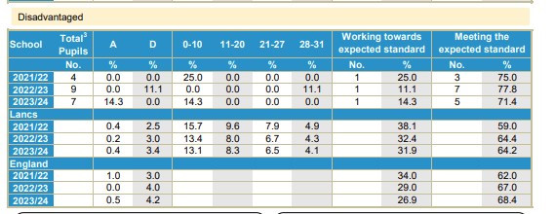
Y2
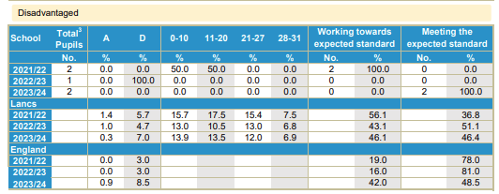

Disadvantaged children performed better than non disadvantaged children in the school and better than disadvantaged children in reading and maths at KS1 but not at KS2.
Disadvantaged children are underperforming in writing.
Reading
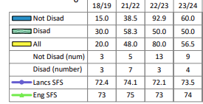
KS1 KS2
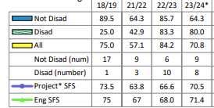

Writing
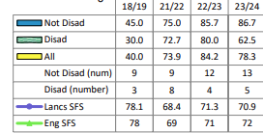
KS1 KS2
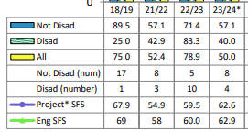
Maths
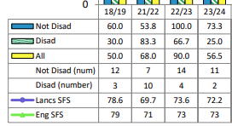
KS1 KS2
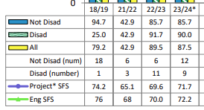
KS2 GPS
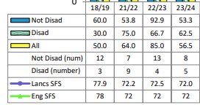
Internal data shows that children in receipt of the Pupil preium grant are achiving in line with non pupil premium across the school and that the gap is closing. Pupil premium children with no SEND needs are in line with national average. There are not enough children in receipt of the Pupil Premium grant achieving greater depth in the core subjects.
We have also drawn on school data and observations to assess wider issues impacting disadvantaged pupils' performance, including attendance, behaviour and wellbeing.
The attendance of pupils in receipt of the Pupil Premium grant was better than that of other pupils however the overall percentage was still below national average and therefore further improvement is necessary. Observations and behaviour and well-being records show that the behaviour of children in receipt of the Pupil Premium grant has improved significantly. 54% of children in receipt of the grant continue to need emotional, well-being or attendance support.
Based on all the information above, the performance of our disadvantaged pupils met expectations, but further progress needs to be made in reading, and we are at present on course to achieve the outcomes we set out to achieve by 2025/26, as stated in the Intended Outcomes section above.
Our evaluation of the approaches delivered last academic year indicates that all interventions have been successful.
We have reviewed our strategy plan and made changes to how we intend to use some of our budget this academic year. The Further Information section below provides more details about our planning, implementation, and evaluation processes.

Externally provided programmes
Please include the names of any non-DfE programmes that you used your pupil premium (or recovery premium) to fund in the previous academic year.
Programme | Provider
N/A

